Supplementary Material 1.
Pyramidal apertures with the a3 and a4, with a12 and a14.

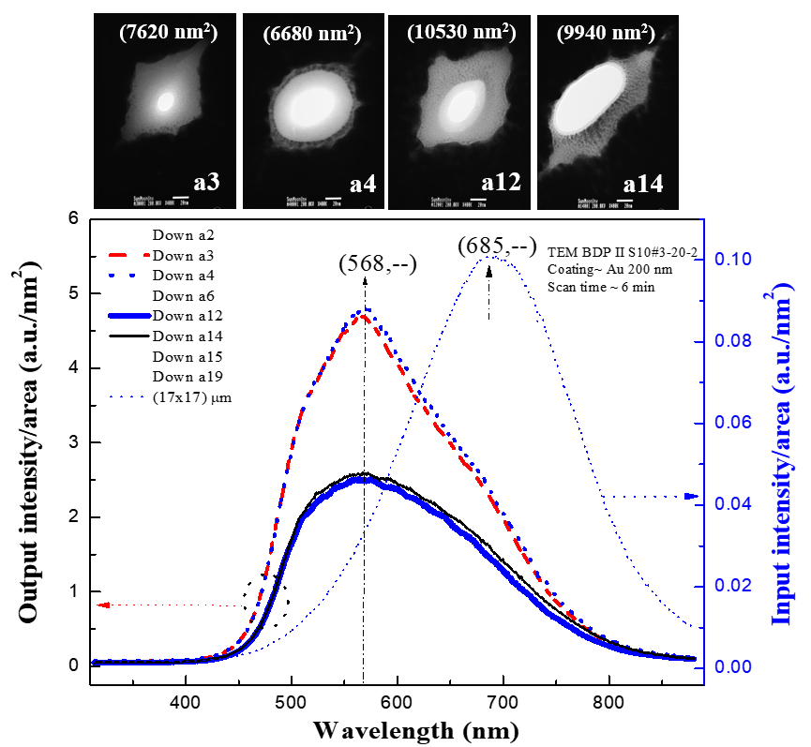

TEM images of the pyramidal apertures a3, a4, a12, and a14 are shown in the top area. The areas for the sample a3 and the sample a4 are measured to be 7620 nm² and 6680 nm², respectively. The areas for the sample a12 and the sample a14 are measured to be 10530 nm² and 9940 nm², respectively.
Both differences between the samples are less than 1000nm². For the area difference less than 1000nm2, the measured optical spectra present almost identical shape with indistinguishable intensities. For these particular samples, the measured optical spectra reveal the similar shapes with almost same intensities for sample a3 and a4, and also similar shapes for the sample a12 and a14.

Supplementary Material 2.: (7x7) slit array _E memb

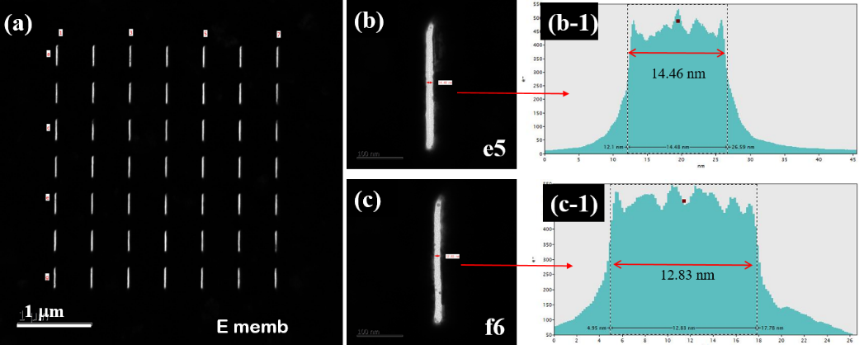

TEM images of the sample E membrane for a (7x7) nanoslit array., Clear TEM images for the slits are presented. TEM images for the slit (e5) and the slit (f6) and the electron profile for the slits are presented in (b-1) and (c-1). Widths from the slit e5 and the slit f6 are found to be 14.46 nm, 12.83 nm, respectively.

Supplementary Material 3:
FESEM image of an ~200 nm diameter Au nanoparticle on C membrane (left) and TEM image of a void aperture of (7.2 μm x 2.3 μm) size on the F membrane (right):

