Supplementary files
Table S1: Primer sequences of Candida albicans for qRT-PCR analysis.
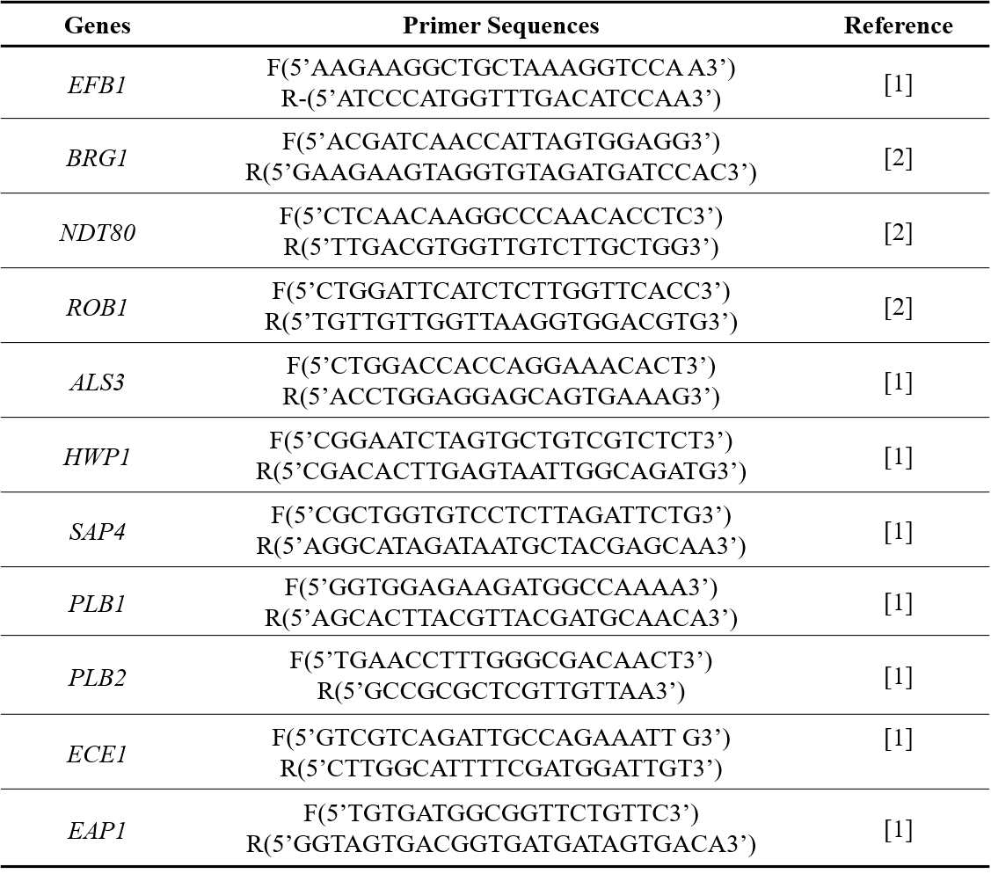

Table S2: Primer sequences of Enterococcus faecalis for qRT-PCR analysis.
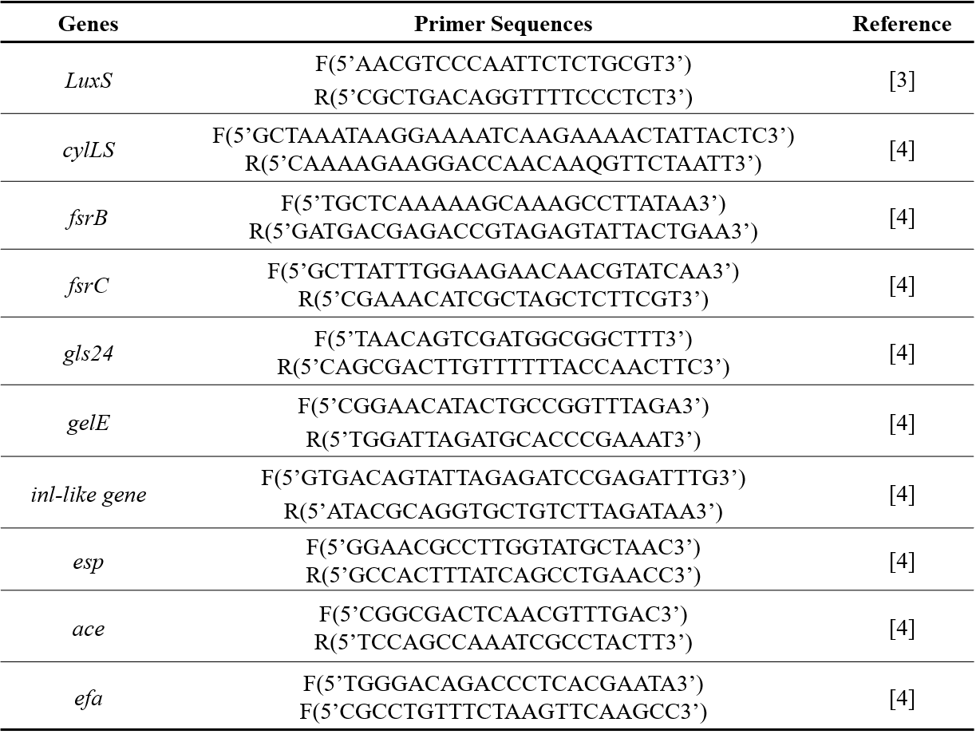

References:
- Samaranayake, Y.H.; Cheung, B.P.; Yau, J.Y.; Yeung, S.K.; Samaranayake, L.P.; Human serum promotes Candida albicans biofilm growth and virulence gene expression on silicone biomaterial. PLoS ONE. 2013, 8, e62902. doi: 10.1371/journal.pone.0062902
- Hnisz, D.; Bardet, A.F.; Nobile, C.J. et al. A histone deacetylase adjusts transcription kinetics at coding sequences during Candida albicans morphogenesis. PLoS Genet. 2012, 8, e1003118, doi: 10.1371/journal.pgen.1003118
- Yang, Y.; Li, W.; Hou, B.; Zhang, C. Quorum sensing LuxS/autoinducer-2 inhibits Enterococcus faecalis biofilm formation ability. J Appl Oral Sci. 2018, 26, e20170566. doi:10.1590/1678-7757-2017-0566
- Brett D.S.; Michael, S.G. Differential Expression of Virulence-Related Genes in Enterococcus faecalis in Response to Biological Cues in Serum and Urine. Infection and Immunity. 2002, 70, 4344–4352. doi:10.1128/IAI.70.8.4344-4352.2002

