Testing different membrane filters for 16S rRNA gene-based metabarcoding in karstic springs

Oana Teodora Moldovan ^{1*}, Andreea Baricz ^{2,3,4*}, Edina Szekeres ^{2,3,4*}, Marius Kenesz ¹, Marial Alexandra Hoaghia ⁵, Erika Andrea Levei ⁵, Ionuț Cornel Mirea ⁶, Ruxandra Năstase-Bucur ¹, Traian Brad ¹, Horia Leonard Banciu ^{2,3}, Iulia Chiciudean ^{2,3}

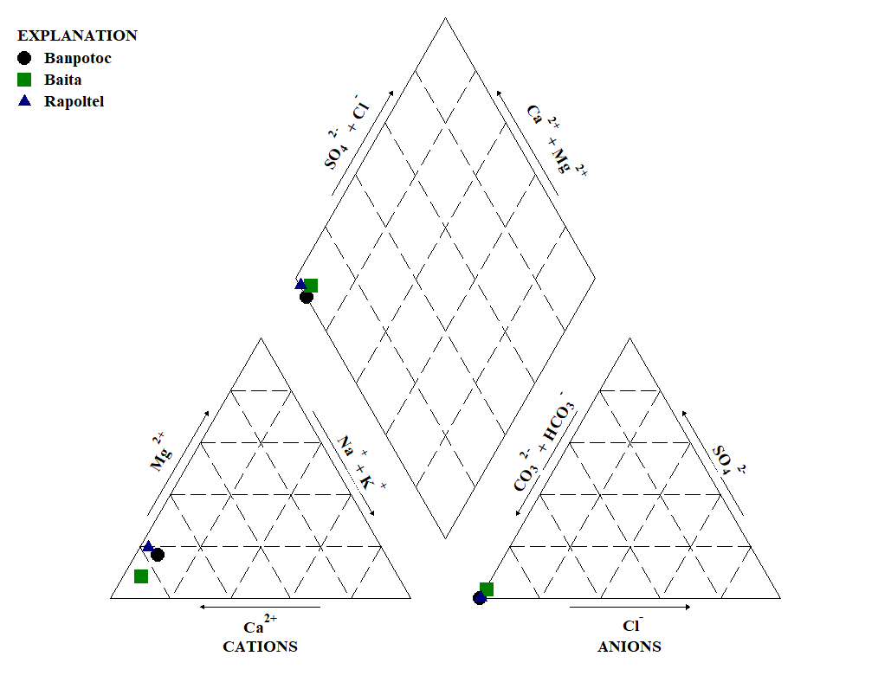
Figure S1. Piper diagram of the chemical elements for the studied springs

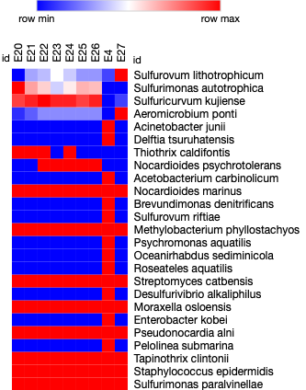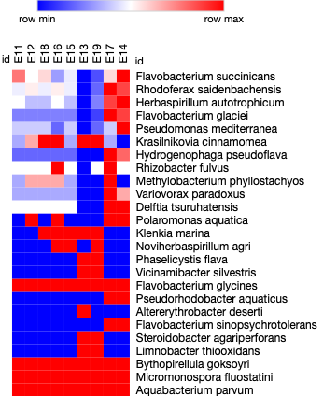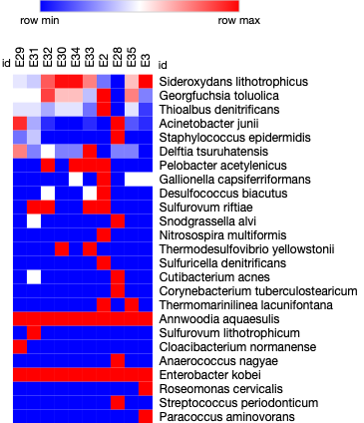
Figure S2. The heat maps of the first 25 most abundant species (above the most abundant) in each of the studied springs, Banpotoc, Baita and Rapoltel (from left to right). Relative abundance of species was considered in the analysis.

Table S1. Number of reads for the pathogenic bacteria for humans and animals found in the three studied karstic springs.
Species/1L | BANPOTOC |  |  |  |  |  |  |  |  | BAITA |  |  |  |  |  |  |  |  | RAPOLTEL
 | E20 | E21 | E22 | E23 | E24 | E25 | E26 | E4 | E27 | E11 | E12 | E18 | E16 | E15 | E13 | E19 | E17 | E14 | E29 | E31 | E32 | E30 | E34 | E33 | E2 | E28 | E35 | E3
[Bacteroides] coagulans | 0 | 0 | 0 | 0 | 0 | 0 | 0 | 0 | 0 | 0 | 0 | 0 | 0 | 0 | 0 | 0 | 0 | 0 | 0 | 1 | 0 | 0 | 0 | 0 | 0 | 0 | 0 | 0
Abiotrophia defectiva | 0 | 0 | 0 | 0 | 0 | 0 | 0 | 0 | 0 | 0 | 0 | 0 | 0 | 0 | 0 | 0 | 0 | 0 | 0 | 0 | 0 | 0 | 0 | 0 | 0 | 0 | 14 | 0
Acidovorax citrulli | 0 | 0 | 0 | 0 | 0 | 0 | 0 | 9 | 0 | 4 | 6 | 6 | 10 | 6 | 3 | 9 | 13 | 13 | 0 | 0 | 0 | 0 | 0 | 0 | 0 | 0 | 0 | 0
Acinetobacter johnsonii | 0 | 0 | 0 | 0 | 0 | 0 | 0 | 0 | 0 | 1 | 1 | 1 | 2 | 1 | 1 | 4 | 1 | 2 | 0 | 0 | 35 | 0 | 0 | 0 | 0 | 1 | 0 | 0
Acinetobacter junii | 80 | 2 | 3 | 6 | 7 | 8 | 8 | 1819 | 14 | 2 | 2 | 2 | 28 | 6 | 30 | 6 | 1 | 0 | 1371 | 418 | 144 | 110 | 106 | 164 | 78 | 1417 | 326 | 187
Actinomyces viscosus | 0 | 0 | 0 | 0 | 0 | 0 | 0 | 0 | 0 | 0 | 0 | 0 | 0 | 0 | 0 | 0 | 0 | 0 | 0 | 0 | 0 | 0 | 26 | 0 | 0 | 1 | 0 | 0
Aerococcus viridans | 0 | 0 | 1 | 0 | 0 | 0 | 1 | 0 | 0 | 0 | 0 | 0 | 0 | 0 | 0 | 0 | 0 | 0 | 0 | 0 | 0 | 0 | 0 | 0 | 0 | 8 | 0 | 0
Aeromonas caviae | 0 | 0 | 0 | 0 | 0 | 0 | 0 | 0 | 0 | 0 | 0 | 0 | 1 | 0 | 0 | 0 | 0 | 0 | 0 | 0 | 0 | 0 | 0 | 0 | 0 | 0 | 0 | 2
Arcobacter cryaerophilus | 0 | 0 | 0 | 0 | 0 | 0 | 0 | 0 | 0 | 0 | 0 | 0 | 0 | 0 | 0 | 0 | 0 | 0 | 0 | 0 | 0 | 0 | 4 | 0 | 0 | 1 | 0 | 0
Arsenophonus nasoniae | 0 | 0 | 0 | 0 | 0 | 0 | 0 | 0 | 0 | 0 | 0 | 0 | 0 | 0 | 1 | 0 | 0 | 0 | 0 | 0 | 0 | 0 | 0 | 0 | 0 | 0 | 0 | 0
Atopobium parvulum | 0 | 0 | 0 | 0 | 0 | 0 | 0 | 0 | 0 | 0 | 0 | 0 | 0 | 0 | 0 | 0 | 0 | 0 | 0 | 0 | 1 | 0 | 0 | 0 | 0 | 0 | 0 | 0
Atopobium vaginae | 0 | 0 | 0 | 0 | 0 | 0 | 0 | 0 | 0 | 0 | 0 | 0 | 0 | 0 | 0 | 0 | 0 | 0 | 0 | 21 | 0 | 0 | 0 | 0 | 0 | 163 | 0 | 0
Burkholderia multivorans | 0 | 0 | 0 | 0 | 0 | 0 | 0 | 0 | 0 | 0 | 0 | 0 | 0 | 0 | 0 | 0 | 0 | 0 | 0 | 0 | 0 | 0 | 0 | 1 | 0 | 1 | 0 | 0
Capnocytophaga sputigena | 0 | 0 | 0 | 0 | 0 | 0 | 0 | 0 | 0 | 0 | 0 | 0 | 0 | 0 | 0 | 0 | 0 | 0 | 4 | 0 | 0 | 0 | 0 | 0 | 0 | 0 | 0 | 0
Chlamydia pneumoniae | 0 | 0 | 0 | 0 | 0 | 0 | 0 | 0 | 0 | 1 | 1 | 2 | 5 | 2 | 1 | 3 | 0 | 0 | 0 | 0 | 0 | 0 | 0 | 0 | 0 | 0 | 0 | 0
Chryseobacterium hominis | 0 | 0 | 0 | 0 | 0 | 0 | 0 | 0 | 1 | 0 | 0 | 0 | 0 | 0 | 0 | 0 | 0 | 0 | 41 | 8 | 0 | 0 | 0 | 0 | 0 | 93 | 0 | 56
Comamonas testosteroni | 12 | 1 | 1 | 2 | 2 | 0 | 9 | 117 | 1 | 0 | 1 | 0 | 4 | 0 | 1 | 1 | 0 | 0 | 65 | 33 | 0 | 39 | 10 | 8 | 0 | 86 | 31 | 5
Corynebacterium pseudodiphtheriticum | 0 | 0 | 0 | 0 | 0 | 0 | 0 | 0 | 0 | 0 | 0 | 0 | 0 | 0 | 0 | 0 | 0 | 0 | 0 | 0 | 0 | 0 | 0 | 0 | 0 | 0 | 9 | 0
Corynebacterium tuberculostearicum | 2 | 0 | 0 | 2 | 1 | 1 | 0 | 6 | 1 | 0 | 0 | 0 | 1 | 0 | 0 | 0 | 0 | 0 | 26 | 39 | 17 | 0 | 31 | 70 | 0 | 228 | 81 | 0
Coxiella burnetii | 0 | 0 | 0 | 0 | 0 | 0 | 0 | 0 | 0 | 9 | 11 | 16 | 38 | 20 | 20 | 26 | 6 | 4 | 0 | 0 | 0 | 0 | 0 | 0 | 0 | 0 | 0 | 0
Enterobacter kobei | 81 | 0 | 0 | 1 | 1 | 1 | 0 | 193 | 0 | 1 | 0 | 0 | 6 | 0 | 11 | 0 | 0 | 0 | 88 | 62 | 0 | 59 | 0 | 24 | 7 | 83 | 65 | 56
Escherichia fergusonii | 0 | 0 | 0 | 0 | 0 | 0 | 1 | 11 | 0 | 0 | 0 | 0 | 0 | 0 | 1 | 0 | 0 | 0 | 0 | 130 | 0 | 0 | 0 | 1 | 0 | 13 | 0 | 0
Gardnerella vaginalis | 0 | 0 | 0 | 0 | 0 | 0 | 0 | 0 | 0 | 0 | 0 | 0 | 0 | 0 | 0 | 0 | 0 | 0 | 0 | 23 | 0 | 0 | 0 | 0 | 0 | 244 | 0 | 0
Haemophilus parainfluenzae | 0 | 0 | 0 | 0 | 0 | 0 | 0 | 0 | 0 | 0 | 0 | 0 | 0 | 0 | 0 | 0 | 0 | 0 | 16 | 0 | 0 | 0 | 0 | 4 | 0 | 21 | 0 | 0
Haemophilus pittmaniae | 0 | 0 | 0 | 0 | 0 | 0 | 0 | 0 | 0 | 0 | 0 | 0 | 0 | 0 | 0 | 0 | 0 | 0 | 0 | 0 | 0 | 0 | 17 | 0 | 0 | 0 | 0 | 23
Klebsiella variicola | 0 | 0 | 0 | 0 | 0 | 0 | 0 | 0 | 0 | 0 | 0 | 0 | 0 | 0 | 1 | 0 | 0 | 0 | 0 | 0 | 0 | 0 | 0 | 0 | 0 | 0 | 0 | 0
Lactobacillus sakei | 0 | 0 | 0 | 0 | 0 | 0 | 0 | 0 | 0 | 0 | 0 | 0 | 0 | 0 | 0 | 0 | 0 | 0 | 0 | 0 | 0 | 0 | 0 | 0 | 0 | 7 | 0 | 0
Lactococcus garvieae | 0 | 0 | 0 | 0 | 0 | 0 | 0 | 0 | 0 | 0 | 0 | 0 | 0 | 0 | 0 | 0 | 0 | 0 | 0 | 3 | 0 | 0 | 0 | 0 | 0 | 0 | 0 | 0
Legionella hackeliae | 0 | 0 | 0 | 0 | 0 | 0 | 0 | 0 | 0 | 0 | 1 | 1 | 3 | 1 | 2 | 1 | 0 | 0 | 0 | 0 | 0 | 0 | 0 | 0 | 0 | 0 | 0 | 0
Legionella longbeachae | 0 | 0 | 0 | 0 | 0 | 0 | 0 | 0 | 0 | 0 | 0 | 0 | 0 | 1 | 0 | 0 | 0 | 0 | 0 | 0 | 0 | 0 | 0 | 0 | 0 | 0 | 0 | 0
Legionella maceachernii | 0 | 0 | 0 | 0 | 0 | 0 | 0 | 0 | 0 | 0 | 0 | 0 | 1 | 0 | 0 | 0 | 0 | 0 | 0 | 0 | 0 | 0 | 0 | 0 | 0 | 0 | 0 | 0
Legionella oakridgensis | 0 | 0 | 0 | 0 | 0 | 0 | 0 | 0 | 0 | 0 | 0 | 0 | 0 | 0 | 1 | 0 | 0 | 0 | 0 | 0 | 0 | 0 | 0 | 0 | 0 | 0 | 0 | 0
Legionella pneumophila | 0 | 0 | 0 | 0 | 0 | 0 | 0 | 0 | 0 | 4 | 7 | 14 | 33 | 11 | 15 | 11 | 2 | 1 | 0 | 0 | 0 | 0 | 0 | 0 | 4 | 0 | 0 | 0
Legionella santicrucis | 0 | 0 | 0 | 0 | 0 | 0 | 0 | 0 | 0 | 0 | 1 | 1 | 1 | 3 | 4 | 2 | 1 | 0 | 0 | 0 | 0 | 0 | 0 | 0 | 0 | 0 | 0 | 0
Legionella spiritensis | 0 | 0 | 0 | 0 | 0 | 0 | 0 | 0 | 0 | 0 | 0 | 0 | 0 | 0 | 1 | 0 | 0 | 0 | 0 | 0 | 0 | 0 | 0 | 0 | 0 | 0 | 0 | 0
Moraxella osloensis | 55 | 15 | 14 | 28 | 31 | 23 | 43 | 6 | 0 | 0 | 0 | 0 | 0 | 0 | 1 | 0 | 0 | 0 | 27 | 41 | 0 | 0 | 2 | 2 | 18 | 152 | 0 | 84
Neisseria mucosa | 0 | 0 | 0 | 0 | 0 | 0 | 0 | 0 | 0 | 0 | 0 | 0 | 0 | 0 | 0 | 0 | 0 | 0 | 0 | 0 | 0 | 0 | 14 | 0 | 0 | 21 | 0 | 0
Pseudomonas chlororaphis | 0 | 0 | 0 | 0 | 0 | 0 | 0 | 0 | 0 | 0 | 0 | 0 | 0 | 0 | 0 | 0 | 1 | 0 | 0 | 0 | 0 | 0 | 0 | 0 | 0 | 0 | 0 | 0
Pseudomonas fragi | 0 | 0 | 0 | 0 | 0 | 0 | 0 | 0 | 0 | 0 | 0 | 0 | 0 | 0 | 0 | 0 | 0 | 0 | 0 | 0 | 0 | 0 | 0 | 0 | 1 | 0 | 0 | 0
Pseudomonas luteola | 0 | 0 | 0 | 0 | 0 | 0 | 0 | 0 | 0 | 0 | 0 | 0 | 0 | 1 | 0 | 0 | 0 | 0 | 0 | 0 | 0 | 0 | 0 | 0 | 0 | 0 | 0 | 0
Pseudomonas migulae | 0 | 0 | 0 | 0 | 0 | 0 | 0 | 0 | 0 | 0 | 0 | 0 | 0 | 0 | 0 | 0 | 0 | 1 | 0 | 0 | 0 | 0 | 0 | 0 | 0 | 0 | 0 | 0
Pseudomonas putida | 0 | 0 | 0 | 0 | 0 | 0 | 0 | 0 | 0 | 0 | 0 | 1 | 0 | 0 | 0 | 0 | 0 | 0 | 0 | 0 | 0 | 0 | 0 | 0 | 0 | 0 | 0 | 0
Ralstonia pickettii | 5 | 0 | 0 | 1 | 0 | 0 | 1 | 35 | 2 | 5 | 6 | 9 | 27 | 8 | 0 | 1 | 8 | 6 | 52 | 13 | 1 | 0 | 21 | 67 | 9 | 17 | 10 | 0
Rickettsia canadensis | 0 | 0 | 0 | 0 | 0 | 0 | 0 | 0 | 0 | 0 | 1 | 1 | 0 | 1 | 1 | 1 | 0 | 0 | 0 | 0 | 0 | 0 | 0 | 0 | 0 | 0 | 0 | 0
Rickettsia conorii | 0 | 0 | 0 | 0 | 0 | 0 | 0 | 0 | 0 | 0 | 0 | 0 | 1 | 0 | 0 | 0 | 0 | 0 | 0 | 0 | 0 | 0 | 0 | 0 | 0 | 0 | 0 | 0
Rickettsia japonica | 0 | 0 | 0 | 0 | 0 | 0 | 0 | 0 | 0 | 0 | 0 | 0 | 1 | 0 | 1 | 0 | 0 | 0 | 0 | 0 | 0 | 0 | 0 | 0 | 0 | 0 | 0 | 0
Rickettsia rhipicephali | 0 | 0 | 0 | 0 | 0 | 0 | 0 | 0 | 0 | 0 | 0 | 0 | 1 | 0 | 1 | 0 | 0 | 0 | 0 | 0 | 0 | 0 | 0 | 0 | 0 | 0 | 0 | 0
Serratia quinivorans | 0 | 0 | 0 | 0 | 0 | 0 | 0 | 0 | 0 | 0 | 0 | 0 | 0 | 0 | 0 | 1 | 0 | 0 | 0 | 0 | 0 | 0 | 0 | 0 | 0 | 0 | 0 | 0
Staphylococcus epidermidis | 32 | 6 | 10 | 20 | 26 | 22 | 33 | 24 | 1 | 2 | 2 | 2 | 7 | 2 | 0 | 1 | 1 | 0 | 484 | 744 | 7 | 12 | 13 | 88 | 0 | 2020 | 69 | 51
Veillonella dispar | 0 | 0 | 0 | 0 | 0 | 0 | 0 | 0 | 0 | 0 | 0 | 0 | 0 | 0 | 0 | 0 | 0 | 0 | 0 | 7 | 0 | 0 | 0 | 71 | 0 | 21 | 124 | 0

