Supplementary information

QSAR Model for Predicting the Cannabinoid Receptor 1 Binding Affinity and Dependence Potential of Synthetic Cannabinoids
Wonyoung Lee¹, So-Jung Park¹, Ji-Young Hwang¹, Kwang-Hyun Hur¹, Yong Sup Lee², Jongmin Kim³, Xiaodi Zhao¹, Aekyung Park⁴, Kyung Hoon Min³, Choon-Gon Jang ^{1,}* and Hyun-Ju Park ^{1,}*
¹ School of Pharmacy, Sungkyunkwan University, Suwon, Gyeonggi-do 16419, Republic of Korea; wonyoung1007@naver.com (W.L.); sojung1024@gmail.com (S.-J. P.); innetjy@hotmail.com (J.-Y.H.); khh508@naver.com (K.-H. H.); 663975199@qq.com (X.Z.)
² Department of Pharmacy, College of Pharmacy, Kyung Hee University, Seoul 02447, Republic of Korea; kyslee@khu.ac.kr
³ College of Pharmacy, Chung-Ang University, Seoul, 06974, Republic of Korea; drugfriend2@gmail.com (J.K.); khmin@cau.ac.kr (K.H.M.)
⁴ College of Pharmacy, Sunchon National University, Suncheon 57922, Korea; parkak11@scnu.ac.kr
* Correspondences: jang@skku.edu; Tel.: +82-31-2907780 (C.-G. J.); hyunju85@skku.edu; Tel.: + 82-31- 290 7719 (H.-J. P.)

Syntheses of Synthetic Cannabinoids
Synthesis of CRA13, 7c, and 8c
The derivatives of CRA13, 7c [1] and 8c [2] were synthesized as published previously.
CRA13 was synthesized starting from 1-naphthol and 1-naphthoyl chloride in 3-steps sequence of reactions as described previously [3] and its structure and purity were confirmed by the following spectroscopic and HPLC analyses.
¹H NMR (400 MHz, CDCl3) δ 9.00 (d, J = 8.3 Hz, 1H), 8.39 (dd, J = 8.3 Hz, 0.9 Hz, 1H), 8.23 (dd, J = 8.3 Hz, 0.9 Hz, 1H), 7.97 (d, J = 8.3 Hz, 1H), 7.90 (dd, J = 7.8 Hz, 1.5 Hz, 1H), 7.66 (ddd, J = 8.31 Hz, 6.83 Hz, 1.48 Hz, 1H), 7.59–7.42 (m, 6H), 6.61(J = 8.3 Hz, 1H), 4.13 (t, J = 5.4 Hz, 2H), 1.97–1.88 (m, 2H), 1.59–1.49 (m, 2H), 1.47–1.37 (m, 2H), 0.97 (t, J = 7.3 Hz, 3H); 13C NMR (100 MHz, CDCl3) δ 199.1, 159.2, 139.1, 135.5, 134.0, 133.1, 131.5, 131.3, 129.0, 128.6, 128.5, 128.3, 127.5, 126.6, 126.3, 126.2 (2C), 126.2, 124.7, 122.7, 103.0, 68.8, 29.0, 28.6, 22.7, 14.3; HR-MS calcd for C26H25O2 [M+H]+ 369.1849, found 369.1863; HPLC purity = 99.06%, Luna (C18) 5 ㎛ (150 x 4.6 mm), mobile phase: 0.1% formic acid in water(A)/acetonitrile(B), 0–30 min (A/B = 10/90).

(a) ¹H-NMR Spectrum of CRA13 (400 MHz, CDCl3)
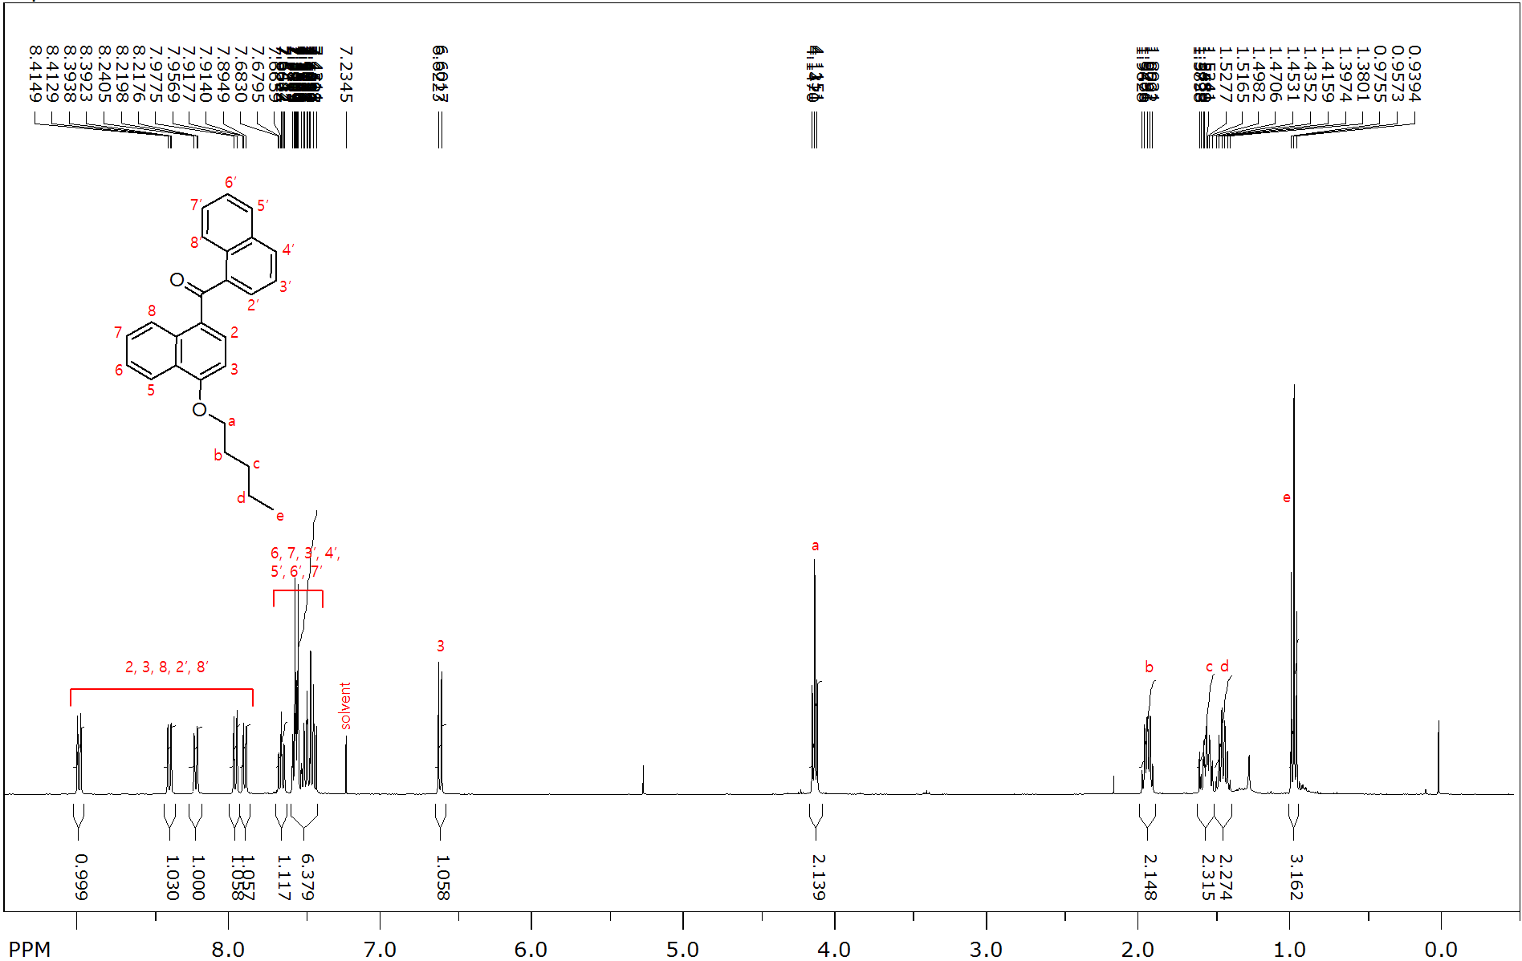

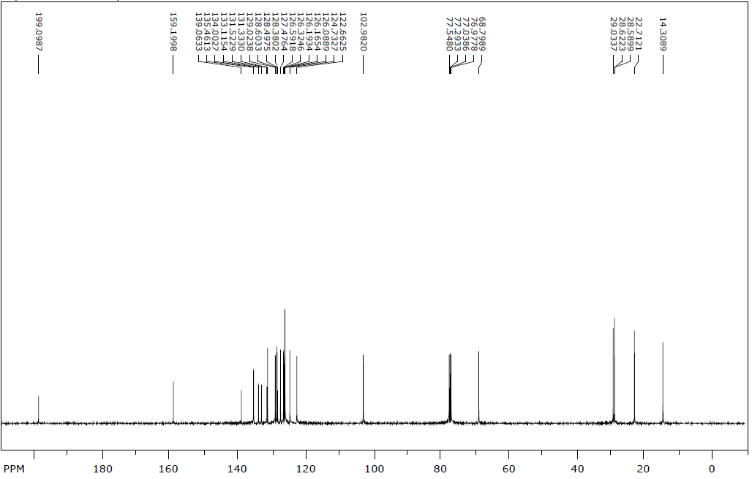
(b) ¹³C-NMR spectrum of CRA13 (100 MHz, CDCl3)

(c) High Resolution Mass spectrum of CRA13.
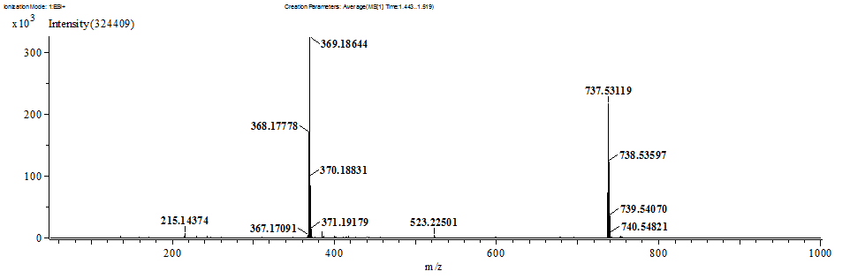
(d) High Performance Liquid Chromatography (HPLC) chromatogram of CRA13.

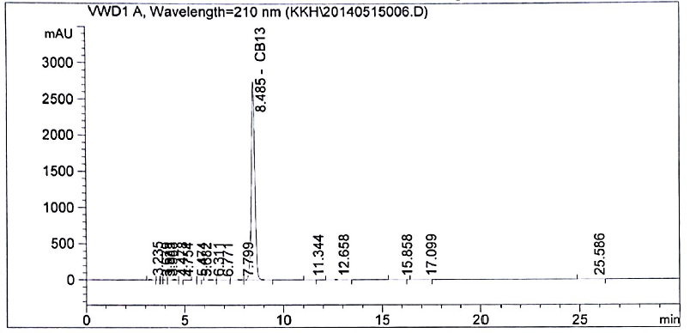
HPLC Condition

Column | Conditions | Detector | Sample
Luna (C18) 5 ㎛ 150 x 4.6 mm | Mobile Phase A: 0.1% formic acid in water  Mobile Phase B: 0.1% formic acid in acetonitrile  0–30 min; A/B = 10/90 | 210 nm | Concentration :  5 ㎎/㎖ in acetonitrile;  5 ㎕ injection

Results: 99.06% purity
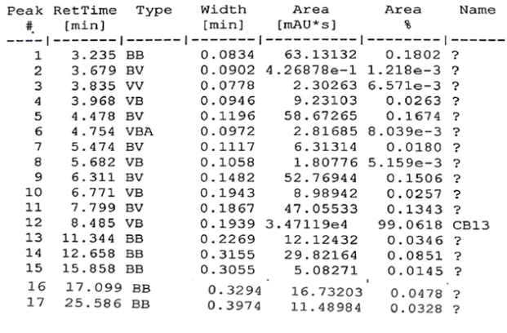
Synthesis of JWH-018
JWH-018 was synthesized by alkylation of indole with pentyl bromide followed by acylation of the resulting 1-pentylindole with 1-naphthoyl chloride as described [4].

(a)¹H-NMR spectrum of JWH-018.
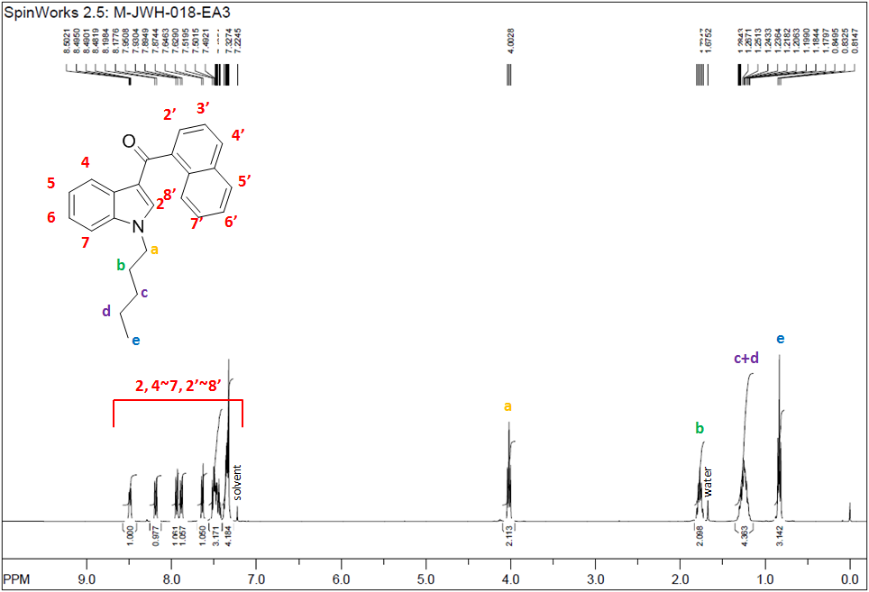
(b) ¹³C-NMR spectrum of JWH-018.
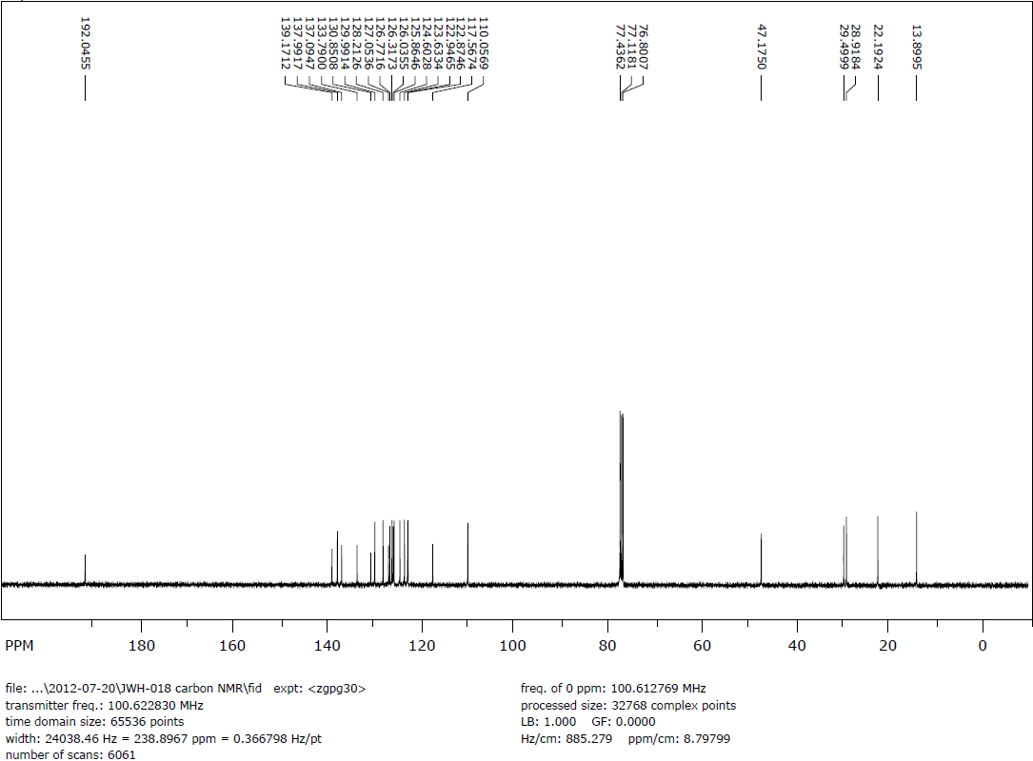

(c) High Resolution Mass spectrum of JWH-018.

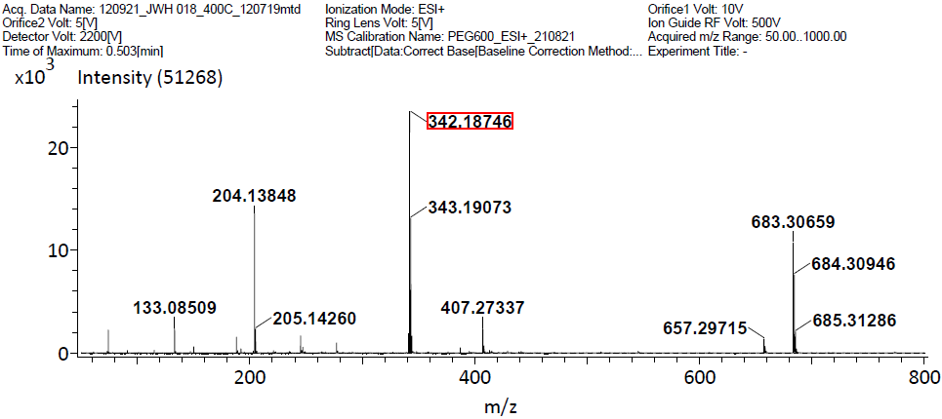
Synthesis of CP47,497 and its homologs (CP47,497-C6, C8, and C9)
CP47,497 and its homologs (CP47,497-C6, C8, and C9) were synthesized by the following procedure. The derivatives of 1-methoxy CP47,497 were prepared according to the reported method [5]. Treatment of 1-methoxy CP47,497 derivatives with 1-propanthiol and n-butyllithium in HMPA gave the desired compounds (CP47,497-C6, C8, and C9).

2-((1S,3R)-3-hydroxycyclohexyl)-5-(2-methyloctan-2-yl)phenol (CP47,497)
¹H NMR (300 MHz, CDCl₃) δ 7.09 (d, J = 8.4 Hz, 1H), 6.87 (dd, J = 8.4 Hz, 2.1 Hz, 1H), 6.70 (d, J = 2.1 Hz, 1H), 3.69-3.86 (m, 1H), 2.79-2.99 (m, 1H), 2.13-2.27 (m, 2H), 1.98-2.13 (m, 2H), 1.80-1.98 (m, 2H), 1.49-1.75 (m, 4H), 1.26 (s, 6H), 1.01-1.30 (m, 8H), 0.79-0.94 (m, 3H) LRMS(EI) m/z 317.9

2-((1S,3R)-3-hydroxycyclohexyl)-5-(2-methylheptan-2-yl)phenol (CP47,497-C6)
1H NMR (300 MHz, CDCl3) : δ 7.08 (d, J = 7.8 Hz, 1H), 6.86 (dd, J = 7.8 Hz, 2.1 Hz, 1H), 6.70 (d, J = 2.1 Hz, 1H), 3.71-3.90 (m, 1H), 2.80-3.00 (m, 1H), 2.11-2.40 (m, 2H), 1.95-2.10 (m, 2H), 1.78-1.94 (m, 2H), 1.30-1.74 (m, 4H), 1.25 (s, 6H), 0.98-1.40 (m, 6H), 0.80-0.90 (m, 3H) ; HRMS(ESI) m/z calcd for C20H32O2 [M+1]+ : 304.2402, found 305.2479

2-((1S,3R)-3-hydroxycyclohexyl)-5-(2-methylnonan-2-yl)phenol (CP47,497-C8)
1H NMR (300 MHz, CDCl3) : δ 7.08 (d, J = 8.1 Hz, 1H), 6.86 (dd, J = 8.1 Hz, 1.8 Hz, 1H), 6.69 (d, J = 1.8 Hz, 1H), 3.70-3.83 (m, 1H), 2.81-2.94 (m, 1H), 2.12-2.41 (m, 2H), 1.95-2.13 (m, 2H), 1.78-1.96 (m, 2H), 1.37-1.63 (m, 4H), 1.25 (s, 6H), 0.98-1.38 (m, 10H), 0.80-0.98 (m, 3H) ; HRMS(ESI) m/z calcd for C22H36O2 [M+1]+ : 332.2715, found 333.2787

2-((1S,3R)-3-hydroxycyclohexyl)-5-(2-methyldecan-2-yl)phenol (CP47,497-C9)
1H NMR (300 MHz, CDCl3) : δ 7.08 (d, J = 8.1 Hz, 1H), 6.86 (dd, J = 8.1 Hz, 1.8 Hz, 1H), 6.69 (d, J = 1.8 Hz, 1H), 3.70-3.84 (m, 1H), 2.81-2.94 (m, 1H), 1.78-2.3 (m, 6H), 1.36-1.60 (m, 6H), 1.24 (s, 6H), 0.97-1.36 (m, 12H), 0.86 (t, J = 6.6 Hz, 3H) ; HRMS(ESI) m/z calcd for C23H38O2 [M+1]+ : 346.2872, found 347.2943

Table S1. CB1R-binding affinity raw data for 15 synthetic cannabinoids.
 | THC |  |  | AM694 |  |  | CP47,497 |  |  | CP47,497-C6 |  |  | CP47,497-C8 |  |  | CP47,497-C9 |  |  | JWH-018 |  |  | JWH-015
M | 1 |  |  | 2 |  |  | 3 |  |  | 4 |  |  | 5 |  |  | 6 |  |  | 7 |  |  | 8
10⁻⁴ |  |  |  | 169 | 0 | 124 | 71 | -2 | 83 | 60 | 217 | 203
10⁻⁵ | 49 | 0 | 0 | 337 | 55 | 56 | 293 | 250 | 588 | 650 | 579 | 736 | 0 | 0 | 0 | 0 | 0 | 0 | 0 | 0 | 24
10⁻⁶ | 356 | 287 | 285 | 831 | 367 | 599 | 716 | 572 | 771 | 917 | 1018 | 1100 | 268 | 95 | 208 | 316 | 587 | 294 | 121 | 158 | 230 | 408 | 816 | 737
10⁻⁷ | 514 | 616 | 724 | 1098 | 740 | 717 | 1106 | 755 | 826 | 791 | 1108 | 1039 | 920 | 775 | 662 | 553 | 2601 | 916 | 130 | 394 | 433 | 656 | 1162 | 1060
10⁻⁸ | 981 | 961 | 1235 | 868 | 1056 | 897 | 923 | 1235 | 1164 | 848 | 1136 | 1031 | 1058 | 1225 | 739 | 1129 | 1249 | 979 | 972 | 966 | 854 | 899 | 968 | 1122
10⁻⁹ | 700 | 891 | 991 | 1184 | 1254 | 1172 | 875 | 1118 | 1317 | 868 | 623 | 998 | 1176 | 1554 | 776 | 1070 | 1338 | 896 | 615 | 572 | 1095 | 676 | 499 | 1312
10⁻¹⁰ | 532 | 570 | 837 | 1765 | 1174 | 884 | 552 | 1031 | 1173 | 738 | 604 | 1136 | 1033 | 1215 | 626 | 1159 | 1303 | 708 | 784 | 853 | 1634 | 987 | 919 | 755
10⁻¹¹ |  |  |  | 1169 | 1131 | 1148 | 1237 | 962 | 1118 |  |  |  |  |  |  | 791 | 831 | 748 |  |  |  | 1190 | 1365 | 1006
Ki(M) | 2.06E-07 |  |  | 2.83E-07 |  |  | 8.62E-07 |  |  | 1.18E-05 |  |  | 1.15E-07 |  |  | 4.81E-07 |  |  | 2.26E-08 |  |  | 0.005558
 | JWH-073 |  |  | RCS-4 |  |  | JWH-081 |  |  | JWH-210 |  |  | CRA13 |  |  | 7c |  |  | 8c
M | 9 |  |  | 10 |  |  | 11 |  |  | 12 |  |  | 13 |  |  | 14 |  |  | 15
10⁻⁴ |  |  |  | 202 | 23 | 199 |  |  |  |  |  |  | 649 | 702 | 762 | 57 | 299 | 499 | 1025 | -347 | 597
10⁻⁵ | 43 | -27 | 35 | 702 | 871 | 868 | -143 | 245 | 170 | -39 | 35 | -3 | 729 | 761 | 644 | 454 | 205 | 1313 | 1067 | 1038 | 1363
10⁻⁶ | 785 | 728 | 267 | 877 | 909 | 770 | -19 | 358 | 60 | -10 | 107 | 91 | 1189 | 1643 | 1165 | 1321 | 686 | 659 | 1327 | 1777 | 1321
10⁻⁷ | 1429 | 1049 | 1179 | 801 | 971 | 1164 | 747 | 1041 | 810 | 319 | 571 | 646 | 1872 | 1516 | 1656 | 1540 | 1702 | 2137 | 1747 | 1929 | 1631
10⁻⁸ | 1763 | 1647 | 1301 | 918 | 1068 | 861 | 1380 | 1776 | 1311 | 1018 | 1049 | 790 | 2211 | 2054 | 1450 | 1494 | 2873 | 2297 | 1651 | 1886 | 2226
10⁻⁹ | 1414 | 1640 | 1417 | 1154 | 1323 | 1403 | 1606 | 1532 | 1748 | 1006 | 1475 | 1435 | 1880 | 2255 | 1602 | 2122 | 2491 | 2402 | 1514 | 1504 | 1972
10⁻¹⁰ | 1670 | 1706 | 1320 | 1203 | 1203 | 1288 | 1218 | 1433 | 1030 | 1164 | 1403 | 1241 | 1462 | 2009 | 1796 | 3161 | 3175 | 2689
10⁻¹¹ | 1733 | 1797 | 1443 | 1174 | 1100 | 1187 | 1255 | 1588 | 1188 | 1162 | 1368 | 1269 | 1936 | 1656 | 1899 | 2118 | 2352 | 2418
Ki(M) | 2.28E-07 |  |  | 1.16E-05 |  |  | 6.16E-08 |  |  | 2.20E-08 |  |  | 4.80E-07 |  |  | 8.00E-08 |  |  | 5.42E-06

Table S2. List of descriptors used for QSAR models.
Descriptor Name | Descriptor Type | Descriptor class | Definition
XLogP | XLogP | Constitutional Descriptor | Prediction of logP based on the atom-type method called XLogP
VP.7 | ChiPath | Topological Descriptor | Evaluates chi path descriptors Valence path orders 7
SPC.5 | ChiPathCluster | Topological Descriptor | Evaluates chi path cluster descriptors, Simple path cluster, order 5
TopoPSA | TPSA | Topological Descriptor | Calculation of topological polar surface area based on fragment contributions (TPSA)
WTPT.4 | WeightedPath | Topological Descriptor | Evaluates the weighted path descriptors.sum of path lengths starting from oxygens
Kier1 | KappaShapeIndices | Topological Descriptor | Kier and Hall kappa molecular shape indices compare the molecular graph with minimal and maximal molecular graphs, First kappa shape index
MW | Weight | Constitutional Descriptor | Molecular weight
BCUTc.1l | BCUT | Hybrid descriptor | Eigenvalue based descriptor noted for its utility in chemical diversity, nhigh lowest partial charge weighted BCUTS(nhigh : The number of highest eigenvalue)
MLogP | MannholdLogP | Constitutional descriptor | Prediction of logP based on the number of carbon and hetero atoms.
Wlambda3.unity | WHIM | Hybrid descriptor | Holistic descriptors described by Todeschini et al (Todeschini, R. and Gramatica, P.. Persepectives in Drug Discovery and Design. 1998. null). Wlambda3 directional WHIM descriptors.
WPSA.1 | CPSA | Electronic & geometrical  descriptor | Calculates Charged Partial Surface Area (CPSA)  sum of surface area on positive parts of molecule * total molecular surface area / 1000
FPSA.3 | CPSA | Electronic & geometrical  descriptor | Calculates Charged Partial Surface Area (CPSA)  Charge weighted partial positive surface area/ total molecular surface area
apol | APolDescriptor | Electronic  descriptor | Sum of the atomic polarizabilities  (including implicit hydrogens).
geomShape | PetitjeanShapeIndex | Topological descriptor | Evaluates the Petitjean shape indices,  (geometric shape index)
nHBAcc | HBondAcceptorCount | Electronic  descriptor | This descriptor calculates the number of hydrogen bond acceptors using a slightly simplified version of the PHACIR atom types.
ATSc4 | AutocorrelationDescriptorCharge | Topological descriptor | Calculates the Autocorrelation of a Topological Structure autocorrelation descriptor, where the weight equal to the charges.

Table S3. Statistical Analysis of MLR models.
MLR  Model number | Descriptor | R² | Adjusted | Predicted | training set RMSE | test set  RMSE | Q²
1 | XLogP | 0.611 | 0.567 | -0.857 | 0.558 | 1.071 | 0.527
2 | VP.7 | 0.528 | 0.475 | -0.776 | 0.614 | 1.047 | 0.463
3 | SPC.5 | 0.376 | 0.307 | 0.008 | 0.706 | 0.783 | 0.25
4 | WPSA.1 | 0.372 | 0.302 | 0.216 | 0.708 | 0.695 | 0.272
5 | TopoPSA | 0.319 | 0.244 | 0.539 | 0.737 | 0.533 | 0.224
6 | apol | 0.252 | 0.168 | -0.755 | 0.773 | 1.041 | 0.037
7 | WTPT.4 | 0.227 | 0.141 | 0.546 | 0.786 | 0.529 | 0.156
8 | MLogP | 0.203 | 0.114 | 0.117 | 0.798 | 0.738 | -0.075
9 | MW | 0.17 | 0.078 | -0.477 | 0.814 | 0.955 | -0.033
10 | Kier1 | 0.163 | 0.07 | -0.793 | 0.818 | 1.052 | -0.121
11 | BCUTc.1l | 0.152 | 0.058 | 0.799 | 0.823 | 0.352 | -0.043
12 | geomShape | 0.15 | 0.056 | -0.3 | 0.824 | 0.896 | -0.032
13 | nHBAcc | 0.14 | 0.044 | -0.247 | 0.829 | 0.877 | -0.005
14 | FPSA.3 | 0.132 | 0.035 | 0.556 | 0.833 | 0.524 | -0.092
15 | Wlambda3.unity | 0.107 | 0.008 | -0.983 | 0.844 | 1.106 | -0.188
16 | ATSc4 | 0.097 | -0.003 | 0.466 | 0.849 | 0.574 | -0.078
17 | VP.7, XLogP | 0.696 | 0.621 | -0.607 | 0.492 | 0.996 | 0.546
18 | SPC.5, XLogP | 0.679 | 0.599 | 0.097 | 0.506 | 0.746 | 0.52
19 | WPSA.1, XLogP | 0.655 | 0.569 | -0.334 | 0.525 | 0.907 | 0.468
20 | TopoPSA, XLogP | 0.714 | 0.643 | 0.098 | 0.478 | 0.746 | 0.59
21 | apol, XLogP | 0.625 | 0.532 | -0.635 | 0.547 | 1.005 | 0.455
22 | WTPT.4, XLogP | 0.738 | 0.672 | -0.378 | 0.458 | 0.922 | 0.656
23 | MLogP, XLogP | 0.615 | 0.518 | -0.965 | 0.555 | 1.101 | 0.439
24 | MW, XLogP | 0.647 | 0.559 | -0.986 | 0.531 | 1.107 | 0.515
25 | Kier1, XLogP | 0.616 | 0.519 | -0.718 | 0.554 | 1.03 | 0.41
26 | BCUTc.1l, XLogP | 0.686 | 0.607 | 0.049 | 0.501 | 0.766 | 0.556
27 | geomShape, XLogP | 0.694 | 0.618 | -0.374 | 0.494 | 0.921 | 0.544
28 | nHBAcc, XLogP | 0.636 | 0.544 | -0.402 | 0.539 | 0.93 | 0.503
29 | FPSA.3, XLogP | 0.618 | 0.522 | -1.123 | 0.553 | 1.145 | 0.217
30 | Wlambda3.unity, XLogP | 0.619 | 0.524 | -1.23 | 0.551 | 1.173 | 0.358
31 | ATSc4, XLogP | 0.812 | 0.765 | 0.133 | 0.387 | 0.732 | 0.698
32 | VP.7, ATSc4, XLogP | 0.838 | 0.768 | 0.04 | 0.36 | 0.77 | 0.613
33 | SPC.5, ATSc4, XLogP | 0.834 | 0.762 | 0.465 | 0.364 | 0.575 | 0.664
34 | WPSA.1, ATSc4, XLogP | 0.834 | 0.762 | 0.42 | 0.365 | 0.598 | 0.655
35 | TopoPSA, ATSc4, XLogP | 0.813 | 0.733 | 0.083 | 0.387 | 0.752 | 0.531
36 | apol, ATSc4, XLogP | 0.829 | 0.756 | 0.039 | 0.369 | 0.77 | 0.559
37 | WTPT.4, ATSc4, XLogP | 0.82 | 0.743 | 0.13 | 0.379 | 0.733 | 0.609
38 | MLogP, ATSc4, XLogP | 0.818 | 0.74 | 0.269 | 0.382 | 0.672 | 0.649
39 | MW, ATSc4, XLogP | 0.821 | 0.744 | 0.098 | 0.378 | 0.746 | 0.646
40 | Kier1, ATSc4, XLogP | 0.844 | 0.777 | 0.09 | 0.353 | 0.75 | 0.658
41 | BCUTc.1l, ATSc4, XLogP | 0.817 | 0.739 | 0.28 | 0.382 | 0.667 | 0.618
42 | geomShape, ATSc4, XLogP | 0.813 | 0.732 | 0.157 | 0.387 | 0.721 | 0.599
43 | nHBAcc, ATSc4, XLogP | 0.816 | 0.737 | 0.029 | 0.383 | 0.774 | 0.648
44 | FPSA.3, ATSc4, XLogP | 0.838 | 0.769 | -0.158 | 0.359 | 0.846 | 0.54
45 | Wlambda3.unity, ATSc4, XLogP | 0.829 | 0.756 | -0.153 | 0.369 | 0.843 | 0.628
(R²: coefficient of determination data set, : adjusted R², : R² for external test set, RMSE: root mean squared Error, Q²: cross-validated coefficient of determination (Leave-One-Out method))

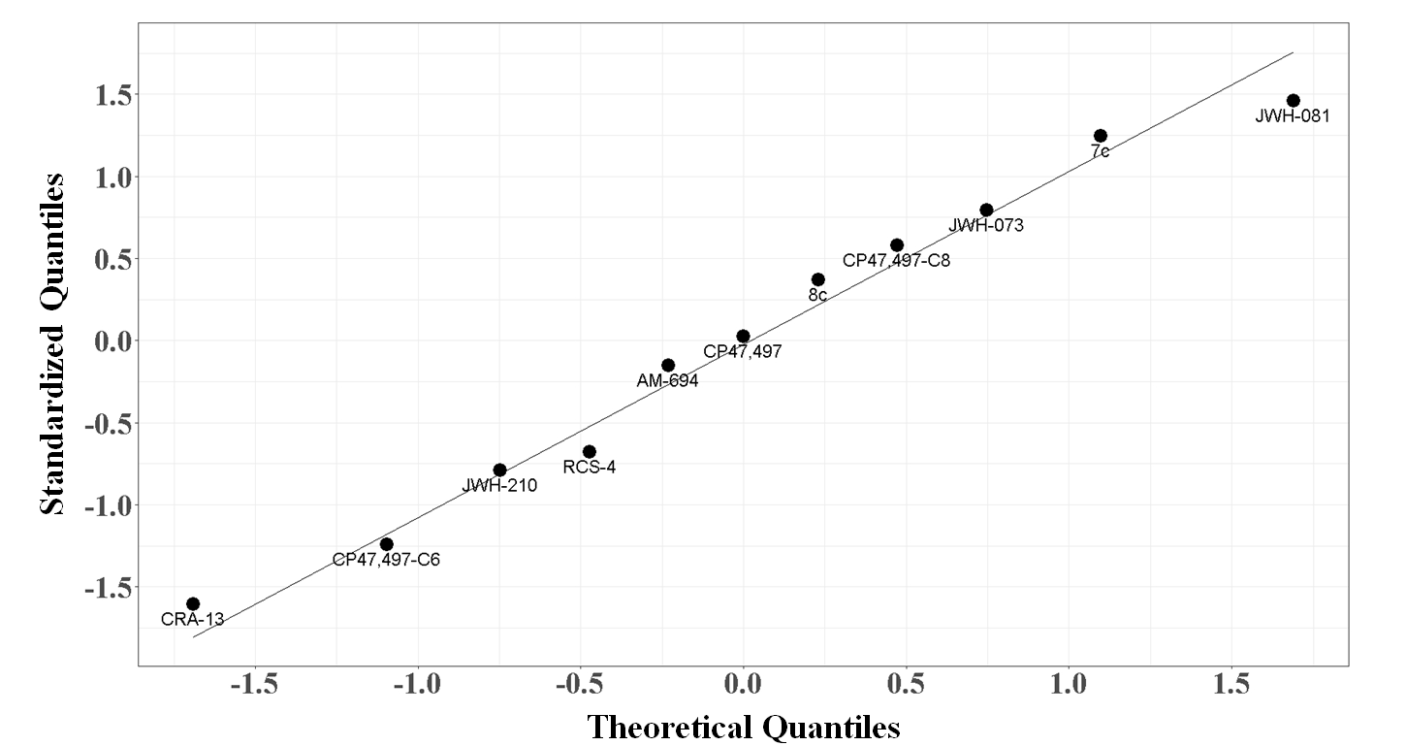
Figure S1. Q-Q plot of the residuals from MLR model 31 showing a normal distribution.

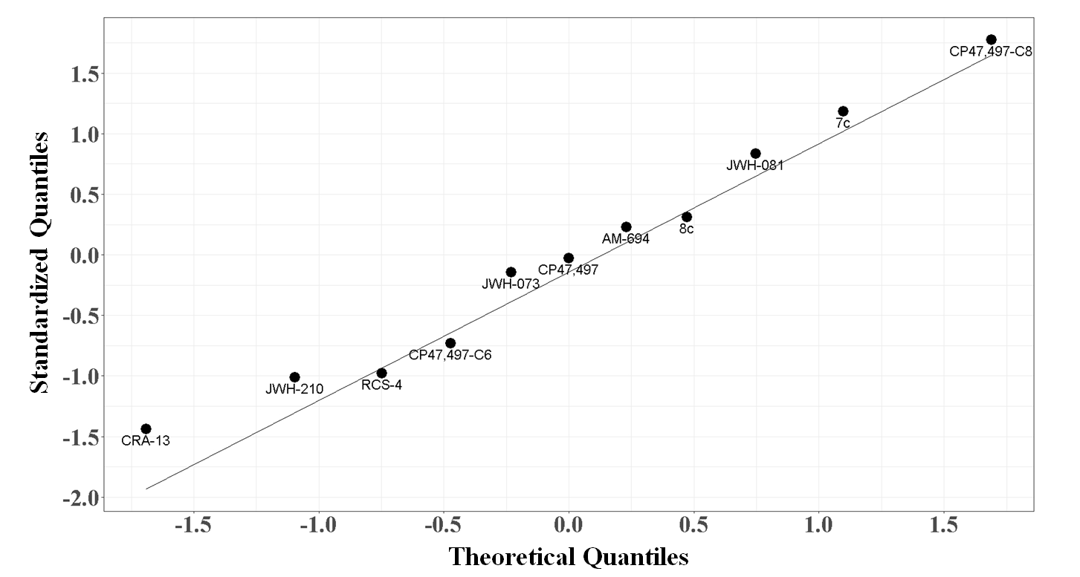

Figure S2. Q-Q plot of the residuals from PLSR model showing a normal distribution.

References
[1] Hassan, A.H., Park, K.T., Kim, H.J., Lee, H.J., Kwon, Y.H., Hwang, J.Y., et al. Fluorinated CRA13 analogues: Synthesis, in vitro evaluation, radiosynthesis, in silico and in vivo PET study. Bioorganic Chemistry. 2020, 103834.
[2] Hassan, A.H., Cho, M.C., Kim, H.I., Yang, J.S., Park, K.T., Hwang, J.Y., et al. Synthesis of oxidative metabolites of CRA13 and their analogs: Identification of CRA13 active metabolites and analogs thereof with selective CB2R affinity. Bioorganic & medicinal chemistry. 2018, 26, 5069-78.
[3] Dziadulewicz, E.K., Bevan, S.J., Brain, C.T., Coote, P.R., Culshaw, A.J., Davis, A.J., et al. Naphthalen-1-yl-(4-pentyloxynaphthalen-1-yl) methanone: a potent, orally bioavailable human CB1/CB2 dual agonist with antihyperalgesic properties and restricted central nervous system penetration. Journal of medicinal chemistry. 2007, 50, 3851-6.
[4] Appendino, G., Minassi, A., Taglialatela-Scafati, O. Recreational drug discovery: natural products as lead structures for the synthesis of smart drugs. Natural product reports. 2014, 31, 880-904.
[5] Huffman, J.W., Hepburn, S.A., Reggio, P.H., Hurst, D.P., Wiley, J.L., Martin, B.R. Synthesis and pharmacology of 1-methoxy analogs of CP-47,497. Bioorganic & medicinal chemistry. 2010, 18, 5475-82.

