Supporting Information

Substantial decreases in NO₂ emissions from reduced transportation volumes in US cities during COVID-19 shutdowns reveal health vulnerabilities of urban populations
Asrah Heintzelman^{1,2}, Vijay O. Lulla³, and Gabriel M. Filippelli^{1,2#}

¹Department of Earth Sciences, Indiana University-Purdue University Indianapolis (IUPUI)
²Environmental Resilience Institute, Indiana University
³Department of Geography, Indiana University-Purdue University Indianapolis (IUPUI)
#Corresponding author: gfilippe@iu.edu

Location  (NO₂ Sensors) | Jan  (ppb) | Mar  (ppb) | Apr  (ppb) | 5-yr Change  (Jan to Mar) | 5-yr Change  (Jan to Apr)
LA | 22.01 | 16.60 | 13.68 | -24.57% | -37.85%
Indianapolis | 13.79 | 13.23 | 11.83 | -4.00% | -14.18%
San Francisco | 18.21 | 11.45 | 8.88 | -37.12% | -51.21%
Ft. Worth | 10.26 | 7.69 | 6.07 | -25.09% | -40.88%
Houston | 15.00 | 10.42 | 10.02 | -30.54% | -33.20%
San Antonio | 9.64 | 5.54 | 4.71 | -42.56% | -51.10%
Austin | 15.42 | 13.83 | 13.35 | -10.32% | -13.44%
Dallas | 12.57 | 8.73 | 7.25 | -30.61% | -42.34%
San Jose | 18.11 | 12.98 | 10.80 | -28.31% | -40.38%
San Diego | 15.32 | 12.93 | 11.41 | -15.64% | -25.51%
Queens-NY | 20.60 | 17.68 | 14.35 | -14.14% | -30.31%
Table S1. NO₂ averages of January, March, and April from 2015-2019n
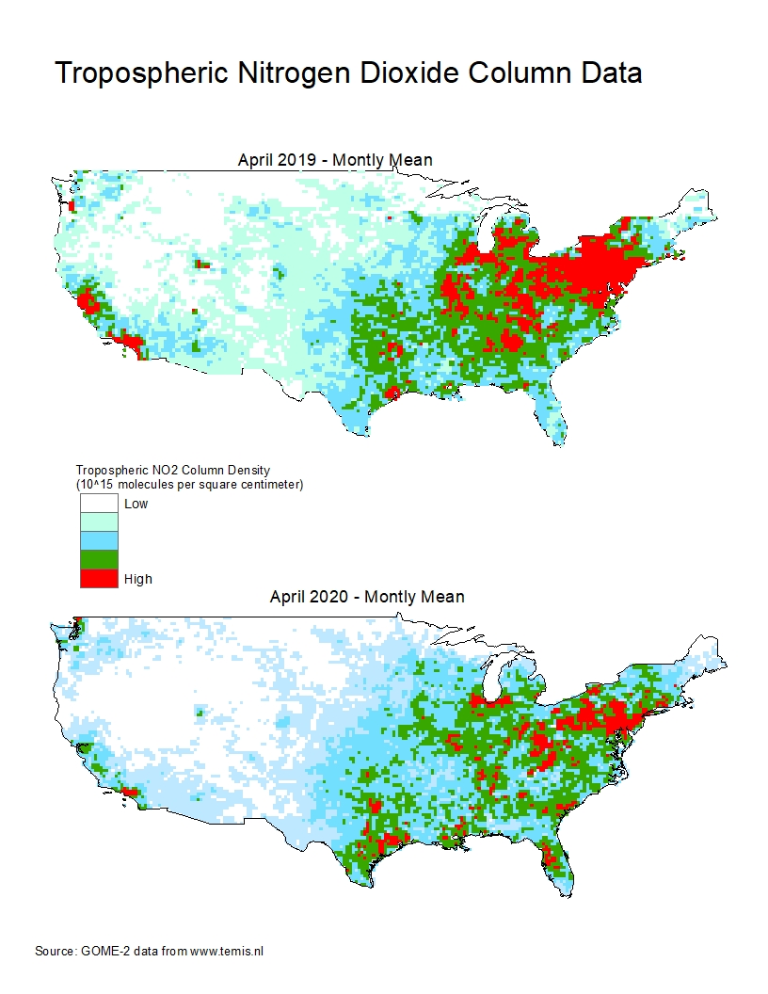
Figure S1. NO₂ averages from April in 2019 and 2020

Figure S2. NO₂ averages from January, March, and April in 2020

Figure S3. VMT changes between January to March and January to April in 2020

Figure S4. NO₂ and VMT percent changes between January and March in 2020

Figure S5. NO₂ and VMT percent changes between January and April 2020

