Supplementary Data

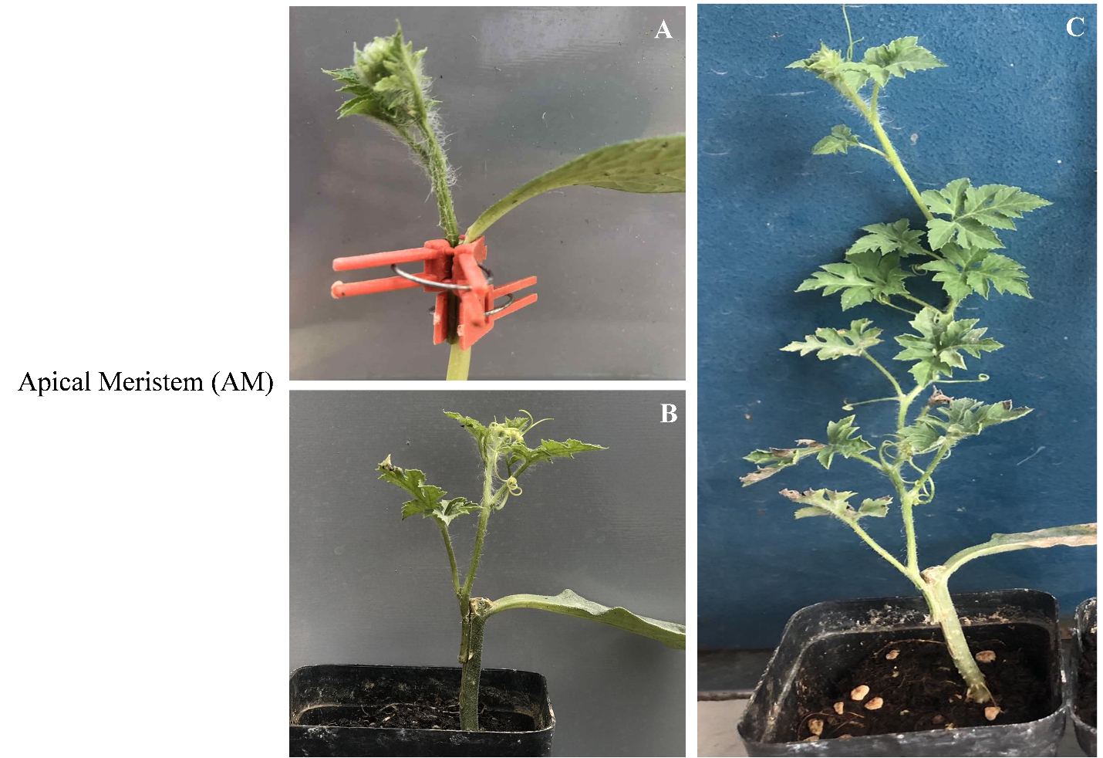
(Figure S1). Effect of Scion/rootstocks combinations on the survival of polyploid watermelon grafting using (AM) as scion. (A): at 0 DAG, (B) 15 DAG, and (C): 30 DAG, DAG: Days after Grafting.
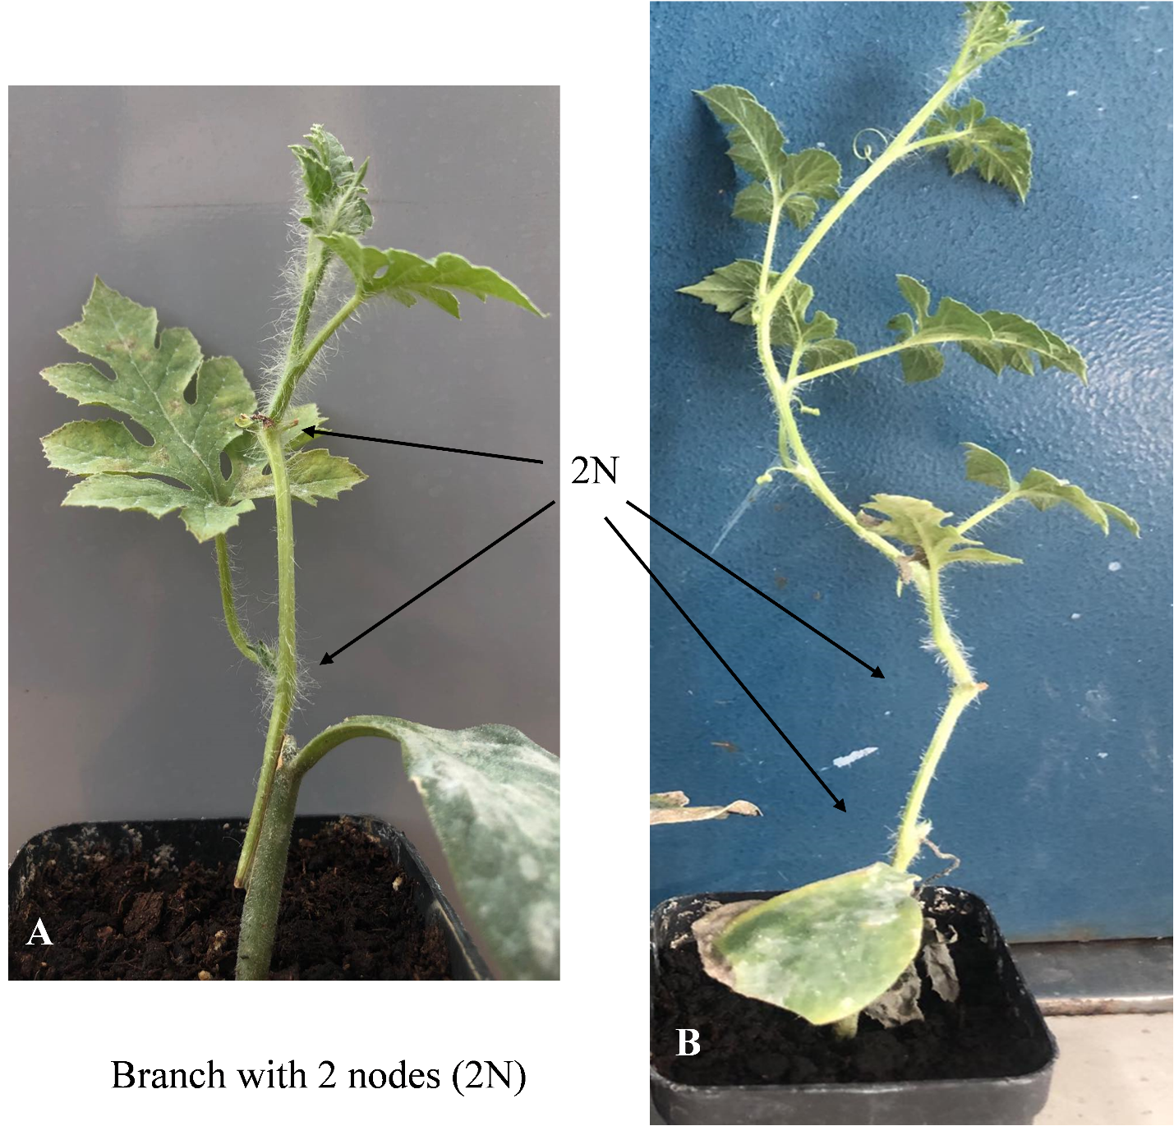
(Figure S2) Effect of Scion/rootstocks combinations on the survival of polyploid watermelon grafting using (2N) as scion. (A): at 15 DAG, and (B) 30 DAG.
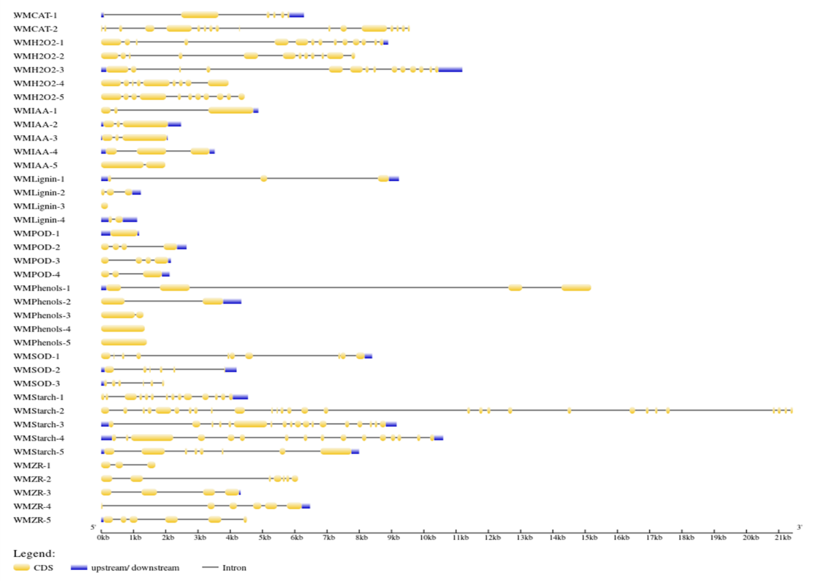
(Figure S3) Structure of genes involved in graft compatibility during watermelon grafting process. Yellow boxes and black lines indicating exons and introns respectively, while blue boxes at the both end of each gene indicates untranslated regions (UTRs).

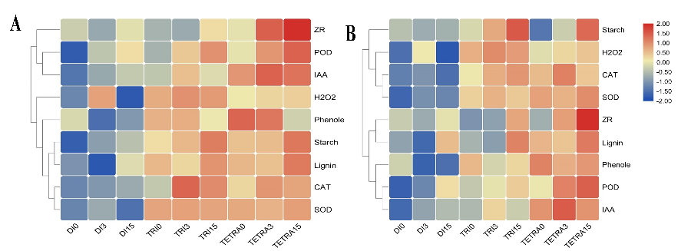
Figure S4. Heat map representing the contents of hormones, starch, antioxidants and biochemicals in the grafting union at 0, 3 and 15 days after grafting. ] Di: Diploid, Tri: triploid, Tetra: Tetraploid.

Table S1: Genes linked to graft compatibility having high homology with other genes selected from different plant species.
 |  | High homology
WMCAT | WMCAT-1 | CMCAT_Cucurbita moschata  CMCAT_Cucurbita_maxima
 | WMCAT-2 | CPCAT_Cucurbita pepo.
WMPOD | WMPOD-1 | CSPOD_Cucumis sativus3  CMPOD_Cucumis melo3.
 | WMPOD-2 | CMPOD_Cucumis melo2  CSPOD_Cucumis sativus2
 | WMPOD-3 | CMPOD_Cucumis melo  CSPOD_Cucumis sativus
 | WMPOD-4 | CMPOD_Cucumis melo4 and CSPOD_Cucumis sativus4
WMIAA | WMIAA-1 | CSIAA_Cucumis sativus3 and CMIAA_Cucumis melo3
 | WMIAA-2 | CSIAA_Cucumis sativus2 and CMIAA_Cucumis melo2
 | WMIAA-3 | CSIAA_Cucumis sativus and CMIAA_Cucumis melo
 | WMIAA-4 | CMIAA_Cucumis melo4 and CSIAA_Cucumis sativus4
 | WMIAA-5 | CMIAA_Cucumis melo5 and CSIAA_Cucumis sativus5
WMZR | WMZR-1 | CSZR_Cucumis sativus2, CSZR_Cucumis sativus3 CMZR_Cucumis melo2, and CMZR_Cucumis melo3
 | WMZR-2 | -
 | WMZR-3 | CSZR_Cucumis sativus5 and CMZR_Cucumis melo5
 | WMZR-4 | CMZR_Cucumis melo4 and CSZR_Cucumis sativus4
 | WMZR-5 | CMZR_Cucumis melo and CSZR_Cucumis sativus
WMPhenols | WMPhenols-1 | CSPhenols_Cucumis sativus5 and CMPhenols_Cucumis melo5
 | WMPhenols-2 | CSPhenols_Cucumis sativus3 and CMPhenols_Cucumis melo3
 | WMPhenols-3 | CMPhenols_Cucumis melo, and CSPhenols_Cucumis sativus.
 | WMPhenols-4 | -
 | WMPhenols-5 | CMPhenols_Cucumis melo2, CMPhenols_Cucumis melo4  CSPhenols_Cucumis sativus2, CSPhenols_Cucumis sativus4.
WMLignin | WMLignin-1 | CSLignin_Cucumis sativus and CMLignin_Cucumis melo
 | WMLignin-2 | CMLignin_Cucumis melo4, CSLignin_Cucumis sativus4, and CSLignin_Cucumis sativus5.
 | WMLignin-3 | -
 | WMLignin-4 | CMLignin_Cucumis melo1, CMLignin_Cucumis melo3, CSLignin_Cucumis sativus1, and CSLignin_Cucumis sativus3.
WMStarch | WMStarch-1 | CSStarch_Cucumis sativus4.
 | WMStarch-2 | CMStarch_Cucumis melo2
 | WMStarch-3 | CMStarch_Cucumis melo4, and CSStarch_Cucumis sativus3.
 | WMStarch-4 | CMStarch_Cucumis melo3, and CSStarch_Cucumis sativus2.
 | WMStarch-5 | CMStarch_Cucumis melo5, and CSStarch_Cucumis sativus5
WMH₂O₂ | WMH₂O₂-1 | CSH₂O₂_Cucumis sativus5 and CMH₂O₂_Cucumis melo4
 | WMH₂O₂-2 | CSH₂O₂_Cucumis sativus2.
 | WMH₂O₂-3 | CSH₂O₂_Cucumis sativus5 and CMH₂O₂_Cucumis melo4
 | WMH₂O₂-4 | CCH₂O₂_Citrullus colocynthis.
 | WMH₂O₂-5 | CSH₂O₂_Cucumis sativus6, and CSH₂O₂_Cucumis sativus7.
WMSOD | WMSOD-1, | CSSOD_Cucumis sativus2, CMSOD_Cucumis melo, and CMSOD_Cucumis melo2.
 | WMSOD-2 | CSSOD_Cucumis sativus3.
 | WMSOD-3 | CSSOD_Cucumis sativus

Table S2: Primers used for qRT-PCR in this study.
ID | primer
Actin-F | GTACGACAACGGGCCTTAAA
Actin-R | ATGGGCTTGACAGGTTGTTC
WMCAT-1-F | CTAATGTGTTGAGCGGCAAA
WMCAT-1-R | GTCTTACGAACCGCTCTTGC
WMCAT-2-F | CGGCATTACTAAAGCGGAAG
WMCAT-2-R | TAGTCCAGAAGGGGGTGTTG
WMPOD-1-F | TTGGATGCCTACACGATCAA
WMPOD-1-R | GTATTGGCCAGCTTCACCAT
WMPOD-2-F | CATTGGGAAGGAAGGACTCA
WMPOD-2-R | CAATGTCAAGCCCTTGGTTT
WMPOD-3-F | GCTCTTTCAGGAAGCCACAC
WMPOD-3-R | GGTAGGGCTCACAAAGTCCA
WMPOD-4-F | TGGCTGTGATGCTTCTATGC
WMPOD-4-R | CTGCACAAGAGACGATTCCA
WMSOD-1-F | TTTCTAAGGTCCACCGCAAC
WMSOD-1-R | GGGAATTGGGTTTGAAGGAT
WMSOD-2-F | CAAGAAGACGATGGAGCACA
WMSOD-2-R | TCCATCAGCATTGGCAATTA
WMSOD-3-F | CCATCCAGTTCGTCCAAGAT
WMSOD-3-R | CCTCCATGGTCCTTCTTCAA
WMH2O2-1-F | GGGTTACTTCGGACCAGACA
WMH2O2-1-R | GAAACCCGTCAGCCTATCAA
WMH2O2-2-F | ATGACCAAAAACGTCGGAAG
WMH2O2-2-R | ACTCGCTCGACTCGTTCATT
WMH2O2-3-F | AACTTCTGCTTCGACCTCCA
WMH2O2-3-R | AACTCGTGCGAGAAATGCTT
WMH2O2-4-F | AGCCAACAAACGAAACCAAC
WMH2O2-4-R | TCTGTGGCGATATTGGATGA
WMH2O2-5-F | CAGTCCAGGTTCCATTCGTT
WMH2O2-5-R | TTCTCAACGCGAACTCCTTT
WMIAA-1-F | AATGTCGAGTGGCCGATAAC
WMIAA-1-R | GCACCGTGGTGCCTTATACT
WMIAA-2-F | TTCCCACGCTGGAATTTTAC
WMIAA-2-R | GGGAGGAATTCGAAGTAGCC
WMIAA-3-F | ACCTCTATGTGCCTGGGTTG
WMIAA-3-R | GGCAAAGAATGGCCTCATTA
WMIAA-4-F | GGTGAATTTGAAGCCGATGT
WMIAA-4-R | CAAGCTCCTTTTGCAACTCC
WMIAA-5-F | AACAATTCCAGGCCACTACG
WMIAA-5-R | CCCTGTCGGTATACGCTGTT
WMZR-1-F | GACCGCCTATTGCCTCATTA
WMZR-1-R | TTCCCACACACATTGCTGTT
WMZR-2-F | CGCATTATCCCAGCTCTCAT
WMZR-2-R | TAGCGAGACTGAGCGAGACA
WMZR-3-F | GTTAGCGAGGGGAGCTTTCT
WMZR-3-R | AGCACTCTTTTTGGCGTTGT
WMZR-4-F | GTGTCGTGGACATGTTGGAG
WMZR-4-R | GCTAGAGCCAAATGCTGTCC
WMZR-5-F | GTTACGCGGGGTATATGGTG
WMZR-5-R | GCTGCTTTCAAACTCGGTTC
WMLignin-1-F | CCTTTATGGGGGAATCCTGT
WMLignin-1-R | GTGAACAAAAACGGGTTGCT
WMLignin-2-F | ACTCGTTGCCTTTGTCTCGT
WMLignin-2-R | GAAACTGCAACTCGTGCAAA
WMLignin-3-F | TATGGAAAAGGATGGGTGGA
WMLignin-3-R | CTTTAACGTGGCTCGTCCTC
WMLignin-4-F | GAGTCGGAGGTTTGGTGTGT
WMLignin-4-R | CCGACCAAGAGATGAGAAGG
WMPhenols-1-F | GGCTCATAAATCCCCCATTT
WMPhenols-1-R | TGCAGGTTGTTGTCCAGTGT
WMPhenols-2-F | CTCACTATGTCGCCGGATTT
WMPhenols-2-R | ACCGTGAAGGTGGAGAGATG
WMPhenols-3-F | AAGGTGCCTGCTTCACCTAA
WMPhenols-3-R | TATTTCCCCAACCAAACCAA
WMPhenols-4-F | CGATTGAGCAACAAAAAGCA
WMPhenols-4-R | CTGTAGGAGGGCTCACGAAC
WMPhenols-5-F | CCCGATACTCATCGTTCGTT
WMPhenols-5-R | GGCGTAGAAACCCAGGTACA
WMStarch-1-F | TGATTGGCACACAGCTCTTC
WMStarch-1-R | AATTGATCGGGCAGATTCAG
WMStarch-2-F | GCAAAATTTTCCCGAGATGA
WMStarch-2-R | TTTTATTCTCGCACGCCTCT
WMStarch-3-F | GCTCTGGCTTTGGTTCTTTG
WMStarch-3-R | GTCGCATTTTACACGAAGCA
WMStarch-4-F | TTTGATCATGGGAGCATTCA
WMStarch-4-R | GCCTCTTTGGGAACATGAAA
WMStarch-5-F | AAAGGACGGACAACCAAGTG
WMStarch-5-R | GCCAGCTACGTCTCCAAGTC

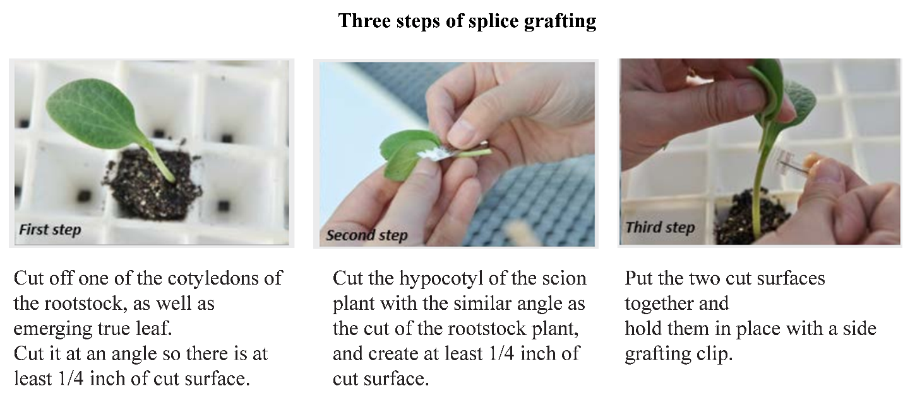
(Figure S5) Splice grafting method steps in polyploid watermelon plants

