Process Simulation and Techno-Economic Analysis of Large-Scale Bioproduction of Sweet Protein Thaumatin II
Supplementary material

Kirolos D. Kelada¹, Daniel Tusé², Yuri Gleba³, Karen A. McDonald^{1,4}, and Somen Nandi^{1,4*}

¹Department of Chemical Engineering, University of California, Davis, CA, USA; ²DT/Consulting Group, Sacramento, CA, USA; ³Nomad Bioscience GmbH, Halle, Germany; ⁴Global HealthShare® Initiative, University of California, Davis, CA, USA

*Corresponding author. Email: snandi@ucdavis.edu; Address: 1035 Academic Surge, 1 Shields Avenue, Davis, CA 95616

Transgenic Facilities Economic Inputs
The facilities’ economic evaluation is based on the US dollar value in 2020. A 4% inflation rate is used to adjust for equipment purchase prices from previous years. Field growth economic variables were obtained from various sources. Fertilizer quantity and cost were obtained from a cost estimation spreadsheet developed University of Kentucky department of Agricultural Economics (UKAE) (TN-KY Burley Tobacco Budget, 2018). The quantity was estimated by linear extrapolation based on 120 days growth and adjusted from the 42 days growth period in this model. Field irrigation was estimated from the Food and Agriculture Organization of the United Nations water requirement for tobacco (Food and Agriculture Organization of the United Nations, n.d.). For land purchase prices, farm real estate average value per acre in Florida was estimated based on the USDA land values 2018 summary report (United States Department of National Agriculture (USDA) Agricultural Statistics Service, 2018). Drip irrigation costs were obtained from (Simonne et al., 2008). Fuel, lubrication, and repair costs for tractors and other field equipment were obtained from the 2015 UC ANR field cost study (Smith & Tumber, 2015) and were adjusted based on the average annual spinach producer price indices obtained from the Federal Reserve Bank of St. Louis (FRED Federal Reserve Bank of St. Louis, 2020). Indoor cost variables were adapted from (McNulty et al., 2019). Downstream processing economic values were obtained from (Nandi et al., 2016), (McNulty et al., 2019), SuperPro Designer default values, and WPK. Startup and validation costs were estimated as 5% of direct fixed capital (DFC). Working capital was estimated to cover expenses for 30 days of operation.
Transient Facility Economic Inputs
The facility’s economic evaluation is based on the US dollar value in 2020. A 4% inflation rate is used to adjust for equipment purchase prices from previous years. Spinach field growth economic parameters were adjusted based on the average annual spinach producer price indices obtained from the Federal Reserve Bank of St. Louis (FRED Federal Reserve Bank of St. Louis, 2020). VPL’s economic parameters were adapted from (Nandi et al., 2016) and equipment purchase prices were adjusted according to the following equation:
$$C=C_{0}{\left(\frac{Q}{Q_{0}}\right)}^{0.6}$$
where C is the equipment cost, C₀ is the base cost, Q is the capacity variable, Q₀ is the base capacity. Other unit operation equipment costs were estimated from the built-in SuperPro Designer cost models.
Farm real estate average value per acre in California was estimated based on the USDA land values 2018 summary report (USDA, 2018). Drip irrigation costs were obtained from Simonne et al. (2008). Fuel, lubrication, and repair costs for tractors and other field equipment were obtained from the 2015 UC ANR cost study (Smith & Tumber, 2015). Downstream processing economic values were obtained from Nandi et al. (2016), McNulty et al. (2019), SuperPro Designer default values, and WPK.

Table S1. Transgenic thaumatin production facilities base case design parameters and assumptions; FW, fresh weight; WPK, working process knowledge; Calc, calculation; MT, metric ton
Parameter | Value | Unit | Reference
Upstream facility (field), with downstream chromatography
Production level | 50 | MT thaumatin/yr | Assumption
Number of batches | 157 | batches/yr | Calc
Batch duration | 45.3 | days | Calc
Recipe cycle time | 2 | days | Calc
Growth time (seeding to induction) | 35 | days | WPK
Incubation time (induction to harvest) | 7 | days | WPK
Land turnaround duration | 3 | days | WPK
Thaumatin expression level | 1.5 | g/kg FW | WPK
Plant density | 130,000 | plants/acre | Assumption  (based on 3 plants/ft²)
N. tabacum aerial biomass at harvest | 100 | g/plant | [(Knödler, Rühl, Emonts, & Buyel, 2019)]
Germination efficiency | 90 | % | Assumption
Acreage per batch | 24.5 | acres | Calc
Number of plots | 22 | plots/total field | Calc
Total field acreage (footprint) | 538 | acres | Calc
Total annual cultivated acreage | 3,850 | acres/yr | Calc
Location | Florida, USA |  | Assumption
Upstream facility (indoor), with downstream chromatography
Production level | 50 | MT thaumatin/yr
Number of batches | 157 | batches/yr | Calc
Batch duration | 42.6 | days | Calc
Recipe cycle time | 2 | days | Calc
Growth time (seeding-induction) | 35 | days | [(McNulty et al., 2019)]
Incubation time (induction-harvest) | 7 | days | [(McNulty et al., 2019)]
Thaumatin expression level | 1.5 | g/kg FW | WPK
N. benthamiana aerial biomass at harvest | 15 | g/plant | [(McNulty et al., 2019)]
Plants per batch | 21,200,000 | plants/batch | Calc
Germination efficiency | 95 | % | Assumption
Plants per tray | 94 | Plants tray | [(McNulty et al., 2019)]
Tray area | 0.15 | m²/tray | [(McNulty et al., 2019)]
Growth space design | 10 | layers | Assumption
Growth space utilization | 90 | % | Assumption
Facility footprint | 83,000 | m² | Calc
Downstream processing facility, with chromatography
Batch duration | 54.5 | hours | Calc
Downstream recovery | 66.8 | % | Assumption
Final product purity | 98.0 | % | Assumption
Downstream processing facility, without chromatography
Batch duration | 38.4 | hours | Calc
Downstream recovery | 80 | % | Assumption
Final product purity | 74.8 | % | Assumption

Table S2. Transient production of thaumatin in spinach base case parameters and assumptions FW, fresh weight; WPK, working process knowledge; Calc, calculation; MT, metric ton
Parameter | Value | Unit | Reference
Overall facility
Production level | 50 | MT thaumatin/yr
Number of batches | 153 | batches/yr | Calc
Batch duration | 68 | days | Calc
Recipe cycle time | 1.94 | days | Calc
Location | California, USA
Spinach field growth
Growth time (seeding-spraying) | 45 | days | [(Koike et al., 2011)]
Incubation time (spraying-harvest) | 15 | days | WPK
Thaumatin expression level | 1 | g/kg FW | WPK
Field plant density | 174,240 | plants/acre | Assumption
Spinach yield | 15,240 | kg FW/acre | [(Koike et al., 2011)], WPK
Seed quantity | 1.25 million | seeds/acre | [(Koike et al., 2011),(Smith & Tumber, 2015)]
 | 31.3 | lbs/acre
Acreage per batch | 22.6 | acres/batch | Calc
Number of plots | 34 | plots/total field | Calc
Total field acreage (footprint) | 767 | acres | Calc
Total cultivated acreage (assuming no reusing of land) | 3,450 | acres | Calc
Viral particles production
N. benthamiana growth time  (seeding-infiltration) | 35 | days | [(Nandi et al., 2016)]
N. benthamiana incubation time  (infiltration-harvest) | 7 | days | [(Nandi et al., 2016)]
Viral particles expression level | 1 | g/kg FW | [(Klimyuk, Pogue, Herz, Butler, & Haydon, 2014)]
Viral particle concentration in spray suspension | 10¹⁴ | particles/L | WPK
Viral particle molecular weight | 31,750 | kDa | WPK
Spray volume requirement | 2 | mL/plant | WPK
Downstream Processing
Downstream recovery | 95 | % | WPK
Downstream Processing time | 30.2 | hrs/batch | Calc
Final thaumatin purity | 94 | % | Assumption

Table S3. Downstream processing losses breakdown per unit operation; P&F, plate and frame filtration; DSP, downstream processing; UF/DF, ultrafiltration/diafiltration; Chrom, chromatography
DSP facility without chromatography
Step | Screw Press | P&F 1 | P&F 2 | P&F 3 | UF/DF | Chrom  and UF/DF 2 | Drying
Loss (% of initial thaumatin) | 3.0 | 5.0 | 5.0 | 1.5 | 5.0 | - | 0.5
Cumulative recovery (% of initial thaumatin) | 97.0 | 92.0 | 87.0 | 85.5 | 80.5 | - | 80.0
Start (kg/batch) | 398 | 386 | 366 | 346 | 340 | - | 320
End (kg/batch) | 386 | 366 | 346 | 340 | 320 | - | 319
% loss per unit | 3.0 | 5.2 | 5.4 | 1.7 | 5.8 | - | 0.6
DSP facility with chromatography

Step | Screw Press | P&F 1 | P&F 2 | P&F 3 | UF/DF | Chrom  and UF/DF 2 | Drying
Loss (% of initial thaumatin) | 3.0 | 5.0 | 5.0 | 1.5 | 5.0 | 13.2 | 0.5
Cumulative recovery (% of initial thaumatin) | 97.0 | 92.0 | 87.0 | 85.5 | 80.5 | 67.3 | 66.8
Start (kg/batch) | 477 | 463 | 439 | 415 | 408 | 384 | 320
End (kg/batch) | 463 | 439 | 415 | 408 | 384 | 320 | 319
% loss per unit | 3.0 | 5.2 | 5.4 | 1.7 | 5.8 | 17 | 0.6

 | Upstream (Field) | Upstream (Indoor) | Downstream
Unlisted Equipment | Seeding:  0.03 x PC* | Seeding:  0.2 x PC | Entire Facility:  0.2 x PC
 | Plant Growth:  0.03 x PC | Plant Growth:  0.2 x PC
 | Induction + Incubation:  0.03 x PC | Induction + Incubation:  0.2 x PC
 | Harvesting:  0.03 x PC | Harvesting  0.2 x PC
 | Transportation:  0.2 x PC | Transportation  0.2 x PC
Lang Factor | Seeding:  1.0 x PC | Seeding:  3.0 x PC | Entire Facility:  DFC= DC+IC+OC
 | Plant Growth:  1.0 x PC | Plant Growth:  3.0 x PC | DC: **  Piping (A)= 0.35 x PC  Instrumentation (B)= 0.40 x PC  Insulation (C)= 0.03 x PC  Electrical Facilities (D)= 0.10 x PC  Buildings (E)= 0.45 x PC  Yard Improvement (F)= 0.15 x PC  Auxiliary Facilities (G)= 0.40 x PC
 | Induction + Incubation:  1.0 x PC | Induction + Incubation:  3.0 x PC | Unlisted Equipment Installation Cost= 0.50 x Unlisted Equipment purchase cost  Listed Equipment Installation Cost: Equipment specific
 | Harvesting:  1.0 x PC | Harvesting:  3.0 x PC | IC:  Engineering= 0.25 x DC  Construction= 0.25 x DC
 | Transportation:  3.0 x PC | Transportation:  3.0 x PC | OC:  Contractor’s Fee= 0.05 x (DC + IC)  Contingency= 0.10 x (DC + IC)
Table S4. Transgenic production facilities DFC estimation parameters. DFC, direct fixed cost; PC, purchase cost; DC, direct cost; IC, indirect cost; OC, other costs.

*Purchase Cost (PC) = Listed equipment purchase cost + unlisted equipment purchase cost
** Direct Cost (DC)= PC + Installation +A + B + C + D + E + F + G

 | VPL | Field Growth | Downstream
Unlisted Equipment | 0.2 x PC | 0.03 x PC | Entire Facility:  0.2 x PC
Lang Factor | 3.0 x PC | 1.0 x PC | Entire Facility:  DFC= DC+IC+OC
DC: **
Piping (A)= 0.35 x PC
Instrumentation (B)= 0.40 x PC
Insulation (C)= 0.03 x PC
Electrical Facilities (D)= 0.10 x PC
Buildings (E)= 0.45 x PC
Yard Improvement (F)= 0.15 x PC
Auxiliary Facilities (G)= 0.40 x PC
Unlisted Equipment Installation Cost= 0.50 x Unlisted Equipment purchase cost
Listed Equipment Installation Cost: Equipment specific
IC:
Engineering= 0.25 x DC
Construction= 0.25 x DC
OC:
Contractor’s Fee= 0.05 x (DC + IC)
Contingency= 0.10 x (DC + IC)
Table S5. Transient production facility DFC estimation parameters. DFC, direct fixed cost; PC, purchase cost; DC, direct cost; IC, indirect cost; OC, other costs; VPL, virion production laboratory.
*Purchase Cost (PC) = Listed equipment purchase cost + unlisted equipment purchase cost
** Direct Cost (DC)= PC + Installation +A + B + C + D + E + F + G

Table S6. Working capital (WC) estimation parameters for all facilities.
Parameter | Value
Cover labor expenses for | 30 days
Cover raw materials expenses for | 30 days
Cover utilities expenses for | 30 days
Cover waste treatment expenses for | 30 days
Startup and Validation | 5% of DFC

Table S7. Transgenic production facilities detailed annual labor cost. BLC, basic labor cost; TLC, total labor cost.
Facility | Labor type | BLC | TLC*** | Direct Demand Hours per year | Total Demand Hours per year
Upstream (field) | Upstream operator | $17/h | $39.10/h | 30,647 | 40,863
Upstream (Indoor) | Upstream operator | $20/h | $46/h | 3,938 | 4,145
Downstream | Downstream operator | $25/h | $57.50/h | 21,663 | 28,884
***TLC= BLC x (1 + Benefits (0.4) + Supervision (0.2) + Supplies (0.1) + Administration (0.6))

Table S8. Transient production facility detailed annual labor cost. BLC, basic labor cost; TLC, total labor cost.
Facility  Section | Labor type | BLC | TLC*** | Direct Demand Hours per year | Total Demand Hours per year
VLP | Upstream operator | $20/h | $46/h | 13,616 | 18,155
Field Growth | Field operator | $17/h | $39.10/h | 36,620 | 48,827
Downstream | Downstream operator | $25/h | $57.50/h | 7,919 | 10,559
***TLC= BLC x (1 + Benefits (0.4) + Supervision (0.2) + Supplies (0.1) + Administration (0.6))

Table S9. Transgenic production facilities dependent costs estimation parameters
Facility | Raw Material | Unit Cost
Upstream (field) | Maintenance | Included as consumables
 | Depreciation | Straight line over 10 years (5 % salvage value). Land is non-depreciable.
 | Insurance | 0.09% DFC
 | Local taxes | 2.51% DFC
 | Factory expenses | 0.12% DFC
Upstream (indoor) | Maintenance | Section dependent (0.10-0.40 % DFC)
 | Depreciation | Straight line over 10 years (5 % salvage value)
 | Insurance | 1% DFC
 | Local taxes | 2% DFC
 | Factory expenses | 5% DFC
Downstream | Maintenance | Equipment specific
 | Depreciation | Straight line over 20 years (5 % salvage value)
 | Insurance | 1% DFC
 | Local taxes | 2% DFC
 | Factory expenses | 5% DFC

Table S10. Transient production facilities dependent costs estimation parameters
Facility | Raw Material | Unit Cost
VPL | Maintenance | 0.40 % DFC
 | Depreciation | Straight line over 10 years (5 % salvage value). Land is non-depreciable.
 | Insurance | 0.09% DFC
 | Local taxes | 2.51% DFC
 | Factory expenses | 0.12% DFC
Field growth | Maintenance | Included as consumables
 | Depreciation | Straight line over 10 years (5 % salvage value)
 | Insurance | 0.09% DFC
 | Local taxes | 2.51% DFC
 | Factory expenses | 0.12% DFC
Downstream | Maintenance | Equipment specific
 | Depreciation | Straight line over 10 years (5 % salvage value)
 | Insurance | 1% DFC
 | Local taxes | 2% DFC
 | Factory expenses | 5% DFC

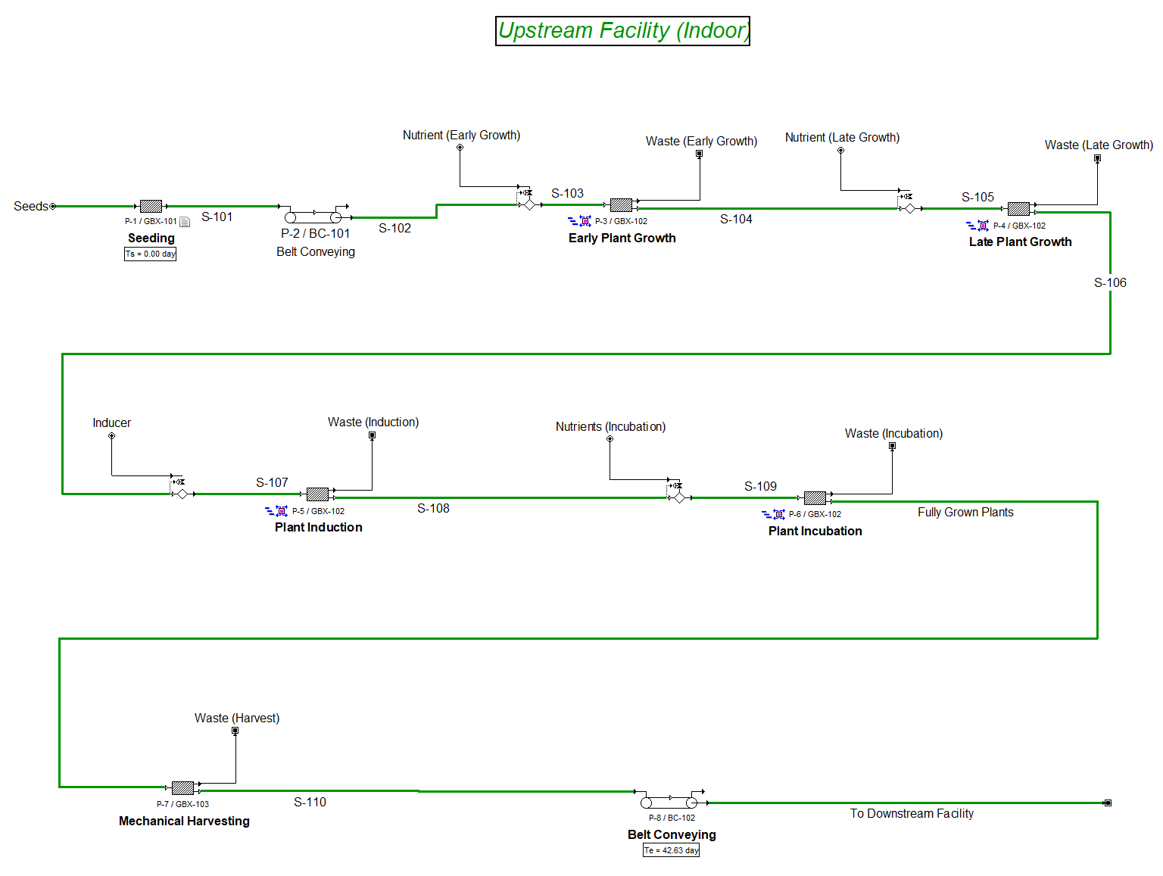
Figure S1. SuperPro Designer model flowsheet for vertical farming (indoor) upstream transgenic production facility

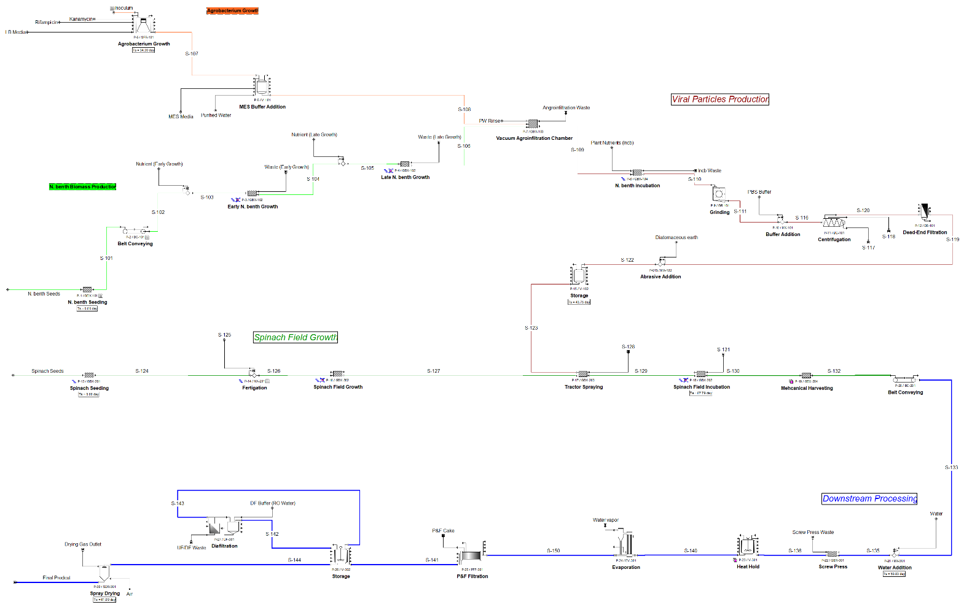
Figure S2. SuperPro Designer model flowsheet for thaumatin transient production in spinach. V-103: 73,000L (10 in parallel)

Supplemental Materials References:
Food and Agriculture Organization of the United Nations. (n.d.). Land & Water Tobacco. Retrieved March 15, 2019, from http://www.fao.org/land-water/databases-and-software/crop-information/tobacco/en/
FRED Federal Reserve Bank of St. Louis. (2020). U.S. Bureau of Labor Statistics, Producer Price Index by Commodity for Farm Products: Spinach [WPU01130224]. Retrieved April 23, 2020, from https://fred.stlouisfed.org/series/WPU01130224
Klimyuk, V., Pogue, G., Herz, S., Butler, J., & Haydon, H. (2014). Production of Recombinant Antigens and Antibodies in Nicotiana benthamiana Using `Magnifection’ Technology: GMP-Compliant Facilities for Small- and Large-Scale Manufacturing. In K. Palmer & Y. Gleba (Eds.), Plant Viral Vectors (pp. 127–154). Berlin, Heidelberg: Springer Berlin Heidelberg. https://doi.org/10.1007/82_2012_212
Knödler, M., Rühl, C., Emonts, J., & Buyel, J. F. (2019). Seasonal Weather Changes Affect the Yield and Quality of Recombinant Proteins Produced in Transgenic Tobacco Plants in a Greenhouse Setting. Frontiers in Plant Science, 10, 1245. https://doi.org/10.3389/fpls.2019.01245
Koike, S. T., Cahn, M., Cantwell, M., Fennimore, S., Lestrange, M., Natwick, E., … Takele, E. (2011). Spinach production in California.
McNulty, M. J., Gleba, Y., Tusé, D., Hahn-Löbmann, S., Giritch, A., Nandi, S., & McDonald, K. A. (2019). Techno-economic analysis of a plant-based platform for manufacturing antimicrobial proteins for food safety. Biotechnology Progress, 36(1), e2896. https://doi.org/10.1002/btpr.2896
Nandi, S., Kwong, A. T., Holtz, B. R., Erwin, R. L., Marcel, S., & McDonald, K. A. (2016). Techno-economic analysis of a transient plant-based platform for monoclonal antibody production. MAbs, 8(8), 1456–1466. https://doi.org/10.1080/19420862.2016.1227901
Simonne, E., Hochmuth, R., Breman, J., Lamont, W., Treadwell, D., & Gazula, A. (2008). Drip-irrigation systems for small conventional vegetable farms and organic vegetable farms. University of Florida IFAS Extension.
Smith, R. F., & Tumber, K. P. (2015). Sample Costs to Produce and Harvest Organic Spinach.
TN-KY Burley Tobacco Budget. (2018). Burley Tobacco Budget 2018 Estimated Costs And Returns. Retrieved March 15, 2019, from http://www.uky.edu/Ag/AgriculturalEconomics/pubs/exttobbudget201857.xls
United States Department of National Agriculture (USDA) Agricultural Statistics Service. (2018). Land Values 2018 Summary.

