SUPPLEMENTAL FIGURES

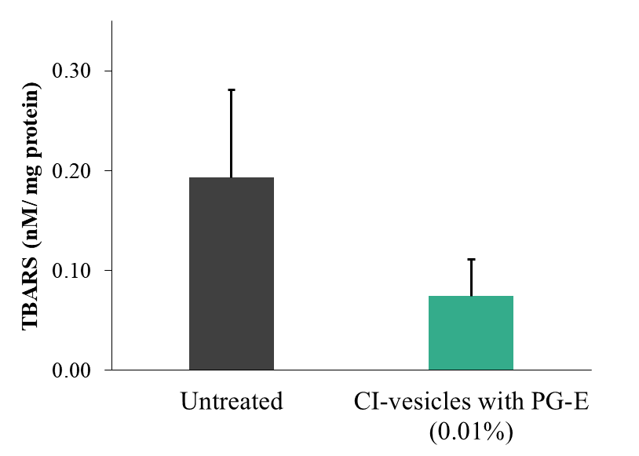
Figure S1.- TBARS (nM /mg protein) determined in HaCaT cells exposed to UV radiation after treatment for 24 hours with cauliflower inflorescence vesicles (CI-vesicles) with pomegranate extract (PG-E) (0.01%). Data are means ± SE (n = 6).

