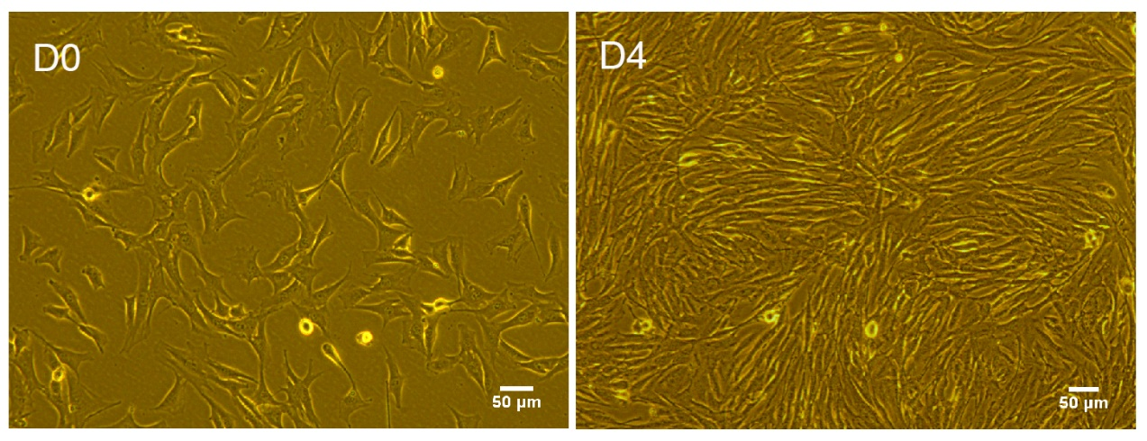
Figure S1 C2C12 myoblasts differentiate into mature myotubes. D0, C2C12 myoblasts differentiated for 0 days. D4, C2C12 myoblasts differentiated for 4 days. Scale bar = 50μm.

Figure S2 Ratios of Gast, TA, Sol and Quad muscle to body weight. n=8 per group. Gast, gastrocnemius; TA, tibialis anterior muscle; sol, soleus muscle; Quad, quadriceps. Data are shown as mean ± SEM. * P＜0.05 vs. Ctrl. ** P＜0.01 vs. Ctrl. # P＜0.05 vs. DEX. ## P＜0.01 vs. DEX. DEX, dexamethasone. TMZ, trimetazidine. Ctrl, control.

Table S1. Antibodies for Western Blot
Antibody | Source | Vendor | Catalog No. | Dilution
Fbx32(Atrogin-1) | Rabbit | abcam | ab168372 | 1:1500
Caspaase1 | Rabbit | abcam | ab179515 | 1:1000
IL-18 | Rabbit | abcam | ab71495 | 1:1000
p-FoxO3a (Ser253) | Rabbit | Cell Signaling Technology | #9466 | 1:1000
FoxO3a | Rabbit | Cell Signaling Technology | #2497 | 1:1000
Gasdermin D (L60) | Rabbit | Cell Signaling Technology | #93709S | 1:1000
NLRP3 (D4D8T) | Rabbit | Cell Signaling Technology | #15101S | 1:1000
IL-1β (3A6) | Mouse | Cell Signaling Technology | #12242S | 1:1000
GAPDH | Mouse | Proteintech | 60004-1-Ig | 1:10 000
MURF-1(TRIM63） | Goat | R&D Systems | AF5366-SP | 1ug/ml

Table S2. Primer sets for Real-time PCR analyses
Gene | Forward primer (5′ to 3′) | Reverse Primer (5′ to 3′)
GAPDH | AGGTCGGTGTGAACGGATTTG | TGTAGACCATGTAGTTGAGGTCA
Atrogin-1 | CAGCTTCGTGAGCGACCTC | GGCAGTCGAGAAGTCCAGTC
MuRF1 | GTGTGAGGTGCCTACTTGCTC | GCTCAGTCTTCTGTCCTTGGA
NLRP3 | TGTGAGAAGCAGGTTCTACTCT | GACTGTTGAGGTCCACACTCT
GSDMD | CCATCGGCCTTTGAGAAAGTG | ACACATGAATAACGGGGTTTCC
Caspase-1 | AGGCATGCCGTGGAGAGAAACAA | AGCCCCTGACAGGATGTCTCCA
Caspase-4 | ACAAACACCCTGACAAACCAC | CACTGCGTTCAGCATTGTTAAA
IL-1β | GACTCTTGCGTCAACTTCAAGG | CAGGCTGTCTTTTGTCAACGA
FoxO3a | CTGGGGGAACCTGTCCTATG | TCATTCTGAACGCGCATGAAG

