- Supplementary Material
Supplementary Table 1: Concordant membranous HLA-I HC and β₂-m expression with HLA-I surface expression in FFPE vs. frozen OSCC lesions

cases | FFPE specimen |  | fresh frozen specimen
 | HC: IRS | β₂-m: IRS | HLA-A/B/C: IRS
high membranous HLA expression
Case # 47 | 9 | 6 | 8
Case # 53 | 9 | 6 | 6
Case # 64 | 8 | 6 | 8
Case # 100 | 8 | 8 | 8
Case # 263 | 8 | 8 | 8
low / negative membranous HLA expression
Case # 136 | 0 | 0 | 1
Case # 148 | 0 | 1 | 0
Case # 151 | 0 | 1 | 0
Case # 182 | 0 | 2 | 3
Case # 202 | 0 | 2 | 2
IRS: immune reactive score.

Staining patterns of HLA-I HC and β₂-m on FFPE specimen with known HLA expression status (concordant membranous positivity) were compared to HLA-I surface expression on fresh frozen tissues using the W6/32 antibody recognizing the trimeric HLA-I complex.

Supplementary Table 2: Primers used for analyses of HLA-I and APM component expression

primer | sequence | Tm
TAP1 FWD* | GGA ATC TCT GGC AAA GTC CA | 60° C
TAP1 REV** | TGG GTG AAC TGC ATC TGG TA | 60° C
TAP2 FWD | CCA AGA CGT CTC CTT TGC AT | 60° C
TAP2 REV | TTC ATC CAG CAG CAC CTG TC | 60° C
β₂-m FWD | CTC GCG CTA CTC TCT CTT | 60° C
β₂-m REV | AAG ACC AGT CCT TGC TGA | 60° C
HLA-A, -B, -C FWD | GCC TAC CAC GGC AAG GAT TAC | 60° C
HLA-A, -B, -C REV | GGT GGC CTC ATG GTC AGA GA | 60° C
LMP2 FWD | TGC TGC ATC CAC ATA ACC AT | 60° C
LMP2 REV | TGT GCA CTC TCT GGT TCA GC | 60° C
LMP10 FWD | GGG CTT CTC CTT CGA GAA CT | 60° C
LMP10 REV | CAG CCC CAC AGC AGT AGA TT | 60° C
*fwd = forward; **rev = reverse.

Supplementary Figure 1: In silico correlation of CD8 mRNA expression with HLA-A, β₂-m and APM components
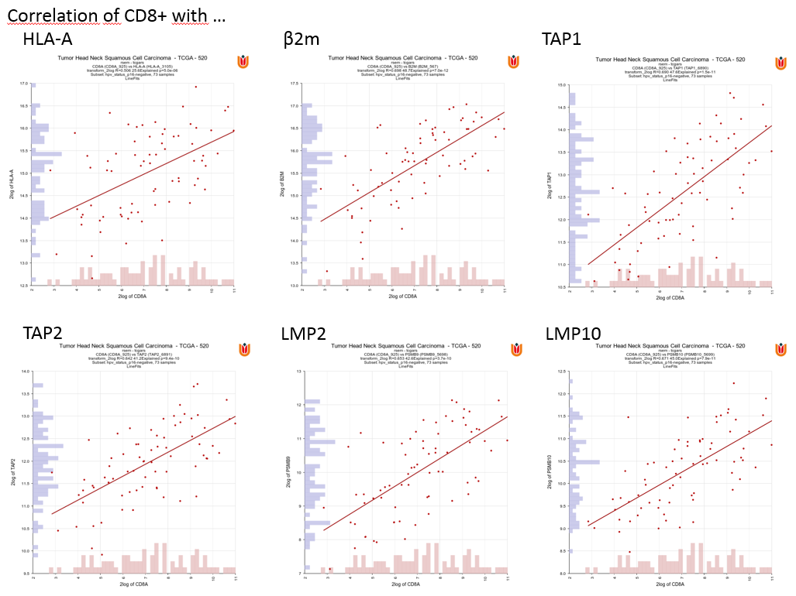
mRNA expression of CD8 was correlated with the mRNA expression of HLA-A, β₂-m, TAP1, TAP2, LMP2 and LMP10 in tumor material of HVP⁻ HNSCC patients of the TCGA cohort (n=73). The histograms show the distribution of the patients as a xy-plot with the histogram and linear fit options. The p-value is given in the header of every histogram.

Supplementary Figure 2: Constitutive and IFN-γ mediated upregulation of HLA-I APM component expression in HNSCC cell lines.
A Effect of IFN-γ treatment on mRNA expression of HNSCC cell lines
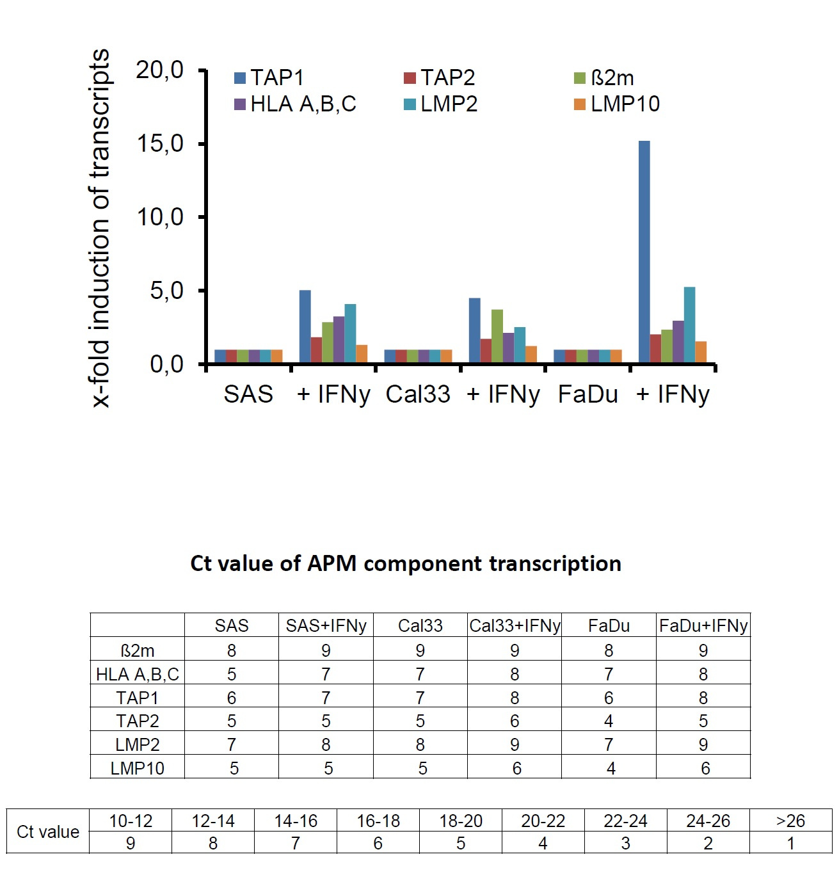
A: HNSCC cell lines were left untreated or treated for 48 h with IFN-γ (200 U/ml) as described in Materials and Methods before qPCR was performed. The data represent the relative mRNA expression levels of the different APM components normalized to that of the housekeeping gene ALAS1. The transcription levels of untreated HNSCC cell lines were set to one, and respective expression levels of IFN-γ-treated cells were calculated. Ct values of HLA-/APM component transcription and their classification are given.

B Effect of IFN-γ on protein expression of HNSCC cell lines
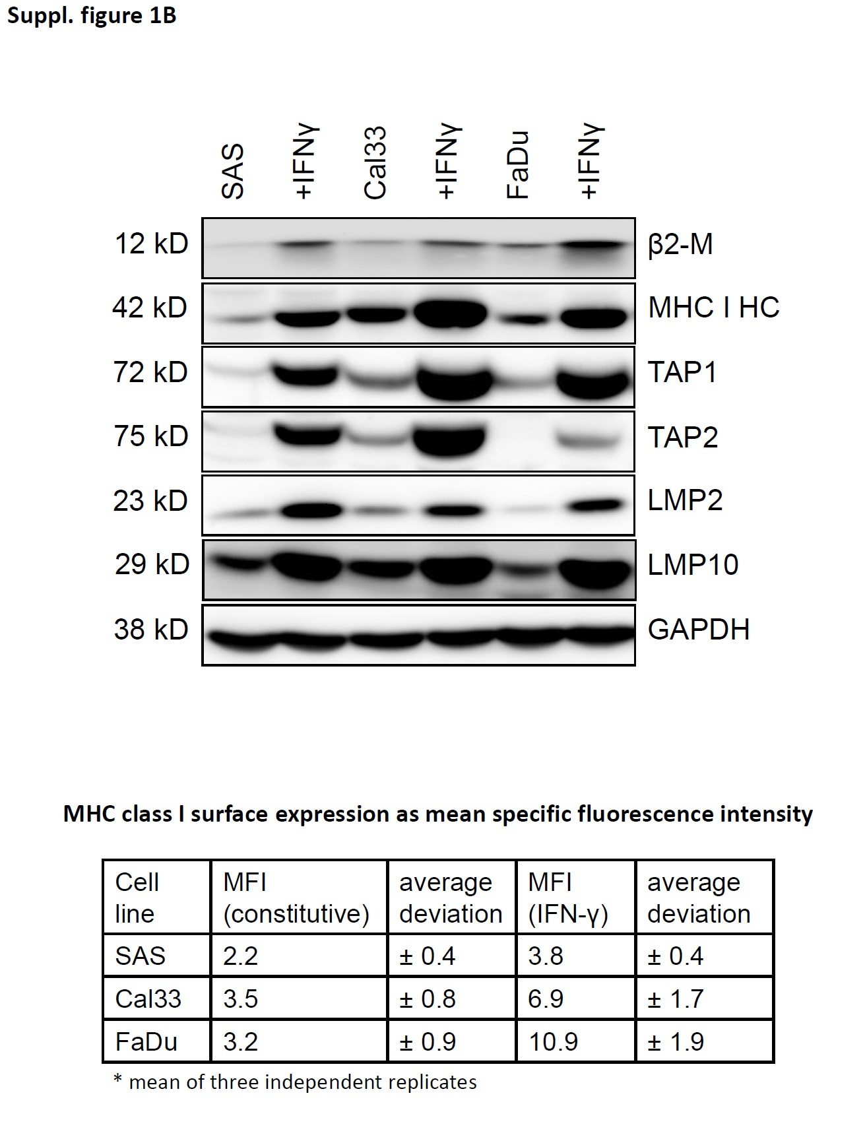
B: Western blot analysis using 50 µg protein lysate/lane of three different HNSCC cell lines (SAS, Cal33, FaDu) left untreated or treated for 48 h with IFN-γ (200 U/ml) was performed as described in Materials and Methods. The detection of GAPDH served as loading control. HLA-I surface expression of untreated and IFN-γ-treated HNSCC cell lines was performed as described and data expressed as MFI.

