Supporting Information

**Green Synthesis of 2-Oxazolidinones by an Efficient and Recyclable CuBr/Ionic Liquid System** **via** **CO2, Propargylic alcohols, and 2-Aminoethanols**

**Chao Bu, 1,3 Yanyan Gong, 2 Minchen Du, 1,3 Cheng Chen, 1 Somboon Chaemchuen, 1 Jia Hu, 1,3 Yongxing Zhang, 1,3 Heriberto Díaz Velázquez, 6 Ye Yuan 1,* and Francis Verpoort 1,3,4,5,\***

1 State Key Laboratory of Advanced Technology for Materials Synthesis and Processing, Wuhan University of Technology, Wuhan 430070, PR China. E-mail: fyyuanye@whut.edu.cn, [francis.verpoort@ghent.ac.kr](mailto:francis.verpoort@ghent.ac.kr)

2 State Key Laboratory of Biobased Material and Green Papermaking, Qilu University of Technology (ShanDong Academy of Sciences), Jinan 250353, PR China

3 School of Materials Science and Engineering, Wuhan University of Technology, Wuhan 430070, PR China

4 National Research Tomsk Polytechnic University, Lenin Avenue 30, Tomsk 634050, Russian Federation

5 Global Campus Songdo, Ghent University, 119 Songdomunhwa-Ro, Yeonsu-Gu, Incheon, Korea

6 Dirección de Investigación en Transformación de Hidrocarburos, Instituto Mexicano del Petróleo, Mexico City 07730, Mexico

* Correspondence: fyyuanye@whut.edu.cn, [francis.verpoort@ghent.ac.kr](mailto:francis.verpoort@ghent.ac.kr)

**1.** **TON reported in the previous literatures.**



**Fig. S1** The literatures reported for the three-component reactions

**Fig. S1** showed the literatures reported for the three-component reactions up to now. A TON of 1260 could be obtained by the Ag2O/TMG catalytic system. Particularly, a higher TON of 2960 was reached by this CuBr/[C4C1im][OAc] system. For the other systems, no TON data was expressly reported, indicating that 2960 is the highest TON up to now for this three-component reaction.

**Table S1**. TON reported in the previous literatures

|  |  |
| --- | --- |
| Ref. | TON |
| 1[1] | No mention |
| 2[2] | 1260 |
| 3[3] | No mention |
| 4[4] | No mention |
| This work | 2960 |

**2. The reaction of propargylic alcohols and CO2**

To prove whether the cyclic carbonates could be produced without the use of aminoethanols, the control experiment was performed as follows:**2a** (7.5 mmol), CuBr (0.025 mmol) and [C4C1im][OAc] (6.5 mmol) were prepared in a Schlenk tube under 1 atm of CO2 at 100℃. After 12 h, the reaction mixture was directly in situ examined by 1H NMR in CDCl3 (**Fig. S2**). A characteristic double peak of the α-alkylidene cyclic carbonate at δ = 4.788 was clearly observed[1], indicating the formation of the corresponding carbonate.



../相关材料/第一步对比图修改.pdf

**Fig. S2.** 1H NMR of the control experiment mixture (red) and the pure cyclic carbonate (blue)

**3. The reaction of** **cyclic carbonates and 2-aminoethanols**

To prove whether the cyclic carbonates from step 1 would react with 2-aminoethanols to give the desired products using the CuBr/[C4C1im][OAc] catalytic system, the following control experiment was performed: **1a** (5 mmol), cyclic carbonates (7.5 mmol), CuBr (0.025 mmol, 0.5 mol%) and [C4C1im][OAc] (6.5 mmol) were mixed in a Schlenk tube under 1 atm of CO2 at 100℃ for 12 h. Once the reaction was finished, the reaction mixture was directly in situ examined by 1H NMR in CDCl3 (**Fig. S3**). The characteristic peaks of **3a** at δ =3.43, 4.32, 4.45 and **4a** at δ =1.41, 2.26, 3.77 were clearly observed, indicating the formation of the final products from cyclic carbonates and 2-aminoethanols. [2]



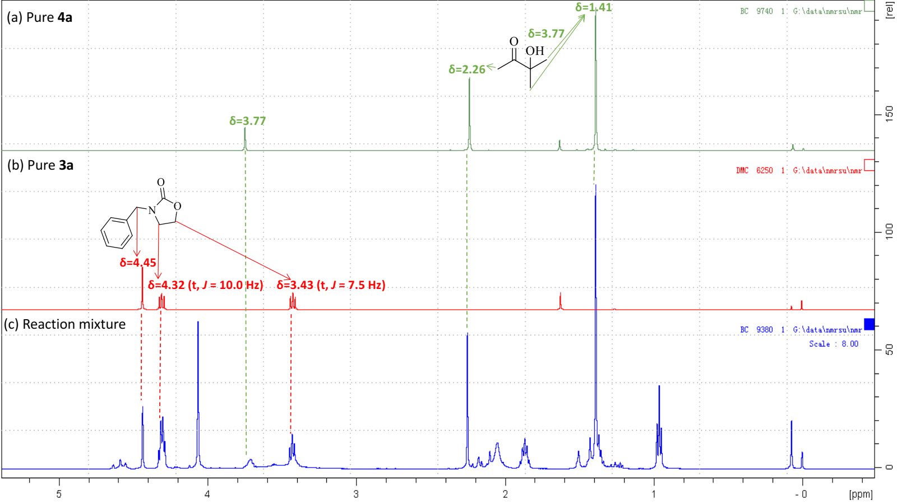

**Fig. S3.** 1H NMR of pure **4a** (green), pure **3a** (red) and the control reaction mixture (blue)

**4. Activation of** **the hydroxyl group** **in the presence of 1 atm of CO2**

Substrate **2a**, and the mixture of **2a**/[C4C1im][OAc] (1.5:1.3), **2a**/**1a** (1.5:1) were respectively prepared in the closed Schlenk tubes at 1 atm of CO2 at 100℃. After 5 mins, three samples were respectively taken from them into DMSO-*d*6 and examined by 1H NMR (**Fig. S4**). As the NMR results showed, in the presence of 1 atm of CO2, the hydroxyl groups of propargylic alcohols could be strongly activated by [C4C1im][OAc] and slightly activated by 2-aminoethanols.

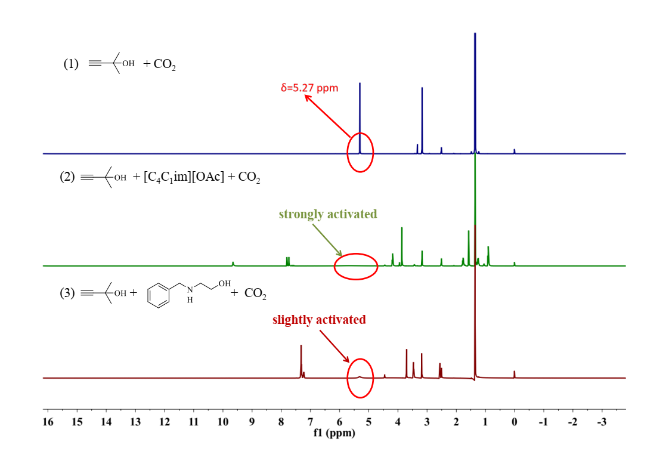

**Fig. S4.** Investigations on the activation of hydroxyl protons in the presence of 1 atm of CO2

**5.** **Exploration of metal leaching in the recycling experiments**

The metal leaching occurred in the extraction process was explored by the ICP analysis after each round. The results were showed below:

**Table S2** Exploration of metal leaching in the recycling experiments

|  |  |  |  |  |
| --- | --- | --- | --- | --- |
|  | initial amount | after  round 1 | after  round 2 | after  round 3 |
| CuBr amount (mmol) | 0.02516 | 0.02124 | 0.01915 | 0.01732 |
| Leaching (%) | / | 15.58 | 9.84 | 9.56 |

Based on the ICP data, we could calculate that after the first round, 15.58% of CuBr was leached from the system, while after 2nd and 3rd rounds, similar leaching values of 9.84% and 9.56% were obtained respectively.

**6. Characterization Data for Substrates and Products**

**1b**

2-(4-Methylbenzylamino)ethanol. Colourless oil. 1H NMR (500 MHz, Chloroform-*d*) δ 7.22 (d, *J* = 7.9 Hz, 2H), 7.16 (d, *J* = 7.8 Hz, 2H), 3.78 (s, 2H), 3.66 (t, *J*=5.0 Hz, 2H), 2.81 (t, *J*=5.0Hz, 2H), 2.36 (s, 3H), 2.19(-OH, -NH) ppm. 13C NMR (126 MHz, Chloroform-*d*) δ 137.0, 136.7, 129.2, 128.1, 61.0, 53.2, 50.5, 21.1 ppm. These data are matched with the reported publication.[3] HRMS (ESI) calcd for C10H16NO+ [M+H]+ 166.1226; found 166.1227.

**1c**

2-(3,4-Dimethylbenzylbenzylamino)ethanol. Colorless solid. 1H NMR (500 MHz, Chloroform-*d*) δ 7.17 – 7.03 (m, 3H), 3.76 (s, 2H), 3.67 (t, *J*=5.0 Hz, 2H), 2.82 (t, *J*=5.0 Hz, 2H), 2.27 (d, *J* = 6.1 Hz, 6H), 2.07(-OH, -NH) ppm. 13C NMR (126 MHz, Chloroform-*d*) δ 137.4 , 136.7 , 135.4 , 129.7, 129.5, 125.5, 60.9, 53.2 , 50.5, 19.7, 19.4 ppm. These data are matched with the reported publication.[3] HRMS (ESI) calcd for C11H18NO+ [M+H]+ 180.1383; found 180.1384.

**1d**

2-(4-Methoxybenzylamino)ethanol. Light yellow oil. 1H NMR (500 MHz, Chloroform-*d*) δ 7.24 (d, *J* = 8.6 Hz, 2H), 6.87 (d, *J* = 8.6 Hz, 2H), 3.80 (s, 3H), 3.74 (s, 2H), 3.65 (t, *J*=5.3 Hz, 2H), 2.77 (t, *J*=5.0 Hz, 2H), 2.69(-OH, -NH) ppm. 13C NMR (126 MHz, Chloroform-*d*) δ 158.8 , 131.78, 129.4, 113.9, 60.8, 55.3, 52.9, 50.5 ppm. These data are matched with the reported publication.[3]HRMS (ESI) calcd for C10H16NO2+ [M+H]+ 182.1176; found 182.1177.

**1e**

2-(4-Chlorobenzylbenzylamino)ethanol. Light yellow oil. 1H NMR (500 MHz, Chloroform-*d*) δ 7.33 – 7.26 (m, 4H), 3.80 (s, 2H), 3.69 – 3.67 (t, *J* = 5.0 Hz, 2H), 2.82 – 2.80 (t, *J* = 5.0 Hz, 2H), 2.05(-OH, -NH) ppm. 13C NMR (126 MHz, Chloroform-*d*) δ 138.5, 132.8, 129.4, 128.6, 61.0, 52.8, 50.5 ppm. These data are matched with the reported publication.[3]HRMS (ESI) calcd for C9H13ClNO2+ [M+H]+ 186.0680; found 186.0681.

**1f**

2-(4-Nitrobenzylbenzylamino)ethanol. Brown solid. 1H NMR (500 MHz, Chloroform-*d*) δ 8.21 (d, *J* = 8.6 Hz, 2H), 7.53 (d, *J* = 8.5 Hz, 2H), 3.96 (s, 2H), 3.73-3.71 (t, *J* = 5.0 Hz, 2H), 2.86-2.84 (t, *J* = 5.0 Hz, 2H), 2.05(-OH, -NH) ppm. 13C NMR (126 MHz, Chloroform-*d*) δ 147.8, 147.2, 128.6, 123.7, 61.2, 52.8, 50.7 ppm. These data are matched with the reported publication.[3]HRMS (ESI) calcd for C9H13N2O3+ [M+H]+ 197.0921; found 197.0922.

**3a**

3-Benzyloxazolidin-2-one. Light yellow solid. 1H NMR (500 MHz, Chloroform-*d*) δ 7.39 – 7.28 (m, 5H), 4.45 (s, 2H), 4.32 (t, *J* = 10.0 Hz, 2H), 3.46 – 3.43 (t, *J* = 7.5 Hz, 2H). 13C NMR (126 MHz, Chloroform-*d*) δ 135.8, 128.8, 128.2, 128.0 , 61.8, 48.5, 44.0 ppm. These data are matched with the reported publication.[3]HRMS (ESI) calcd for C10H11NNaO2+ [M+Na]+ 200.0682; found 200.0683.

**3b**

3-(4-Methylbenzyl)oxazolidin-2-one. Colorless oil. 1H NMR (500 MHz, Chloroform-*d*) δ 7.21 – 7.17 (m, 4H), 4.40 (s, 2H), 4.30 (t, *J* = 10.0 Hz, 2H), 3.42 (t, *J* =10.0 Hz, 2H), 2.36 (s, 3H) ppm. 13C NMR (126 MHz, Chloroform-*d*) δ 158.5, 137.8, 122.7, 129.5, 128.2, 61.8, 48.1, 43.9, 21.1 ppm. These data are matched with the reported publication.[3]HRMS (ESI) calcd for C11H14NO2+ [M+H]+ 192.1019; found 192.1020.

**3c**

3-(3,4-Dimethylbenzyl)oxazolidin-2-one. Light yellow oil. 1H NMR (500 MHz, Chloroform-*d*) δ 7.25 – 7.02 (m, 3H), 4.38 (s, 2H), 4.31 (t, *J*= 10.0 Hz, 2H), 3.43 (t, *J* =7.5 Hz, 2H), 2.28 (s, 6H) ppm. 13C NMR (126 MHz, Chloroform-*d*) δ 158.5, 137.1, 136.4, 130.0, 129.5, 125.7, 61.8, 48.2, 43.9, 19.7, 19.4 ppm. These data are matched with the reported publication.[3]HRMS (ESI) calcd for C12H16NO2+ [M+H]+ 206.1176; found 206.1177.

**3d**

3-(4-Methoxybenzyl)oxazolidin-2-one. Colorless solid. 1H NMR (500 MHz, Chloroform-*d*) δ 7.14 (d, *J* = 8.5 Hz, 2H), 6.81 (d, *J* = 8.5 Hz, 2H), 4.29 (s, 2H), 4.21 (t, *J* = 10.0 Hz, 2H), 3.73 (s, 3H), 3.33 (t, *J* = 10.0 Hz, 2H) ppm. 13C NMR (126 MHz, Chloroform-*d*) δ 159.4, 158.5, 129.6, 127.8, 114.2, 61.8, 55.3, 47.8, 43.8 ppm. These data are matched with the reported publication.[3]HRMS (ESI) calcd for C11H14NO3+ [M+H]+ 208.0968; found 208.0968.

**3e**

3-(4-Chlorobenzyl)oxazolidin-2-one. Light yellow oil. 1H NMR (500 MHz, Chloroform-*d*) δ 7.35 (d, *J* = 8.3 Hz, 2H), 7.25 (d, *J* = 8.3 Hz, 2H), 4.42 (s, 2H), 4.33 (t, *J* = 10.0 Hz, 2H), 3.44 (t, *J* = 7.5 Hz, 2H) ppm. 13C NMR (126 MHz, Chloroform-*d*) δ 158.5 , 134.3, 133.9, 129.5, 129.0, 61.8, 47.8, 44.0 ppm. These data are matched with the reported publication.[3]HRMS (ESI) calcd for C10H11ClNO2+ [M+H]+ 212.0473; found 212.1473.

**3f**

3-(4-Nitrobenzyl)oxazolidin-2-one. Light yellow solid. 1H NMR (500 MHz, Chloroform-*d*) δ 8.25 (d, *J* = 8.0 Hz, 2H), 7.50 (d, *J* = 8.0 Hz, 2H), 4.56 (s, 2H), 4.40 (t, *J* = 7.8 Hz, 2H), 3.50 (t, *J* = 7.8 Hz, 2H) ppm. 13C NMR (126 MHz, Chloroform-*d*) δ 158.5, 147.8, 143.2, 128.8, 124.1, 61.9, 47.9, 44.3 ppm. These data are matched with the reported publication.[6]HRMS (ESI) calcd for C10H11N2O4+ [M+H]+ 223.0713; found 223.0713.

**3g**

3-(2-Hydroxyethyl)oxazolidin-2-one. Colorless oil. 1H NMR (500 MHz, Chloroform-*d*) δ 4.36 (t, *J* = 7.5 Hz, 2H), 3.81 (t, *J* = 5.1 Hz, 2H), 3.71 (t, *J* = 7.5 Hz, 2H), 3.41 (t, *J* = 5.0 Hz, 2H) ppm. 13C NMR (126 MHz, Chloroform-*d*) δ 159.4, 62.2, 60.5, 46.9, 45.7 ppm. These data are matched with the reported publication.[3]HRMS (ESI) calcd for C5H10NO3+ [M+H]+ 132.0655; found 132.0656.

**3h**

3-Methyl-2-oxazolidinone. Oil. 1H NMR (500 MHz, Chloroform-*d*) δ 4.23 (t, *J* = 8.0 Hz, 2H), 3.50 (t, *J* = 8.0 Hz, 2H), 2.80 (s, 3H) ppm. 13C NMR (126 MHz, Chloroform-*d*) δ 61.5, 46.7, 31.0. These data are matched with the reported publication.[7] HRMS (ESI) calcd for C4H8NO2+ [M+H]+ 102.0553; found 102.0550.

**3i**

3-Ethyl-2-oxazolidinone. Yellow liquid. 1H NMR (500 MHz, Chloroform-*d*) δ 4.31 (t, *J* = 8.0 Hz, 2H), 3.55 (t, *J* = 8.0 Hz, 2H), 3.31 (q, *J* = 7.2 Hz, 2H), 1.16 (t, *J* = 7.2 Hz, 3H) ppm. 13C NMR (126 MHz, Chloroform-*d*) δ 61.6, 43.9, 38.9, 12.5 ppm. These data are matched with the reported publication.[8] HRMS (ESI) calcd for C5H10NO2+ [M+H]+ 116.0708; found 116.0706.

**3j**

3-Isopropyl-2-oxazolidinone. Yellow liquid. 1H NMR (500 MHz, Chloroform-*d*) δ 4.31 (t, *J* = 8.0 Hz, 2H), 4.11 (hept, *J* = 6.8 Hz, 1H), 3.51 (t, *J* = 8.0 Hz, 2H), 1.19 (d, *J* = 6.8 Hz, 6H) ppm. 13C NMR (126 MHz, Chloroform-*d*) δ 61.9, 44.8, 39.6, 19.7 ppm. These data are matched with the reported publication.[8] HRMS (ESI) calcd for C6H12NO2+ [M+H]+ 130.0863; found 130.0863.

**4a**

3-Hydroxy-3-methylbutan-2-one. Colorless oil. 1H NMR (500 MHz, DMSO-*d*6) δ 5.22 (s, 1H), 2.16 (s, 3H), 1.18 (s, 6H) ppm. 13C NMR (126 MHz, DMSO-*d*6) δ 214.3, 76.2, 26.6, 24.7 ppm. These data are matched with the reported publication.[3]

**4b**

3-Hydroxy-3-methylpentan-2-one. Colorless oil. 1H NMR (500 MHz, DMSO-*d*6) δ 5.04 (s, 1H), 2.14 (s, 3H), 1.61 (m, 1H), 1.47 (m, 1H), 1.13 (s, 3H), 0.76 (t, *J* = 7.5 Hz, 3H) ppm. 13C NMR (126 MHz, DMSO-*d*6) δ 214.5, 78.9, 32.2, 25.5, 24.5, 8.3. These data are matched with the reported publication.[3]

**4c**

3-Hydroxy-3-dimethyl-2-hexanone. 1H NMR (500 MHz, DMSO-*d*6) δ 4.99 (s, 1H), 2.17 (s, 3H), 1.59 (dd, *J* = 13.9, 6.9 Hz, 1H), 1.42 (dd, *J* = 13.9, 5.6 Hz, 1H), 1.15 (s, 3H), 0.87 (d, *J* = 6.6 Hz, 3H), 0.79 (d, *J* = 6.6 Hz, 3H) ppm. 13C NMR (126 MHz, DMSO-*d*6) δ 214.8, 79.0, 48.0, 26.4, 25.6, 24.7, 24.2 ppm. These data are matched with the reported publication.[9]

**4d**

1-(1-Hydroxycyclohexyl)ethenone. Yellow oil. 1H NMR (500 MHz, DMSO-*d*6) δ 5.06 (s, 1H), 2.14 (s, 3H), 1.60 – 1.42 (m, 9H), 1.18 (m, 1H) ppm. 13C NMR (126 MHz, DMSO-*d*6) δ 214.6, 77.3, 33.3, 25.5, 24.9, 21.3 ppm. These data are matched with the reported publication.[3]

**4e**

3-Hydroxy-3-phenylbutan-2-one. Brown oil. 1H NMR (500 MHz, DMSO-*d*6) δ 7.44 (d, *J* = 7.2 Hz, 2H), 7.35 (t, *J* = 7.6 Hz, 2H), 7.27 (t, *J* = 7.3 Hz, 1H), 6.04 (s, 1H), 2.02 (s, 3H), 1.52 (s, 3H). 13C NMR (126 MHz, DMSO-*d*6) δ 210.7, 143.7, 128.6, 127.6, 125.5, 80.2, 26.5, 24.7 ppm. These data are matched with the reported publication.[3]

**7. NMR Spectral Copies of the Substrates and Products**

**1b** 1H NMR (500 MHz, CDCl3)

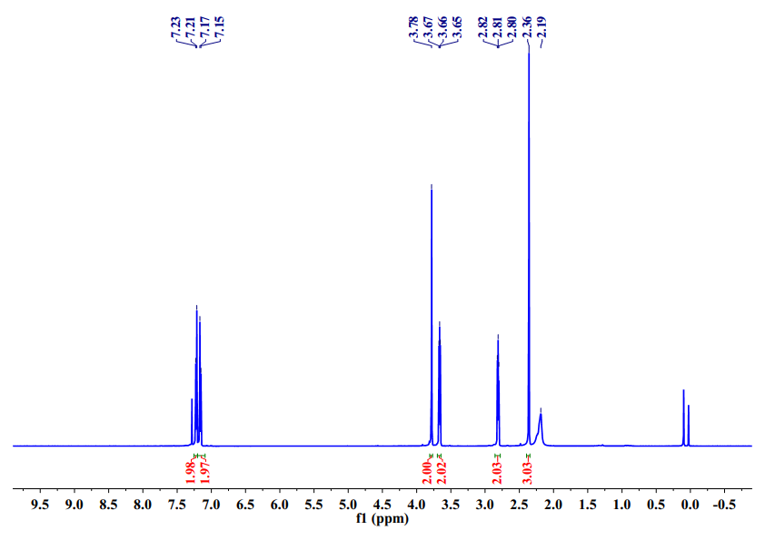

**1b** 13C NMR (126 MHz, CDCl3)

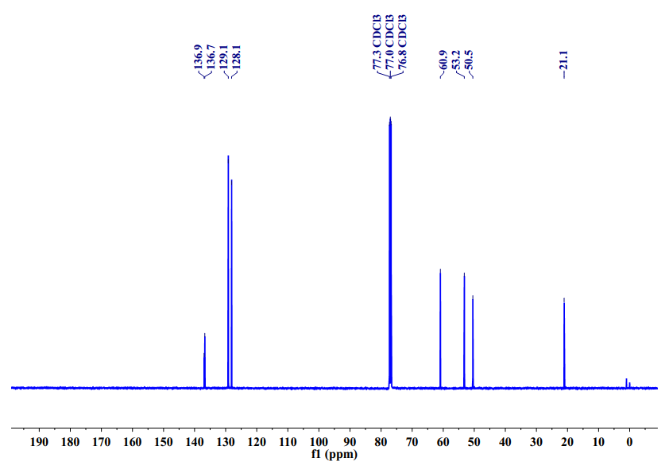

**1c** 1H NMR (500 MHz, CDCl3)

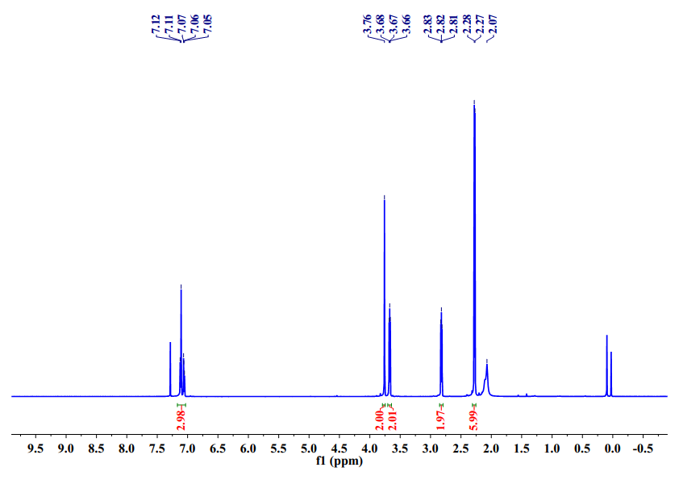

**1c** 13C NMR (126 MHz, CDCl3)

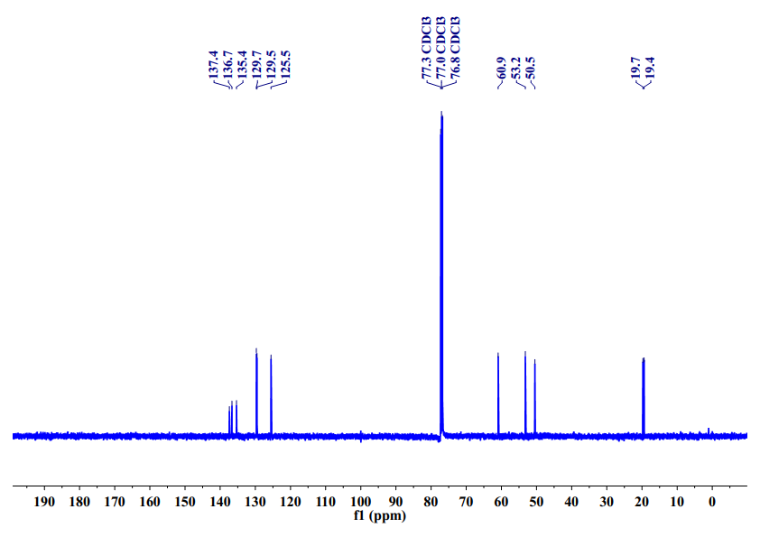

**1d** 1H NMR (500 MHz, CDCl3)

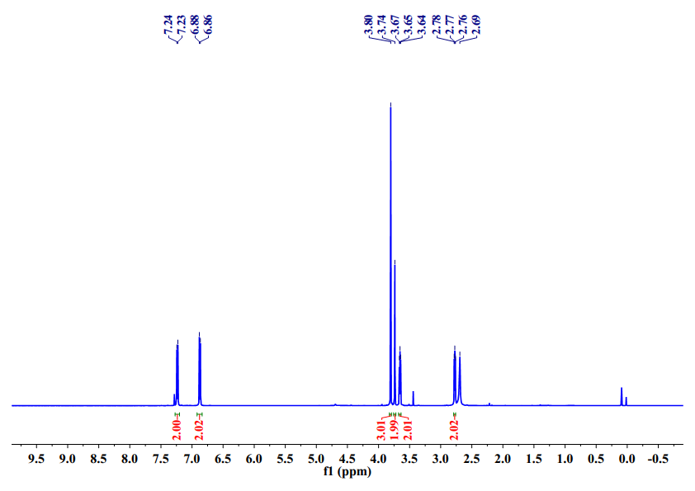

**1d** 13C NMR (126 MHz, CDCl3)

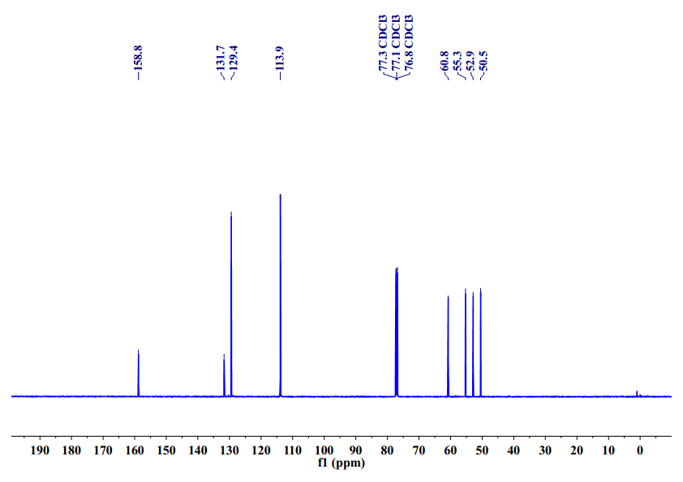

**1e** 1H NMR (500 MHz, CDCl3)

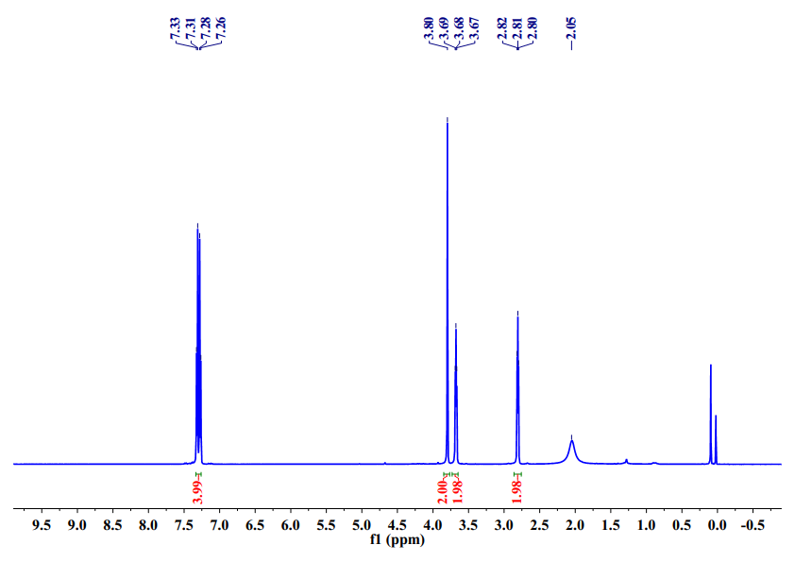

**1e** 13C NMR (126 MHz, CDCl3)

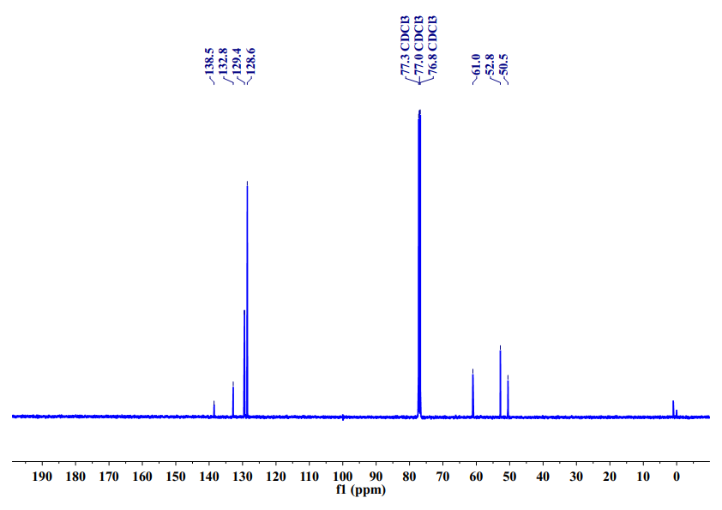

**1f** 1H NMR (500 MHz, CDCl3)

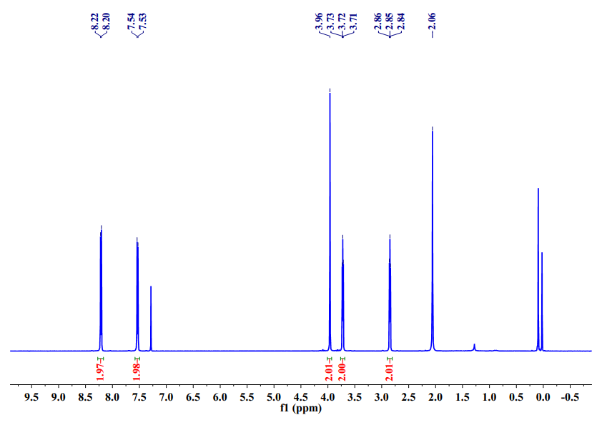

**1f** 13C NMR (126 MHz, CDCl3)

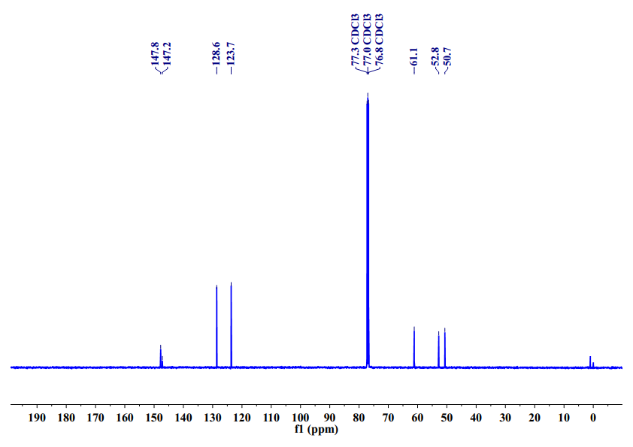

**3a** 1H NMR (500 MHz, CDCl3)

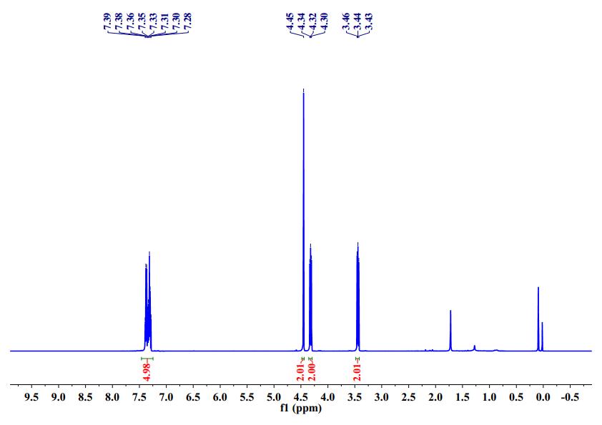

**3a** 13C NMR (126 MHz, CDCl3)

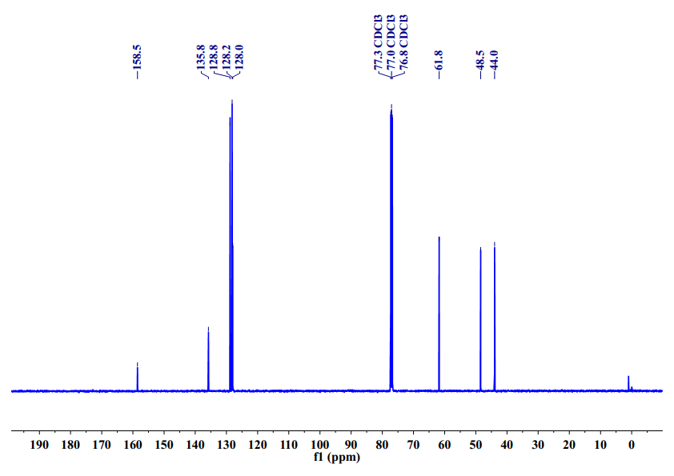

**3b** 1H NMR (500 MHz, CDCl3)

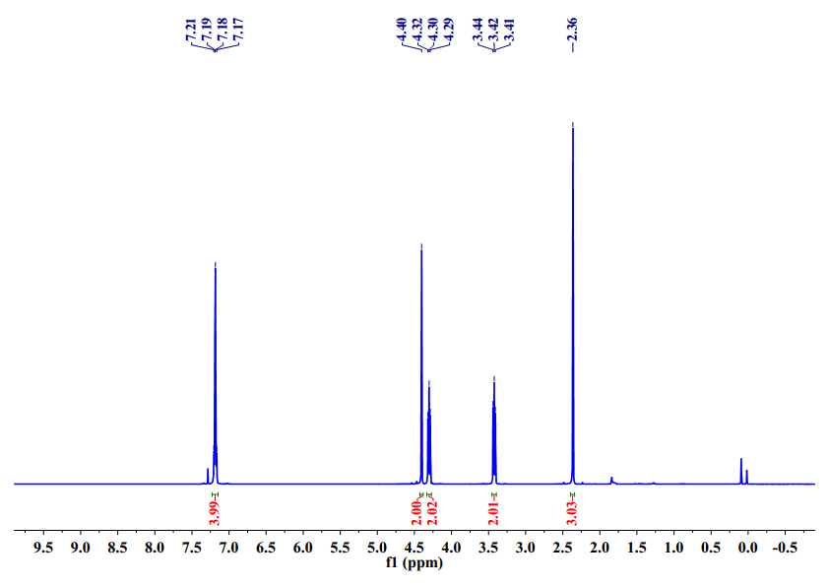

******3b** 13C NMR (126 MHz, CDCl3)

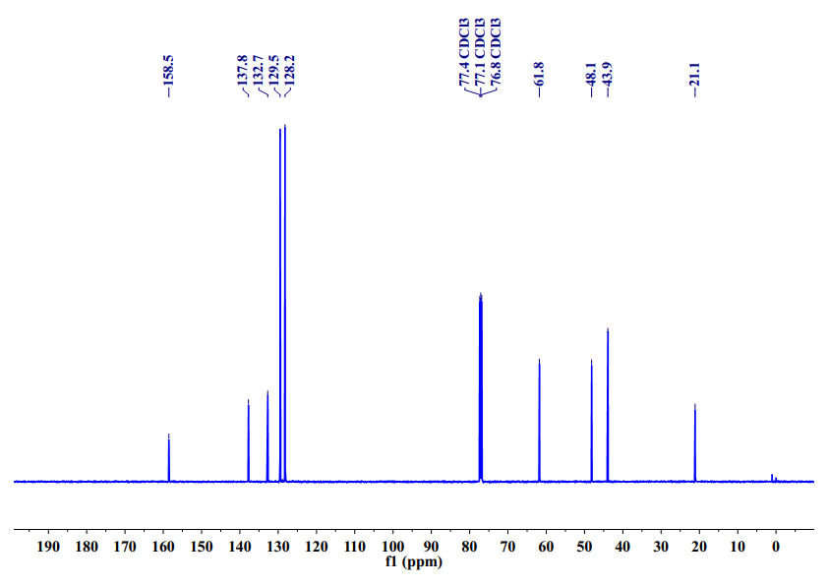

**3c** 1H NMR (500 MHz, CDCl3)

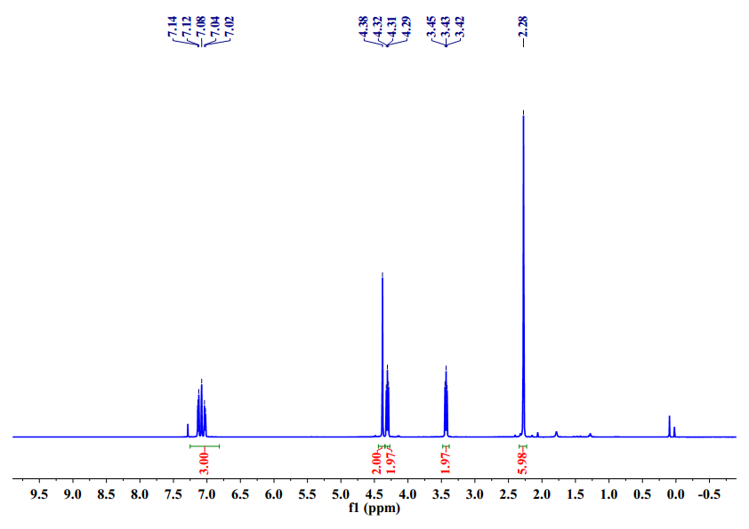

**3c** 13C NMR (126 MHz, CDCl3)

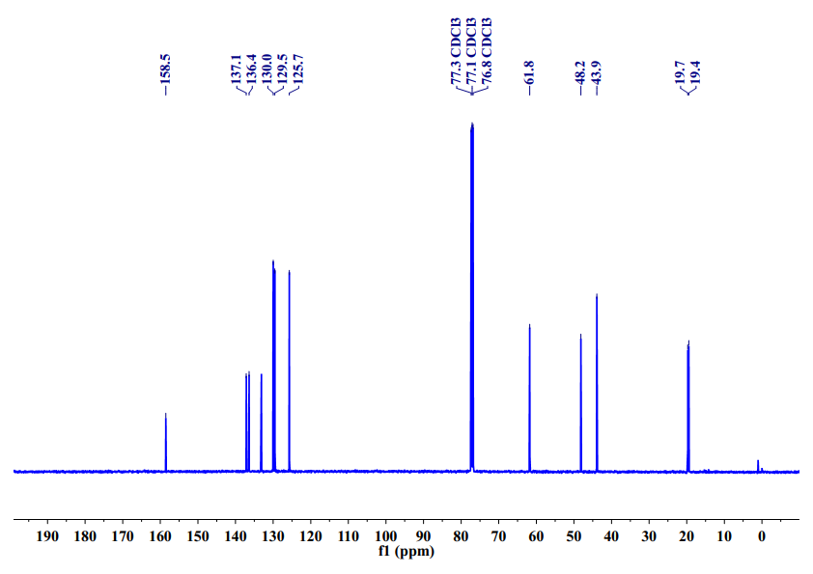

**3d** 1H NMR (500 MHz, CDCl3)

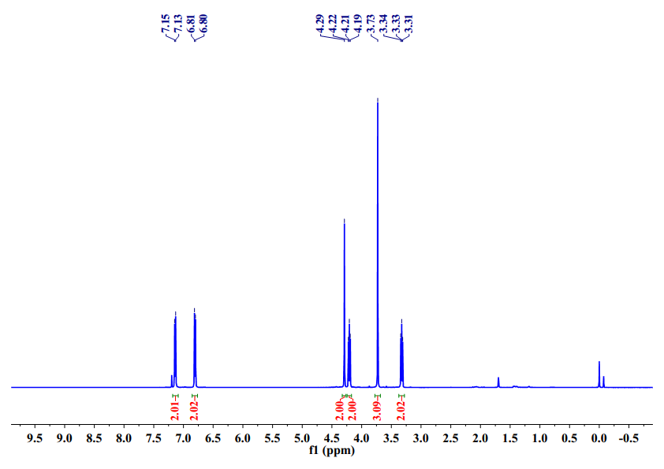

**3d** 13C NMR (126 MHz, CDCl3)

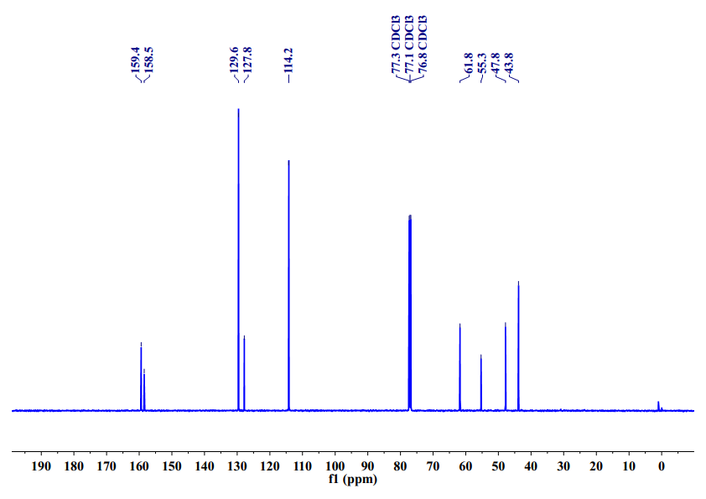

**3e** 1H NMR (500 MHz, CDCl3)

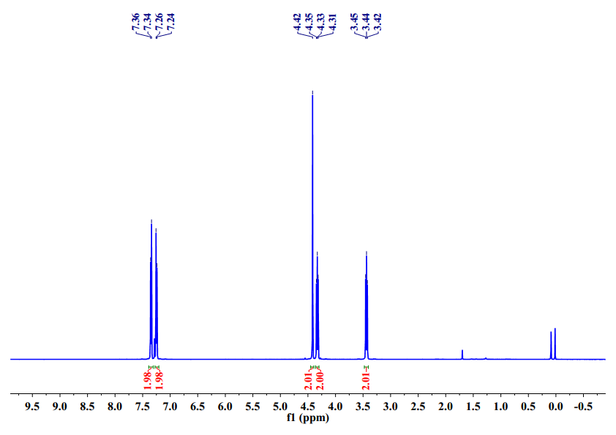

**3e** 13C NMR (126 MHz, CDCl3)

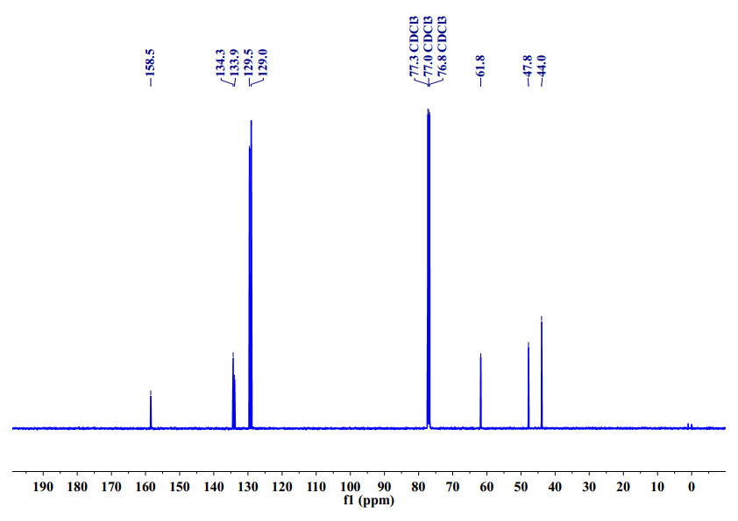

**3f** 1H NMR (500 MHz, CDCl3)

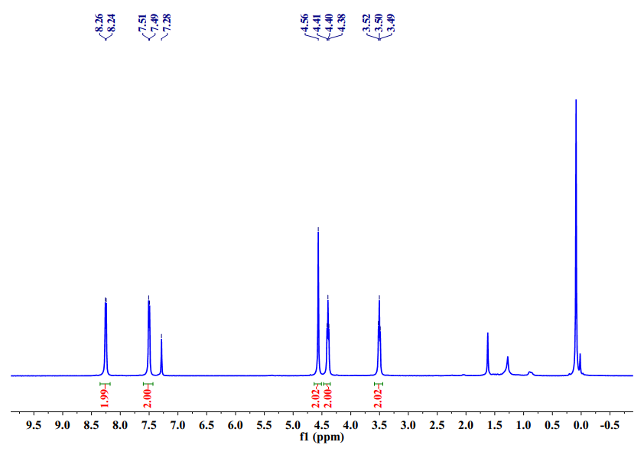

**3f** 13C NMR (126 MHz, CDCl3)

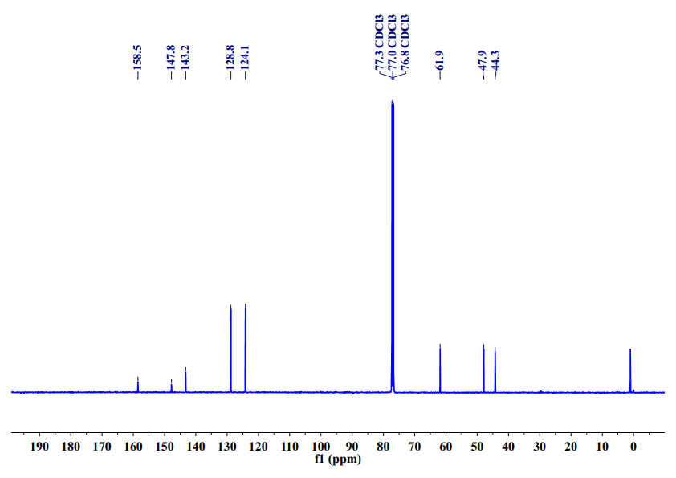

**3g** 1H NMR (500 MHz, CDCl3)

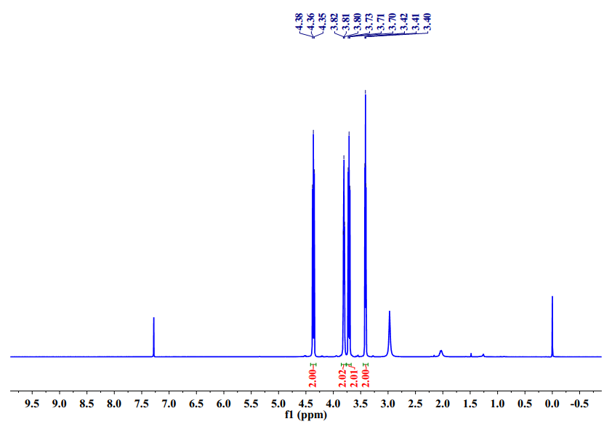

**3g** 13C NMR (126 MHz, CDCl3)

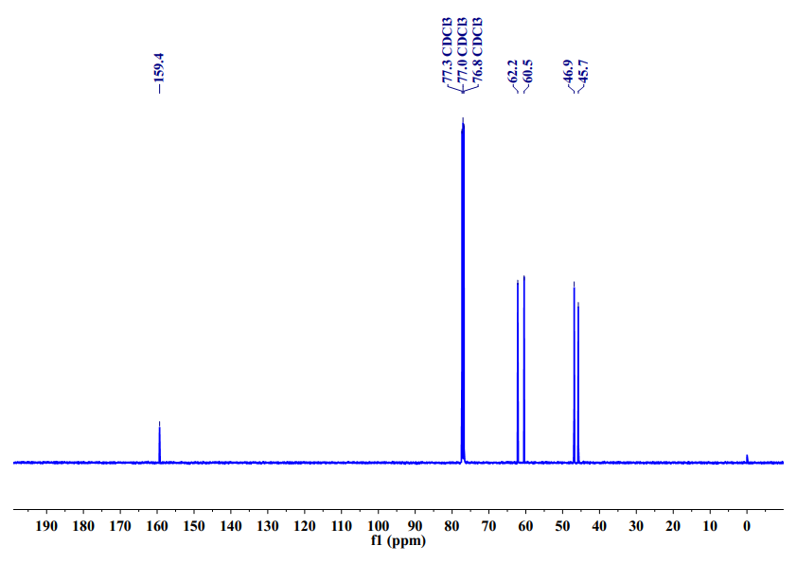

**3h** 1H NMR (500 MHz, CDCl3)

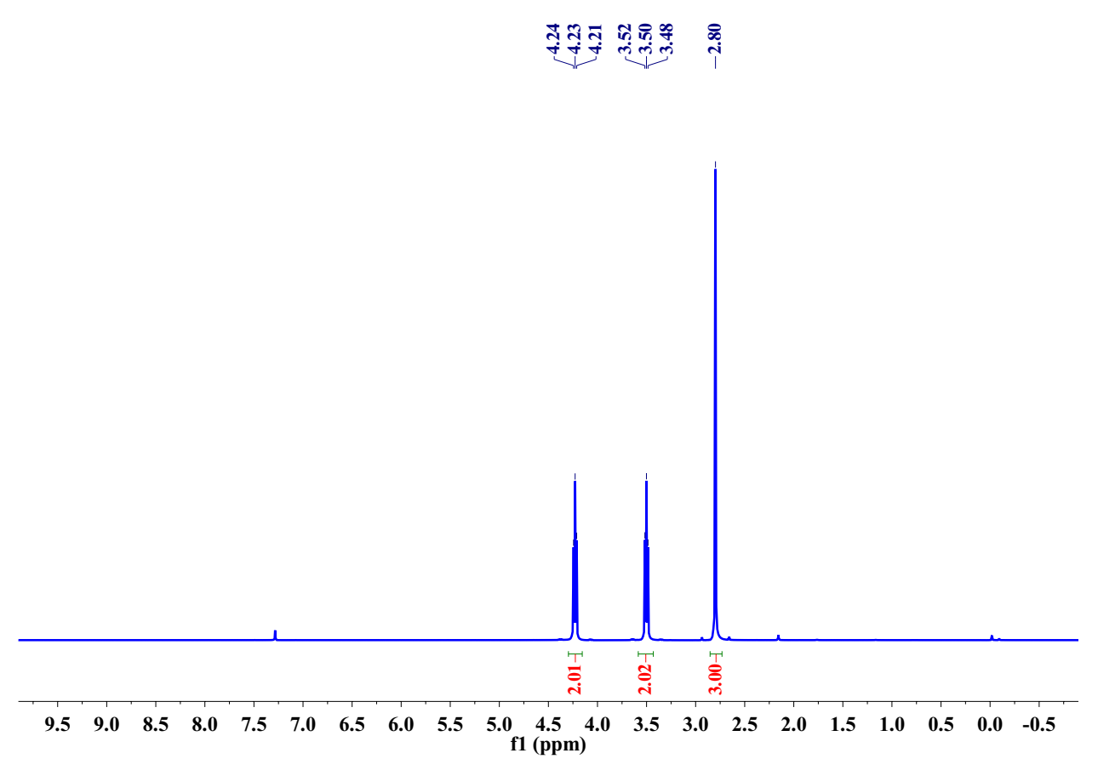

**3h** 13C NMR (126 MHz, CDCl3)

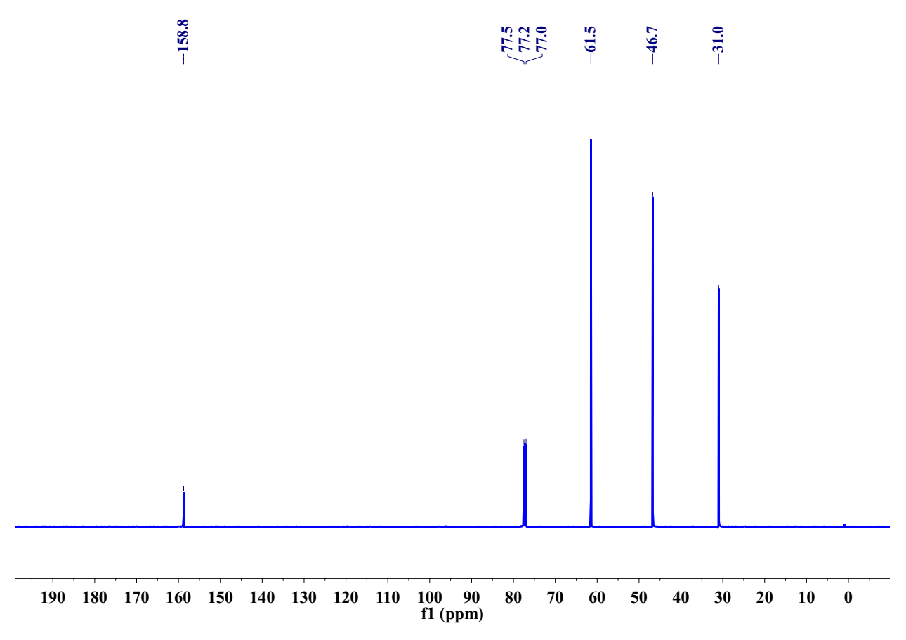

**3i** 1H NMR (500 MHz, CDCl3)

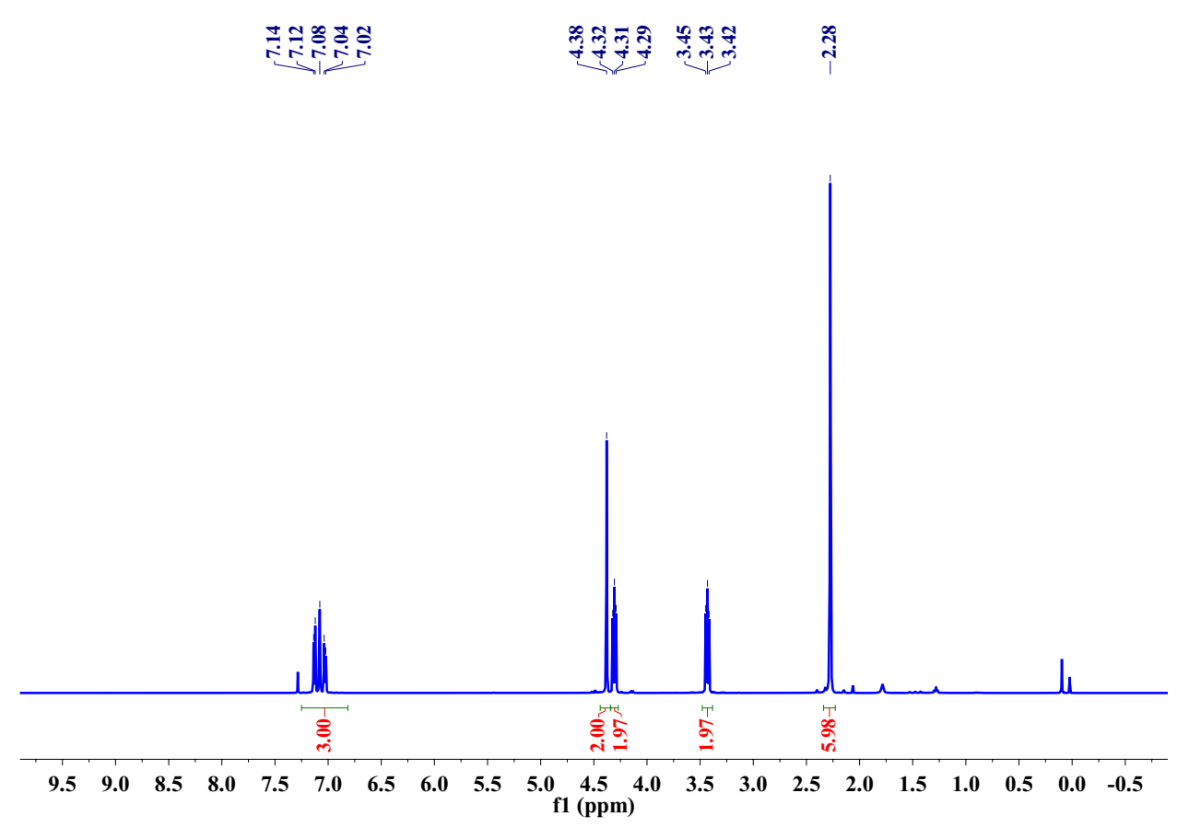

**3i** 13C NMR (126 MHz, CDCl3)

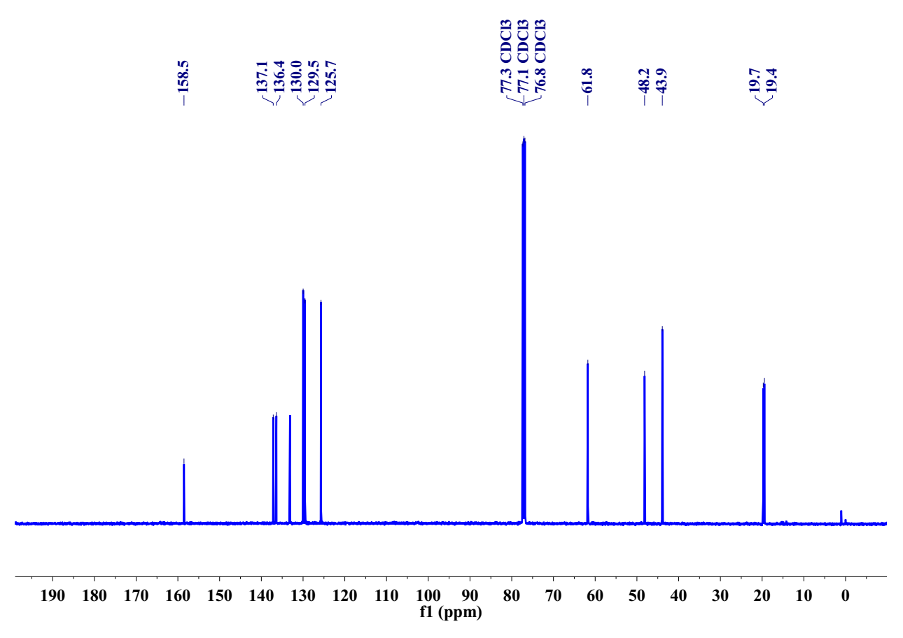

**3j** 1H NMR (500 MHz, CDCl3)

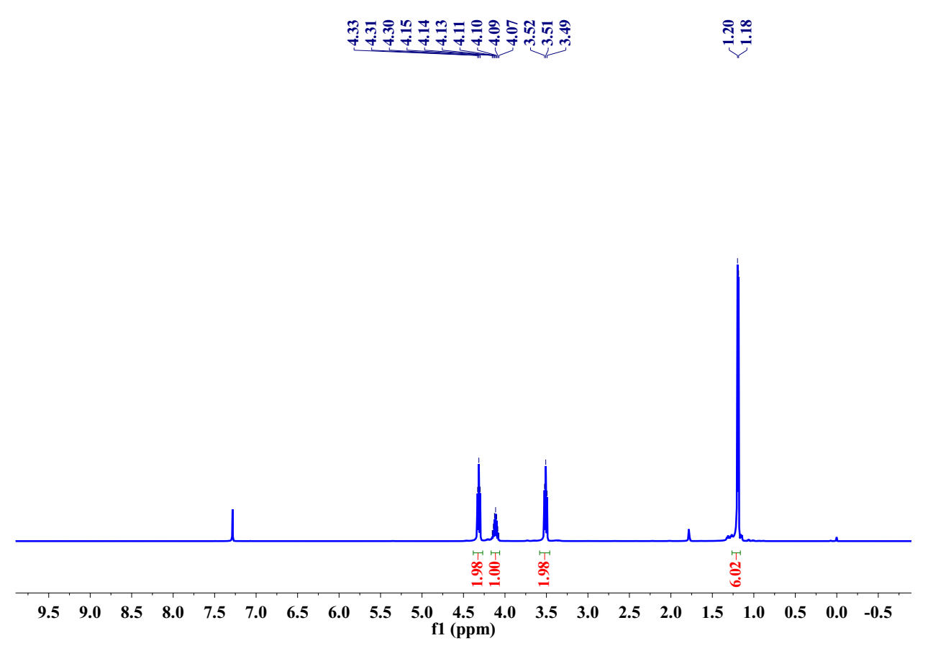

**3j** 13C NMR (126 MHz, CDCl3)

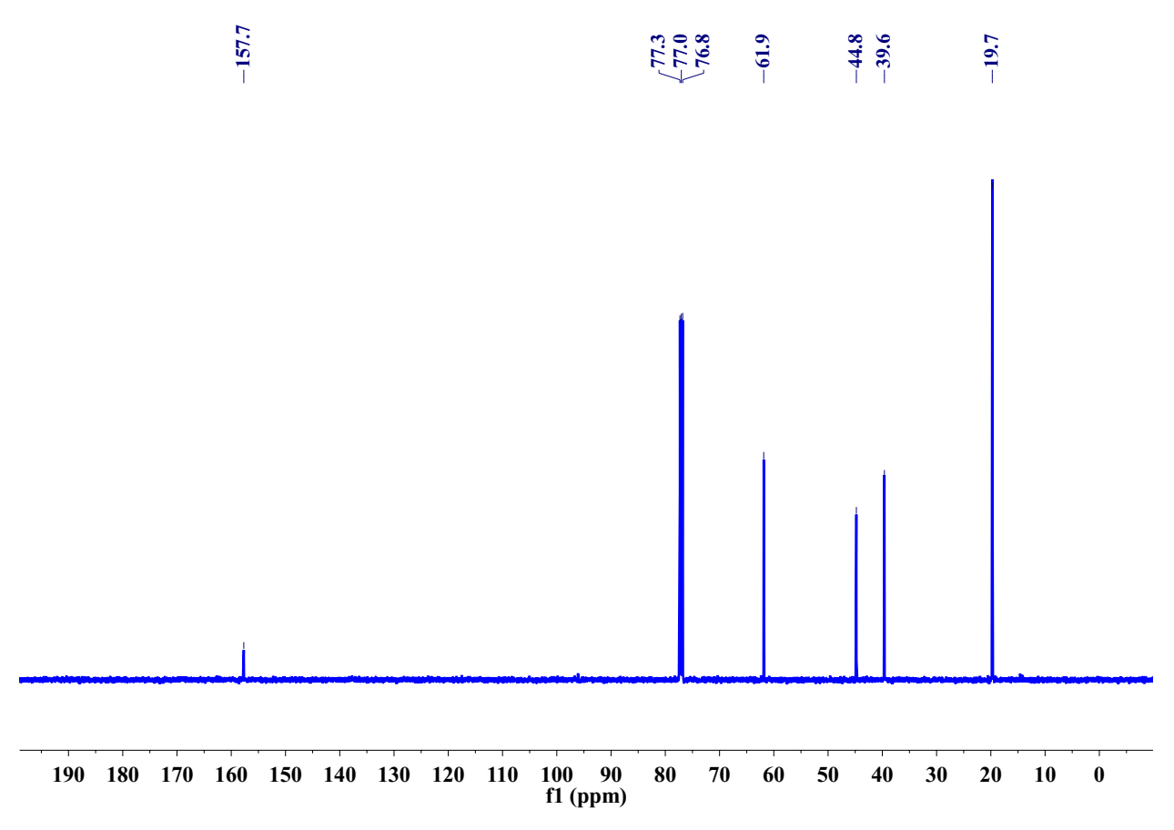

**4a** 1H NMR (500 MHz, DMSO-*d6*)

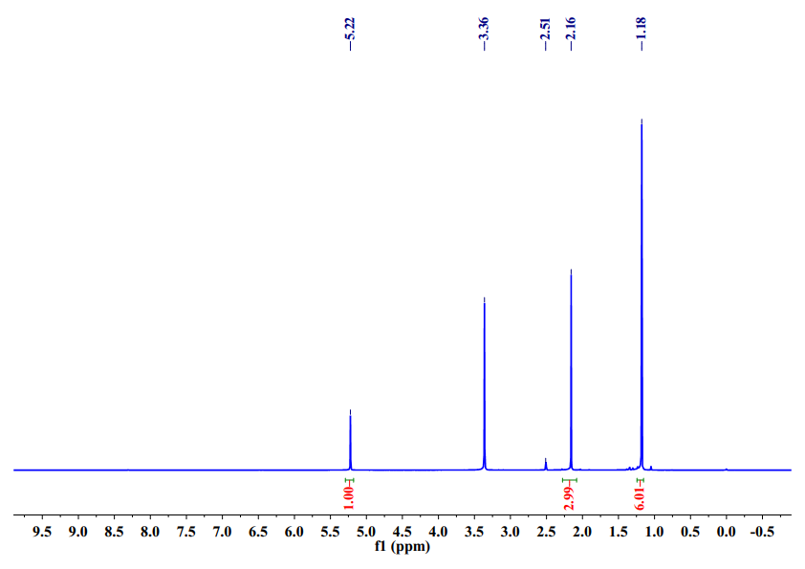

**4a** 13C NMR (126 MHz, DMSO-*d6*)

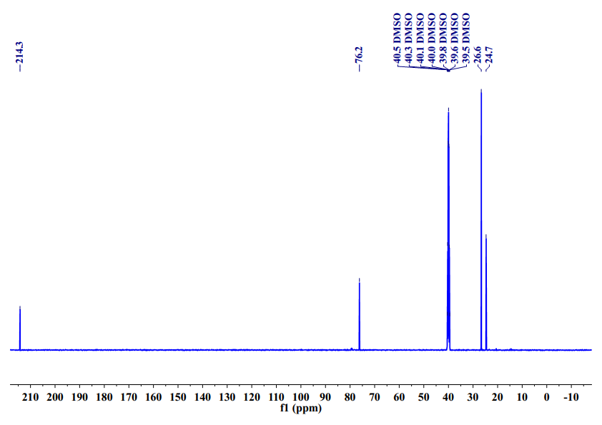**4b** 1H NMR (500 MHz, DMSO-*d6*)

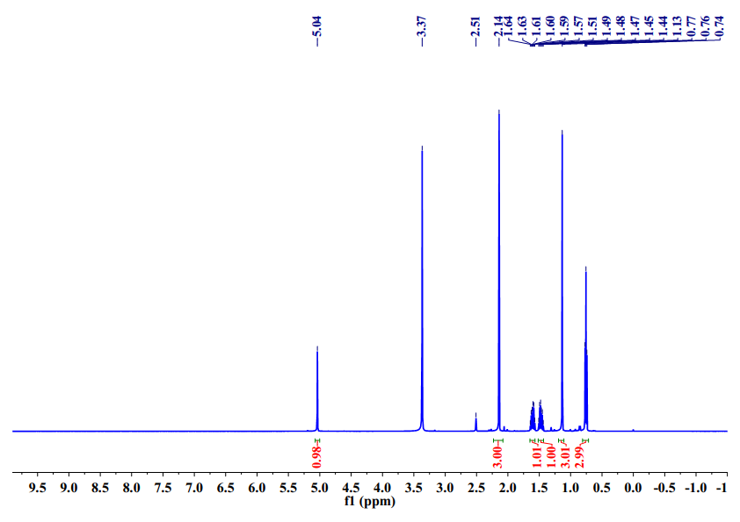

**4b** 13C NMR (126 MHz, DMSO-*d6*)

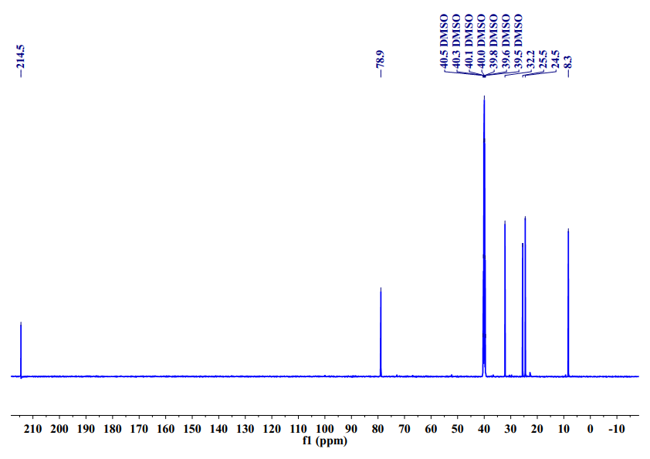

**4c** 1H NMR (500 MHz, DMSO-*d6*)

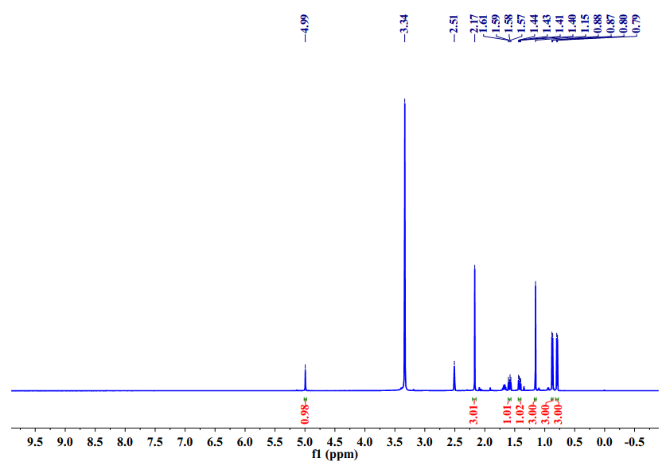

**4c** 13C NMR (126 MHz, DMSO-*d6*)

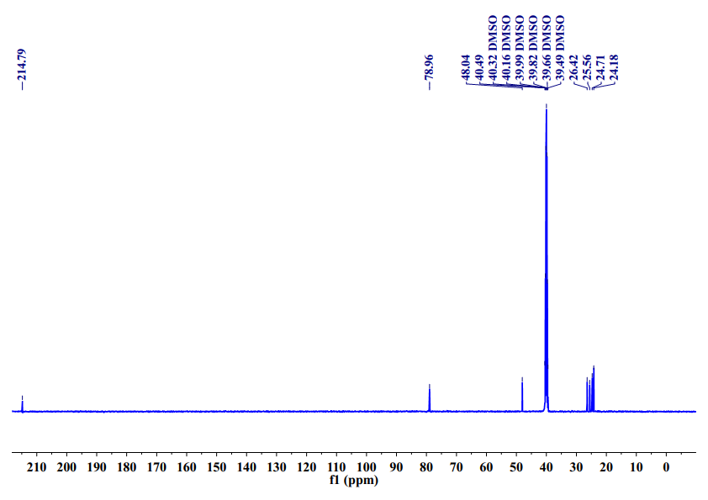**4d** 1H NMR (500 MHz, DMSO-*d6*)

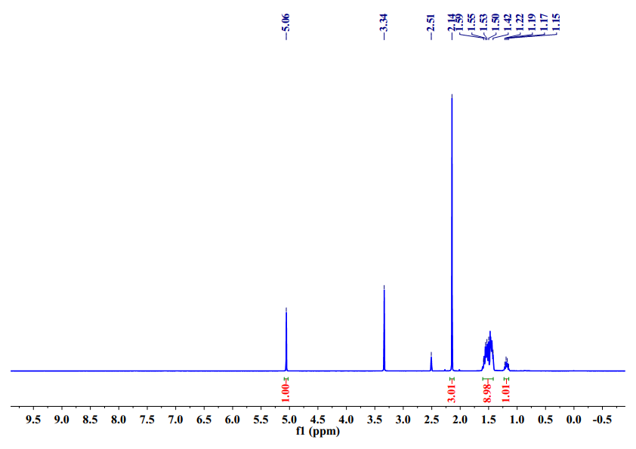

**4d** 13C NMR (126 MHz, DMSO-*d6*)

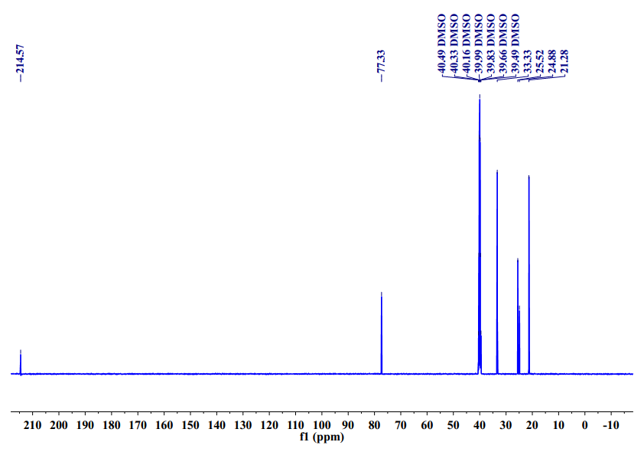

**4e** 1H NMR (500 MHz, DMSO-*d6*)

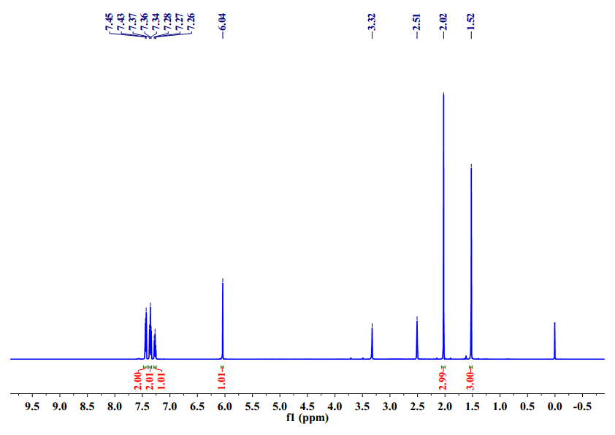

**4e** 13C NMR (126 MHz, DMSO-*d6*)

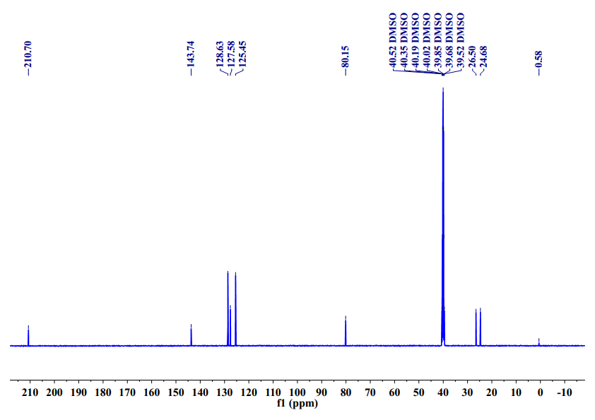

**References**

[1] Q.-W. Song, Z.-H. Zhou, M.-Y. Wang, K. Zhang, P. Liu, J.-Y. Xun, L.-N. He, Thermodynamically Favorable Synthesis of 2-Oxazolidinones through Silver-Catalyzed Reaction of Propargylic Alcohols, CO2, and 2-Aminoethanols, ChemSusChem 9(16) (2016) 2054-2058, https://doi.org/10.1002/cssc.201600470.

[2] X.-D. Li, Q.-W. Song, X.-D. Lang, Y. Chang, L.-N. He, AgI/TMG-Promoted Cascade Reaction of Propargyl Alcohols, Carbon Dioxide, and 2-Aminoethanols to 2-Oxazolidinones, ChemPhysChem 18(22) (2017) 3182-3188, https://doi.org/10.1002/cphc.201700297.

[3] X.-D. Li, Y. Cao, R. Ma, L.-N. He, Thermodynamically favorable protocol for the synthesis of 2-oxazolidinones via Cu(I)-catalyzed three-component reaction of propargylic alcohols, CO2 and 2-aminoethanols, J. CO2 Util. 25 (2018) 338-345, https://doi.org/10.1016/j.jcou.2018.01.022.

[4] S. Xia, Y. Song, X. Li, H. Li, L.-N. He, Ionic Liquid-Promoted Three-Component Domino Reaction of Propargyl Alcohols, Carbon Dioxide and 2-Aminoethanols: A Thermodynamically Favorable Synthesis of 2-Oxazolidinones, Molecules 23(11) (2018), https://doi.org/10.3390/molecules23113033.

[5] Q.-W. Song, W.-Q. Chen, R. Ma, A. Yu, Q.-Y. Li, Y. Chang, L.-N. He, Bifunctional Silver(I) Complex-Catalyzed CO2 Conversion at Ambient Conditions: Synthesis of alpha-Methylene Cyclic Carbonates and Derivatives, Chemsuschem 8(5) (2015) 821-827. https://doi.org/10.1002/cssc.201402921

[6] T. Buyck, D. Pasche, Q. Wang, J. Zhu, Synthesis of Oxazolidin-2-ones by Oxidative Coupling of Isonitriles, Phenyl Vinyl Selenone, and Water, Chem.-Eur. J. 22(7) (2016) 2278-2281, https://doi.org/10.1002/chem.201505050.

[7] M. Makoto, N. Masahiro, K. Shozo, Cyclization of (2-​hydroxyethyl)​urea derivatives to give 3-​nitroso-​2-​oxazolidinones under usual nitrosation conditions, Chem. Pharm. Bull. 33(2) (1985) 497-502, https://doi.org/ 10.1248/cpb.33.497.

[8] A.H. Fournier, G. de Robillard, C.H. Devillers, L. Plasseraud, J. Andrieu, Imidazolium and Potassium Hydrogen Carbonate Salts as Ecofriendly Organocatalysts for Oxazolidinone Synthesis, Eur. J. Org. Chem. 2016(21) (2016) 3514-3518. https://doi.org/10.1002/ejoc.201600550.

[9] Y. Zhao, Z. Yang, B. Yu, H. Zhang, H. Xu, L. Hao, B. Han, Z. Liu, Task-specific ionic liquid and CO2-cocatalysed efficient hydration of propargylic alcohols to alpha-hydroxy ketones, Chem. Sci. 6(4) (2015) 2297-2301, https://doi.org/10.1039/c5sc00040h.