(A)

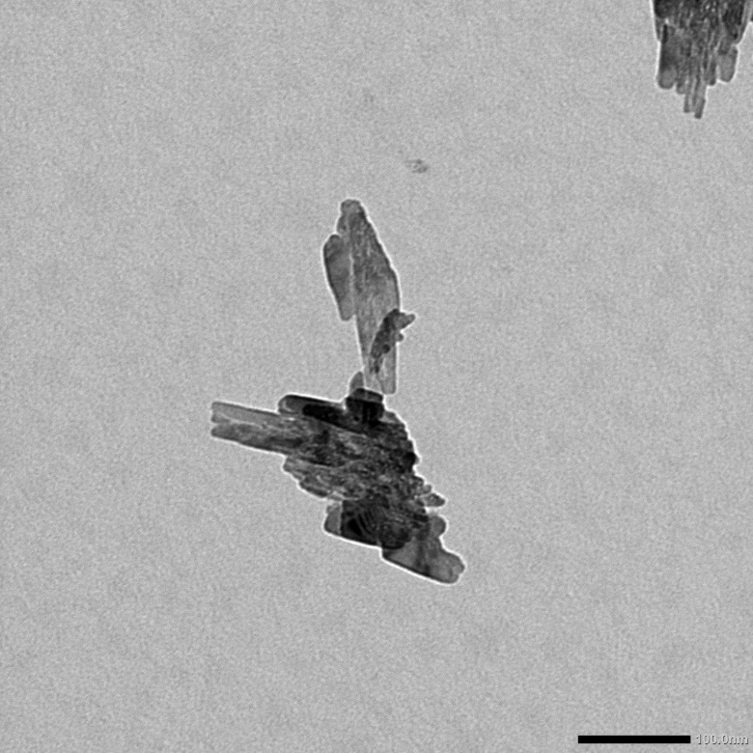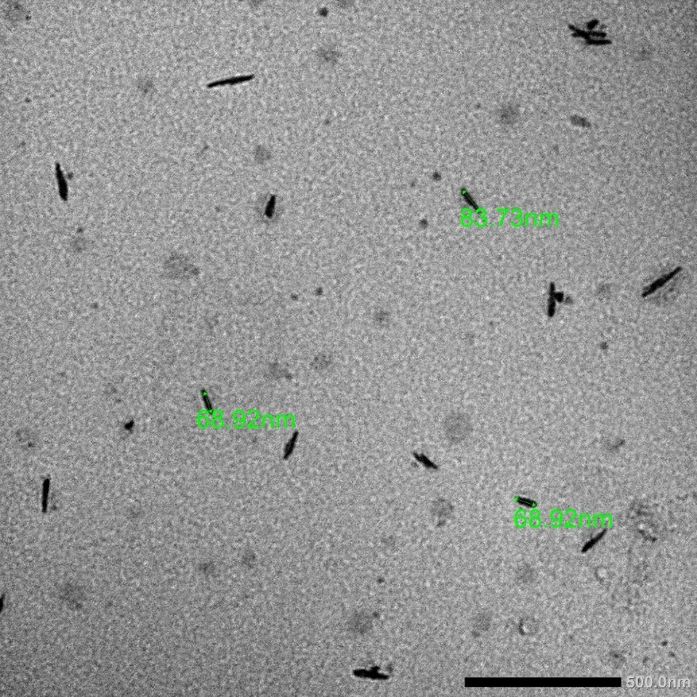
(B)
(C)
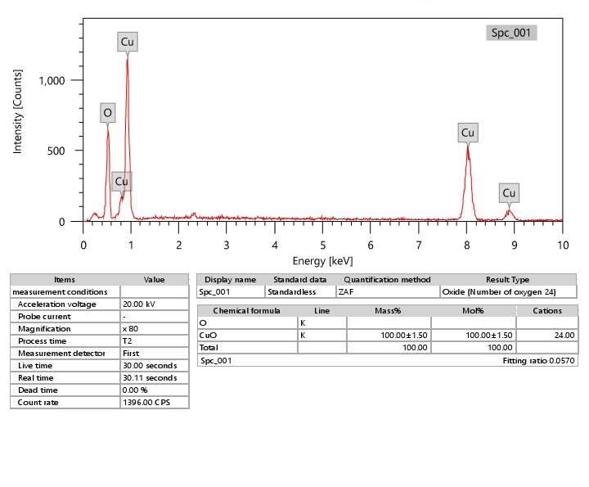
Fig. S1. Characterization of CuONPs used in the present study.
Fig. S1A Transmission electron microscopy (TEM) image of CuONPs nanorods with average size of 68.92 ± 3.49 nm,
Fig. S1B zeta potential of -15.5 mV, and
Fig. S1C the composition analysis by energy-dispersive X-ray spectroscopy (EDX) of the constituents showing the presence of copper and oxygen elements.

