Supplementary Materials.
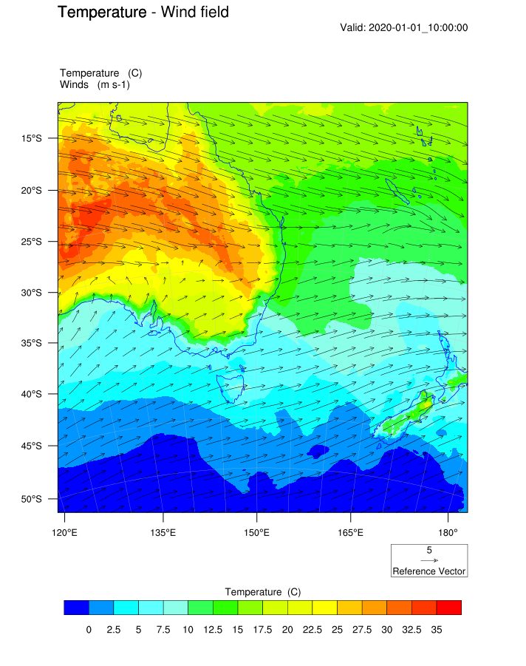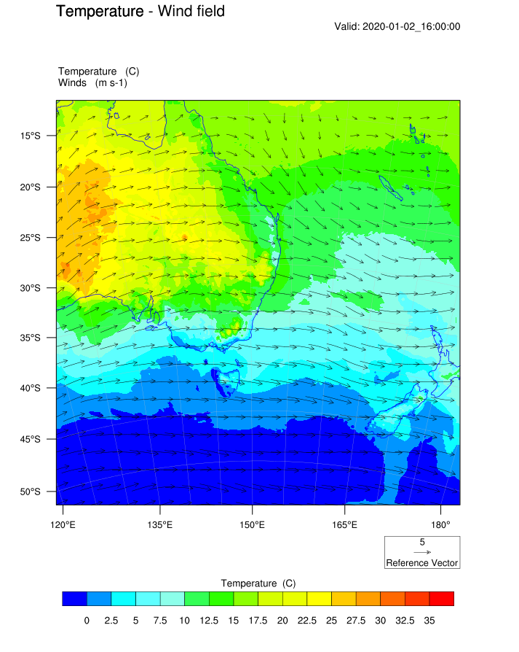
(a) (b)
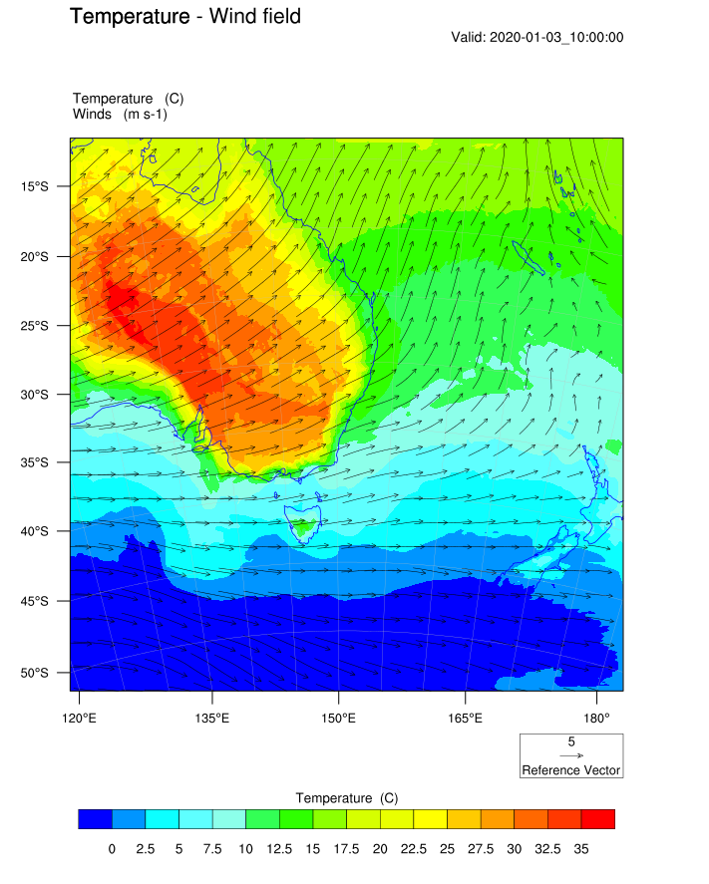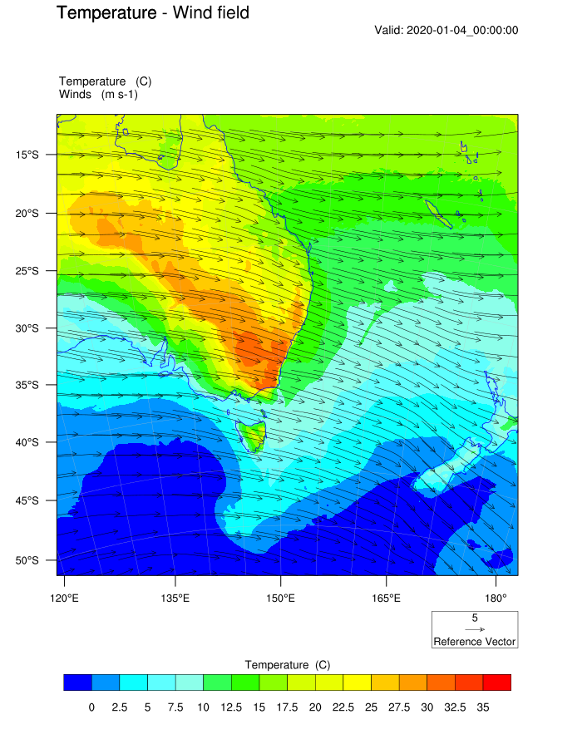
(c) (d)
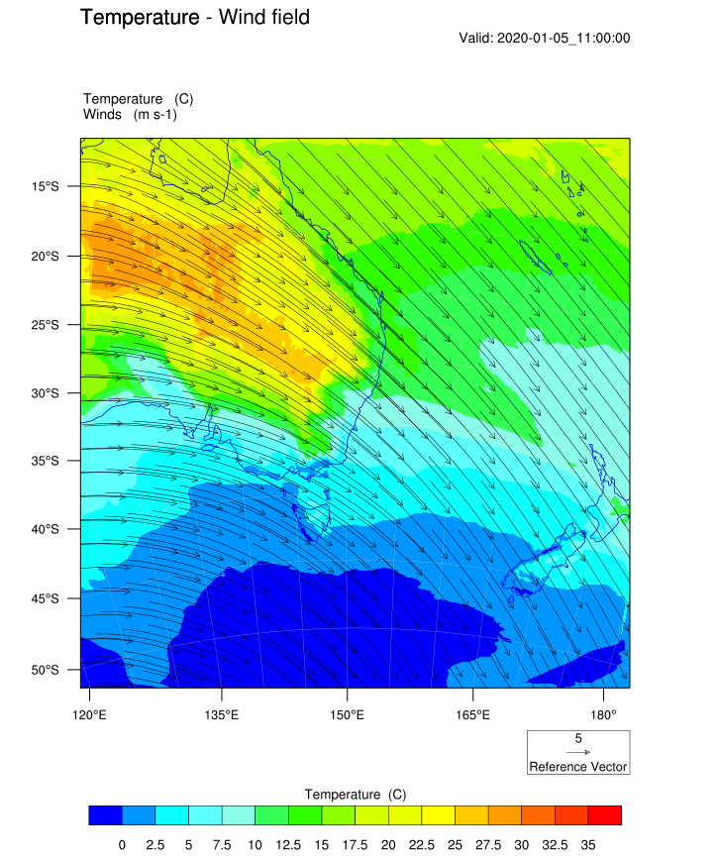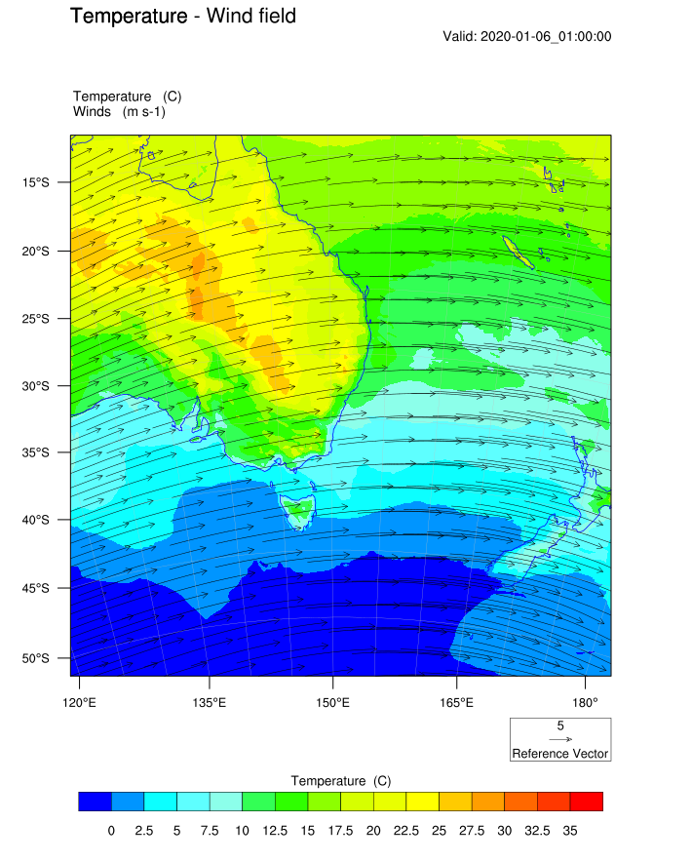
(e) (f)
Figure S.1 - Predicted surface wind and temperature on (a) 1 January 2020 10:00 UTC and (b) 2 January 2020 16:00 (c) 3 January 2020 10:00 UTC (d) 4 January 0:00 UTC (e) 5 January 2020 11:00 UTC and (f) 6 January 2020 1:00 UTC

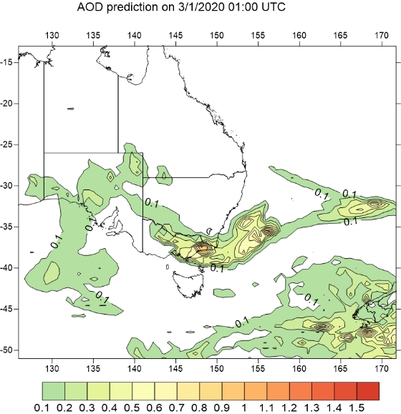  (a) | 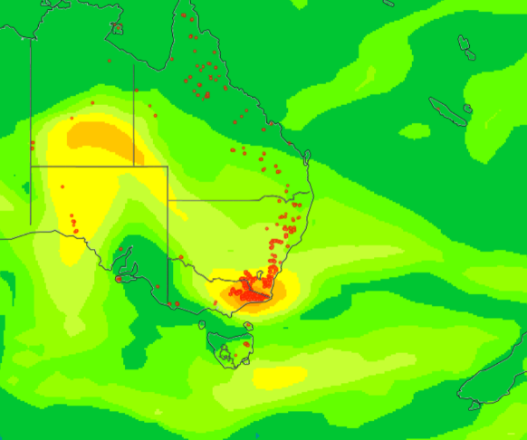  (b)
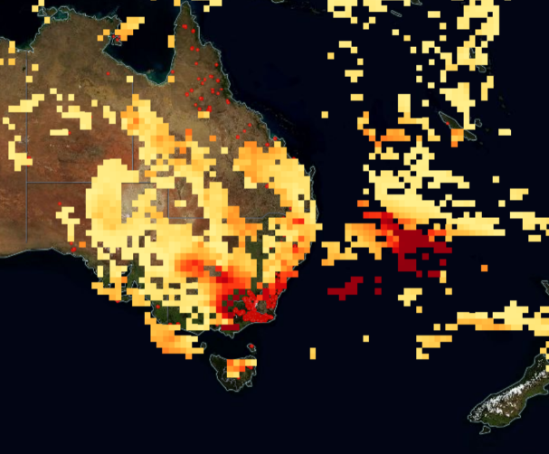  (c) | 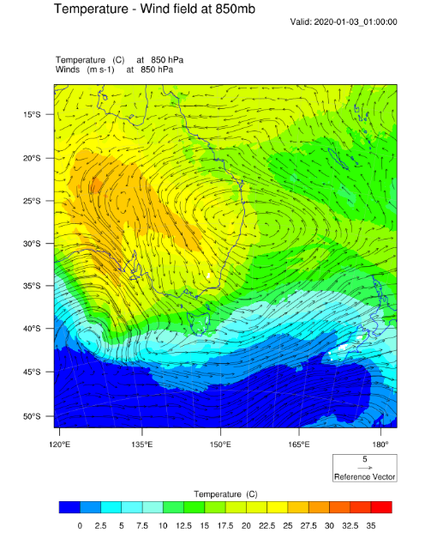  (d)

Figure S.2 – Predicted AOD on 3/1/2020 01:00 UTC (a) as compared with AOD prediction from NCAR ACOM (Atmospheric Chemistry Observations & Modeling) model called WACCM (Whole Atmosphere Community Climate Model), at the same time (source: https://worldview.acom.ucar.edu/) (b) AOD as measured and value-added by MODIS combined Aqua/Terra satellite product (c). Wind field at 850mb height (d).
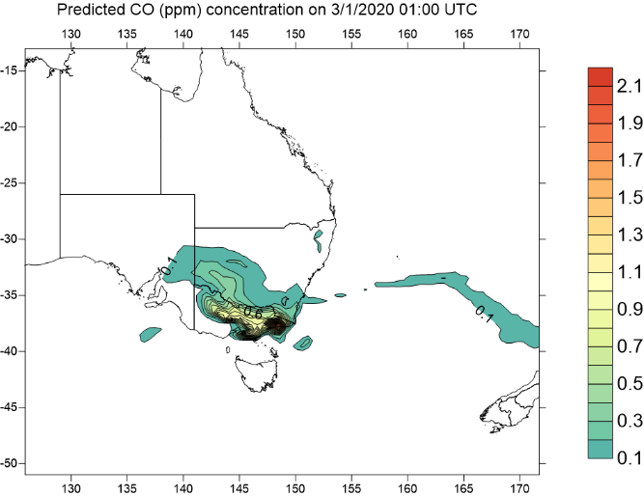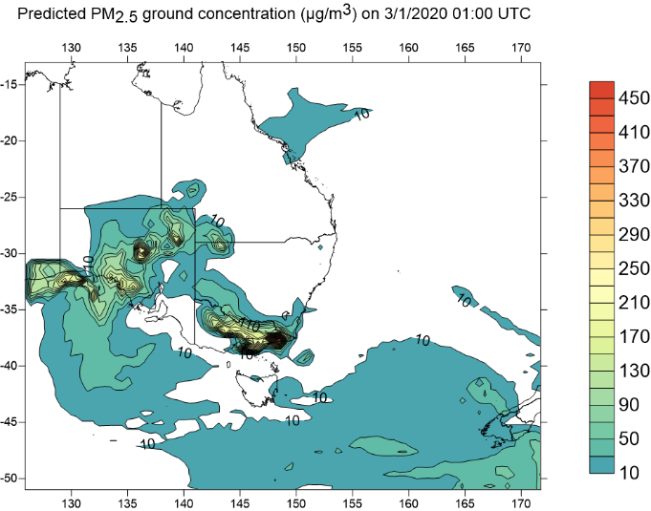
(a) (b)
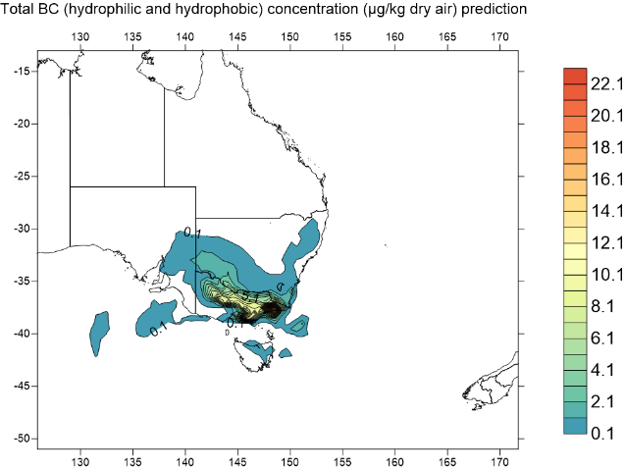
(c)
Figure S.3 – Predicted concentration of CO, PM_{2.5}, BC (hydrophilic and hydrophobic BC) on 3/1/2020 01:00 UTC. Dust storm also happened in Central Australia as evidence of high PM_{2.5} concentration occurred in South Australia near dust source in Lake Eyre Basin.
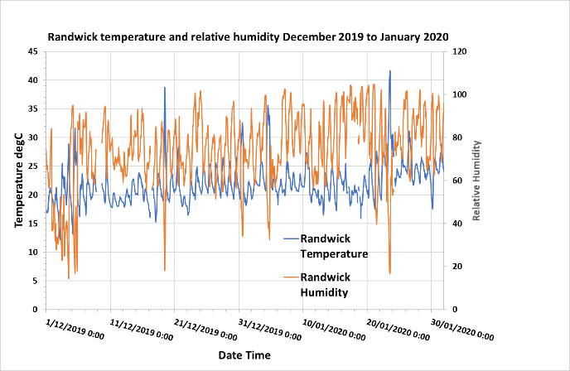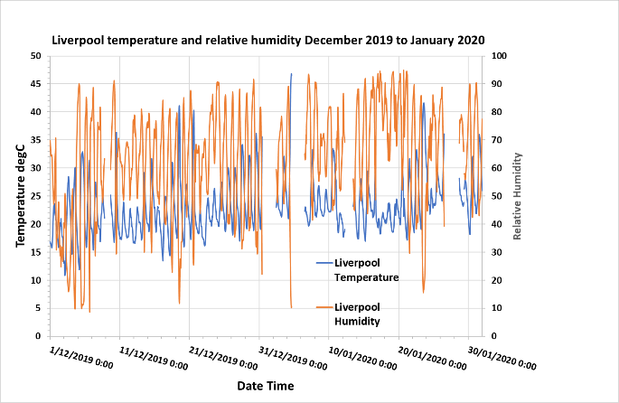
(a) (b)
Figure S.4 – Temperature and relative humidity at Randwick and Liverpool.
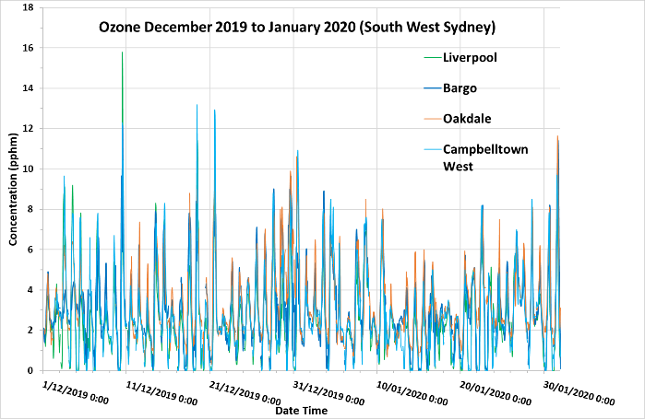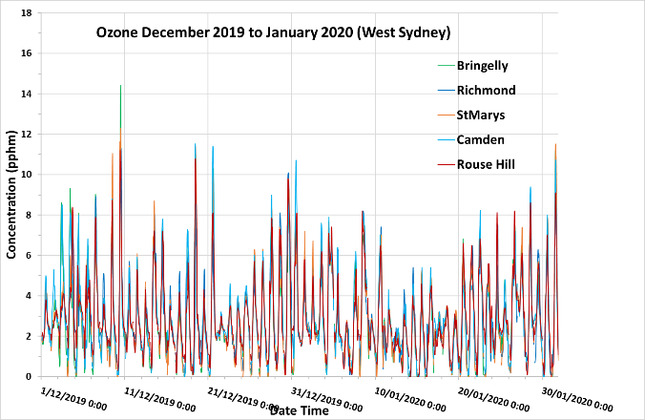
- (b)
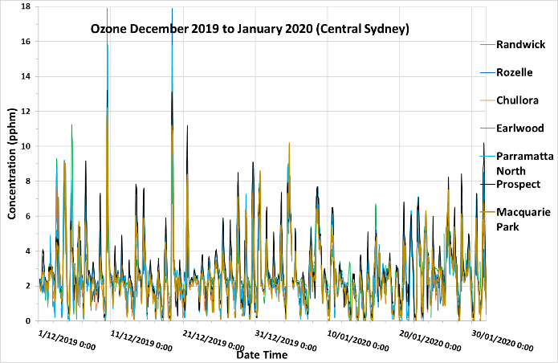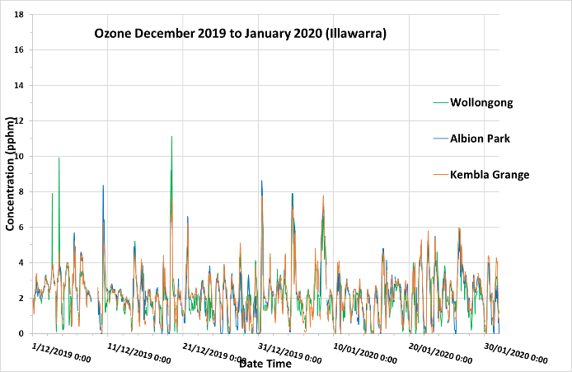
(c) (d)
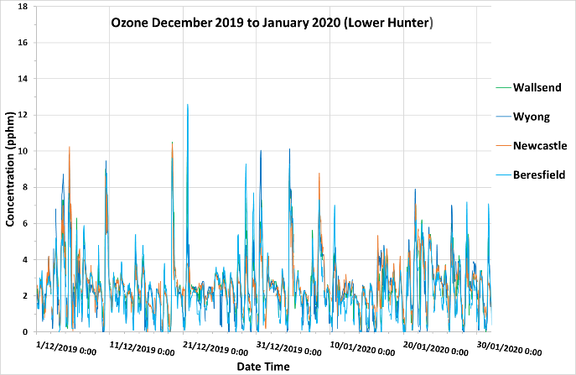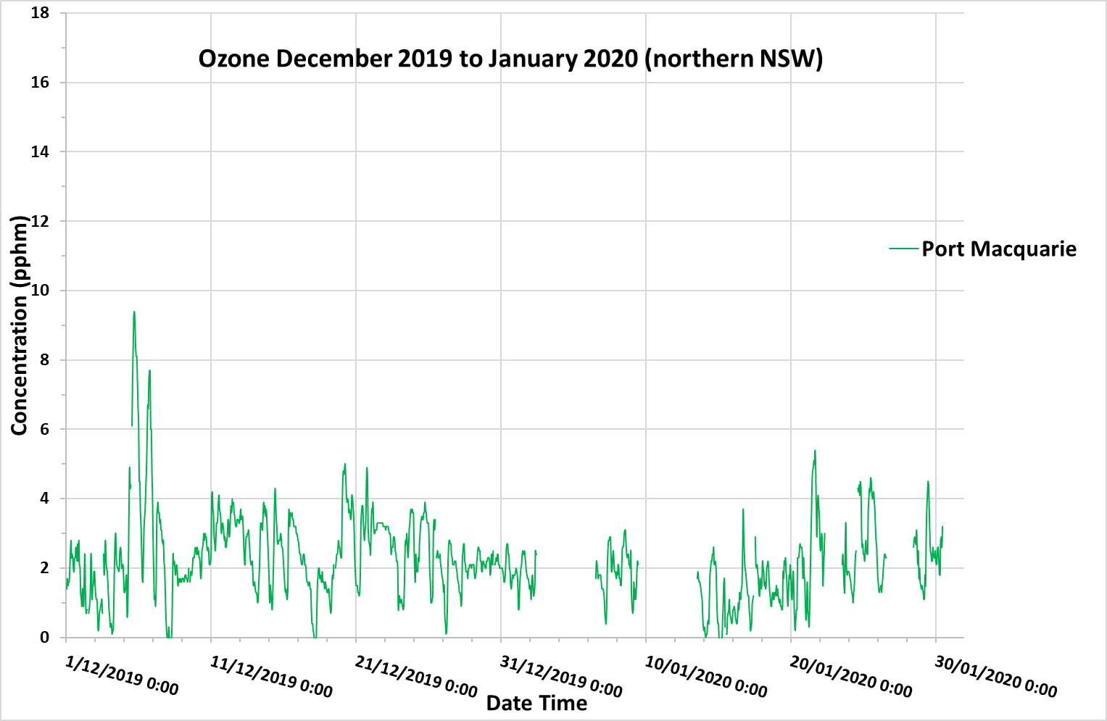
(e) (f)
Figure S.5 - Ozone concentration at sites in south west Sydney (a), west Sydney (b), central Sydney (c), Illawarra (d), Hunter (e) and northern NSW (f) from 1 December 2019 to 31 January 2020

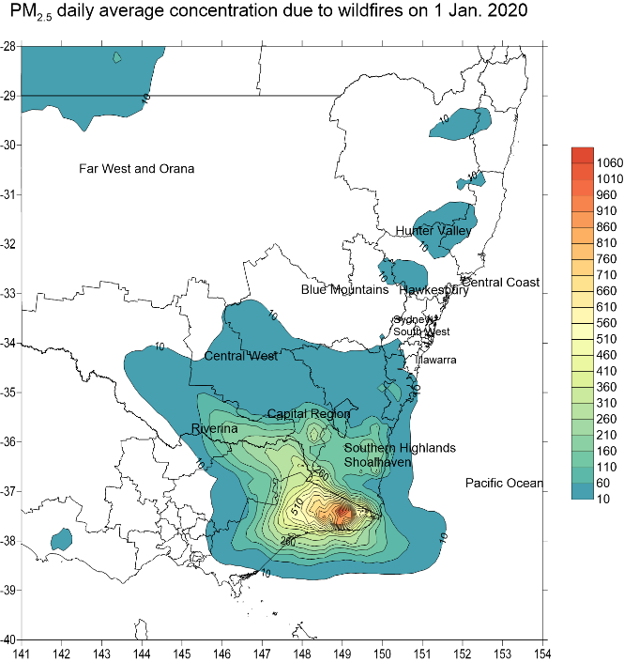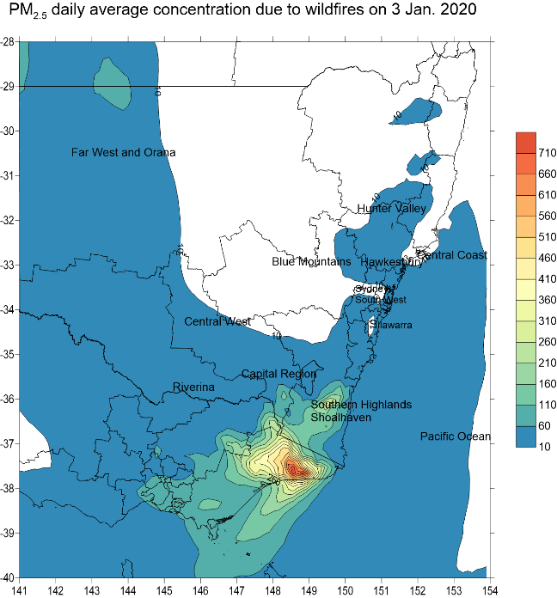
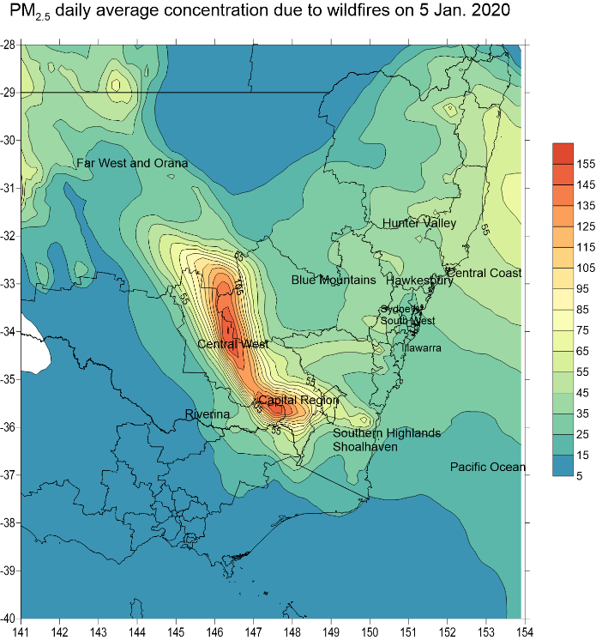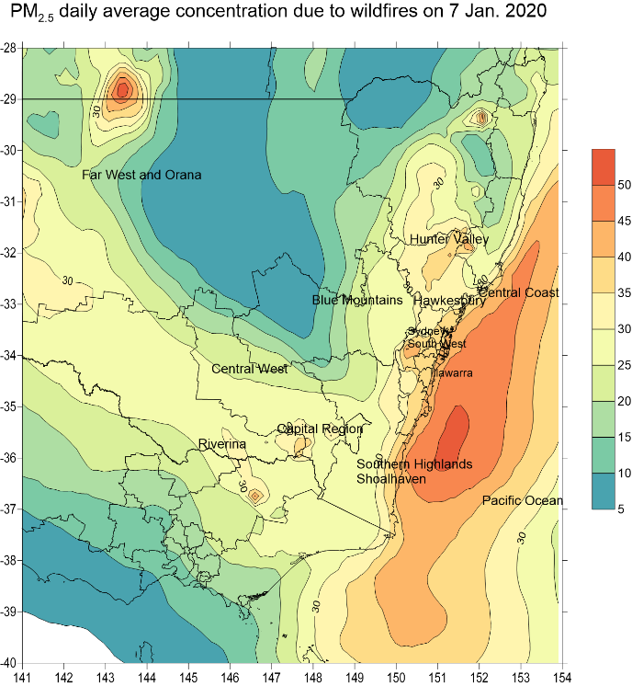
Figure S.6 – Predicted daily average PM_{2.5} across south eastern Australia due to wildfires for some selected days in January 2019

