 | M2 | CitA | Opa60 | VDAC
¹H (H-N) | 119 to 149 kHz | 118 to 147 kHz | 113 to 141 kHz | 116 to 145 kHz
¹⁵N (H-N) | 30 kHz | 30 kHz | 30 kHz | 30 kHz
H-N contact | 1000 μs | 1000 μs | 1000 μs | 1000 μs
¹H (N-H) | 137 to 110 kHz | 110 to 137 kHz | 136 to 109 kHz | 110 to 138 kHz
¹⁵N (N-H) | 30 kHz | 30 kHz | 30 kHz | 30 kHz
N-H contact | 500 μs | 500 μs | 600 μs | 600 μs
t1 max | 31.4 ms | 15.6 ms | 44.3 ms
Interscan delay | 1.1 s | 1.1 s | 0.8 s | 1.2 s
¹H (H-C) | 111 to 139 kHz | 115 to 135 kHz | 113 to 141 kHz | 113 to 133 kHz
¹³C (H-C) | 29 kHz | 21 kHz | 29 kHz | 30 kHz
H-C contact | 1200 μs | 1200 μs | 1200 μs | 500 μs
¹H (C-H) | 127 to 102 kHz | 124 to 105 kHz | 116 to 136 kHz | 133 to 113 kHz
¹³C (C-H) | 29 kHz | 21 kHz | 31 kHz | 30 kHz
C-H contact | 350 μs | 350 μs | 350 μs | 250 μs
t1 max | 10.7 ms | 8.4 ms | 10 ms
Interscan delay | 1.1 s | 1.1 s | 0.8 s | 1.2 s
Table S1. CP parameters for acquisition of the (H)CH and (H)NH spectra at 950 MHz spectrometer.

 | M2 | CitA | Opa60 | VDAC
¹H (H-N) | 140 to 174 kHz | 148 to 185 kHz | 142 to 178 kHz | 146 to 183 kHz
¹⁵N (H-N) | 65 kHz | 62 kHz | 66 kHz | 60 kHz
H-N contact | 1400 μs | 1400 μs | 1400 μs | 1000 μs
¹H (N-H) | 174 to 140 kHz | 180 to 144 kHz | 178 to 142 kHz | 179 to 143 kHz
¹⁵N (N-H) | 65 kHz | 62 kHz | 66 kHz | 60 kHz
N-H contact | 350 μs | 350 μs | 350 μs | 600 μs
t1 max | 63 ms | 12.3 ms | 24.9 ms
Interscan delay | 1.3 s | 1.1 s | 0.9 s | 1.2 s
¹H (H-C) | 142 to 178 kHz | 154 to 192 kHz | 155 to 194 kHz | 154 to 193 kHz
¹³C (H-C) | 46 kHz | 75 kHz | 72 kHz | 73 kHz
H-C contact | 1200 μs | 1200 μs | 1200 μs | 500 μs
¹H (C-H) | 178 to 142 kHz | 192 to 154 kHz | 155 to 194 kHz | 187 to 150 kHz
¹³C (C-H) | 46 kHz | 75 kHz | 74 kHz | 73 kHz
C-H contact | 250 μs | 250 μs | 250 μs | 250 μs
t1 max | 17 ms | 8.5 ms | 8.5 ms
Interscan delay | 1.3 s | 1.1 s | 1.0 s | 1.2 s
Table S2. CP parameters for acquisition of the (H)CH and (H)NH spectra at 1200 MHz spectrometer.

Figure |  | 7A,D,E,F | 7A | 7A | 7B / 7C | 7B /7C
G34: | δ_{iso,H} (ppm) | H^{N} | H^{A2} | H^{A3} | H^{N} | H^{A2}+ H^{A3}
GLY34: H^{N} | 8.193 | 1 | 3 | 3 | 1 | 3
GLY34: H^{A2} | 4.307 | 2 | 1 | 2 | 2 | 1
GLY34: H^{A3} | 3.551 | 3 | 2 | 1 | 3 | 2
ILE35: H^{N} | 8.4 | 4 | 10 | 4 | 9 | 6
ILE33: H^{N} | 8.5 | 5 |  |  | 10
ILE33: H^{G21} | 0.9 | 6 | 6 | 6 | 6
ILE33: H^{G22} | 0.9 | 7 | 7 | 7 | 7
ILE33: H^{G23} | 0.9 | 8 | 8 | 8 | 8 | 7
ASN31:H^{A} | 4.6 | 9 |  | 5 | 11 | 9
ILE33: H^{A} | 4.3 | 10 |  |  | 12
HIS37:H^{B2} | 2.96 |  | 4 |  |  | 11
HIS37:H^{B3} | 2.68 |  | 5 | 9 |  | 12
HIS37:H^{N} | 8.3 |  | 9 | 10
HIS37:H^{D2} | 7.5 |  | 11 |  |  | 8
ILE33:H^{G12} | 1.1 | 11 | 12 |  |  | 10
ILE33:H^{G13} | 1.2 | 12
ILE35: H^{A} | 4.4 |  |  | 11
ILE35:H^{G13} | 1.2 |  |  | 12
H₂X- | 4.6(7B) / 3.21, 1.95 (7C) |  |  |  | 4-5 | 4-5
Table S3 shows the set of spins that were used in the linewidths simulations for amide proton (H^{N}) and aliphatic protons (H^{A2}, H^{A3}). The number indicates the order in which spins were added. For Figure 7A, the spectrum was simulated as the sum of three separate simulated spectra, taking the closest spins for each of the amide and two alpha protons, as shown in columns 3-5 of the table. For panel Figure 7B and C in the main text, two additional protons were added, replacing other protons, as discussed in the main text. Both aliphatic protons were simulated together with the set of spins indicated in the last column. For 7B the H₂X- protons have the same δ_{iso,H} of 4.6 ppm, whereas for 7C 3.21 ppm and 1.95 ppm where used.

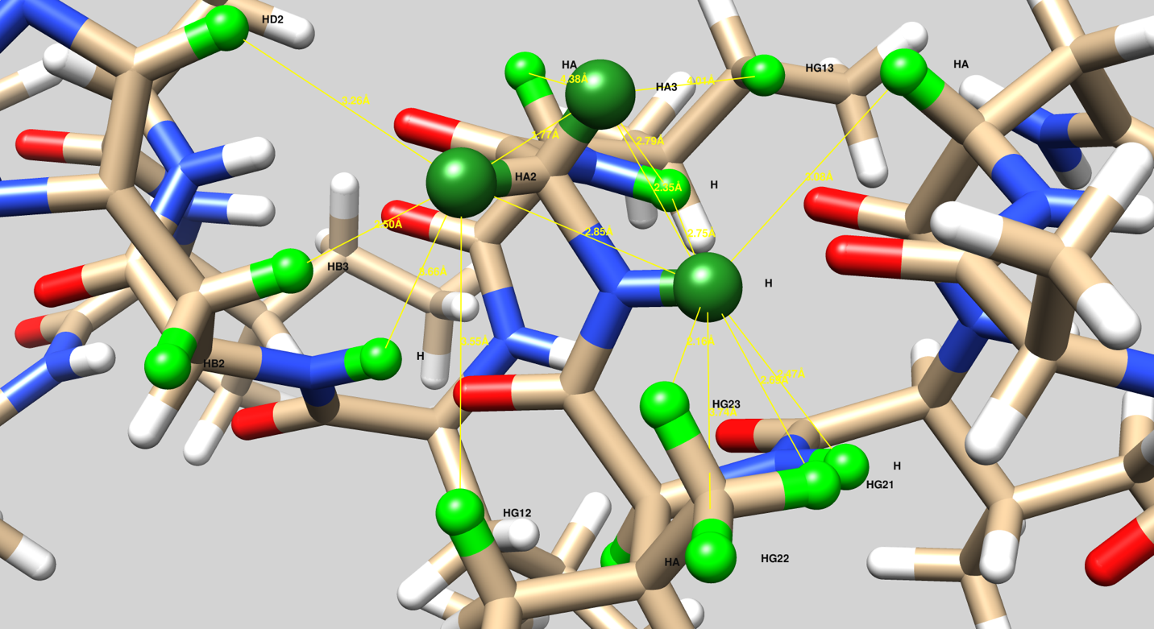
Figure S1. The schematic representation of 16 spins (Table S3), which were taken into linewidth simulations. The seven nearest protons to GLY34 H^{N} are: ILE33 H^{G23} (2.16 Å); ILE34 H^{A3} (2.35 Å); ILE33 H^{N} (2.47 Å); ILE33 H^{G21} (2.69 Å); ILE35 H^{N} (2.75 Å); ILE34 H^{A2} (2.85 Å); ASN31 H^{A} (3.08 Å). The seven nearest protons to GLY34 H^{A2} are: ILE34 H^{A3} (1.77 Å); HIS37 H^{B3} (2.49 Å); GLY34 H^{N} (2.85 Å); HIS37 H^{D2} (3.26 Å); ILE33 H^{G23} (3.44 Å); ILE33 H^{G12} (3.55 Å); ILE35 H^{N} (3.56 Å). The seven nearest protons to GLY34 H^{A3} are: ILE34 H^{A2} (1.77 Å); GLY34 H^{N} (2.35 Å); ILE35 H^{N} (2.79 Å); ASN31 H^{A} (3.22 Å); ILE33 H^{G23} (3.72 Å); ILE35 H¹³ (4.01 Å); HIS H^{B3} (4.03 Å). For Figures 7B-C, two additional protons were placed near the glycine alpha protons. For GLY34 H^{A2} the distances are: 2.6 Å and 2.86 Å; for GLY34 H^{A3} the distances are: 2.66 Å and 2.91 Å. For H^{N} the distances are 3.29 Å and 4.13 Å.

