Supporting Information for
“Analysis of Arctic spring ozone anomaly in the phases of QBO and 11-year solar cycle for 1979–2011” by
Yousuke Yamashita^{1,2}, Hideharu Akiyoshi¹, and Masaaki Takahashi^{1,3}
¹National Institute for Environmental Studies
²Japan Agency for Marine-Earth Science and Technology
³Atmosphere and Ocean Research Institute, The University of Tokyo

Contents of this file

Figure S1
Figure S2
Figure S3
Introduction
Figures S1, S2, and S3, are supplied to support Figures 7, 8, and 12, respectively.

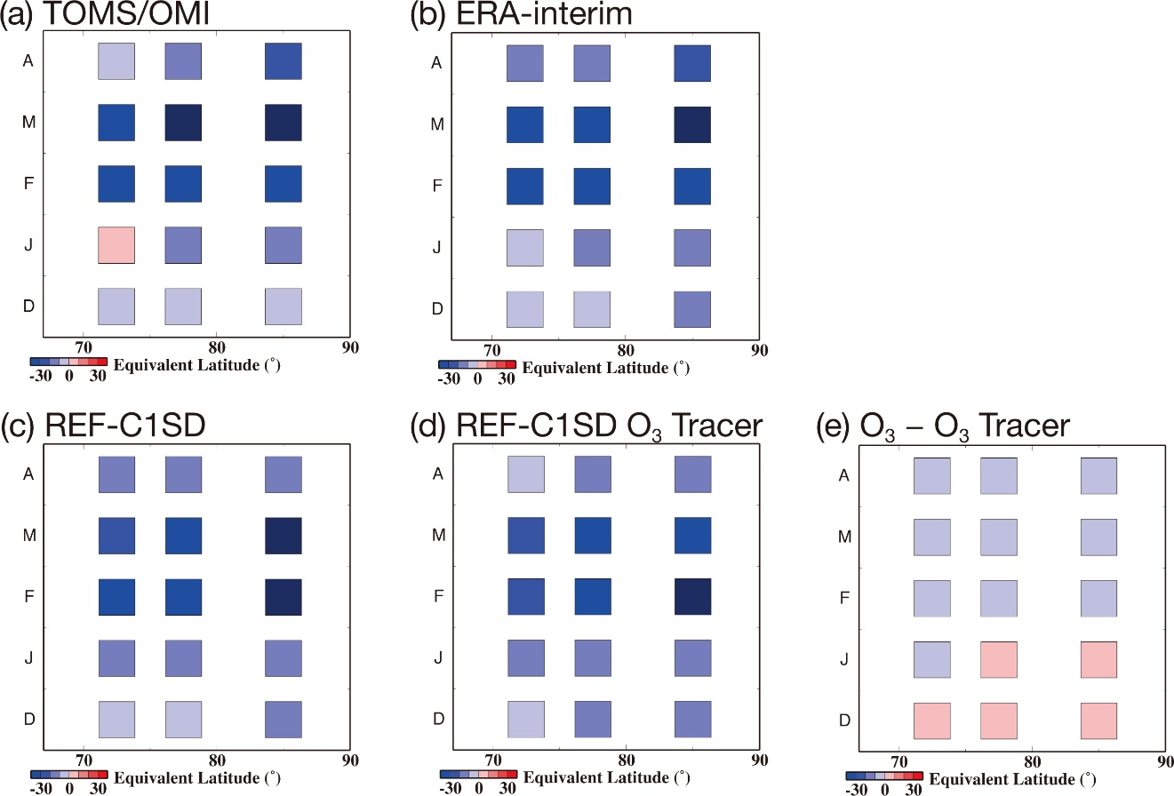

Figure S1. Same as Figure 7, but for the anomalies without 2009.

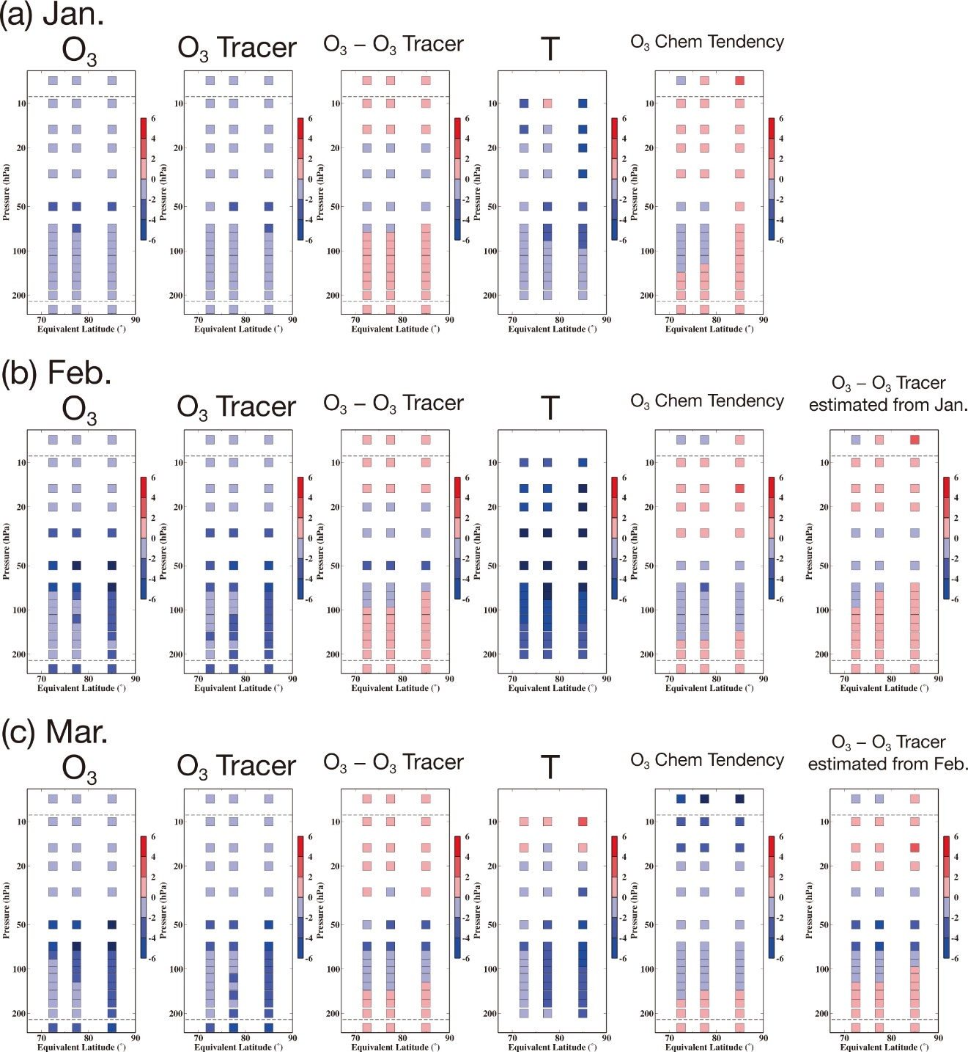

Figure S2. Same as Figure 8, but for the partial column mean anomaly without 2009.

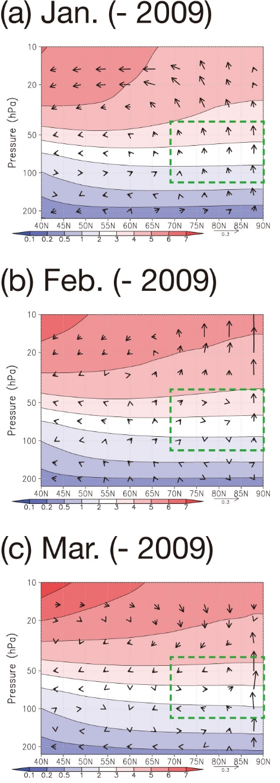

Figure S3. (a) The residual mean meridional circulation anomaly for QBO-W/S_{min} in January, but for anomalies without 2009. The vertical component of the residual circulation is magnified 200 times relative to the horizontal component, and the scale for the horizontal vector is shown at the bottom right of the panel in units of m/s. The contours/shadings indicate ozone mixing ratio averaged for 1979–2011 with units of DU. (b) Same as (a), but for February. (c) Same as (a), but for March.

