Table S1.
CHClF₂ hydrodechlorination on Pd-Pt/(acac)/Norit1600 catalysts precalcined at 320 ºC for 1 h. Turnover frequencies, product selectivities and activation energies.
Catalyst^{a,b} | Reaction temperature  ºC | TOF^{c}  s⁻¹ | Product selectivity, % |  |  |  | Activation energy,  kJ/mol
 |  |  | CH₄ | CH₃F | CHF₃ | CH₂F₂
Pd100(acac)  H/Pd = 0.123 | 272 | 1.06E-3 | 26.7 | - | - | 73.3 | 97.3 ± 1.9
 | 262 | 7.15E-4 | 23.2 | - | - | 76.8
 | 252 | 4.7E-4 | 20.6 | - | - | 79.4
Pd80Pt20(acac)  H/(Pd+Pt) = 0.191 | 271 | 1.41E-3 | 32.8 | 3.6 | - | 63.6 | 97.8 ± 5.2
 | 262 | 1.02E-3 | 24.7 | 5.2 | - | 70.1
 | 251 | 6.2E-4 | 24.9 | 6.0 | - | 69.1
Pd60Pt40(acac)  H/(Pd+Pt) = 0.252 | 271 | 1.95E-3 | 43.0 | 9.5 | - | 47.5 | 91.1 ± 8.8
 | 262 | 1.30E-3 | 40.8 | 9.3 | - | 48.9
 | 251 | 9.0E-4 | 36.6 | 14.8 | - | 48.6
Pd40Pt60(acac)  H/(Pd+Pt) = 0.331 | 271 | 1.64E-3 | 44.2 | 13.5 | - | 42.3 | 76.6 ±4.3
 | 263 | 1.25E-3 | 40.9 | 14.6 | - | 44.5
 | 252 | 8.7E-4 | 36.5 | 14.9 | - | 48.6
Pt100(acac)  H/Pt = 0.465 | 271 | 6.0E-4 | 58.4 | 14.9 | 14.0 | 12.7 | 103.6 ± 2.7
 | 262 | 4.0E-4 | 60.2 | 20.7 | 4.0 | 19.1
 | 251 | 2.5E-4 | 74.0 | 9.4 | - | 16.6
ª For the catalyst designation, see Methods (subsection 3.1).
^{b} Metal dispersion data (from H₂ chemisorption) located below catalyst designation.
^{c} GHSV 5760 h⁻¹, catalyst weight 0.20 g.

Table S2.
CHClF₂ hydrodechlorination on Pd-Pt/(acac)/Norit1600 catalysts precalcined at 350 ºC for 1 h. Turnover frequencies, product selectivities and activation energies.
Catalyst^{a,b} | Reaction temperature  ºC | TOF^{c}  s⁻¹ | Product selectivity, % |  |  |  | Activation energy,  kJ/mol
 |  |  | CH₄ | CH₃F | CHF₃ | CH₂F₂
Pd100(acac)  H/Pd = 0.161 | 272 | 2.30E-3 | 29.5 | - | - | 70.5 | 102.3 ±1.5
 | 261 | 1.46E-3 | 25.0 | - | - | 75.0
 | 251 | 9.25E-4 | 20.6 | - | - | 79.4
Pd80Pt20(acac)  H/(Pd+Pt) = 0.223 | 272 | 2.30E-3 | 38.0 | 4.2 | - | 57.8 | 98.8 ± 2.8
 | 261 | 1.50E-3 | 33.7 | 4.0 | - | 62.3
 | 251 | 9.6E-4 | 30.0 | 4.0 | - | 66.0
Pd60Pt40(acac)  H/(Pd+Pt) = 0.243 | 272 | 2.32E-3 | 43.6 | 7.9 | - | 48.5 | 97.7 ± 4.8
 | 261 | 1.61E-3 | 39.4 | 8.5 | - | 52.1
 | 251 | 1.02E-3 | 35.0 | 8.5 | - | 56.5
Pd40Pt60(acac)  H/(Pd+Pt) = 0.321 | 272 | 2.25E-3 | 47.2 | 13.2 | - | 39.6 | 92.9 ±1.3
 | 262 | 1.55E-3 | 41.5 | 14.9 | - | 43.6
 | 251 | 9.9E-4 | 38.4 | 15.6 | - | 46.0
Pt100(acac)  H/Pt = 0.348 | 272 | 7.5E-4 | 52.8 | 13.8 | 22.0 | 11.4 | 107.5 ±0.4
 | 262 | 4.8E-4 | 60.2 | 20.6 | - | 19.2
 | 251 | 2.9E-4 | 66.3 | 18.7 | - | 15.0

^{a,b,c} As in Table 1.

Table S3.
CHClF₂ hydrodechlorination on Pd-Pt/(acac)(/Nortit1600 catalysts precalcined at 400 ºC for 15 min. Turnover frequencies, product selectivities and activation energies.

Catalyst^{a,b} | Reaction temperature  ºC | TOF^{c}  s⁻¹ | Product selectivity^{c}, % |  |  |  | Activation energy,  kJ/mol
 |  |  | CH₄ | CH₃F | CHF₃ | CH₂F₂
Pd100(acac)  H/Pd = 0.105 | 272 | 2.63E-3 | 33.7 | - | - | 66.3 | 98.5± 3.7
 | 262 | 1.80E-3 | 30.1 | - | - | 69.9
 | 252 | 1.15E-3 | 24.4 | - | - | 75.6
Pd80Pt20(acac)  H/(Pd+Pt) = 0.198 | 272 | 2.50E-3 | 37.5 | 4.0 | - | 58.5 | 92.6 ± 8.3
 | 262 | 1.60E-3 | 33.2 | 4.0 | - | 62.8
 | 251 | 1.1E-4 | 28.9 | 3.9 | - | 67.2
Pd60Pt40(acac)  H/(Pd+Pt) = 0.212 0.229 | 272 | 2.52E-3 | 42.6 | 7.8 | - | 49.5 | 94.4 ± 6.4
 | 261 | 1.72E-3 | 38.4 | 8.4 | - | 53.2
 | 251 | 1.09E-3 | 34.0 | 8.5 | - | 57.5
Pd40Pt60(acac)  H/(Pd+Pt) = 0.317 | 272 | 2.10E-3 | 44.2 | 14.0 | - | 41.8 | 88.3 ± 2.8
 | 262 | 1.43E-3 | 40.5 | 14.9 | - | 44.6
 | 252 | 1.0E-4 | 36.4 | 15.7 | - | 47.9
Pt100(acac)  H/Pt = 0.273 | 271 | 9.2E-4 | 53.1 | 13.8 | 21.5 | 11.5 | 97.9 ± 12.8
 | 262 | 5.8E-4 | 60.4 | 19.2 | - | 20.4
 | 251 | 4.0E-4 | 70.2 | 19.3 | - | 10.5

^{a,b,c} As in Table 1.

Table S4.
CHClF₂ hydrodechlorination on Pd-Pt/Norit catalysts prepared from metal chlorides. Turnover frequencies, product selectivities and activation energies.

Catalyst^{a,b} | Reaction temperature  ºC | TOF^{c}  s⁻¹ | Product selectivity^{c}, % |  |  |  | Activation energy,  kJ/mol
 |  |  | CH₄ | CH₃F | CHF₃ | CH₂F₂
Supported on Norit1600, after calcination at 400 ºC (0.25 h), and reduction at 400 ºC (3 h)
Pd100(Cl)  H/Pd = 0.266 | 271 | 2.80E-3 | 36.8 | 1.2 | - | 62.0 | 95.9 ± 1.3
 | 261 | 1.90E-3 | 33.6 | 1.2 | - | 65.2
 | 252 | 1.30E-3 | 30.1 | - | - | 69.9
Pd60Pt40(Cl)  H/(Pd+Pt) = 0.277 0.287 | 271 | 2.80 E-3 | 53.4 | 5.6 | - | 41.0 | 91.1 ± 1.4
 | 261 | 1,90 E-3 | 50.9 | 5.9 | - | 43.2
 | 252 | 1.35E-3 | 47.4 | 6.3 | - | 46.2
Pt100(Cl)  H/Pt = 0.62 | 271 | 1.0E-3 | 70.9 | 12.9 | 0.3 | 15.8 | 97.0 ± 4.4
 | 261 | 6.9E-4 | 68.7 | 12.7 | - | 18.5
 | 252 | 4.6E-4 | 66.9 | 13.5 | - | 19.6
Supported on Norit1800, after reduction at 400 ºC for 3 h
3 wt.% Pd  H/Pd = 0.215 | 272 | 2.90E-3 | 34.8 | - | - | 65.2
 | 261 | 2.10E-3 | 31.0 | - | - | 69.0 | 86.4 ± 9.1
 | 251 | 1.35E-3 | 25.7 | - | - | 74.3

^{a,b,c} As in Table 1.

SET S1. Characteristics of 3 wt.% Pd/Norit1800 catalyst.
Taken from M. Bonarowska, B. Burda, W. Juszczyk J. Pielaszek, Z. Kowalczyk, Z. Karpiński, Appl. Catal. B 35 (2001) 13-20 .
Support: Norit RO 08 activated by helium pretreatment at 1800 ºC.
Preparation: ex-PdCl_{2,aq} acidified with HCl, incipient wetness
Metal dispersion after reduction at 400 ºC: H/Pd = 0.20; CO/Pd = 0.21 (previous data);
H/Pd = 0.215 (recent measurement).
Pd crystallite size (from XRD line broadening): -~3 nm.
adapted from Bonarowska et al., cited above.

Characteristics based on determination of N₂ adsorption isotherm.

BET surface area 85.2 m²/g
T_{plot micropore volume} = 0.0010 cm³/g
BJH pore volume (adsorption) 0.2082 cm³/g
BJH pore volume (desorption) 0.2065 cm³/g.

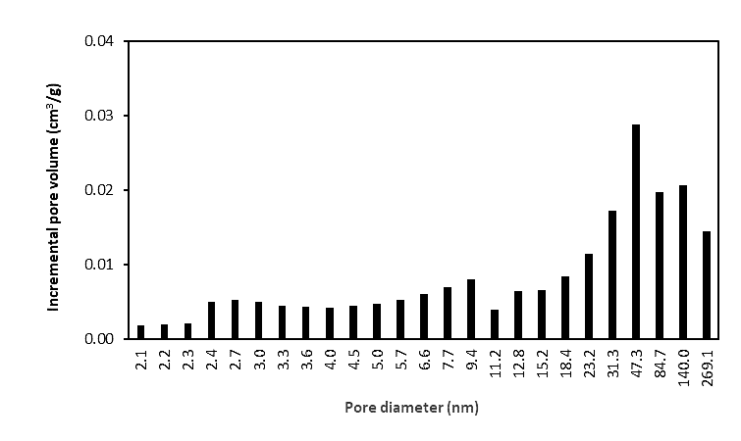
Pore size distribution

