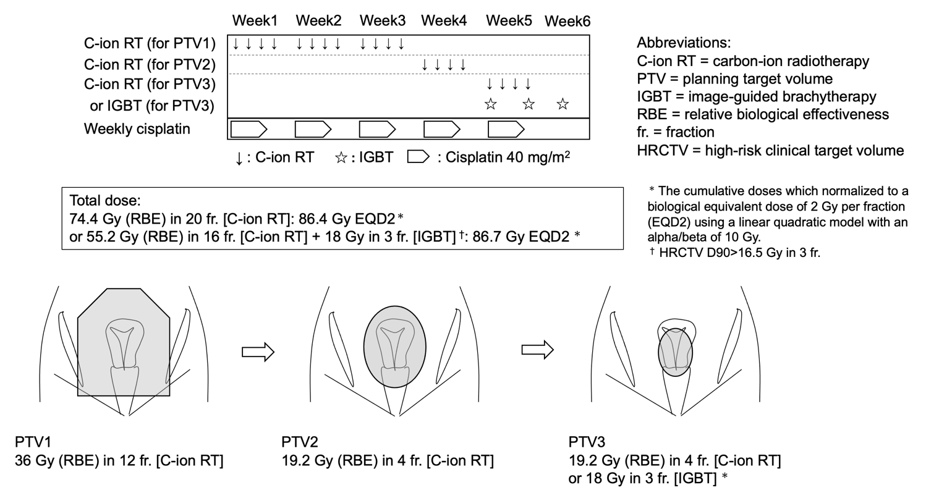Figure S1. Outline of treatment of the present study.

Table S1. Details of target definitions.
Target volume | Definition | Note
Gross tumor volume (GTV) | MRI findings and gynecological examination immediately before each treatment planning.
Clinical target volume 1 (CTV1) | Whole-pelvic irradiation included all areas of gross and potentially microscopic disease, which consisted of the primary site (GTV, whole uterus, parametrium, ovaries, and at least the upper half of the vagina) and the whole pelvic node region (enlarged lymph node, common iliac, internal iliac, external iliac, obturator, and presacral node regions). | In case patient has massive tumor invasion reaching lower 1/3 of vagina, CTV1 includes whole vagina.
Planning target volume 1 (PTV1) | CTV1 plus a 10 mm safety margin for positioning uncertainty. | Consider an additional margin (+5mm) for uterine position uncertainty by checking several times of CT images.
Clinical target volume 2 (CTV2) | Uterus with GTV, parametrium, and swollen pelvic lymph nodes. | In case patient has massive tumor invasion reaching lower 1/3 of vagina, CTV1 includes whole vagina.
Planning target volume 2 (PTV2) | CTV2 plus a 5 mm safety margin for positioning uncertainty. | Consider an additional margin (+5mm) for uterine position uncertainty by checking several times of CT images.
Clinical target volume 3 (CTV3) | Primary GTV
Planning target volume 3 (PTV3) | CTV3 plus a 0-5 mm margin. | The gastrointestinal tract was excluded from the PTV3.

