Supplementary materials:

Supplementary Table 1
Primers for amplification and sequencing of plastome fragments
Plastome fragment | Primers 5’-3’ | Annealing temperature
(trnH(ugu)-psbA | F: CGC GCA TGG TGG ATT CAC AAT CC  R: GTT ATG CAT GAA CGT AAT GCT C | 58 ⁰C
rpl32-trnL(tag) | F: CAGTTCCAAAAAAACGTACTTC  R: CTGCTTCCTAAGAGCAGCGT | 56 ⁰C
trnT(ugu)-trnL(uaa) | F: TCT ACC GAT TTC GCC ATA TC  R: CAA ATG CGA TGC TCT AAC CT | 55 ⁰C

Supplementary Figure S1. Hybridization of different DNA probes on chromosomes of C-I (a, d, g, j, n, o) and C-II (b, e, h, k, m) groups of Ae. columnaris in comparison with Ae. neglecta – T (c, f, i, l, m). Chromosomal group, accession numbers, and probe combinations are given on corresponding cell images; probe color corresponds to signal color. Chromosomes are numbered according to genetic nomenclature; the U^{c} chromosomes are designated with yellow, while the X^{c} – white letters. Scale bar – 10 µm.
Supplementary Figure S2. Sequential FISH with 5S (red) and 45S (green) rDNA probes (a, c, e) followed by hybridization with GAA_{n} (green) and pTa-713 (red) (b, d, f) on chromosomes of Ae. columnaris accessions AE 1607 (C-I, a, b), PI 542191 (C-II, c, d), and Ae. neglecta, PI 564182. Chromosomes are designated according to genetic nomenclature, the U^{c} chromosomes with white and X^{c} with yellow letters. Translocated 76U^{c}:X^{c} chromosomes are indicated (b); white arrows point to the position of minor NORs on the chromosome 1X^{c} (c). Green arrows point to minor NORs on chromosome 6X^{tr} (f). Owing to a limited space of metaphase images, the superscripts “^{c”} and ^{‘tr’} are omitted from the Figure.
Supplementary Figure S3. Location of minor NORs on chromosomes of Ae. neglecta, PI 564182 by sequential FISH with oligo-probes pTa71-1 (green) and pTa794 (red) – a, followed by GAA_{n} (red) and pAs1 (green) - b. Minor NORs are indicated with arrows (a), and the respective chromosomes are identified according to their GAA_{n}-FISH patterns (b).
Supplementary Figure S4. Diversity of the pTa-713 probe (red) patterns on chromosomes of Ae. columnaris, C-I (a-f) in comparison with Ae. neglecta, T (g, h) and Ae. columnaris, C-II (i-l): a – AE 1607; b – K-4241; c – K-1193; d - i-570045); e – PI 486281; f – PI 554178; g – PI 564182; h – IG 170209; i – PI 542191; j – PI 564181; k – TA2084; l – PI 564180. Chromosomes are classified based on pSc119.2 (a, l) or GAA_{n}-labelling patterns (green signals). Chromosomes are classified according to genetic nomenclature; translocated chromosomes are designated. Invariable pTa-713 sites are shown with yellow dotted lines.

Supplementary Figure S5. Diversity of gliadin spectra of Ae. columnaris accessions collected from different countries in comparison with Ae. neglecta (N). Accession numbers are shown on the top, while their geographic origin – on the bottom of the figure. α, β, γ, and ω - zones in electrophoretic spectra.

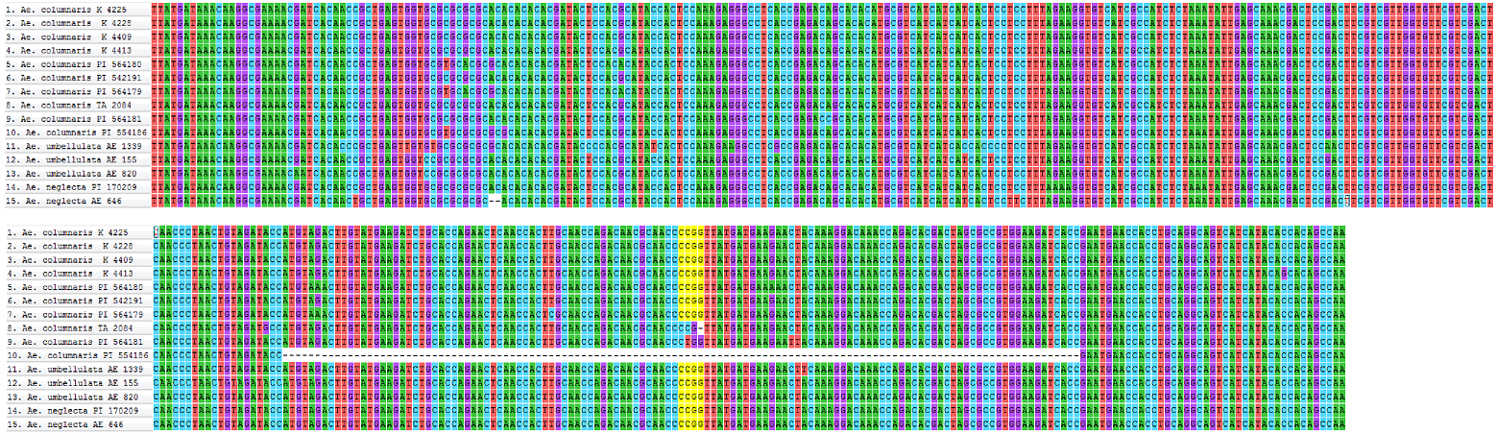
Supplementary Figure S6. Nucleotide variability in the U31 region of analyzed Aegilops accessions. The MspI restriction site is highlighted in yellow.

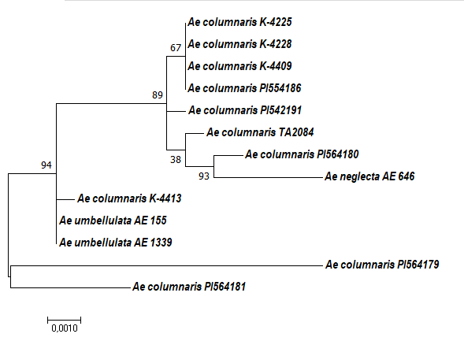
Supplementary Figure S7. Maximum-Likelihood (Tamura-3 parameter model) phylogenetic tree of the combined trnH-psbA, trnT-trnL, rpL32-trnL sequences; the numbers above the branches indicate bootstrap values: branch length measured in a number of substitutions per site.

