Concurrent heavy metal exposures and idiopathic dilated cardiomyopathy: A case-control study from the Katanga mining area of the Democratic Republic of Congo

Abstract
Blood and/or urine levels of 27 heavy metals were determined by ICPMS in 41 patients with dilated cardiomyopathy (DCM) and 29 presumably healthy subjects from the Katanga Copperbelt (KC), in the Democratic Republic of Congo (DRC).
After adjusting for age, gender, education level, and renal function, DCM probability was almost maximal for blood concentrations above 0.75 and 150 µg/dl for arsenic and copper, respectively. Urinary concentrations above 1 for chromium, 20 for copper, 600 for zinc, 30 for selenium, 2 for cadmium, 0.2 for antimony, 0.5 for thallium and 0.05 for uranium, all in μg/g of creatinine, were also associated with increased DCM probability.
Concurrent and multiple exposures to heavy metals, well beyond permissible levels, are associated with increased probability for DCM. Study findings warrant screening for metal toxicity in case of DCM and prompt public health measures to reduce exposures in the KC, DRC.

Key Words: environmental exposures, heavy metals, idiopathic dilated cardiomyopathy, Katanga Copperbelt

1. Introduction
The Katanga Copperbelt (KC), with its significant copper and cobalt reserves, is a theater of intense mining and ore processing, producing more than half and about 6% of the world's cobalt (the modern-day “oil” of a low-carbon economy) and copper, respectively (Cailteux et al. 2005; Ober 2018; Sovacool 2019). Low-grade mining infrastructures compounding with artisanal mining, environmental degradation, and poor regulation account for concurrent and multiple environmental exposures to heavy metals and metalloids including but not limited to arsenic (As), cadmium (Cd), cobalt (Co), copper (Cu), lead (Pb) and zinc (Zn) (Prasad MS 1989; Pourret et al. 2016). Recent reports indicate that KC is one of the most polluted places in the world due to the contamination of water, soil, air, and food by toxic metals (Muhaya et al. ; Banza et al. 2009; Narendrula et al. 2012; Atibu Emmanuel K. et al. 2013; Cheyns et al. 2014; Edwards et al. 2014; Mudimbi Kalonda et al. 2015; Atibu Emmanuel K. et al. 2016; Squadrone et al. 2016; Muhaya et al. 2017; Atibu E. K. et al. 2018; Nemery and Banza Lubaba Nkulu 2018).
Previous studies in the KC have established an association between human exposure to toxic metals and disorders of neurodevelopment, decline in male and female fertility, and an increased occurrence of birth defects (Lubala et al. 2012; Mbuyi-Musanzayi et al. 2018; Mukendi et al. 2018; Bora et al. 2019; Kayembe-Kitenge et al. 2019). Other studies have shown that exposure to toxic metals confers a cardiovascular risk (Tellez-Plaza et al. 2013; Aneni et al. 2016; Chowdhury et al. 2018). Toxic metals may have a direct effect on the functioning of cardiomyocyte membranes, ion channels, receptors, sarcomere, enzymes involved in the production of energy and the antioxidant defense (Frustaci et al. 1999; Lorscheider and Vimy 2000; Furieri et al. 2011; Ferramola et al. 2012; Chen et al. 2015; Perez and Tang 2015; Ferreira de Mattos et al. 2017; Hantson 2018; Shen et al. 2018; Xie et al. 2019). They may also lead to the dyshomeostasis of essential trace elements promoting adverse remodeling and ultimately dilated cardiomyopathy(Alexanian et al. 2014).
Recently in Lubumbashi, the largest mining city of the KC, severe cases of dilated cardiomyopathy burdened with high mortality were reported in relatively young patients in contrast to findings in other populations. While risk factors such as hypertension, alcoholism, overweight and/or obesity, kidney dysfunction, atrial fibrillation, and difficult living conditions have been highlighted, the potential contribution of toxic metals to the high prevalence of idiopathic dilated cardiomyopathy (DCM) has been suspected previously (Malamba-Lez et al. 2018). Lubumbashi is growing in population with many challenges of urbanization and sanitation. There are many unpaved roads, dilapidated sewers dating from colonial times which are insufficient for draining of rainwater and even effluents of mining companies that are located in the vicinity of homes. Garbage collection and recycling of dangerous products such as batteries and wrecks of vehicles is also a big challenge for the city. The majority of the population is poor and artisanal mining is a major subsistence activity. Concurrent and multiple exposures to heavy metals including some radioactive elements such as uranium have been documented(Banza et al. 2009; Banza Lubaba Nkulu et al. 2018). There is no universal health coverage and the burden of major chronic diseases including cardiac morbidities lies on individuals (Atibu Emmanuel K. et al. 2016; Bamba Bukengu Muhaya Sonia Catherine Mulongo Clarisse Zoza Kunyonga Faustin Zigabe Mushobekwa Matthieu Kayembe wa 2017; Initiative 2019; Sovacool 2019). In such contexts, identification of preventable causes of chronic illness and/or disability is of the utmost importance. In this study, we unveiled associations between idiopathic DCM and multiple exposures to heavy metals.

2. Subjects and Methods
2.1. Subjects
A total of 97 subjects seen for cardiovascular evaluations at the university clinic and the Lubumbashi's Centre of Cardiology were consecutively enrolled in the study between November 2017 through January 2019. They were at least 16 years old of age, male or female, living in the general population of the KC. Of these 97, 68 (70.1%) had symptoms and signs of heart failure, elevated NT-proBNP and DCM on echocardiography (either presumed idiopathic or postpartum cardiomyopathy). Twenty-nine subjects (29.9%) had no cardiovascular disease after cardiovascular check-up and were therefore kept as controls in the present study. They all have a normal 12-lead ECG. Of the 68 above subjects, those over 70 years, with known diabetes, renal failure with the need for dialysis, positive HIV test, and transthoracic echocardiography supporting rheumatic or degenerative valvular heart disease, pericarditis, cor pulmonale, congenital defects, suspected ischemic heart disease or dilation attributed to hypertension were excluded from the study (Figure 1).

2.2. Readout parameters and measurements
Demographic data, past medical history, signs, and symptoms of heart failure were collected using a standardized questionnaire.
Fasting routine blood (Total blood cells count, INR, HIV test, sodium, potassium, magnesium, calcium, chloride, total cholesterol, HDL, LDL, triglycerides, urea, creatinine, uric acid, glycemia, AST, ALT, direct bilirubin, indirect bilirubin) and urine tests (strip and microscopy) were performed in all subjects.
Transthoracic echocardiography was performed using a Vivid i ultraportable echo system (GE Medical Systems, Tirat Carmel, Israel). For each registration, five heartbeats were recorded. Cine loops were stored digitally and later analyzed in EchoPac version 113 software (GE Vingmed, Horten, Norway). Simpson's biplane method was applied for the assessment of left ventricle volumes and ejection fraction. 2D parameters and conventional Doppler parameters were measured according to recommendations (Lang et al. 2015; Nagueh et al. 2016).
Electrocardiogram was obtained with Cardiax PC system (Imed, Budapest, Hungary) and interpreted according to The Minnesota code manual of electrocardiography(Prineas et al. 2010) and a 24-hour Holter-ECG was recorded by a DMS 300-4A Holter recorder (DM Software, Hunfelden-Dauborn, Germany). Data from each Holter assessment were processed using CardioScan software (Cardioscan GmbH, Hamburg, Germany).
A spot sample of urine, which was voided directly into 40 ml polystyrene vials with screw caps, was obtained from each patient. A blood sample was drawn by a trained nurse from a brachial vein into a 4- ml BD Vacutainer tube with spray-coated K2EDTA. Blood and urine samples were obtained the day of the first visit or the morning of the following day. Levels of 27 heavy metals were measured: lithium (Li), beryllium (Be), aluminum (Al), titanium (Ti), vanadium(V), chromium (Cr), manganese (Mn), cobalt (Co), nickel (Ni), copper (Co), zinc (Zn), arsenic (As), selenium (Se), molybdenum (Mo), palladium (Pd), cadmium (Cd), indium (In), tin (Sn), antimony (Sb), tellurium (Te), barium (Ba), platinum (Pt), mercury (Hg), thallium (Tl), lead (Pb), bismuth (Bi), and uranium (U) were determined. Palladium and mercury were only measured in the blood while titanium and indium were only measured in the urine. Urinary concentrations of metals were reported in μg/g of urinary creatinine. A value of half the urinary limit of detection (LOD) of beryllium, vanadium, manganese, and antimony was attributed to respectively 2, 7, 9 and 1 participants whose concentration was below the LOD. All measurements were carried out at the Louvain Centre for Toxicology and Applied Pharmacology (Université Catholique de Louvain, Belgium), using Agilent 7500ce instrument(for urine) and Agilent 7500cx instrument (for blood). The same techniques already widely described were used (Banza et al. 2009; Hoet et al. 2013; Banza Lubaba Nkulu et al. 2018). Samples were anonymized and analyses were performed blind.

2.3. Statistical analysis
Shapiro-Wilk normality test was used to determine the distributions of metals levels which were right-skewed, therefore summary results are presented as geometric means with their 95% CIs. The Zn / Cu ratio was calculated and included in the statistical analysis as previously of interest in other studies (Salehifar et al. 2008; Shokrzadeh et al. 2009). For the association studies, generalized linear models were used to obtain adjusted estimates, 95% confidence interval, and p-value. Graphs of the fitted models showing DCM probability were produced using genmod procedure with SAS 9.4 TS Level1M5 2016 (SAS Institute Inc., Cary, NC, USA). The level of statistical significance was set at p < 0.05 (two-sided).

3. Results
3.1. General characteristics of study participants
Table S1 (supplementary material) gives the general characteristics of patients with DCM. On average participants were 48±14 years old. Three-quarters (78%) of them were hospitalized for an average of 14(8) days. As comorbidities and risk factors, 39 % of them regularly consumed clay and 27 % misused alcohol at the time of diagnosis. They were symptomatic with fatigue (93%), breathlessness (83%), orthopnea (83%) and early satiety (85%). Several of them were congested with pulmonary rales (49%), hepatomegaly(63%), sacral (66%) and legs edema (71%). They were functioning in NYHA classes III and IV in 71% with a severely reduced ejection fraction (21±8 %). The initial treatment was essentially made of furosemide (95%) and ACE-i (85%).

Table S2 (supplementary material) compares patients with controls according to demography, anthropometry, education level, and routine biology. On average, patients were less educated, had elevated glycemia (108 vs 88 mg/dL), uric acid (11 vs 6 mg/dL) and C-Reactive protein (45 vs 7 mg/L). They also had more renal dysfunction (41% vs 7%), electrolytes imbalance (sodium, potassium, calcium), hepatic dysfunction (elevated ALT, bilirubin, INR) and more hematologic disorders (WBC, red cell indices).
3.2. Blood concentrations of heavy metals and dilated cardiomyopathy
Geometric means of cobalt, copper, and arsenic were significantly higher in patients than in controls, and beyond the reference values. Conversely, vanadium, zinc, antimony, and barium were significantly higher in controls than in patients, and also beyond the reference values. Higher Zn/Cu ratio was found in controls (Table 1). DCM prediction models with adjustment for age, sex, education, and renal function (Table 2) revealed that higher blood levels of arsenic and copper were independently associated with DCM. However, a high Zn / Cu ratio, and high concentrations of vanadium, zinc, antimony, and barium were not associated with DCM.

Probability curves of the likelihood of developing DCM as a function of heavy metals blood concentrations are showed in Figure 2. A sharp rise of DCM probability at levels of blood copper between 100 and 150 µg/dL was observed. Above 150 μg/dL, the probability was almost 100%. The same trend was seen with arsenic above 0.75 μg/dL. In contrast, DCM probability decreases as blood concentrations of vanadium (2C), zinc (2D), antimony (2E) and the Zn/Cu ratio increase.
3.3. Urine concentrations of heavy metals and dilated cardiomyopathy
As summarized in Table 3, the concentrations of beryllium, chromium, manganese, cobalt, copper, zinc, selenium, cadmium, tin, antimony, thallium, and uranium were well beyond the reference values and significantly higher in patients than in controls.

DCM prediction models with adjustment for age, sex, or educational level showed that higher levels of chromium, copper, zinc, selenium, cadmium, antimony, thallium, and uranium in urine were significantly associated with DCM (Table 4). At concentrations (in μg/g) of creatinine above 1 for chromium, 20 for copper, 600 for zinc, 30 for selenium, 2 for cadmium, 0.2 for antimony, 0.5 for thallium and 0.05 for uranium, the probability of DCM was almost maximum (Figure 3). Significant correlations were seen between blood and urinary concentrations of several of the heavy metals of interest (Table S3 and Figure S1).

4. Discussion
This is the first study to look at estimated Glomerular Filtration Rate (eGFR)-adjusted associations between idiopathic DCM and high blood or urinary concentrations of several heavy metals in a rarely documented context of concurrent and multiple exposures. Blood and urinary concentrations for most of the metals of interest were above reference values (Hoet et al. 2013; Nisse et al. 2017; Banza Lubaba Nkulu et al. 2018). In addition, significant correlations were found between blood and urine concentrations of metals, underlining complex interactions in the biology of heavy metals including those with known beneficial biological properties strengthening the validity of study procedures and measurements (Rehman et al. 2018; Wang et al. 2018).
Blood and/or urinary concentrations of several metals were above reference values both in subjects with DCM and those presumably healthy though significantly higher in subjects with DCM when considering metal concentrations in urine. In the DRC contexts of poorly regulated mining and consistent with previous studies (Banza et al. 2009; Banza Lubaba Nkulu et al. 2018; Bora et al. 2019), our findings possibly reflect community-wide concurrent and multiple exposures to toxic compounds. We also showed that DCM probability almost reaches the maximum beyond specific thresholds for blood arsenic and copper concentrations or urinary concentrations of chromium, cadmium, antimony, thallium and uranium.
The blood arsenic concentration found in our subjects (0.39 µg/dL) far exceeds what has been reported in the general population of France (0.17 µg/dL) (Nisse et al. 2017), Brazil (0.11 µg/dL)(Nunes et al. 2010), Pakistan (0.21µg/dL)(Waseem and Arshad 2016) and China (0.23µg/dl) (Ding et al. 2014). Whether the association between DCM probability and higher blood levels of arsenic implies the later may contribute to the etiology of DCM is not known, but remains a possibility. Experimental studies in rodents, however, have demonstrated the toxic effect of arsenic on myocardial tissue through the inhibition of anti-oxidative stress defense enzymes (Manna et al. 2008; Das et al. 2010). Arsenic exposure has been associated with cardiopathologic effects including ischemia, arrhythmia and heart failure (Alamolhodaei et al. 2015). Possible mechanisms include increased oxidative stress, depletion of antioxidant status, DNA fragmentation, apoptosis by mitochondrial disruption, caspase activation, MAPK signaling and p53, functional changes in ion channels, dyshomeostasis of trace elements(Alamolhodaei et al. 2015). It has also been revealed that arsenic can induce all kinds of diseases, including heart diseases through epigenetic modifications associated with hypermethylation of genes coding for ion channels and diverse proteins of oxidative stress and energy production (Mo et al. 2011; Smeester et al. 2011).
Exposure to copper is associated with increased cardiovascular risk (Domingo-Relloso et al. 2019). High copper concentrations had been associated with heart failure incidence (Oster 1993; Cenac et al. 1996; Chou et al. 1998; Topuzoglu et al. 2003; Kosar et al. 2006; Alexanian et al. 2014) and bad outcomes such as re-hospitalizations and deaths over a one-year follow-up (Malek et al. 2003). Copper is an important trace element in humans which is incorporated in several enzymes of vital functions. However, at high concentrations due to permanent exposure or in Wilson's disease for example, its free fraction increases in such manner that its infiltrates the myocardial tissue, induces cellular toxicity and promotes harmful free radicals formation (Gaetke and Chow 2003; Gaetke et al. 2014; Grandis et al. 2017; Fukai et al. 2018). Although the blood concentration of copper reported in this study was slightly higher than the upper limit of the reference value (143.7 vs 140 µg/dl) (WHO 1996), the urine concentration far exceeds levels reported as reference value (Canada 2010; Hoet et al. 2013) and in a very high-exposure environment (Banza Lubaba Nkulu et al. 2018). This high urinary concentration, which, moreover, was strongly correlated with blood concentration (r = 0.73235, p <0.000), was precisely an indication of a strong recent exposure. It was also an indication of a permanent exposure to this metal which, ironically, is the great wealth of the KC. Because of copper and cobalt, the KC has been invaded by many mining companies that are the main polluters in the region.
The association between zinc deficiency and dilated cardiomyopathy is well documented (Oster 1993; Topuzoglu et al. 2003; Salehifar et al. 2008; Weber et al. 2009; Choi et al. 2018; Yu et al. 2018). Urinary concentrations of Zn in subjects with DCM was 4 times the reference value denoting very high excretion (Nisse et al. 2017), a commonly noted phenomenon during heart failure. Aldosteronism and activation of atrial natriuretic peptides increase urinary excretion of zinc and loss in feces (Ripa et al. 1998; Thomas et al. 2007). Aldosteronism also causes intracellular calcium overload, with the consequent induction of oxidative stress leading to necrosis of myocardial cells. Increasing intracellular calcium is coupled with zinc entry into cells to counteract the prooxidant effect of calcium overload. Aldosteronism causes acidification of the urine and a state of alkalosis which are conducive to the urinary excretion of zinc. The inverse effects of acetazolamide would therefore be beneficial to curb this excretion(Gandhi et al. 2008). Competition with heavy metals, especially with copper and cadmium also explains its blood deficit and high urine excretion (Brzoska and Moniuszko-Jakoniuk 2001). As zinc serves to maintain normal cell structure and function by its anti-oxidant and anti-inflammatory properties (Yu et al. 2018; Prasad AS and Bao 2019), both, absolute or relative deficiency, would impact negatively the proper function of the heart.
We found a strong correlation between blood copper and urinary zinc that illustrated the intimate relationship between the two metals. Indeed, the increase in blood copper leads to increased excretion of zinc and consequently its deficit. The copper-zinc intimacy is also illustrated by the Zn / Cu ratio. The fact that the highest Zn / Cu ratios were associated with a zero probability of DCM is in line with previous findings (Cenac et al. 1996).
Urinary levels of chromium, cadmium, antimony, thallium and uranium were significantly higher in DCM patients than controls. These toxic metals have all been implicated in cardiovascular disease. For example, the concept of chromium cardiomyopathy is discussed in a study in rats that were treated with potassium dichromate and later showed changes in cardiac muscle and interstitial fibrosis. In addition, there was vacuolization, hemorrhages and cell necrosis (Soudani et al. 2011). Accumulation of chromium in the myocardial tissue of patients with idiopathic DCM (Frustaci et al. 1999) has also been reported. Cadmium exposure may increase the prevalence of stroke and heart failure (Peters et al. 2010). At lower concentrations than those of this study, cadmium was associated with idiopathic dilated cardiomyopathy (Smetana and Glogar 1986). These cadmium concentrations being obtained in essentially non-smoking patients argue in favor of exogenous (environmental) exposure.
Leishmaniasis treatment with antimony can cause serious arrhythmias such as torsade-de-pointe or, reportedly, an alteration of myocardial contractility through oxidative stress and disruption of intracellular calcium handling (Alvarez et al. 2005; Sundar and Chakravarty 2010; Perez and Tang 2015; Hantson 2018). In our study, higher urinary concentrations of antimony were associated with DCM, supporting the above thesis on putative cardiotoxicity and this, possibly due to yet to be fully documented environmental exposures.
Thallium, an extremely toxic metal, has the same ionic radius as potassium. Thallium follows the distribution of potassium in the cellular and extracellular compartments. The cell membrane cannot differentiate between these two ions. The Na+/K+-ATPase pump has ten times more affinity for thallium than for potassium. Thus all potassium-dependent biological processes are altered in the presence of thallium. Through this, thallium can have immediate cardiovascular effects such as tachycardia, hypertension, ventricular fibrillation and other electrocardiographic abnormalities. Thallium can also directly stimulate chromaffin cells and lead to a significant release of catecholamines that are deleterious for the myocardium (Hoffman 2003; Cvjetko et al. 2010; Osorio-Rico et al. 2017; Lin et al. 2019). Measurement of urinary thallium is a simple way to detect exposure to thallium (Xiao et al. 2012). The fact that thallium was found in greater concentration in the patients' urine relative to controls suggests a participation of this metal in DCM morbidity.
Known studies in animal models exposed to uranium have not shown a cardiovascular effect (Keith et al. 2013; Bjorklund et al. 2017). However, numerous signs have been reported in the course of acute uranium poisoning, including myocarditis resulting in episodic atrial flutter(Pavlakis et al. 1996). Patients' urinary uranium was approximately 2.5 times that of controls and reference values. This may suggest a harmful effect of this metal on the myocardium.
It is difficult to determine whether blood and/or urinary concentrations of all the above culprits contribute to DCM morbidity due to challenges in analytical methods for multiple exposures and because of mutual influences heavy metals exert on each other biology in concurrent exposures. A relatively small sample size and the lack of normal reference for the KC population are the main limitations of the present study. A larger sample size would have allowed studying the interactions between metals and controlling for other important clinical and/or biological features including but not limited to inflammation and/or liver functions. Nevertheless, our findings are consistent with those from previous studies that have shown ubiquitous and concurrent exposures to potentially cardiotoxic metals in the KC mining area. GFR-adjusted associations between DCM and concentrations of several of the above-mentioned heavy metals warrant public health measures to mitigate exposures to the toxic culprits. In addition, we recommend screening for heavy metals in contexts of cardiac morbidity and obvious environmental pollution from mining and/or ore processing activities. Chelation therapies and/or supplementation with elements with beneficial benefits to cellular homeostasis should also be thoroughly assessed as direct options to prevent cardiotoxicity in such contexts.
Ethical Approval
The study protocol was approved by the Committee of Medical Ethics of the University of Lubumbashi (UNILU/CEM/075/2017).
Consent to Participate
All subjects have agreed to participate in the present study after informed consent.

Consent to Publish
The Authors hereby grant the Publisher permission to publish the Paper

Author contributions
DML, DTK, and DNN designed the study; DML, DNN performed the measurements; DNN and WM were involved in planning and supervised the work; DML performed the analysis, drafted the manuscript and designed the figures. All authors aided in interpreting the results and finalizing the manuscript.

Funding
Vlaamse Interuniversitaire Raad (CD2017TEA439A104) and University of Hasselt; supported in part by National Institutes of Health grant NIEHS/FIC R01ES019841 for training and capacity building.

Competing Interests
No conflict of interest to be disclosed for any of the authors.

Availability of data and materials

The fully anonymized data that support the findings of this study are available
from the corresponding author upon reasonable request.
Acknowledgments
We are grateful to professor Wilfried Mullens for his fruitful comments on the research work and findings. We thank professor Célestin Banza Lubaba Nkulu who facilitated the storage and shipment of samples in Belgium for the ICP-MS metal assay; professor Benoît Nemery for his involvement so that our samples can be analyzed in priority at the UCL laboratory; all patients and controls who understood the merits of this study and who gave their consent to be participants. We also thank Denk Pharma for the drugs provided free of charge to patients during the study.
References
Alamolhodaei NS, Shirani K, Karimi G. 2015. Arsenic cardiotoxicity: An overview. Environmental toxicology and pharmacology. 40(3):1005-1014. eng.
Alexanian I, Parissis J, Farmakis D, Athanaselis S, Pappas L, Gavrielatos G, Mihas C, Paraskevaidis I, Sideris A, Kremastinos D et al. 2014. Clinical and echocardiographic correlates of serum copper and zinc in acute and chronic heart failure. Clinical Research in Cardiology. 103(11):938-949.
Alvarez M, Malécot CO, Gannier F, Lignon JM. 2005. Antimony-induced cardiomyopathy in guinea-pig and protection by L-carnitine. Br J Pharmacol. 144(1):17-27. eng.
Aneni EC, Escolar E, Lamas GA. 2016. Chronic Toxic Metal Exposure and Cardiovascular Disease: Mechanisms of Risk and Emerging Role of Chelation Therapy. Current Atherosclerosis Reports. 18(12):1-8.
Atibu EK, Devarajan N, Laffite A, Giuliani G, Salumu JA, Muteb RC, Mulaji CK, Otamonga J-P, Elongo V, Mpiana PT et al. 2016. Assessment of trace metal and rare earth elements contamination in rivers around abandoned and active mine areas. The case of Lubumbashi River and Tshamilemba Canal, Katanga, Democratic Republic of the Congo. Chemie der Erde - Geochemistry. 76(3):353-362.
Atibu EK, Devarajan N, Thevenon F, Mwanamoki PM, Tshibanda JB, Mpiana PT, Prabakar K, Mubedi JI, Wildi W, Poté J. 2013. Concentration of metals in surface water and sediment of Luilu and Musonoie Rivers, Kolwezi-Katanga, Democratic Republic of Congo. Applied Geochemistry. 39:26-32.
Atibu EK, Lacroix P, Sivalingam P, Ray N, Giuliani G, Mulaji CK, Otamonga JP, Mpiana PT, Slaveykova VI, Pote J. 2018. High contamination in the areas surrounding abandoned mines and mining activities: An impact assessment of the Dilala, Luilu and Mpingiri Rivers, Democratic Republic of the Congo. Chemosphere. 191:1008-1020. eng.
Bamba Bukengu Muhaya Sonia Catherine Mulongo Clarisse Zoza Kunyonga Faustin Zigabe Mushobekwa Matthieu Kayembe wa K. 2017. Trace Metal Contamination of Water in Naviundu River Basin, Luano and Ruashi Rivers and Luwowoshi Spring in Lubumbashi City, Democratic Republic of Congo. 环境科学与工程：A. 6(7):329-336.
Banza CL, Nawrot TS, Haufroid V, Decree S, De Putter T, Smolders E, Kabyla BI, Luboya ON, Ilunga AN, Mutombo AM et al. 2009. High human exposure to cobalt and other metals in Katanga, a mining area of the Democratic Republic of Congo. Environ Res. 109(6):745-752.
Banza Lubaba Nkulu C, Casas L, Haufroid V, De Putter T, Saenen ND, Kayembe-Kitenge T, Musa Obadia P, Kyanika Wa Mukoma D, Lunda Ilunga JM, Nawrot TS et al. 2018. Sustainability of artisanal mining of cobalt in DR Congo. Nature sustainability. 1(9):495-504. eng.
Bjorklund G, Christophersen OA, Chirumbolo S, Selinus O, Aaseth J. 2017. Recent aspects of uranium toxicology in medical geology. Environ Res. 156:526-533. eng.
Bora BK, Ramos-Crawford AL, Sikorskii A, Boivin MJ, Lez DM, Mumba-Ngoyi D, Mukalay Wa Mukalay A, Okitundu-Luwa D, Tshala-Katumbay D. 2019. Concurrent exposure to heavy metals and cognition in school-age children in Congo-Kinshasa: A complex overdue research agenda. Brain research bulletin. 145:81-86. eng.
Brzoska MM, Moniuszko-Jakoniuk J. 2001. Interactions between cadmium and zinc in the organism. Food and chemical toxicology : an international journal published for the British Industrial Biological Research Association. 39(10):967-980. eng.
Cailteux JLH, Kampunzu AB, Lerouge C, Kaputo AK, Milesi JP. 2005. Genesis of sediment-hosted stratiform copper–cobalt deposits, central African Copperbelt. Journal of African Earth Sciences. 42(1):134-158.
mCanada H. 2010. Report on human biomonitoring of environmental chemicals in Canada. Results of the Canadian Health Measures Survey Cycle 1 (2007–2009). Health Canada Ottawa, Ontario.
Cenac A, Simonoff M, Djibo A. 1996. Nutritional status and plasma trace elements in peripartum cardiomyopathy. A comparative study in Niger. Journal of cardiovascular risk. 3(6):483-487. eng.
Chen CY, Zhang SL, Liu ZY, Tian Y, Sun Q. 2015. Cadmium toxicity induces ER stress and apoptosis via impairing energy homoeostasis in cardiomyocytes. Bioscience reports. 35(3). eng.
Cheyns K, Banza Lubaba Nkulu C, Ngombe LK, Asosa JN, Haufroid V, De Putter T, Nawrot T, Kimpanga CM, Numbi OL, Ilunga BK et al. 2014. Pathways of human exposure to cobalt in Katanga, a mining area of the D.R. Congo. The Science of the total environment. 490:313-321.
Choi S, Liu X, Pan Z. 2018. Zinc deficiency and cellular oxidative stress: prognostic implications in cardiovascular diseases. Acta pharmacologica Sinica. 39(7):1120-1132. eng.
Chou HT, Yang HL, Tsou SS, Ho RK, Pai PY, Hsu HB. 1998. Status of trace elements in patients with idiopathic dilated cardiomyopathy in central Taiwan. Zhonghua yi xue za zhi = Chinese medical journal; Free China ed. 61(4):193-198. eng.
Chowdhury R, Ramond A, O'Keeffe LM, Shahzad S, Kunutsor SK, Muka T, Gregson J, Willeit P, Warnakula S, Khan H et al. 2018. Environmental toxic metal contaminants and risk of cardiovascular disease: systematic review and meta-analysis. BMJ (Clinical research ed). 362:k3310. eng.
Cvjetko P, Cvjetko I, Pavlica M. 2010. Thallium toxicity in humans. Arhiv za higijenu rada i toksikologiju. 61(1):111-119. eng.
Das AK, Sahu R, Dua TK, Bag S, Gangopadhyay M, Sinha MK, Dewanjee S. 2010. Arsenic-induced myocardial injury: protective role of Corchorus olitorius leaves. Food and chemical toxicology : an international journal published for the British Industrial Biological Research Association. 48(5):1210-1217. eng.
Ding C, Pan Y, Zhang A, Wu B, Huang H, Zhu C, Liu D, Zhu B, Xu G, Shao H et al. 2014. [Study of distribution and influencing factors of arsenic in whole blood and urine among population in 8 provinces in China]. Zhonghua yu fang yi xue za zhi [Chinese journal of preventive medicine]. 48(2):97-101. chi.
Domingo-Relloso A, Grau-Perez M, Briongos-Figuero L, Gomez-Ariza JL, Garcia-Barrera T, Duenas-Laita A, Bobb JF, Chaves FJ, Kioumourtzoglou MA, Navas-Acien A et al. 2019. The association of urine metals and metal mixtures with cardiovascular incidence in an adult population from Spain: the Hortega Follow-Up Study. International journal of epidemiology. 48(6):1839-1849. eng.
Edwards DP, Sloan S, Weng L, Dirks P, Sayer J, Laurance WF. 2014. Mining and the African Environment. Conservation Letters. 7(3):302-311.
Ferramola ML, Pérez Díaz MFF, Honoré SM, Sánchez SS, Antón RI, Anzulovich AC, Giménez MS. 2012. Cadmium-induced oxidative stress and histological damage in the myocardium. Effects of a soy-based diet. Toxicology and Applied Pharmacology. 265(3):380-389.
Ferreira de Mattos G, Costa C, Savio F, Alonso M, Nicolson GL. 2017. Lead poisoning: acute exposure of the heart to lead ions promotes changes in cardiac function and Cav1.2 ion channels. Biophysical reviews. 9(5):807-825.
Frustaci A, Magnavita N, Chimenti C, Caldarulo M, Sabbioni E, Pietra R, Cellini C, Possati GF, Maseri A. 1999. Marked elevation of myocardial trace elements in idiopathic dilated cardiomyopathy compared with secondary cardiac dysfunction. Journal of the American College of Cardiology. 33(6):1578-1583. eng.
Fukai T, Ushio-Fukai M, Kaplan JH. 2018. Copper transporters and copper chaperones: roles in cardiovascular physiology and disease. American journal of physiology Cell physiology. 315(2):C186-c201. eng.
Furieri LB, Fioresi M, Junior RFR, Bartolomé MV, Fernandes AA, Cachofeiro V, Lahera V, Salaices M, Stefanon I, Vassallo DV. 2011. Exposure to low mercury concentration in vivo impairs myocardial contractile function. Toxicology and Applied Pharmacology. 255(2):193-199.
Gaetke LM, Chow-Johnson HS, Chow CK. 2014. Copper: toxicological relevance and mechanisms. Archives of toxicology. 88(11):1929-1938. eng.
Gaetke LM, Chow CK. 2003. Copper toxicity, oxidative stress, and antioxidant nutrients. Toxicology. 189(1-2):147-163. eng.
Gandhi MS, Deshmukh PA, Kamalov G, Zhao T, Zhao W, Whaley JT, Tichy JR, Bhattacharya SK, Ahokas RA, Sun Y et al. 2008. Causes and consequences of zinc dyshomeostasis in rats with chronic aldosteronism. Journal of cardiovascular pharmacology. 52(3):245-252. eng.
Grandis DJ, Nah G, Whitman IR, Vittinghoff E, Dewland TA, Olgin JE, Marcus GM. 2017. Wilson's Disease and Cardiac Myopathy. The American journal of cardiology. 120(11):2056-2060. eng.
Hantson P. 2018. Mechanisms of toxic cardiomyopathy. Clinical toxicology (Philadelphia, Pa).1-9. eng.
Hoet P, Jacquerye C, Deumer G, Lison D, Haufroid V. 2013. Reference values and upper reference limits for 26 trace elements in the urine of adults living in Belgium. Clinical chemistry and laboratory medicine. 51(4):839-849. eng.
Hoffman RS. 2003. Thallium toxicity and the role of Prussian blue in therapy. Toxicological reviews. 22(1):29-40. eng.
Initiative EEIT. 2019. The Democratic Republic of Congo. [accessed 2019 7/17/2019]. https://eiti.org/democratic-republic-of-congo.
Kayembe-Kitenge T, Kasole Lubala T, Musa Obadia P, Katoto Chimusa P, Katshiez Nawej C, Banza Lubaba Nkulu C, Devriendt K, Nemery B. 2019. Holoprosencephaly: A case series from an area with high mining-related pollution. Birth defects research. 111(19):1561-1563. eng.
Keith S, Faroon O, Roney N, Scinicariello F, Wilbur S, Ingerman L, Llados F, Plewak D, Wohlers D, Diamond G. 2013. Agency for Toxic Substances and Disease Registry (ATSDR) Toxicological Profiles. Toxicological Profile for Uranium. Atlanta (GA): Agency for Toxic Substances and Disease Registry (US).
Kosar F, Sahin I, Taskapan C, Kucukbay Z, Gullu H, Taskapan H, Cehreli S. 2006. Trace element status (Se, Zn, Cu) in heart failure. Anadolu kardiyoloji dergisi : AKD = the Anatolian journal of cardiology. 6(3):216-220. eng.
Lang RM, Badano LP, Mor-Avi V, Afilalo J, Armstrong A, Ernande L, Flachskampf FA, Foster E, Goldstein SA, Kuznetsova T et al. 2015. Recommendations for cardiac chamber quantification by echocardiography in adults: an update from the American Society of Echocardiography and the European Association of Cardiovascular Imaging. European heart journal cardiovascular Imaging. 16(3):233-270. eng.
Lin G, Yuan L, Bai L, Liu Y, Wang Y, Qiu Z. 2019. Successful treatment of a patient with severe thallium poisoning in a coma using Prussian blue and plasma exchange: A case report. Medicine (Baltimore). 98(8):e14629-e14629. eng.
Lorscheider F, Vimy M. 2000. Mercury and idiopathic dilated cardiomyopathy. Journal of the American College of Cardiology. 35(3):819.
Lubala TK, Shongo MY, Munkana AN, Mutombo AM, Mbuyi SM, wa Momat FK. 2012. [Congenital malformations in Lubumbashi (Democratic Republic of Congo): about 72 cases observed and advocacy for the development of a National Registry of Congenital Malformations and a National Reference Center for Human Genetics]. Pan Afr Med J. 13:84. fre.
Malamba-Lez D, Ngoy-Nkulu D, Steels P, Tshala-Katumbay D, Mullens W. 2018. Heart Failure Etiologies and Challenges to Care in the Developing World: An Observational Study in the Democratic Republic of Congo. J Card Fail. 24(12):854-859.
Malek F, Dvorak J, Jiresova E, Spacek R. 2003. Difference of baseline serum copper levels between groups of patients with different one year mortality and morbidity and chronic heart failure. Central European journal of public health. 11(4):198-201. eng.
Manna P, Sinha M, Sil PC. 2008. Arsenic-induced oxidative myocardial injury: protective role of arjunolic acid. Archives of toxicology. 82(3):137-149. eng.
Mbuyi-Musanzayi S, Kayembe TJ, Kashal MK, Lukusa PT, Kalenga PM, Tshilombo FK, Devriendt K, Reychler H. 2018. Non-syndromic cleft lip and/or cleft palate: Epidemiology and risk factors in Lubumbashi (DR Congo), a case-control study. Journal of cranio-maxillo-facial surgery : official publication of the European Association for Cranio-Maxillo-Facial Surgery. 46(7):1051-1058. eng.
Mo J, Xia Y, Wade TJ, DeMarini DM, Davidson M, Mumford J. 2011. Altered gene expression by low-dose arsenic exposure in humans and cultured cardiomyocytes: assessment by real-time PCR arrays. Int J Environ Res Public Health. 8(6):2090-2108. eng.
Mudimbi Kalonda D, Kabamba Tshikongo A, Kodondi Kule koto F, Kasongo Busambwa C, Kisunka Bwalya Y, Musola Cansa H, Kahambwe Tambwe J-L, Lukumwena Kalala Z, Longanga Otshudi A. 2015. Profile of heavy metals contained in food plants commonly consumed in a few mining areas of Katanga province. Journal of Applied Biosciences. 96:9049 – 9054. french.
Muhaya BB, Kunyonga CZ, Mulongo SC, Mushobekwa FZ, Bisimwa AM. Trace Metal Contamination of Sediments in Naviundu River Basin, Luano and Ruashi Rivers and Luwowoshi Spring in Lubumbashi City, Democratic Republic of Congo.
Muhaya BB, wa Kayembe MK, Kunyonga CZ, Catherine S. 2017. Assessment of Trace Metal Contamination of Sediments in the Lubumbashi River Basin, Kafubu, Kimilolo and Kinkalabwamba Rivers in Lubumbashi City, Democratic Republic of Congo. Journal of Environmental Science and Engineering A. 6(4):167-177.
Mukendi RA, Banza CLN, Mukeng CA, Ngwe JTM, Mwembo AN, Kalenga PMK. 2018. [Exposure of man to metal trace elements and alteration of sperm parameters: study conducted in the mining areas of Haut-Katanga in the Democratic Republic of Congo]. Pan Afr Med J. 30:35. fre.
Nagueh SF, Smiseth OA, Appleton CP, Byrd BF, 3rd, Dokainish H, Edvardsen T, Flachskampf FA, Gillebert TC, Klein AL, Lancellotti P et al. 2016. Recommendations for the Evaluation of Left Ventricular Diastolic Function by Echocardiography: An Update from the American Society of Echocardiography and the European Association of Cardiovascular Imaging. Journal of the American Society of Echocardiography : official publication of the American Society of Echocardiography. 29(4):277-314.
Narendrula R, Nkongolo KK, Beckett P. 2012. Comparative soil metal analyses in Sudbury (Ontario, Canada) and Lubumbashi (Katanga, DR-Congo). Bulletin of environmental contamination and toxicology. 88(2):187-192. eng.
Nemery B, Banza Lubaba Nkulu C. 2018. Assessing exposure to metals using biomonitoring: Achievements and challenges experienced through surveys in low- and middle-income countries. Toxicology Letters. 298:13-18.
Nisse C, Tagne-Fotso R, Howsam M, Richeval C, Labat L, Leroyer A. 2017. Blood and urinary levels of metals and metalloids in the general adult population of Northern France: The IMEPOGE study, 2008-2010. Int J Hyg Environ Health. 220(2 Pt B):341-363. eng.
Nunes JA, Batista BL, Rodrigues JL, Caldas NM, Neto JA, Barbosa F, Jr. 2010. A simple method based on ICP-MS for estimation of background levels of arsenic, cadmium, copper, manganese, nickel, lead, and selenium in blood of the Brazilian population. Journal of toxicology and environmental health Part A. 73(13-14):878-887. eng.
Ober JA. 2018. Mineral commodity summaries 2018. US Geological Survey.
Osorio-Rico L, Santamaria A, Galvan-Arzate S. 2017. Thallium Toxicity: General Issues, Neurological Symptoms, and Neurotoxic Mechanisms. Advances in neurobiology. 18:345-353. eng.
Oster O. 1993. Trace element concentrations (Cu, Zn, Fe) in sera from patients with dilated cardiomyopathy. Clinica chimica acta; international journal of clinical chemistry. 214(2):209-218. eng.
Pavlakis N, Pollock CA, McLean G, Bartrop R. 1996. Deliberate overdose of uranium: toxicity and treatment. Nephron. 72(2):313-317. eng.
Perez AL, Tang WH. 2015. Contribution of environmental toxins in the pathogenesis of idiopathic cardiomyopathies. Current treatment options in cardiovascular medicine. 17(5):381. eng.
Peters JL, Perlstein TS, Perry MJ, McNeely E, Weuve J. 2010. Cadmium exposure in association with history of stroke and heart failure. Environ Res. 110(2):199-206. eng.
Pourret O, Lange B, Bonhoure J, Colinet G, Decrée S, Mahy G, Séleck M, Shutcha M, Faucon M-P. 2016. Assessment of soil metal distribution and environmental impact of mining in Katanga (Democratic Republic of Congo). Applied Geochemistry. 64:43-55.
Prasad AS, Bao B. 2019. Molecular Mechanisms of Zinc as a Pro-Antioxidant Mediator: Clinical Therapeutic Implications. Antioxidants (Basel, Switzerland). 8(6). eng.
Prasad MS. 1989. Production of copper and cobalt at Gecamines, Zaire. Minerals Engineering. 2(4):521-541.
Prineas JR, Crow SR, Zhang Z-M. 2010. The Minnesota Code Manual of Electrocardiographic Findings: Standards and Procedures for Measurement and Classification. Second edition ed. New York: Springer London Dordrecht Heidelberg
Rehman K, Fatima F, Waheed I, Akash MSH. 2018. Prevalence of exposure of heavy metals and their impact on health consequences. Journal of cellular biochemistry. 119(1):157-184. eng.
Ripa S, Ripa R, Giustiniani S. 1998. Are failured cardiomyopathies a zinc-deficit related disease? A study on Zn and Cu in patients with chronic failured dilated and hypertrophic cardiomyopathies. Minerva medica. 89(11-12):397-403. eng.
Salehifar E, Shokrzadeh M, Ghaemian A, Aliakbari S, Saeedi Saravi SS. 2008. The study of Cu and Zn serum levels in idiopathic dilated cardiomyopathy (IDCMP) patients and its comparison with healthy volunteers. Biological trace element research. 125(2):97-108. eng.
Shen J, Wang X, Zhou D, Li T, Tang L, Gong T, Su J, Liang P. 2018. Modelling cadmium-induced cardiotoxicity using human pluripotent stem cell-derived cardiomyocytes. Journal of cellular and molecular medicine. 22(9):4221-4235. eng.
Shokrzadeh M, Ghaemian A, Salehifar E, Aliakbari S, Saravi SSS, Ebrahimi P. 2009. Serum Zinc and Copper Levels in Ischemic Cardiomyopathy. Biological trace element research. 127(2):116-123.
Smeester L, Rager JE, Bailey KA, Guan X, Smith N, Garcia-Vargas G, Del Razo LM, Drobna Z, Kelkar H, Styblo M et al. 2011. Epigenetic changes in individuals with arsenicosis. Chemical research in toxicology. 24(2):165-167. eng.
Smetana RH, Glogar DH. 1986. Role of cadmium and magnesium in pathogenesis of idiopathic dilated cardiomyopathy. The American journal of cardiology. 58(3):364-366. eng.
Soudani N, Troudi A, Bouaziz H, Ben Amara I, Boudawara T, Zeghal N. 2011. Cardioprotective effects of selenium on chromium (VI)-induced toxicity in female rats. Ecotoxicology and environmental safety. 74(3):513-520.
Sovacool BK. 2019. The precarious political economy of cobalt: Balancing prosperity, poverty, and brutality in artisanal and industrial mining in the Democratic Republic of the Congo. The Extractive Industries and Society.
Squadrone S, Burioli E, Monaco G, Koya MK, Prearo M, Gennero S, Dominici A, Abete MC. 2016. Human exposure to metals due to consumption of fish from an artificial lake basin close to an active mining area in Katanga (D.R. Congo). The Science of the total environment. 568:679-684. eng.
Sundar S, Chakravarty J. 2010. Antimony toxicity. Int J Environ Res Public Health. 7(12):4267-4277. eng.
Tellez-Plaza M, Jones MR, Dominguez-Lucas A, Guallar E, Navas-Acien A. 2013. Cadmium exposure and clinical cardiovascular disease: a systematic review. Curr Atheroscler Rep. 15(10):356. eng.
Thomas M, Vidal A, Bhattacharya SK, Ahokas RA, Sun Y, Gerling IC, Weber KT. 2007. Zinc dyshomeostasis in rats with aldosteronism. Response to spironolactone. American journal of physiology Heart and circulatory physiology. 293(4):H2361-2366. eng.
Topuzoglu G, Erbay AR, Karul AB, Yensel N. 2003. Concentrations of copper, zinc, and magnesium in sera from patients with idiopathic dilated cardiomyopathy. Biological trace element research. 95(1):11-17. eng.
Wang X, Mukherjee B, Park SK. 2018. Associations of cumulative exposure to heavy metal mixtures with obesity and its comorbidities among U.S. adults in NHANES 2003-2014. Environment international. 121(Pt 1):683-694. eng.
Waseem A, Arshad J. 2016. A review of Human Biomonitoring studies of trace elements in Pakistan. Chemosphere. 163:153-176. eng.
Weber KT, Weglicki WB, Simpson RU. 2009. Macro- and micronutrient dyshomeostasis in the adverse structural remodelling of myocardium. Cardiovascular research. 81(3):500-508. eng.
WHO. 1996. Trace elements in human nutrition and health.
Xiao T, Yang F, Li S, Zheng B, Ning Z. 2012. Thallium pollution in China: A geo-environmental perspective. The Science of the total environment. 421-422:51-58. eng.
Xie J, Du G, Zhang Y, Zhou F, Wu J, Jiao H, Li Y, Chen Y, Ouyang L, Bo D et al. 2019. ECG conduction disturbances and ryanodine receptor expression levels in occupational lead exposure workers. Occupational and environmental medicine. 76(3):151-156. eng.
Yu X, Huang L, Zhao J, Wang Z, Yao W, Wu X, Huang J, Bian B. 2018. The Relationship between Serum Zinc Level and Heart Failure: A Meta-Analysis. BioMed research international. 2018:2739014-2739019.
Tables and figures
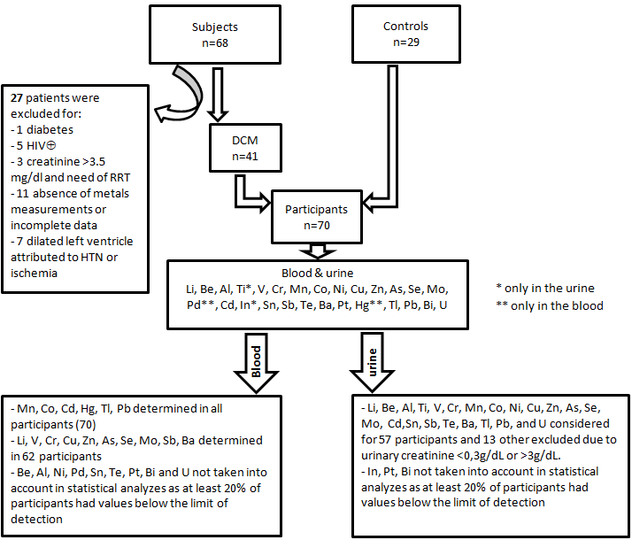
Figure 1: Patients selection, heavy metals measured in total blood and urine
LV denotes Left ventricle, HIV⊕: human immunodeficiency virus positive test, RRT: renal replacement therapy, HTN: hypertension, DCM: dilated cardiomyopathy (idiopathic and postpartum cardiomyopathy)

Table 1: Concentrations (μg/dL) of blood heavy metals in patients compared to controls
Metal  (Reference  Value) | Controls (n=29)  GM (95%CL)  Mean±SD  Median (IQR) | DCM (n=41)Ø  GM (95%CL)  Mean±SD  Median (IQR) | GM ratio  (95%CL) | P
Mn  0.77¥ | 1.59(1.41-1.81)  1.69±0.61  1.59(0.58) | 1.56 (1.39-1.76)  1.67±0.69  1.64(0.80) | 1.02  (0.86-1.22) | 0.8094
Co  0.03¥ | 0.06(0.04-0.08)  0.09±0.08  0.05(0.07) | 0.12 (0.08-0.16)  0.22±0.31  0.09(0.14) | 0.50  (0.31-0.82) | 0.0063
Cd  0.04¥ | 0.16 (0.15-0.17)  0.17±0.04  0.16(0.04) | 0.13 (0.08-0.21)  0.21±0.28  0.14(0.09) | 1.24  (0.86-1.31) | 0.3636
Hg | 0.26 (0.22-0.31)  0.29±0.15  0.27(0.13) | 0.26 (0.22-0.31)  0.31±0.24  0.26(0.13) | 0.99  (0.77-1.28) | 0.9663
Tl  0.002¥ | 0.0027 (0.0024-0.0031)  0.0029±0.0012  0.0027(0.0008) | 0.0028 (0.002-0.0039)  0.0050 ±0.0082  0.0036(0.0027) | 0.96  (0.67-1.38) | 0.8273
Pb  1.88¥ | 5.65 (4.83-6.61)  6.13±2.59  5.83(2.81) | 6.99 (5.94-8.22)  8.02±4.94  6.76(2.93) | 0.81  (0.64-1.02) | 0.0686
Li | 0.21 (0.08-0.61)  1.11±1.05  1.22(1.89) | 0.10 (0.07-0.16)  0.26±0.54  0.10(0.11) | 2.08  (0.67-6.45) | 0.1981
V  0.005* | 0.02 (0.01-0.05)  0.07±0.07  0.52(0.13) | 0.006 (0.004-0.01)  0.02±0.31  0.007(0.008) | 3.5  (1.40-8.98) | 0.0086
Cr  0.04 | 0.20 (0.18-0.22)  0.21±0.06  0.19(0.04) | 0.18 (0.15-0.21)  0.20±0.13  0.17(0.07 | 1.12  (0.94-1.33) | 0.2136
Cu  70-140 ‡ | 110.6 (105-116.4)  111.51±14.83  109.71(20.50) | 143.7 (135.1-153)  145.88±25.74  146.84(31.15) | 0.77  (0.71-0.83) | <0.0001
Zn  580.5 ¥ | 1196.9 (992.1-1444)  1331.38±577.13  1509.84(906.91) | 823.4 (740.3-915.8)  864.21±307.60  797.38(230.11) | 1.5  (1.2-1.8) | 0.0009
Zn/Cu | 10.8 (8.8-13.2)  12.18±5.44  13.33(8.02) | 5.7 (5.1-6.4)  6.08±2.47  5.39(1.95) | 1.9  (1.5-2.4) | <0.0001
As  0.17¥ | 0.23 (0.20-0.26)  0.25±0.09  0.22(0.09) | 0.39 (0.32-0.49)  0.47±0.33  0.38(0.23) | 0.58  (0.46-0.74) | <0.0001
Se  12.5** | 12.6 (11.8-13.4)  12.78±2.12  13.12(3.34) | 11.9 (11.1-12.8)  12.20±2.51  11.82(3.28) | 1.05  (0.9-1.2) | 0.2820
Mo  0.1-0.3‡ | 0.18 (0.16-0.21)  0.20±0.11  0.17(0.07) | 0.21 (0.18-0.25)  0.25±0.23  0.19(0.08) | 0.87  (0.69-1.09) | 0.2385
Sb  0.005 | 1.11 (0.96-1.29)  1.19±0.46  1.18(0.47) | 0.56 (0.49-0.64)  0.61±0.29  0.57(0.27) | 1.98  (1.63-2.42) | <0.0001
Ba  0.05-0.25 | 0.31 (0.2-0.48)  0.53±0.53  0.33(0.68) | 0.13(0.09-0.16)  0.18±0.29  0.11(0.05) | 2.45  (1.50-4.01) | 0.0006
Ø: Lithium, vanadium, chromium, copper, zinc, arsenic, selenium, molybdenum, antimony and barium were measured in only 33 patients with DCM.
‡: WHO. Trace elements in human nutrition and health. 1996
¥: Nisse C et al. Blood and urinary levels of metals and metalloids in the general adult population of Northern France: The IMEPOGE study, 2008-2010. Int J Hyg Environ Health. 2017;220(2 Pt B):341-63
*: Agency for Toxic Substances and Disease Registry (ATSDR). 2012.Toxicological Profile for Vanadium. Atlanta, GA: U.S. Department of Health and Human Services, Public Health Services.
**: Agency for Toxic Substances and Disease Registry (ATSDR). 2003. Toxicological Profile for Selenium (Update). Atlanta, GA: U.S. Department of Health and Human Services, Public Health Service.

Table 2: Adjusted models of DCM as a function of blood metal levels
Variable | Coefficient | SE | Wald 95% Confidence limits |  | Wald χ² | p-value
Arsenic Model
Intercept | -2.84 | 1.65 | -6.06 | 0.39 | 2.97 | 0.0850
As | 9.04 | 3.44 | 2.28 | 15.79 | 6.88 | 0.0087
Age | -0.001 | 0.03 | -0.06 | 0.06 | 0.00 | 0.9639
Male sex | 0.48 | 0.70 | -0.89 | 1.85 | 0.47 | 0.4909
Educationχ | -1.14 | 0.74 | -2.59 | 0.29 | 2.43 | 0.1192
GFR <60 | 2.21 | 1.00 | 0.24 | 4.17 | 4.83 | 0.0279
Copper model
Intercept | -13.49 | 3.98 | -21.29 | -5.68 | 11.48 | 0.0007
Cu | 0.09 | 0.02 | 0.04 | 0.14 | 13.07 | 0.0003
Age | 0.02 | 0.03 | -0.04 | 0.09 | 0.50 | 0.4776
Male sex | 1.46 | 0.87 | -0.24 | 3.15 | 2.85 | 0.0915
Education | -0.79 | 0.80 | -2.37 | 0.77 | 0.99 | 0.3195
GFR <60 | 1.18 | 1.15 | -1.07 | 3.44 | 1.06 | 0.3042
Vanadium model
Intercept | 1.39 | 1.49 | -1.53 | 4.31 | 0.87 | 0.3517
Vanadium | -23.91 | 8.93 | -41.42 | -6.40 | 7.16 | 0.0074
Age | -0.01 | 0.03 | -0.08 | 0.05 | 0.22 | 0.6394
Male sex | 0.30 | 0.68 | -1.04 | 1.65 | 0.19 | 0.6589
Education | -1.18 | 0.70 | -2.55 | 0.19 | 2.83 | 0.0925
GFR <60 | 2.75 | 1.13 | 0.54 | 4.96 | 5.95 | 0.0147
Zinc model
Intercept | 3.36 | 1.86 | -0.28 | 7.00 | 3.28 | 0.0701
Zinc | -0.003 | 0.0009 | -0.005 | -0.001 | 9.53 | 0.0020
Age | -0.02 | 0.03 | -0.08 | 0.05 | 0.21 | 0.6437
Male sex | 0.79 | 0.73 | -0.63 | 2.22 | 1.18 | 0.2769
Education | -1.39 | 0.74 | -2.84 | 0.06 | 3.54 | 0.0598
GFR <60 | 3.32 | 1.31 | 0.75 | 5.88 | 6.43 | 0.0112
Antimony model
Intercept | 4.89 | 2.16 | 0.66 | 9.13 | 5.12 | 0.0236
Antimony | -4.65 | 1.25 | -7.09 | -2.20 | 13.87 | 0.0002
Age | -0.02 | 0.04 | -0.09 | 0.05 | 0.40 | 0.5284
Male sex | 0.58 | 0.82 | -1.01 | 2.19 | 0.52 | 0.4720
Education | -1.42 | 0.84 | -3.07 | 0.22 | 2.89 | 0.0892
GFR <60 | 3.58 | 1.66 | 0.33 | 6.83 | 4.65 | 0.0310
Barium model
Intercept | 1.32 | 1.40 | -1.43 | 4.06 | 0.89 | 0.3459
Barium | -2.73 | 1.24 | -5.17 | -0.29 | 4.81 | 0.0284
Age | -0.01 | 0.03 | -0.07 | 0.05 | 0.15 | 0.6997
Male sex | 0.19 | 0.65 | -1.09 | 1.48 | 0.09 | 0.7673
Education | -1.18 | 0.67 | -2.49 | 0.13 | 3.13 | 0.0769
GFR <60 | 2.54 | 1.01 | 0.57 | 4.51 | 6.36 | 0.0117
Ratio Zinc/Copper
Intercept | 3.63 | 2.03 | -0.35 | 7.61 | 3.20 | 0.0738
Zinc/Copper | -0.46 | 0.14 | -0.74 | -0.19 | 11.01 | 0.0009
Age | -0.01 | 0.04 | -0.09 | 0.07 | 0.06 | 0.8053
Male sex | 1.44 | 0.89 | -0.31 | 3.20 | 2.59 | 0.1077
Education | -1.31 | 0.81 | -2.89 | 0.27 | 2.63 | 0.1050
GFR <60 | 3.73 | 1.71 | 0.38 | 7.07 | 4.76 | 0.0291
χ: Being highly educated (university or post-university) often correlates with higher socio-economic status in the KC settings.

2A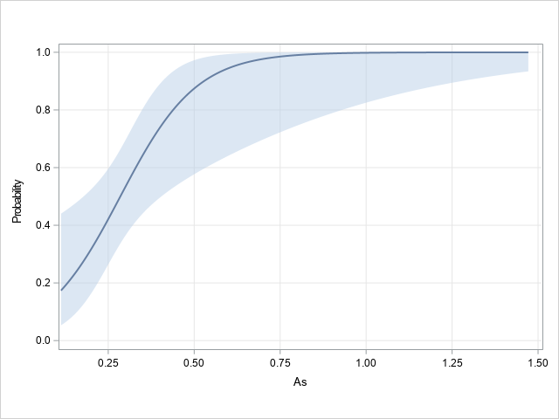 | 2B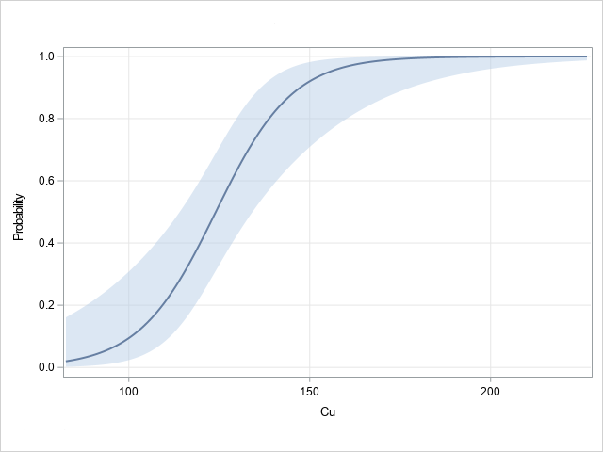
2C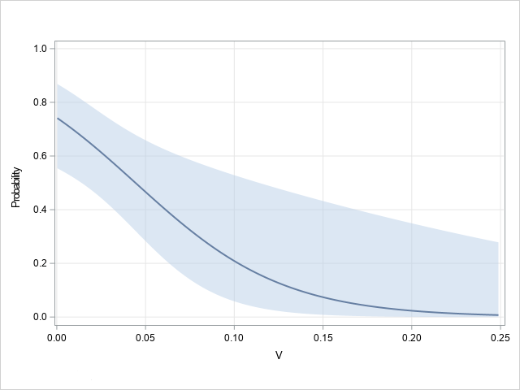 | 2D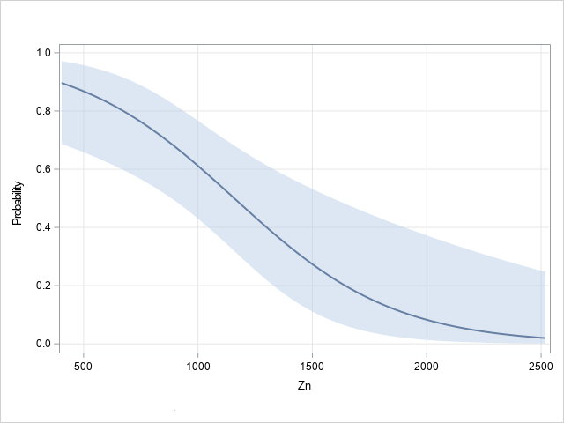
2E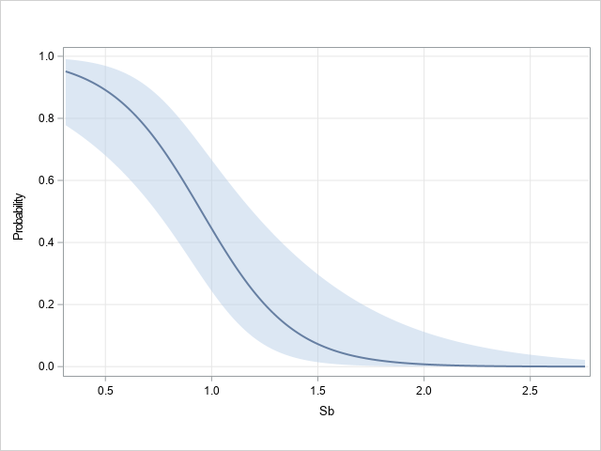 | 2F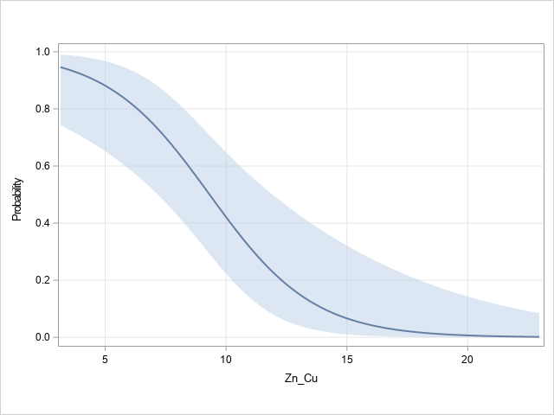

Figure 2: Illustrative predicted probabilities of DCM as a function of blood heavy metal concentrations: Arsenic (2A), Copper (2B), Vanadium (2C), Zinc (2D), Antimony (3E). and Zinc/Copper ratio (2F).

Table 3: Concentrations (μg/g creatinine) of metals in urine from DCM patients and controls

Metal  (Reference  Value) | Controls (n=25)  GM(95%CL)  Mean±SD  Median (IQR) | DCM (n=32)  GM(95%CL)  Mean±SD  Median (IQR) | GM ratio  (95% CL) | P
Li  21.5 | 13.93 (11.98-16.19)  14.92±6.14  13.44(6.04) | 16.06 (12.55-20.57)  20.52±18.51  15.25(13.44) | 0.87  (0.65-1.15) | 0.3189
Be | 0.0009 (0007-0.0012)  0.0011±0009  0.0008(0004) | 0.0029 (0.0015-0.0056)  0.041±0.15  0.0022(0.0059) | 0.31  (0.16-0.62) | 0.0015
Al  2.04 | 10.62 (7.97-14.15)  14.23±15.39  9.59(6.42) | 15.62 (10.22-23.88)  97.42±438.12  11.25(10.62) | 0.68  (0.41-1.12) | 0.1292
Ti | 30.87 (25.19-37.82)  34.49±16.15  29.40(25.48) | 31.13 (23.07-42.02)  39.95±25.09  34.43(29.65) | 0.99  (0.69-1.41) | 0.9612
V  0.22 | 1.46 (0.73-2.93)  3.33±3.49  2.07(3.24) | 1.53 (0.91-2.57)  2.95±3.08  1.92(2.67) | 0.96  (0.42-2.19) | 0.9178
Cr  0.11 | 0.18 (0.14-0.22)  0.20±0.13  0.16(0.08) | 0.36 (0.24-0.54)  1.00±2.91  0.29(0.39) | 0.49  (0.32-0.78) | 0.0033
Mn  <0.043 | 0.12 (0.06-0.21)  0.28±0.37  0.11(0.27) | 0.39 (0.19-0.81)  3.36±8.65  0.29(1.05) | 0.29  (0.11-0.78) | 0.0145
Co  0.2 | 1.18 (0.73-1.92)  2.45±3.58  0.97(1.84) | 2.75 (1.98-3.82)  4.31±5.08  2.24(3.46) | 0.43  (0.25-0.75) | 0.0034
Ni  1.79 | 1.19 (0.94-1.51)  1.39±0.75  1.18(1.24) | 1.49 (1.16-1.92)  1.87±1.33  1.57(1.44) | 0.79  (0.57-1.13) | 0.1967
Cu  6.84 | 7.38 (6.45-8.43)  7.78±2.81  7.06(2.48) | 25.76 (19.93-33.29)  32.48±23.22  28.52(25.87) | 0.29  (0.22-0.38) | <0.0001
Zn  246 | 221.10 (176.70-276.07)  250.38±116.76  256.67(167.09) | 1033.80 (818.5-1305.7)  1256.08±820.55  1007.14(821.22) | 0.21  (0.15-0.29) | <0.0001
As  13.7 | 20.36 (14.99-27.65)  27.19±24.59  19.97(20.48) | 27.06 (20.41-35.89)  35.21±24.55  29.06(29.68) | 0.75  (0.49-1.13) | 0.1689
Se  21.6 | 17.42 (15.48-19.59)  18.09±5.07  18.54(5.63) | 24.53 (21.70-27.73)  25.98±9.23  22.85(12.10) | 0.71  (0.59-0.84) | 0.0001
Mo  29.8 | 60.46 (41.95-87.13)  84.94±74.05  65.18±38.00 | 55.17 (38.23-79.60)  92.35±137.29  49.98(54.58) | 1.09  (0.65-1.83) | 0.4882
Cd  0.22 | 0.61 (0.48-0.76)  0.72±0.54  0.57(0.41) | 1.48 (1.15-1.90)  1.94±1.96  1.44(1.29) | 0.41  (0.29-0.58) | <0.0001
Sn  0.35 | 0.23 (0.19-0.29)  0.26±0.14  0.21(0.11) | 3.59 (1.79-7.19)  11.24±14.55  6.86(16.66) | 0.07  (0.03-0.13) | <0.0001
Sb  0.04 | 0.05 (0.04-0.06)  0.05±0.04  0.046(0.019) | 0.08 (0.05-0.11)  0.11±0.09  0.08(0.14) | 0.64  (0.42-0.97) | 0.0351
Te  0.14 | 0.23 (0.19-0.27)  0.25±0.09  0.21(0.14) | 0.23 (0.19-0.28)  0.27±0.17  0.21(0.24) | 1.01  (0.78-1.32) | 0.9417
Ba  1.86 | 1.27 (0.94-1.72)  1.61±1.19  1.16(0.74) | 1.65 (1.04-2.57)  3.54±4.96  1.89(3.98) | 0.77  (0.45-1.33) | 0.3442
Tl  0.18 | 0.14 (0.11-0.17)  0.16±0.11  0.13(0.05) | 0.23 (0.18-0.29)  0.29±0.19  0.25(0.16) | 0.59  (0.42-0.83) | 0.0031
Pb  1.78 | 1.76 (1.38-2.26)  2.09±1.28  1.68(1.28) | 1.24 (0.90-1.69)  1.91±2.50  1.24(1.22) | 1.42  (0.95-2.15) | 0.0888
U  <0.007 | 0.008 (0.006-0.0105)  0.11±0.01  0.007(0.004) | 0.02 (0.016-0.031)  0.03±0.04  0.02(0.03) | 0.37  (0.24-0.55) | <0.0001

Table 4: Adjusted models of DCM prediction by urine metal concentrations (N = 57)
Variable | Coefficient | SE | Wald 95% Confidence limits |  | Wald χ² | p-value
Chromium model
Intercept | -2.32 | 1.29 | -4.85 | 0.21 | 3.24 | 0.0717
Chromium | 4.69 | 2.09 | 0.60 | 8.78 | 5.05 | 0.0246
Age | 0.02 | 0.02 | -0.02 | 0.07 | 0.90 | 0.3435
Male sex | 1.04 | 0.69 | -0.32 | 2.40 | 2.24 | 0.1344
Education χ | -0.86 | 0.65 | -2.13 | 0.41 | 1.76 | 0.1847
Copper model
Intercept | -5.87 | 2.15 | -10.10 | -1.65 | 7.44 | 0.0064
Copper | 0.32 | 0.11 | 0.10 | 0.54 | 8.32 | 0.0039
Age | 0.03 | 0.04 | -0.04 | 0.10 | 0.69 | 0.4058
Male sex | 0.88 | 0.95 | -0.98 | 2.74 | 0.85 | 0.3556
Education | 0.08 | 0.94 | -1.76 | 1.93 | 0.01 | 0.9313
Zinc model
Intercept | -4.88 | 2.65 | -10.07 | 0.29 | 3.41 | 0.0648
Zinc | 0.02 | 0.01 | 0.01 | 0.03 | 9.45 | 0.0021
Age | -0.05 | 0.06 | -0.17 | 0.07 | 0.67 | 0.4146
Male sex | -0.81 | 1.26 | -3.28 | 1.67 | 0.41 | 0.5231
Education | 0.95 | 1.31 | -1.62 | 3.52 | 0.53 | 0.4684
Selenium model
Intercept | -7.39 | 2.41 | -12.13 | -2.66 | 9.38 | 0.0022
Selenium | 0.24 | 0.08 | 0.09 | 0.39 | 9.84 | 0.0017
Age | 0.05 | 0.03 | -0.01 | 0.10 | 3.11 | 0.0780
Male sex | 1.51 | 0.78 | -0.02 | 3.05 | 3.74 | 0.0533
High education | -1.28 | 0.74 | -2.73 | 0.16 | 3.03 | 0.0818
Cadmium model
Intercept | -2.19 | 1.35 | -4.83 | 0.46 | 2.63 | 0.1051
Cadmium | 2.47 | 0.87 | 0.78 | 4.17 | 8.19 | 0.0042
Age | -0.01 | 0.03 | -0.07 | 0.05 | 0.16 | 0.6850
Male sex | 1.39 | 0.77 | -0.11 | 2.91 | 3.29 | 0.0697
Education | -0.83 | 0.70 | -2.20 | 0.55 | 1.38 | 0.2401
Antimony model
Intercept | -2.39 | 1.33 | -4.99 | -0.22 | 3.23 | 0.0723
Antimony | 14.59 | 6.11 | 2.61 | 26.56 | 5.70 | 0.0170
Age | 0.03 | 0.02 | -00.1 | 0.08 | 1.97 | 0.1602
Male sex | 0.56 | 0.64 | -0.69 | 1.82 | 0.78 | 0.3785
Education | -0.77 | 0.65 | -2.04 | 0.51 | 1.39 | 0.2380
Thallium model
Intercept | -3.13 | 1.40 | -5.88 | -0.38 | 4.96 | 0.0259
Thallium | 8.51 | 3.32 | 2.01 | 15.01 | 6.58 | 0.0103
Age | 0.03 | 0.03 | -0.02 | 0.08 | 1.43 | 0.2324
Male sex | 1.36 | 0.74 | -0.08 | 2.80 | 3.42 | 0.0645
Education | -1.25 | 0.69 | -2.59 | 0.09 | 3.33 | 0.0681
Uranium model
Intercept | -3.78 | 1.62 | -6.95 | -0.61 | 5.48 | 0.0193
Uranium | 85.43 | 35.37 | 16.11 | 154.74 | 5.83 | 0.0157
Age | 0.04 | 0.03 | -0.01 | 0.09 | 2.62 | 0.1055
Male sex | 1.59 | 0.78 | 0.07 | 3.10 | 4.19 | 0.0408
Education | -0.92 | 0.71 | -2.32 | 0.47 | 1.68 | 0.1944
χ: Being highly educated (university or post-university) often correlates with higher socio-economic status in the KC settings.

3A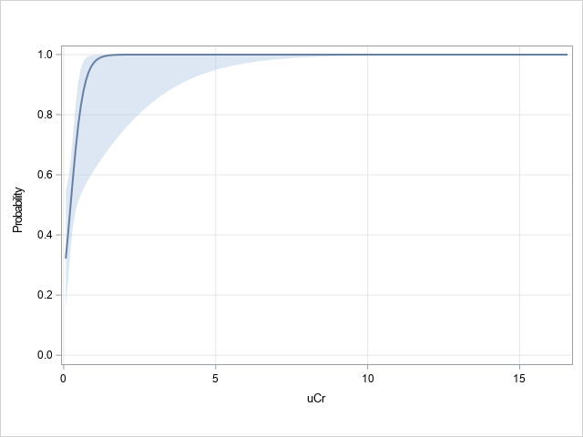 | 3B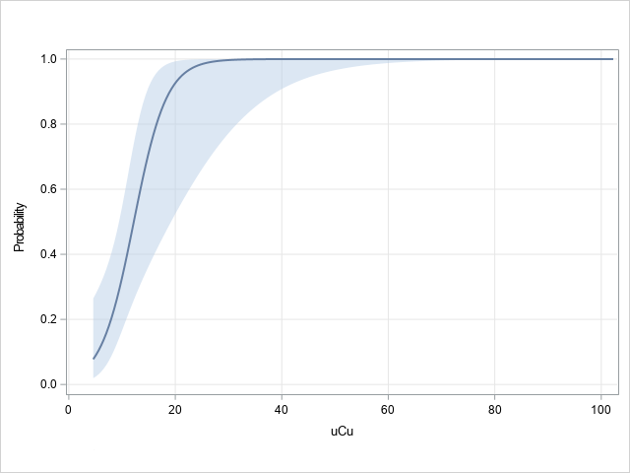
3C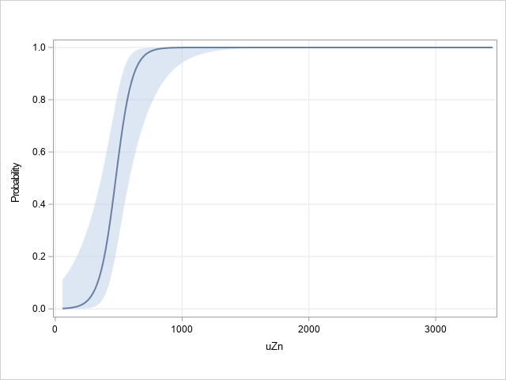 | 3D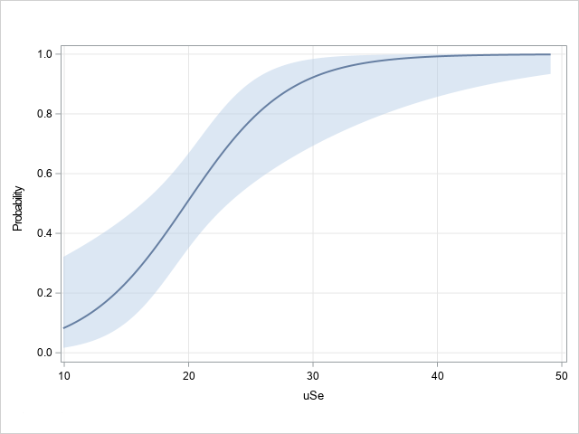
3E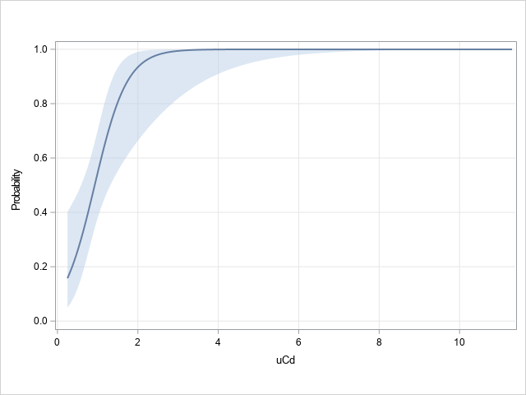 | 3F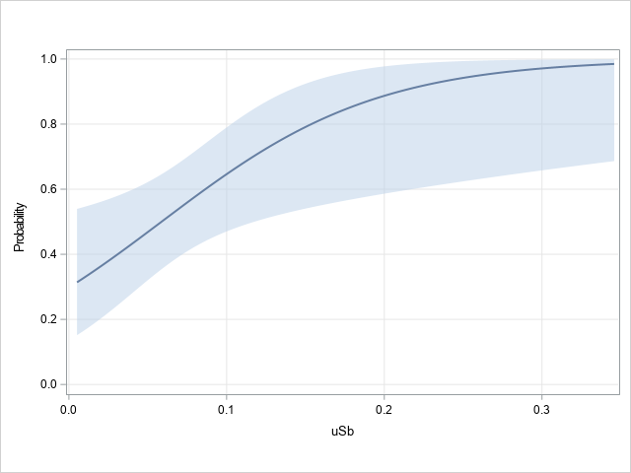
Figure 3: Illustrative predicted probabilities of dilated cardiomyopathy as a function of heavy metals concentrations in urine: 3A Chromium, 3B Copper, 3C Zinc, 3D Selenium, 3E Cadmium, 3F Antimony

3G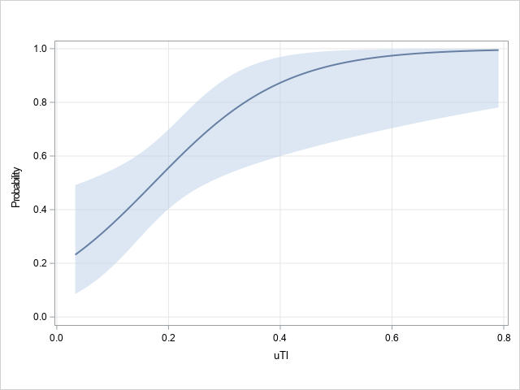 | 3H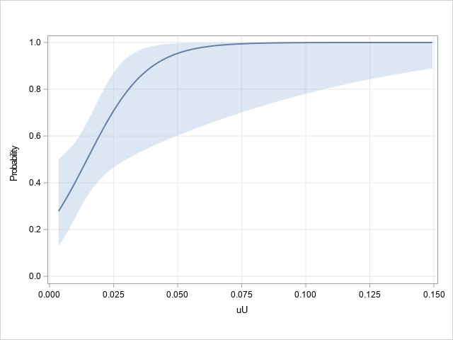
Figure 3 (cont'd): predicted probabilities of dilated cardiomyopathy as a function of heavy metals concentrations in urine: 3G. Thallium, 4H. Uranium

Supplementary material
Table S1: Clinical features of subjects with dilated cardiomyopathy
Category | Variable
Comorbidity and other risk factor n(%) | - Smoking in the past: 4(10)  - Alcohol consumption: 11(27)  - Clay consumption:16(39)  - Inactivity: 32 (78)
Symptoms | - Fatigue: 38(93)  - Breathlessness: 34(83)  - Dyspnea: 36 (88)  - Cough: 34(83)  - Orthopnea: 34 (83)  - Nocturnal dyspnea: 19 (46)  - Nycturia: 14 (34)  - Right hypochondre pain:5(12)  - Early satiety:35(85)
Vital signs | - PAS: 115±20 mmHg  - PAD: 83±16 mmHg  - Pulse: 98±13 /min  - SpO2: 96±5 %
Signs | - NYHA: II 12(29), III 23 (56), IV 6 (15)  - Jugular distension:13(32)  - Arrhythmia: 12(29)  - Murmur of MR: 30(73)  - Murmur of TR: 13(32)  - Tachypnea: 13(32)  - Pulmonary rales: 20(49)  - Hepatomegaly: 26(63)  - Ascites 4(10)  - Sacral edema: 27(66)  - Legs swelling: 29(71)  - Coldness of extremities: 1(2)
Heart failure etiology  n(%) | - Dilated cardiomyopathy 33(80)  - Peripartum cardiomyopathy 8 (20)
Echocardiographic findings & measurements | - Thrombus 10(24)  - LVEF: 21±8 %  -LVIDD:6.4±0.6 cm  - LVEDV: 229±66 ml  - LVESV: 181 ± 55 ml  - LA volume index: 86±27 ml/m²  - Mitral E/Ea average: 15±6  - TR Vmax 2.9±0.4 m/s
12-lead ECG n(%) | - LVH: 32 (78)  - LBBB: 3(7)  - Atrial fibrillation: 4(10)  - PAC:5 (12)  - PVC: 13 (32)
24h holter ECG | - QTc : 587±125 ms  - long QT 17(52)  - Premature ventricular contractions  Number: 202±297/h; 4852±7132/24h  Connections : doublets 31(79)  Triplets 21(54)  Bigeminy 18(46)  Trigeminy 14(36)  Morphology: monomorphic 10(26)  Polymorphic 28(72)  Coupling: short 3(8)  Long 24(61)  Variable 12(31)  -Ventricular tachycardia  Non-sustained VT 20(51), 7±10 episodes/24h
Treatment | - Furosemide 39 (95)  - Beta-blocker 8 (20)  - ACE-i 35 (85)  - ARB 4(10)  - Spironolactone 9 (22)  - Isosorbide dinitrate 4(10)  - LMWH 2(5)  - Acenocoumarol 7 (17)
Outcome | - Inpatient 32 (78)  - Mean (SD) length of hospitalization 14±8 days  - Early mortality 4(10)

Table S2: Comparison of heart failure patients to controls according to demography, education level, and routine biology
variables | Control (n=29) | HF patients (n=41) | p
Age, years | 43±11 | 48±14 | 0.1121
Sex, n(%)  Female  Male | 14(48)  15(52) | 20(49)  21(51) | 0.9668
Education's level  Primary-to-secondary  University and post-univ | 12(41)  17(59) | 30(73)  11(27) | 0.0075
BMI, kg/m² | 26.6±2.5 | 25.2±4.9 | 0.1414
Glycemia, mg/dl | 88±18 | 108±37 | 0.0042
Total cholesterol, mg/dl | 183±37 | 188±67 | 0.6965
HDL, mg/dl | 46±9 | 40±19 | 0.0723
LDL, mg/dl | 118±37 | 128±52 | 0.3708
Triglycerides, mg/dl | 95±55 | 102±37 | 0.5387
Urea, mg/dl | 26±7 | 53±30 | <0.0001
Creatinine, mg/dl | 0.9±0.2 | 1.2±0.4 | 0.0005
GFR, ml/min/1.73m² | 85±18 | 66±21 | <0.0001
Renal dysfunction, n(%) | 2(7) | 17(41) | 0.0014
Uric acid, mg/dl | 6.1±1.6 | 10.7±3.7 | <0.0001
Total bilirubin, mg/dl | 0.7±0.4 | 1.6±2.4 | 0.0259
Direct bilirubin, mg/dl | 0.2±0.1 | 0.9±2.2 | 0.0434
AST, U/l | 27±6 | 101±311 | 0.1351
ALT, U/l | 29±13 | 84±148 | 0.0225
Calcium, mg/dl | 8.7±0.3 | 8.4±0.6 | 0.008
Hypocalcemia, n(%) | 3(10) | 21(51) | 0.0004
Magnesium, mg/dl | 2.04±0.2 | 2.03±0.4 | 0.9167
Hypomagnesemia, n(%) | 0(0) | 6(15) | 0.0343
Sodium, mEq/l | 140.5±1.8 | 138.2±4.4 | 0.0037
Hyponatremia, n(%) | 0(0) | 10 (24) | 0.0039
Potassium, mEq/l | 4.2±0.4 | 3.7±0.7 | 0.0018
Hypokalemia, n(%) | 1(3) | 14(34) | 0.0024
Chlorure, mEq/l | 103.4±2.3 | 102.6±5.4 | 0.4198
C-reactive protein, mg/l | 7±17 | 45±44 | <0.0001
CRP, n(%) | 2(7) | 32(78) | <0.0001
White blood cell, x10³/µl | 4.1±0.8 | 6.9±3.2 | <0.0001
Lymphocytes, x10³/µl | 1.9±0.5 | 1.8±1.1 | 0.3717
Monocytes, x10³/µl | 0.4±0.1 | 0.7±0.3 | <0.0001
Granulocytes, x10³/µl | 1.8±0.5 | 4.5±2.9 | <0.0001
Red blood cell, x10⁶/µl | 5±0.7 | 5.2±0.6 | 0.3253
Hemoglobin, g/dl | 14.2±2.3 | 13.6±1.4 | 0.1842
Hematocrit, % | 40.7±6.7 | 38.5±5.7 | 0.1353
MCV, fL | 81±9 | 76±7 | 0.0080
MCH, pg | 28±4 | 27±3 | 0.0188
MCHC, g/dl | 35±0.8 | 34±2 | 0.0341
RDW, % | 13±3 | 16±3 | 0.0001
Platelets, x10³/µl | 210±63 | 226±78 | 0.3490
MPV, fL | 9.4±0.7 | 9.4±0.8 | 0.9530
PCT, % | 0.19±0.06 | 0.21±0.07 | 0.2392
PDW, % | 13.7±2.3 | 14.2±2.4 | 0.3718
INR | 1.1±0.2 | 1.4±1.0 | 0.0920
Urinary Tract Infection | 4(14) | 12(29) | 0.1064

Table S3: Correlations between blood (b) and urine (u) metal concentrations.
 | bAntimony | bArsenic | bCopper | bVanadium | bZinc
uChromium | -0.22701  0.1056 | 0.40382  0.0030 | 0.36284  0.0082 | 0.09298  0.5121 | -0.06249  0.6598
uCopper | -0.63067  <.0001 | 0.42944  0.0015 | 0.73235  <.0001 | -0.28714  0.0390 | -0.41424  0.0023
uZinc | -0.55511  <.0001 | 0.37591  0.0060 | 0.59046  <.0001 | -0.34853  0.0113 | -0.35405  0.0100
uSelenium | -0.35934  0.0089 | 0.29941  0.0311 | 0.46581  0.0005 | 0.00273  0.9847 | -0.08427  0.5526
uCadmium | -0.50295  0.0001 | 0.40502  0.0029 | 0.70435  <.0001 | -0.17888  0.2045 | -0.31785  0.0217
uAntimony | -0.39179  0.0041 | 0.43208  0.0014 | 0.34748  0.0116 | -0.30900  0.0258 | -0.29591  0.0332
uThallium | -0.35644  0.0095 | 0.18458  0.1902 | 0.42227  0.0018 | -0.14857  0.2932 | -0.31281  0.0240
uUranium | -0.29625  0.0330 | 0.37514  0.0061 | 0.52591  <.0001 | -0.10084  0.4769 | -0.35764  0.0092

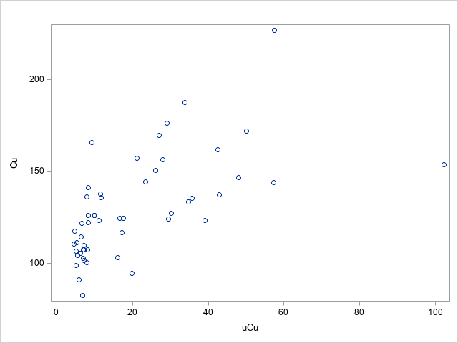 | 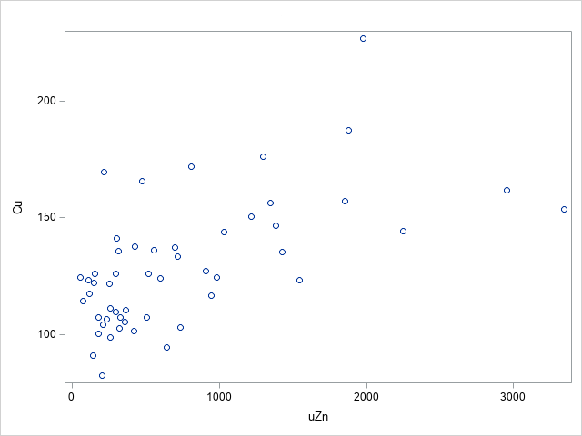
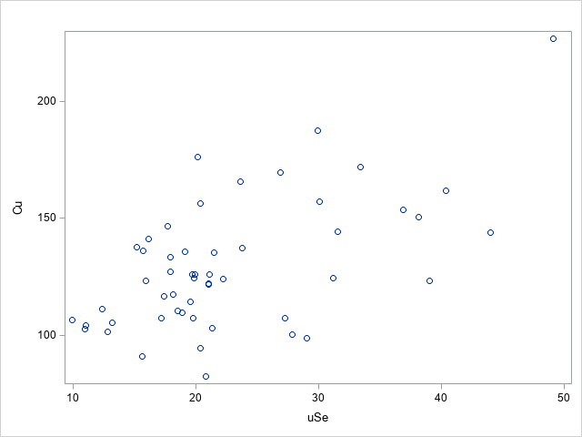 | 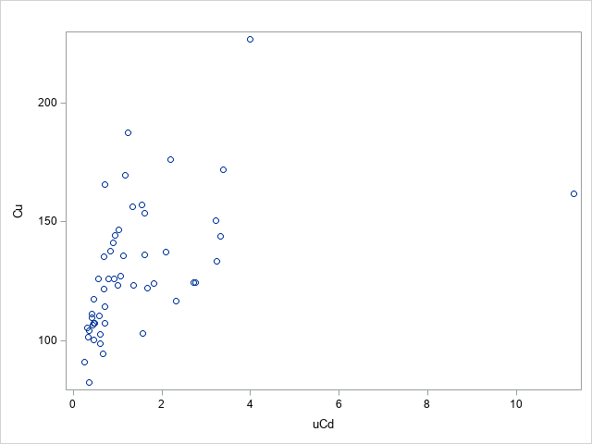
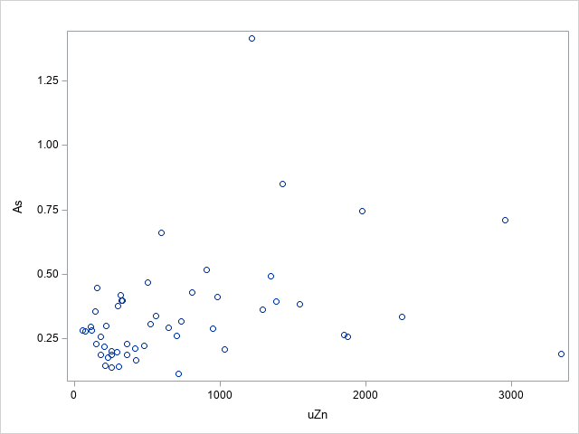 | 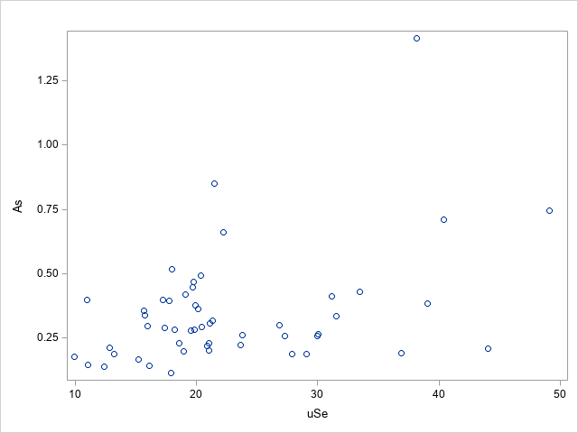
Figure S1: Illustrative correlations between concentrations of copper or arsenic in the blood and concentrations of zinc, selenium, cadmium, and copper in the urine.

