Supplementary Material

Alternative promoter use governs the expression of IgLON cell adhesion molecules in histogenetic fields of the embryonic mouse brain

Toomas Jagomäe^{1,2#} , Katyayani Singh^{1#}*, Mari-Anne Philips¹, Mohan Jayaram¹, Kadri Seppa^{1,2}, Triin Tekko³, Scott F. Gilbert⁴, Eero Vasar¹, Kersti Lilleväli¹

1 Institute of Biomedicine and Translational Medicine, Department of Physiology, University of Tartu, 19 Ravila Street, Tartu 50411, Estonia
2 Institute of Biomedicine and Translational Medicine, Laboratory Animal Centre, University of Tartu, 14B Ravila Street, Tartu 50411, Estonia
3 The Instituto Gulbenkian de Ciência, Rua da Quinta Grande 6, 2780-156 Oeiras, Portugal
4 Department of Biology, Swarthmore College, Swarthmore, PA, USA
# equal contribution
*correspondence

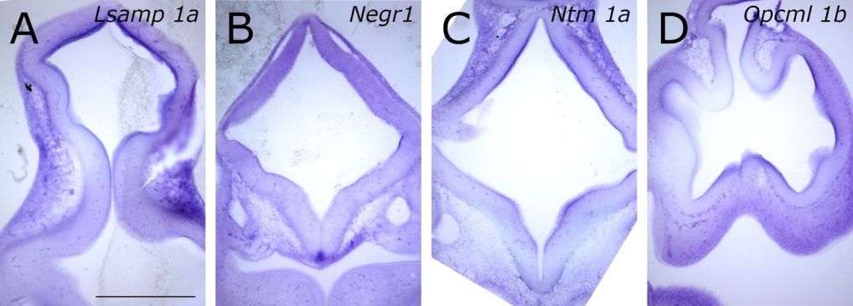

Supplementary Figure S1. In situ mRNA hybridization displaying Lsamp 1a, Negr1, Ntm 1a and Opcml 1b at E10.5 coronal sections. (A) signal from Lsamp 1a probe is intense in the ventricular zone. (B) Intense expression of Negr1 is observable at the floor plate. (C) Ntm 1a expression is established dorsally in the ventricular zone and in the developing ganglionic eminences. (D) singal from Opcml 1b probe is observable throughout the ventricular zone of the developing nervous system. Scale bar: 1 mm.

