Supplemental Files: Building-level wastewater monitoring using passive samplers and RT-LAMP for SARS-CoV-2 RNA detection

Aaron Bivins^{1,2}, Megan Lott³, Marlee Shaffer¹, Zhenyu Wu¹, Devin North¹, Erin K. Lipp³, Kyle Bibby^{1,2*}

¹ Department of Civil & Environmental Engineering & Earth Sciences, University of Notre Dame, 156 Fitzpatrick Hall, Notre Dame, IN 46556
² Environmental Change Initiative, University of Notre Dame, 721 Flanner Hall, Notre Dame, IN 46556
³ Department of Environmental Health Science, University of Georgia, 150 East Green Street, Athens, GA 30602

*kbibby@nd.edu

Table S1 RT-LAMP Primers
Figure S1 RT-LAMP 95% and 67% LODs
Figure S2 RT-LAMP true positive rate
Figure S3 Composite versus passive inhibition rates by extraction kit
Figure S4 Viral RNA Mini versus Power Viral inhibition rates by sample type
Figure S5 Inhibition rate and positivity of tampon swab sorbate fractions
Figure S6 WW proportion positive by RT-LAMP and campus-wide COVID-19 clinical metrics
Figure S7 WW proportion positive by RT-LAMP and COVID-19 clinical metrics aggregated for all residence halls included in wastewater monitoring
Figure S8 Hourly domestic water use in three RHs
Figure S9 RT-LAMP COVID-19 case PPV and NPV stratified by residence halls and weeks of monitoring
Figure S10 RT-LAMP results frequency distribution for convalescent COVID-19 cases returning to residence halls from quarantine
Figure S11 RT-LAMP COVID-19 case PPV and NPV after correction for detection of convalescent COVID-19 cases returning to residence halls from quarantine
Table S1 | SARS-CoV-2 (N2 and E1) and internal control (ACTB) primers used in the NEB SARS-CoV-2 Rapid Colorimetric LAMP Assay Kit (E2019S).

NEB_N2-F3  NEB_N2-B3  NEB_N2-FIP  NEB_N2-BIP  NEB_N2-LF  NEB_N2-LB | ACCAGGAACTAATCAGACAAG  GACTTGATCTTTGAAATTTGGATCT  TTCCGAAGAACGCTGAAGCGGAACTGATTACAAACATTGGCC  CGCATTGGCATGGAAGTCACAATTTGATGGCACCTGTGTA  GGGGGCAAATTGTGCAATTTG  CTTCGGGAACGTGGTTGACC
NEB_E1-F3  NEB_E1-B3  NEB_E1-FIP  NEB_E1-BIP  NEB_E1-LB  NEB_E1-LF | TGAGTACGAACTTATGTACTCAT  TTCAGATTTTTAACACGAGAGT  ACCACGAAAGCAAGAAAAAGAAGTTCGTTTCGGAAGAGACAG  TTGCTAGTTACACTAGCCATCCTTAGGTTTTACAAGACTCACGT  GCGCTTCGATTGTGTGCGT  CGCTATTAACTATTAACG
ACTB-F3  ACTB-B3  ACTB-FIP  ACTB-BIP  ACTB-LF  ACTB-LB | AGTACCCCATCGAGCACG  AGCCTGGATAGCAACGTACA  GAGCCACACGCAGCTCATTGTATCACCAACTGGGACGACA  CTGAACCCCAAGGCCAACCGGCTGGGGTGTTGAAGGTC  TGTGGTGCCAGATTTTCTCCA  CGAGAAGATGACCCAGATCATGT

Figure S1 | The 95% and 67% limits of detection (LODs) for a single RT-LAMP reaction as measured along a concentration gradient of N1 gene copies per reaction (rxn) quantified by RT-ddPCR (x-axis). The percentage of technical replicates positive (TR PP; y-axis) was best fit (R² = 0.997) by a Gaussian distribution with a mean of 44.2 and standard deviation of 19.6.

Figure S2 | (A) RT-LAMP cumulative true positive rate (sensitivity; y-axis) among individual reactions along an N1 gene copy (GC) per reaction gradient (x-axis); (B) SARS-CoV-2 RNA probability of detection among RT-LAMP triplicates (y-axis) as estimated by a logistic regression model (p = 0.0034; R² = 0.24) along the same N1 GC gradient (x-axis); (C) the receiver operating characteristic curve for RT-LAMP performed in triplicate compared to RT-ddPCR detection of SARS-CoV-2 RNA (area under curve = 0.81 95%CI: 0.65 - 0.97; p = 0.0047).

Figure S3 | RT-LAMP inhibition rates among primary influent composite samples (black) and tampon swab sorbate samples (pink) extracted via (A) the Viral RNA Mini Kit and (B) the AllPrep PowerViral DNA/RNA Kit.

Figure S4 | RT-LAMP inhibition rates among (A) primary influent composite samples, (B) tampon swab sorbate samples, and (C) all wastewater samples extracted via the Viral RNA Mini Kit (black) and the AllPrep PowerViral DNA/RNA Kit (pink).

Figure S5 | (A) RT-LAMP inhibition rates among tampon swab sorbate processed by Amicon ultrafiltration, liquid faction only processed by Amicon ultrafiltration, and solid fraction (A), and (B) SARS-CoV-2 RNA positivity by RT-LAMP among the same.

Figure S6 | (A) COVID-19 clinical testing positivity and average 7-day positivity (left y-axis) and wastewater (WW) SARS-CoV-2 proportion positive (right y-axis) during the study period from 0 to 73 days (x-axis); (B) COVID-19 clinical positives and average 7-day positives (left y-axis) and wastewater (WW) SARS-CoV-2 proportion positive (right y-axis) during the study period from 0 to 73 days (x-axis).
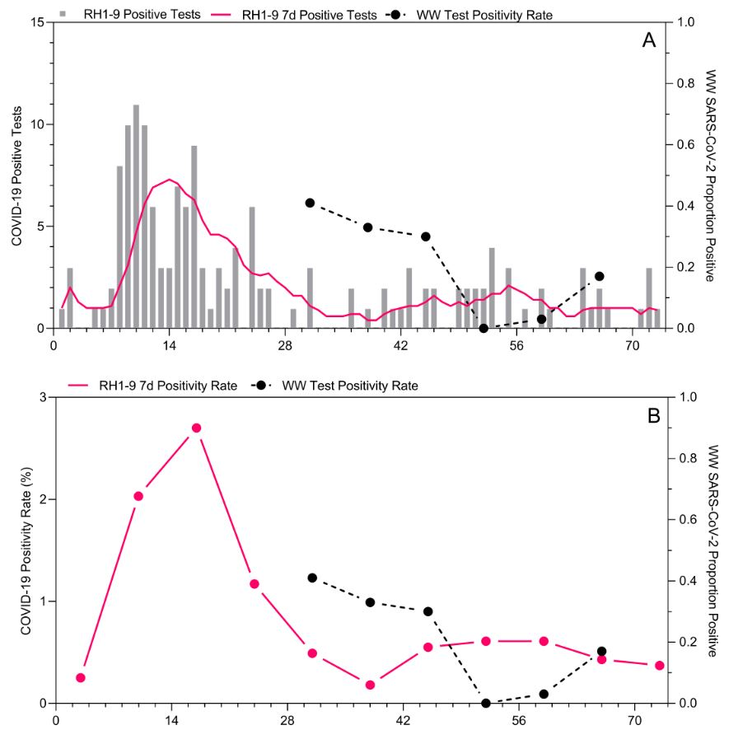

Figure S7 | (A) COVID-19 clinical positives and average 7-day number of positives (left y-axis) and wastewater (WW) SARS-CoV-2 proportion positive (right y-axis) in the nine residence halls included in wastewater monitoring during the study period from 0 to 73 days (x-axis); (B) COVID-19 clinical testing weekly positivity (left y-axis) and wastewater (WW) SARS-CoV-2 proportion positive (right y-axis) in the nine residence halls included in wastewater monitoring during the study period from 0 to 73 days (x-axis).

Figure S8 | Hourly domestic water use (y-axis) in RH2, 6, and 7 during weeks 3 (black) and 4 (pink) of wastewater monitoring.

Figure S9 | Positive predictive value (PPV) of RT-LAMP wastewater monitoring for incident COVID-19 cases from 1 to 7 days post wastewater testing (A) as observed during 6 weeks of monitoring among nine residence halls and (C) as observed among nine residence halls each week for six weeks. Negative predictive value (NPV) of RT-LAMP wastewater monitoring for incident COVID-19 cases from 1 to 7 days post wastewater testing (B) as observed during 6 weeks of monitoring among nine residence halls and (D) as observed among nine residence halls each week for six weeks.

Figure S10 | Cumulative convalescent COVID-19 cases returning from isolation to residence halls in the seven days prior to RT-LAMP wastewater testing when there were no incident COVID-19 cases observed in the seven days following wastewater testing color coded by LAMP positivity cutoffs (1 of 3, 2 of 3, and 3 of 3 reactions positive for SARS-CoV-2 RNA).

Figure S11 | Negative predictive value (NPV) and positive predictive value (PPV) of tampon swab and RT-LAMP wastewater monitoring with correction for false positives attributable to the detection of convalescent COVID-19 cases.

