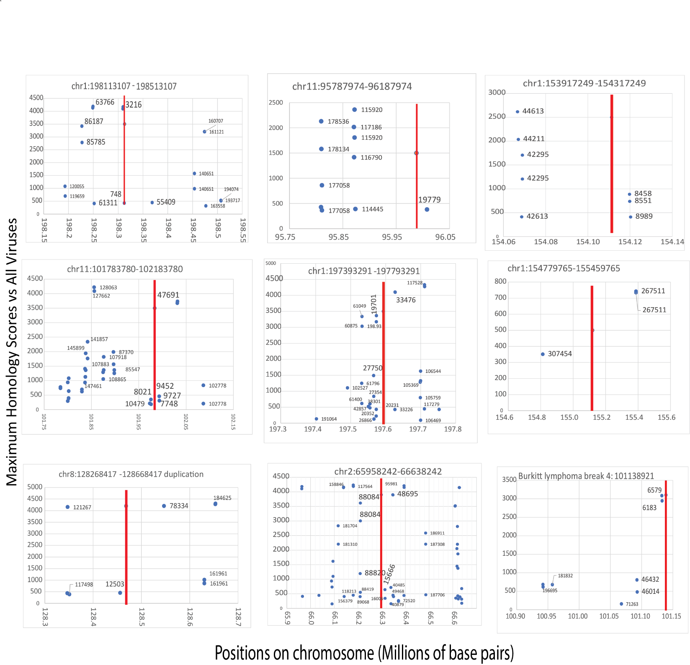

Figure S1. Distributions of EBV variant homologies around eight breakpoints (indicated by red lines) in nasopharyngeal cancer NPC-5989 [29] resemble hereditary breast cancers. Burkitt’s lymphoma break coordinates are also near DNA sequences with EBV variant homologies (lower right panel). The numbers near each of the blue dots are the number of base pairs between the breakpoint and the start of the homologous sequences. The numbers on the horizontal axis are the numbers of base pairs on the chromosome in millions. The vertical axes are again the maximum homology scores vs. all viruses

