Supplementary Material 1: QuantStudio 3D Digital PCR System catalog number, PIK3CA posi-tive example by dPCR, calibration process for dPCR and cycling conditions of PI3KCA exon 9 and 20 for conventional PCR

Supplementary Table 1. Catalog number of QuantStudio TM 3D Digital PCR Products
Product | Catalog Identification Code
Assay E545K | Hs000000086_rm
Assay H1047R | Hs000000088_rm
Assay H1407L | Hs000000089_rm
Master Mix v2 (5ml) | A26359
QuantStudio TM 3D Digital PCR 20K Chip Kit v2 | A26316

Supplementary Table 2. Primers used for conventional PCR
Gene | Exon | Size  (bp) | Forward Primer 5´-3´ | Reverse Primer 5´-3´
PIK3CA | 9 | 297 bp | CTGTGAATCCAGAGGGGAAA | CTCCATTTTAGCACTTACCTGTGACT
 | 20 | 245 bp | GATGACATTGCATACATTCG | CCTATGCAATCGGTCTTTGC
bp base pairs

Supplementary Table 3: Cycling conditions PIK3CA primers exon 20
Phase | Temperature | Time | Cycles
Initial Denaturation | 95°C | 5 minutes | 1
Denaturation | 95°C | 15 seconds | 45
Annealing | 55°C | 30 seconds
Extension | 72°C | 20 seconds
Final Extension | 72°C | 7 minutes | 1
Final stage | 10°C | 5 minutes | 1

Supplementary Table 4: Cycling conditions PIK3CA primers exon 09
Phase | Temperature | Time | Cycles
Initial Denaturation | 95°C | 1 minute | 1
Denaturation | 95°C | 15 seconds | 40
Annealing | 53°C | 15 seconds
Extension | 72°C | 30 seconds
Final Extension | 72°C | 7 minutes | 1
Final stage | 4°C | 5 minutes | 1

Template | Mutation Essay | Mean copies per partition ($λ)$  (Median) | Partition volume (nL) | Total partition number (median) | Total volume of partitions measure µL (median)
Tumor DNA | H1047R | 0.039 | 0.755 | 17084 | 12.90
 | E545K | 0.050 |  | 17065 | 12.88
 | H1047L | 0.045 |  | 17080 | 12.90
Supplementary Table 5: Mean $λ$ , partition volume, total partion number and total volume of part

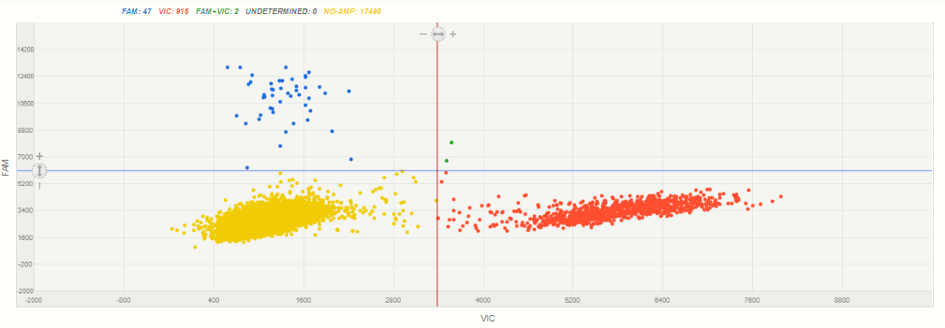
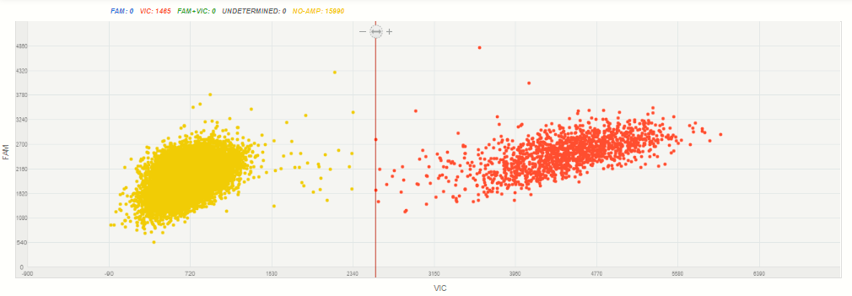
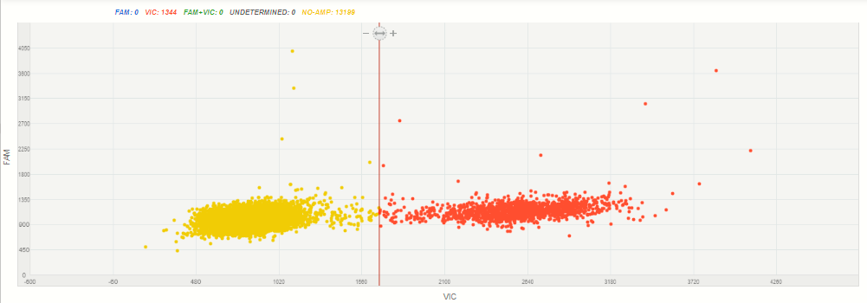
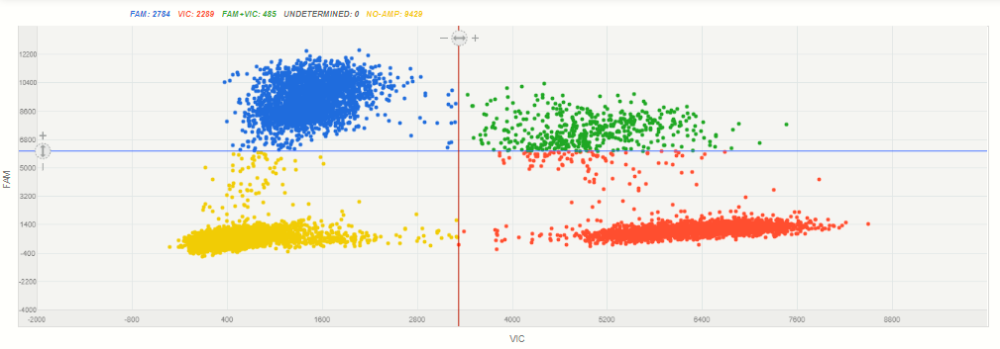
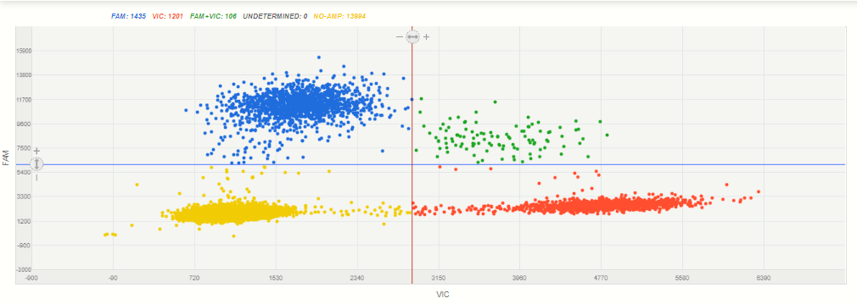
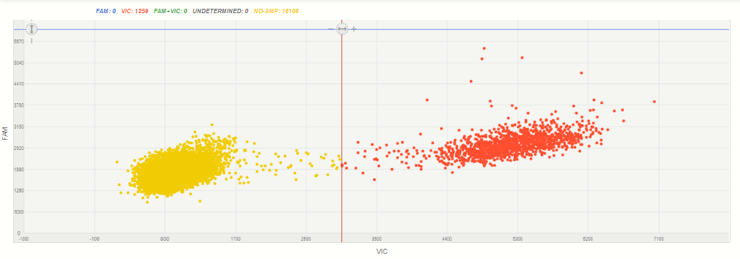
A
B
E
D
C
F
Figure S1. Most representative positive cases by Digital PCR. Image A, C and E correspond to positive model cases from mutation H1047R, E545K and H1047L respectively. Image B, D and F correspond to negative cases from same mutations respectively. The blue dots (FAM) represent the mutant alleles, the red dots (VIC) are the wild type alleles, the yellow dots represent the wells without PCR reaction and the green dots are those with both wild and mutant alleles.

Digital PCR Calibration Process
The Total mutant allele frequency (TMAF) is the proportion of mutant alleles over the sum of wild and mutant alleles. We considered a patient to be positive for a mutation when she had at least one blue dot and a percentage of TMAF higher than 0.23%. This cutoff was established by a dilution assay, where we mixed a control positive case (per mutation) at different concentrations (1%, 0.1% and 0.01%) with DNA from a healthy control. Then Limit of Detection (LOD) and Limit of Quantitation (LOQ) were calculated based on the standard deviation of the response and the slope (1). The standard error of the y-intercepts from the regression line was used as standard deviation for LOD and LOQ calculation.
Results of the dilution and intra-rater assay
In order to define the lowest mutant frequency to be detected by QuantStudio 3D digital PCR system, we performed a dilution assay. One highly positive case per mutation was selected as positive control and mixed at different concentrations with wild type DNA from peripheral blood from healthy controls. LOD for H1047R, E545K, H1047L and the three mutations together were: 0.04, 0.02, 0.11 and 0.08%, respectively. Meanwhile, LOQ for H1047R, E545K, H1047L and the three mutations together were: 0.11, 0.06, 0.34 and 0.23%, respectively. Further, to assess the reliability of the researcher performing dPCR, an intra-rater assay was carried out with 10 paired samples. The assay estimated an ICC of 0.998 (CI 95%: 0.992 – 0.999).

Sample | Theorical Target/total (Y) | Target/Total (X) | CI Target/Total | Copies/microliter  (VIC) | CI Copies/microliter  (VIC) | Copies/microliter (FAM) | CI Copies/microliter (FAM) | Chips
d20R-1% | 1.00% | 0.82% | 0.602% -- 1.123% | 3692.6 | 3581.1 -- 3807.6 | 30.665 | 22.578 -- 41.649 | 1
d20R-0.10% | 0.10% | 0.20% | 0.107% -- 0.367% | 3831.8 | 3719.3 -- 3947.7 | 7.62 | 4.1 -- 14.161 | 1
d20R-0.01% | 0.01% | 0.12% | 5.23E-2% -- 0.253% | 4438.7 | 4306.5 -- 4574.9 | 5.138 | 2.308 -- 11.437 | 1
Supplementary Tables 6: PIK3CA H1047R mutations dilution assay by dPCR.
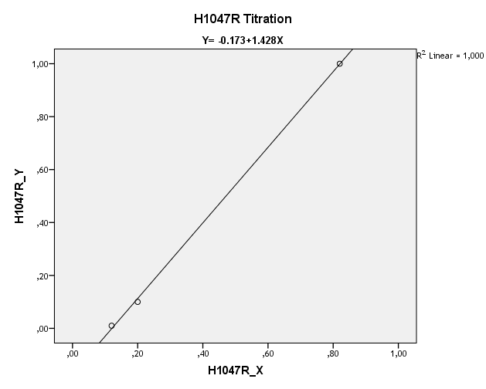
Linear Regression Output
Observations | 3
R square | 1.00
Adjusted R square | 0.999
Prob > F | 0.014
LOD | 0.04
lOQ | 0.11

 | coefficients | standard error | t | p | 95% CI
Variable (x) | 1.428 | 0.032 | 44.841 | 0.014 | 1.024 | 1.833
Y intercept | -0.173 | 0.016 | -11.022 | 0.058 | -0.372 | 0.026

Supplementary tables 7: PIK3CA H1047L mutations dilution assay by dPCR.
Sample | Theorical Target/total (Y) | Target/Total (X) | CI Target/Total | Copies/microliter (VIC) | CI Copies/microliter (VIC) | Copies/microliter (FAM) | CI Copies/microliter (FAM) | Chips
Dl-1 | 1% | 0.88% | 0.568% -- 1.371% | 1754.3 | 1680.7 -- 1831.2 | 15.641 | 10.09 -- 24.243 | 1
dl-0.1 | 0.10% | 0.14% | 4.77E-2% -- 0.419% | 1727 | 1651.5 -- 1805.9 | 2.455 | 0.792 -- 7.612 | 1
dl-0.01 | 0.01% | 0% | NA | 1631.3 | 1561.9 -- 1703.9 | 0 | NA | 1

Linear Regression Output
Observations | 3
R square | 0.996
Adjusted R square | 0.991
P> F | 0.042
LOD | 0.11
lOQ | 0.34
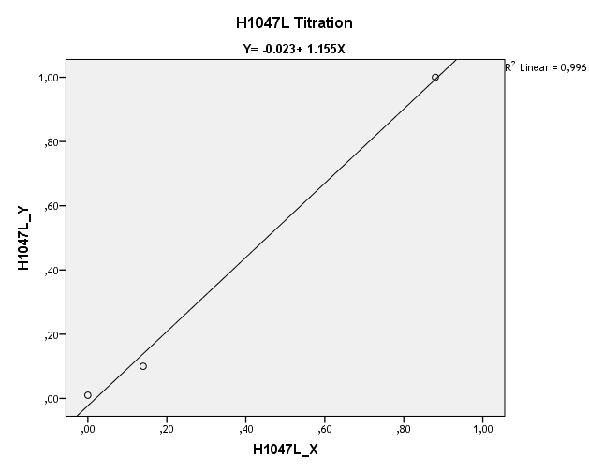

 | coefficients | standard error | t | p | 95% CI
Variable (x) | 1.155 | 0.077 | 15.064 | 0.042 | 0.181 | 2.130000
Y intercept | -0.023 | 0.039 | -0.577 | 0.667 | -0.524 | 0.4790000

Supplementary tables 8: PIK3CA E545K mutations dilution assay by dPCR.
Sample | Theorical Target/total (Y) | Target/Total (X) | CI Target/Total | Copies/microliter (VIC) | CI Copies/microliter (VIC) | Copies/microliter (FAM) | CI Copies/microliter (FAM) | Chips
d9-1 | 1.00% | 0.92% | 0.758% -- 1.118% | 9479.5 | 9268 -- 9695.9 | 88.261 | 73.395 -- 106.14 | 1
d9-0.1 | 0.10% | 0.10% | 5.42E-2% -- 0.177% | 8792.3 | 8599.3 -- 8989.5 | 8.664 | 4.798 -- 15.646 | 1
d9-0.01 | 0.01% | 0.03% | 1.23E-2% -- 8.37E-2% | 9634.7 | 9425.3 -- 9848.7 | 3.128 | 1.174 -- 8.335 | 1
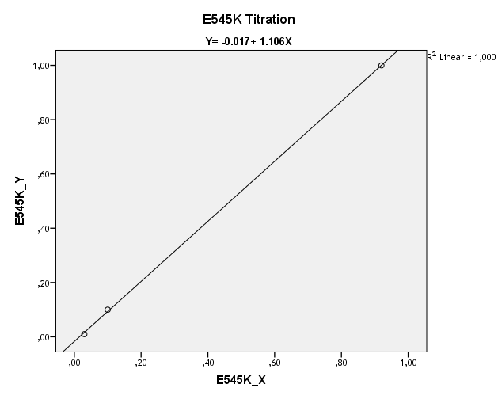
Linear Regression Output
Observations | 3
R square | 1.00
Adjusted R square | 1.00
Prob > F | 0.00891
LOD | 0.02
lOQ | 0.06

 | coefficients | standard error | t | p | 95% CI
Variable (x) | 1.106 | 0.013 | 86.891 | 0.007 | 0.944 | 1.268
Y intercept | -0.017 | 0.007 | -2.521 | 0.240 | -0.104 | 0.069

Supplementary tables 9: PIK3CA mutations dilution assay by dPCR.
Sample | Theorical Target/total (Y) | Target/Total (X) | CI Target/Total | Copies/microliter (VIC) | CI Copies/microliter (VIC) | Copies/microliter (FAM) | CI Copies/microliter (FAM)
d20R-1% | 1.00% | 0.82% | 0.602% -- 1.123% | 3692.6 | 3581.1 -- 3807.6 | 30.665 | 22.578 -- 41.649
d20R-0.10% | 0.10% | 0.20% | 0.107% -- 0.367% | 3831.8 | 3719.3 -- 3947.7 | 7.62 | 4.1 -- 14.161
d20R-0.01% | 0.01% | 0.12% | 5.23E-2% -- 0.253% | 4438.7 | 4306.5 -- 4574.9 | 5.138 | 2.308 -- 11.437
d9-1 | 1.00% | 0.92% | 0.758% -- 1.118% | 9479.5 | 9268 -- 9695.9 | 88.261 | 73.395 -- 106.14
d9-0.1 | 0.10% | 0.14% | 5.42E-2% -- 0.177% | 8792.3 | 8599.3 -- 8989.5 | 8.664 | 4.798 -- 15.646
d9-0.01 | 0.01% | 0.03% | 1.23E-2% -- 8.37E-2% | 9634.7 | 9425.3 -- 9848.7 | 3.128 | 1.174 -- 8.335
Dl-1 | 1.00% | 0.88% | 0.568% -- 1.371% | 1754.3 | 1680.7 -- 1831.2 | 15.641 | 10.09 -- 24.243
dl-0.1 | 0.10% | 0.14% | 4.77E-2% -- 0.419% | 1727 | 1651.5 -- 1805.9 | 2.455 | 0.792 -- 7.612
dl-0.01 | 0.01% | 0.00% | NA | 1631.3 | 1561.9 -- 1703.9 | 0 | NA

Linear Regression Output
R square | 0.986
Adjusted R square | 0.984
P> F | 0
observations | 9
LOD | 0.08
lOQ | 0.23

 | coefficients | standard error | t | p | 95% CI
Variable (x) | 1.208 | 0.055 | 22.014 | 0.000 | 1.079 | 1.338
Y intercept | -0.066 | 0.028 | -2.346 | 0.051 | -0.133 | 0.001

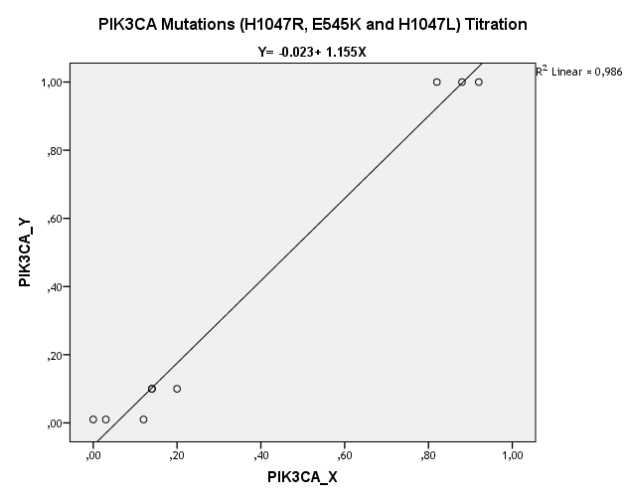

Supplementary Table 10: Inter-rater assay results from mutant allele frequency.
Patient sample | First Assay | Second Assay
I-02 (H1047R) | 57.940% | 54.300%
I-02 (H1047L) | 0.065% | 0.061%
I-24 (E545K) | 54.590% | 51.290%
I-28 (H1047L) | 0.300% | 0.000%
I-33 (H1047R) | 0.000% | 0.000%
I-35 (H1047L) | 0.853% | 0.807%
I-65 (H1047L) | 0.000% | 0.034%
I-68 (H1047R) | 0.020% | 0.000%
I-68 (H1047L) | 0.025% | 0.000%
I-70 (H1047L) | 5.131% | 3.402%

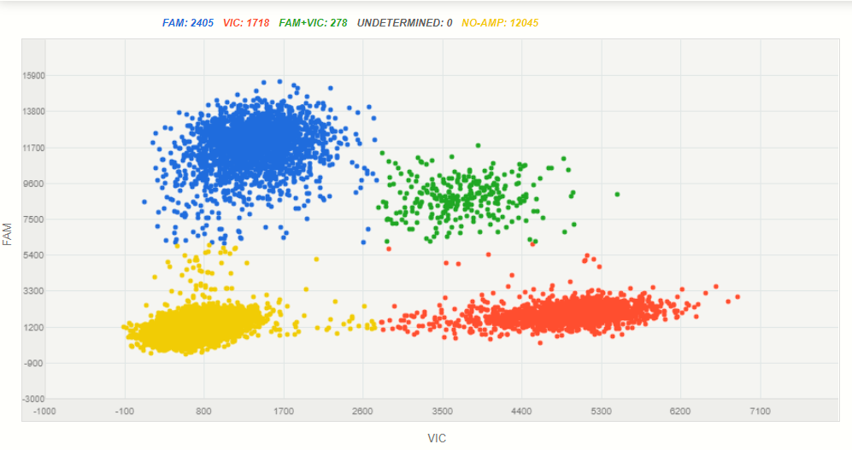
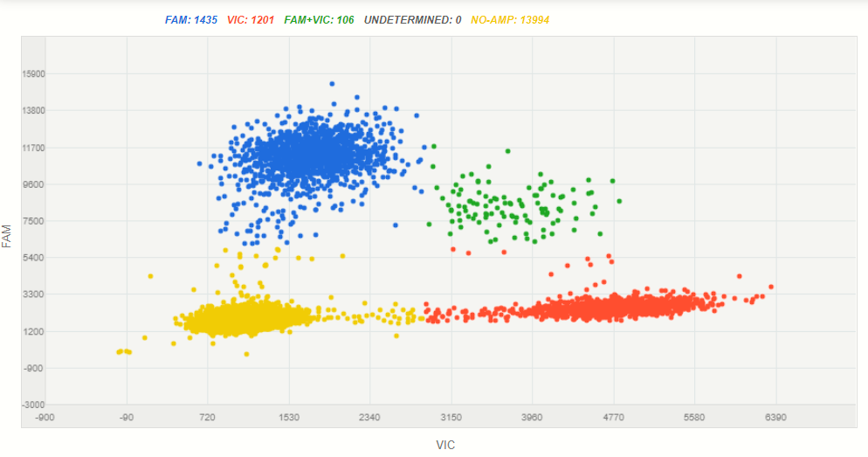
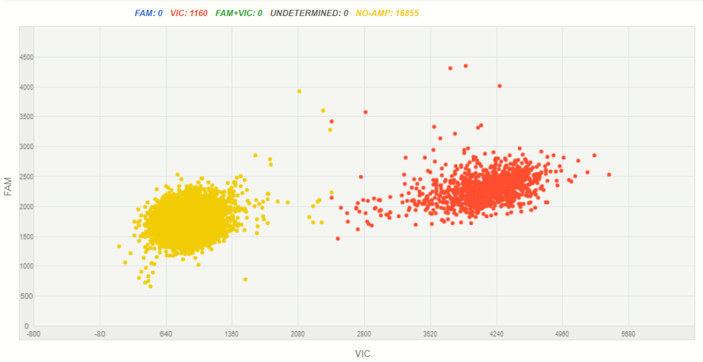
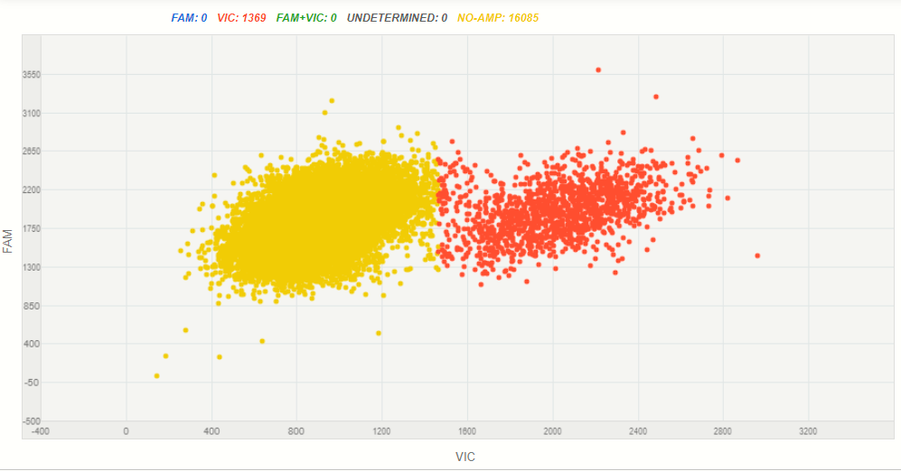
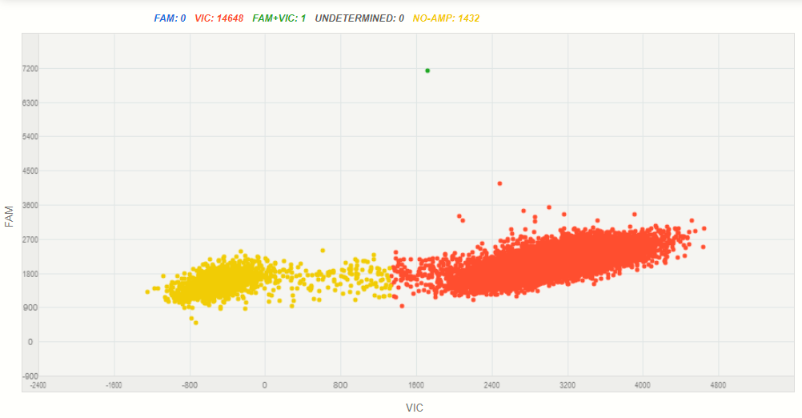
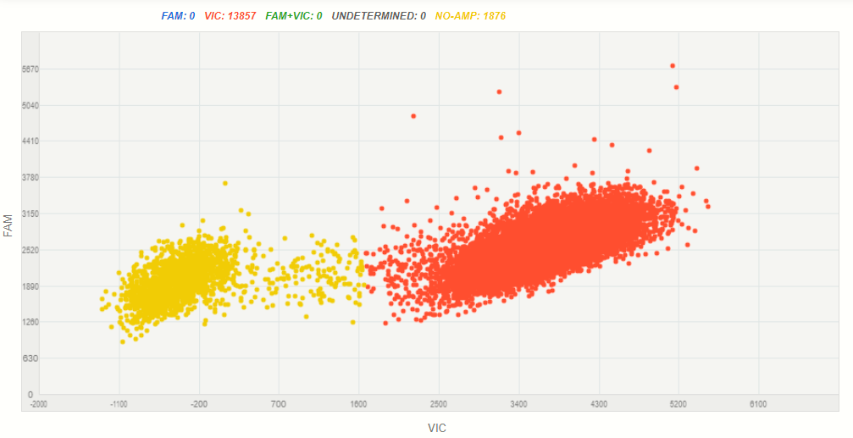
A-I
B-I
A-II
B-II
C-I
C-II
Figure S2: Three examples from the dilution assays´s samples, figure A I and II correspond to sample I-02 H1047R, B I and II to I-33 H1047R, C I and II to I-68 H1047L.

References:
- International Council for Harmonisation of Technical Requirements for Pharmaceuticals for Human Use (ICH). Validation of Analytical Procedures: Text and Methodology Q2(R1). [Internet]. Available at: http://www.ich.org/products/guidelines/quality/article/quality-guidelines.html

Supplementary Material 2: Digital MIQE checklist for authors, reviewers and editors
ITEM TO CHECK | IMPORTANCE | CHECKLIST
EXPERIMENTAL DESIGN
Definition of experimental and control groups | E | Materials & Methods
Number within each group | E | Materials & Methods
Assay carried out by core lab or investigator's lab? | D | Core Laboratory
Power analysis | D | Not applicable
SAMPLE
Description | E | Materials & Methods
Volume/mass of sample processed | D | Not applicable
Microdissection or macrodissection | E | Not applicable
Processing procedure | E | Materials & Methods
If frozen - how and how quickly? | E | Not applicable
If fixed - with what, how quickly? | E | Not available
Sample storage conditions and duration (especially for FFPE samples) | E | Materials & Methods
NUCLEIC ACID EXTRACTION
Nucleic acid quantification | E | NanoDropTM Lite Spectrophotometer (ThermoFisher Scientific, Boston, MA, USA).
DNA or RNA quantification | E | DNA
Quality/Integrity, method/instrument, e.g. RNA integrity | E | Supplementary Material 1
Template structural information | E | Not applicable
Template modification (digestion, sonication, preamplification etc) | E | Not applicable
Template treatment | E | Not applicable
Inhibition dilutions or spike | E | Not applicable
DNA contamination assessment of RNA samples | E | Not applicable
Details of DNase treatment where performed | E | Not applicable
Manufacturer of reagents used and catalogue number | D | Materials & Methods/Additional Files
Storage conditions (Nucleic acid): temperature, concentration, duration, buffer) | E | Materials & Methods
REVERSE TRANSCRIPTION (if necessary)
cDNA priming method and concentration | E | Not applicable
One or two-step protocol | E | Not applicable
Amount of RNA used per reaction | E | Not applicable
Detailed reaction components and conditions | E | Not applicable
RT efficiency | D | Not applicable
Estimated copies measured with and without addition of RT | D | Not applicable
Manufacturer of reagents and catalogue numbers | D | Not applicable
Reaction volume | D | Not applicable
Storage conditions of cDNA | D | Not applicable
dPCR TARGET INFORMATION |  | N/A
Sequence accession number | E | Included in article
Location of amplicon | D | Not applicable
Amplicon length | E | Not applicable
In silico specificity screen (BLAST, etc) | E | Not applicable
Pseudogenes, retropseudogenes or other homologs? | D | Not applicable
Sequence alignment | D | Not applicable
Secondary structure analysis of amplicon and GC content | D | Not applicable
Location of each primer by exon or intron (if applicable) | E | Not applicable
What splice variants are targeted? | E | Not applicable
dPCR OLIGONUCLEOTIDES
Primer sequences | E | Not available
RTPrimerDB Identification Number | D | Not available
Probe sequences | D | Not available
Location and identity of any modifications | E | Not available
Manufacturer of oligonucleotides | D | Not available
Purification method | D | Not available
dPCR PROTOCOL |  | Supplementary Information 2, Table S1
Complete reaction conditions | E | Materials & Methods
Reaction volume and amount of cDNA/DNA | E | Materials & Methods
Primer, (probe), Mg++ and dNTP concentrations | E | Materials & Methods
Polymerase identity and concentration | E | Materials & Methods
Buffer/kit identity and manufacturer | E | Materials & Methods/ Supplementary Material 1
Exact chemical constitution of the buffer | D | Not available
Additives (SYBR Green I, DMSO, etc.) | E | Not applicable
Plates/tubes catalogue number and manufacturer | D | Materials & Methods/ Supplementary Material 1
Complete thermocycling parameters | E | Materials & Methods
Reaction setup (manual/robotic) | D | Manual
Gravimetric or volumetric dilutions (manual/robotic) | D | Volumetric dilutions
Total PCR volume prepared | D | Materials & Methods
Partition number | E | Supplementary Material 1
Individual partition volume | E | Supplementary Material 1
Total volume of the partitions measured (effective reaction size) | E | Supplementary Material 1
Partition volume variance/SD | D | Not available
Comprehensive details and appropriate use of controls | E | Materials & Methods
Manufacturer of dPCR instrument | E | Materials & Methods
dPCR VALIDATION
Optimisation data for the assay | D | Materials & Methods (dilution essay)
Specificity (when measuring rare mutations, pathogen sequences etc) | E | Results: ROC curve (dPCR vs Sanger sequencing)
Limit of detection of calibration control | D | Materials & Methods, Additional File
If multiplexing, comparison with singleplex assays | E | Not applicable
DATA ANALYSIS
Mean copies per partition (λ or equivalent) | E | Supplementary Material 1
dPCR analysis program (source, version) | E | Available upon request
Outlier identification and disposition | E | QuantStudio 3D Analysis SuiteTM Cloud Software
Results of NTCs | E | Available upon request
Examples of positive(s) and negative experimental results as supplemental data | E | Supplementary Material 1
Where appropriate, justification of number and choice of reference genes | E | Included in article
Where appropriate, description of normalization method | E | Not applicable
Number and concordance of biological replicates | D | Not applicable
Number and stage (RT or qPCR) of technical replicates | E | Not applicable
Repeatability (intra-assay variation) | E | Materials & Methods, Results and Supplementary Material 1
Reproducibility (inter-assay/user/lab etc variation) | D | Not applicable
Experimental variance or CI d | E | Materials & Methods
Statistical methods for analysis | E | Materials & Methods
Data submission using RDML (Real-time PCR Data Markup Language) | D | Not applicable
E: Essential information; D: Desirable information.

