Supplementry File
Article
Stress effect of food matrices on viability of probiotic cells during model digestion
Petra Matouskova¹, Julie Hoova¹ , Petr Rysavka² and Ivana Marova ^{1,}*
¹ Brno University of Technology, Faculty of Chemistry, Purkynova 118, 61200 Brno, Czech Republic; marova@fch.vut.cz
² Pharmaceutical Biotechnology, Ltd., Slezska 949/32, 12000 Prague, rysavka.petr@seznam.cz
* Correspondence: marova@fch.vut.cz; Tel.: +420 541149419 (I.M.)

List of Figures:

Figure S1: Bacteria Lactobacilus acidophilus, Bifidobacterium breve and commercial probiotic mixture cultivated for 48 hours in MRS agar

Figure S2. Viability of probiotics analyzed by flow cytometry – results of analysis of commercial probiotic mixture incubated in water medium.

 | 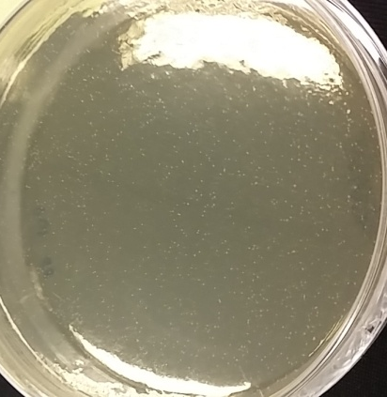 | 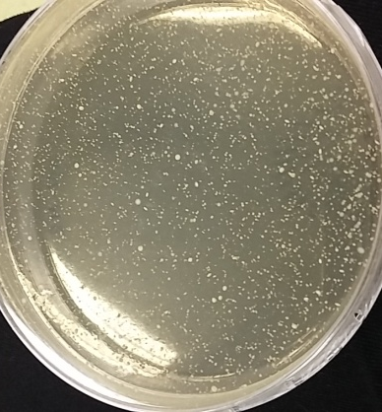
Lactobacilus acidophilus | Bifidobacterium breve | Commercial probiotic mixture

Figure S1: Bacteria Lactobacilus acidophilus, Bifidobacterium breve and commercial probiotic mixture cultivated for 48 hours in MRS agar
Note: During analysis of viability by cultivation method, cells in model and real samples were diluted to approx. 10⁴ cells, placed on Petri dish and over-layered by agar medium to reduce oxygen presence.

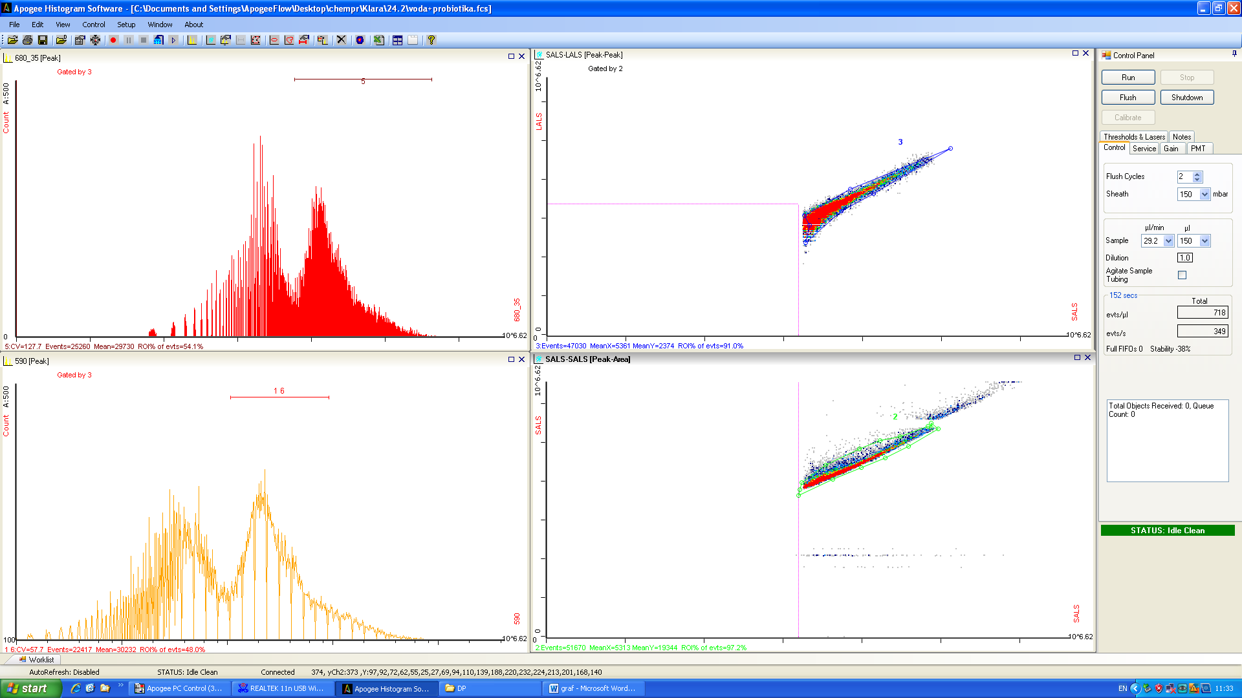

Figure S2. Viability of probiotics analyzed by flow cytometry – results of analysis of commercial probiotic mixture incubated in water medium.

