Table S1. Metrics of Nanopore datasets

Readset | All reads | Longest reads | Filtlong reads
Cumulative size | 93,615,101,387 | 15,000,004,992 | 15,000,009,495
Coverage | 186x | 30x | 30x
Number of reads | 13,094,187 | 214,687 | 316,605
N50 | 26,978 | 68,127 | 50,558
Number of  reads > 50kb | 296,164 | 214,687 | 117,159
coverage > 50kb | 38x | 30x | 15x

Table S2. Metrics of raw Smartdenovo Nanopore assemblies. Statistics were generated on contigs of more than 30kb in size.

Readset | All reads | Longest reads | Filtlong reads
Cumulative size | 413,393,283 | 354,455,409 | 320,273,956
Number of contigs | 596 | 323 | 429
N50 (L50) | 10,591,557 (14) | 4,616,132 (19) | 2,264,044 (35)
N90 (L90) | 246,123 (185) | 326,576 (146) | 263,776 (203)
auN | 9,674,642 | 6,312,816 | 3,679,656
Max. size | 27,174,673 | 18,229,467 | 17,762,612
Complete buscos (%) | 1,576 (97.6%) | 1,436 (88.9%) | 1,557 (96.5%)
Merqury score | 25.1333 | 20.3158 | 23.8738

Table S3. Metrics of raw Flye Nanopore assemblies. Statistics were generated on contigs of more than 30kb in size.

Readset | All reads | Longest reads | Filtlong reads
Cumulative size | 308,405,611 | 340,681,490 | 320,203,564
Number of contigs | 195 | 266 | 382
N50 (L50) | 8,877,964 (12) | 13,456,414 (10) | 6,180,078 (13)
N90 (L90) | 974,980 (48) | 497,751 (58) | 310,436 (106)
auN | 9,118,954 | 12,335,383 | 8,103,042
Max. size | 21,466,788 | 27,098,069 | 22,540,294
Complete buscos (%) | 1,585 (98.2%) | 1,584 (98.1%) | 1,594 (98.8%)
Merqury score | 28.7338 | 27.4808 | 28.0033

Table S4. Metrics of raw Wtdbg2 Nanopore assemblies. Statistics were generated on contigs of more than 30kb in size.

Readset | All reads | Longest reads | Filtlong reads
Cumultive size | 728,902,491 | 541,375,314 | 381,524,645
Number of contigs | 9,550 | 5,095 | 3,213
N50 (L50) | 87,609 (2,265) | 142,868 (574) | 206,244 (357)
N90 (L90) | 38,374 (7,405) | 42,678 (3,598) | 44,750 (2,179)
auN | 144,875 | 654,911 | 450,988
Max. size | 1,853,134 | 6,900,900 | 3,496,279
Complete buscos (%) | 1,455 (90.1%) | 1,365 (84.6%) | 1,402 (86.9%)
Merqury score | 17.4181 | 15.9445 | 18.4839

Table S5. Metrics of the raw Necat Nanopore assembly. Statistics were generated on contigs of more than 30kb in size.

Readset | All reads
Cumulative size | 442,919,932
Number of contigs | 299
N50 (L50) | 10,445,217 (12)
N90 (L90) | 856,761 (58)
auN | 14,175,039
Max. size | 45,040,585
Complete buscos (%) | 1,567 (97.1%)
Merqury score | 27.513

Table S6. Metrics of the Necat assembly after each polishing step. Statistics were generated on contigs of more than 30kb in size.

 | Raw | Racon | Medaka | Hapo-G x2
Cumulative size | 442,919,932 | 443,505,353 | 443,619,512 | 443,649,441
Number of contigs | 299 | 299 | 299 | 299
N50 (L50) | 10,445,217 (12) | 10,458,156 (12) | 10,461,728 (12) | 10,461,875 (12)
N90 (L90) | 856,761 (58) | 857,014 (58) | 850,928 (58) | 857,267 (58)
auN | 14,175,039 | 14,197,548 | 14,204,585 | 14,202,687
Max. size | 45,040,585 | 45,103,281 | 45,117,601 | 45,115,632
Complete  buscos (%) | 1,567 (97.1%) | 1,592 (98.6%) | 1,602 (99.3%) | 1,604 (99.4%)
Merqury score | 27.513 | 29.8573 | 31.0464 | 36.4423

Table S7. Hybrid scaffolding results.

 | Nanopore contigs | Hybrid scaffolds | Contigs left | Assembly after Hybrid scaffolding | Scaffolds after BisCoT treatment | Contigs after BisCoT treatment | Scaffolds after polishing with Hapo-G
Number | 299 | 53 | 208 | 261 | 236 | 296 | 236
N50 (L50) | 10,461,875  (12) | 16,816,852  (8) | 154,636  (53) | 16,816,852  (8) | 17,017,530  (8) | 10,256,302  (14 | 17,017,634  (8)
N90 (L90) | 857,267  (58) | 4,034,000  (45) | 67,775  (152) | 1,954,922  (32) | 3,409,196  (30) | 981,751  (59) | 3,409,175  (30)
Min size | 30,349 | 118,769 | 30,349 | 30,349 | 30,347 | 30,347 | 30,348
Max size | 45,115,632 | 44,052,815 | 978,115 | 44,052,815 | 44,068,965 | 27,443,240 | 44,069,534
Cumulative size | 443,649,441 | 420,416,306 | 26,002,488 | 446,418,794 | 443,948,706 | 441,033,740 | 443,951,349
%N | 0% | 0.7% | 0% | 0.66% | 0.66% | 0% | 0.66%

Table S8. Metrics of the Pore-C raw PromethION run with (left column) or without (right column) reads of more than 100kb in size.

Readset | All reads | Reads < 100kb
Cumulative size | 15,551,590,510 | 15,502,009,110
Number of reads | 5,894,741 | 5,894,524
N50 | 3,990 | 3,990
Number of  reads > 100kb | 217 | 0
Cumulative size > 100kb | 49,581,400 | 0

Figure S1. Dotplots of polished Necat contigs aligned to Brassica rapa Chiifu (left) or Brassica napus Darmor-BZH A genome (right).

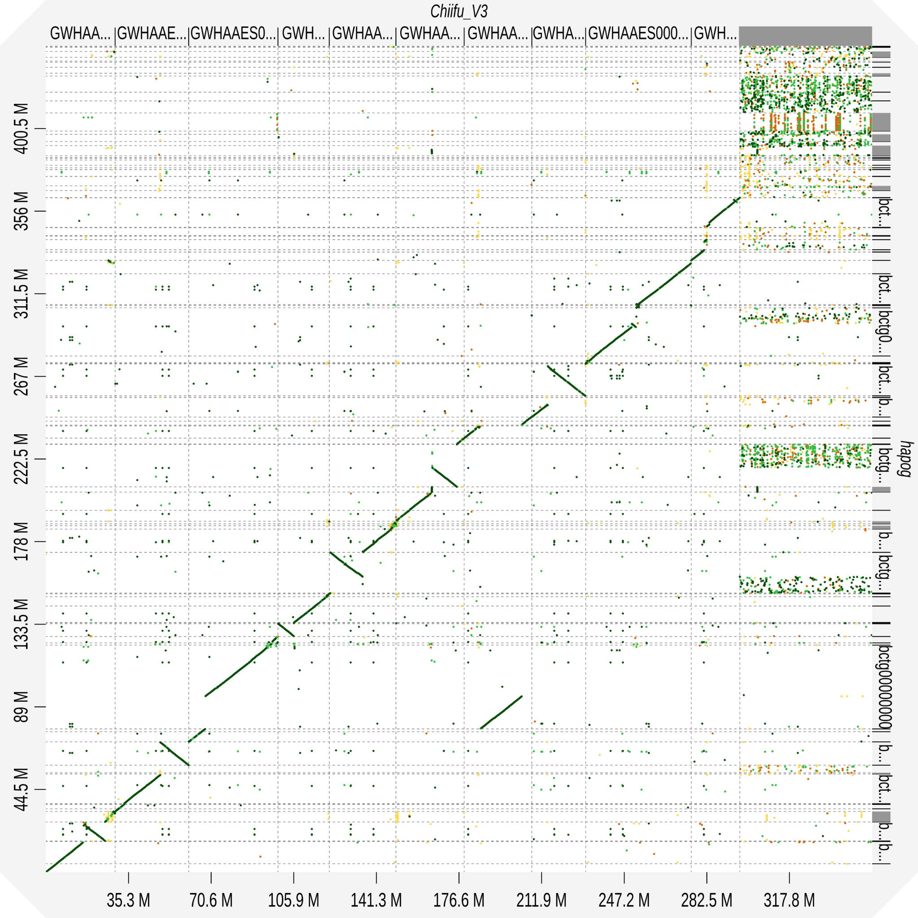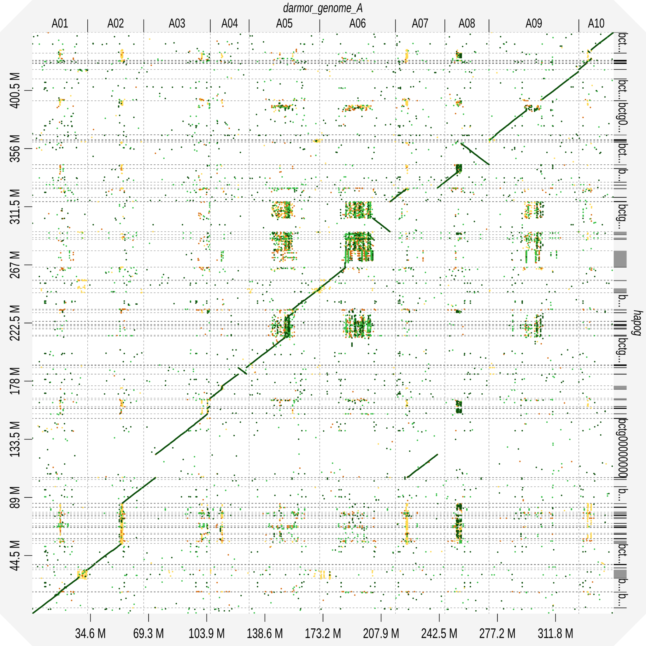

Figure S2. Dotplots of Bionano scaffolds aligned to Brassica rapa Chiifu (left) or Brassica napus Darmor-BZH A genome (right).

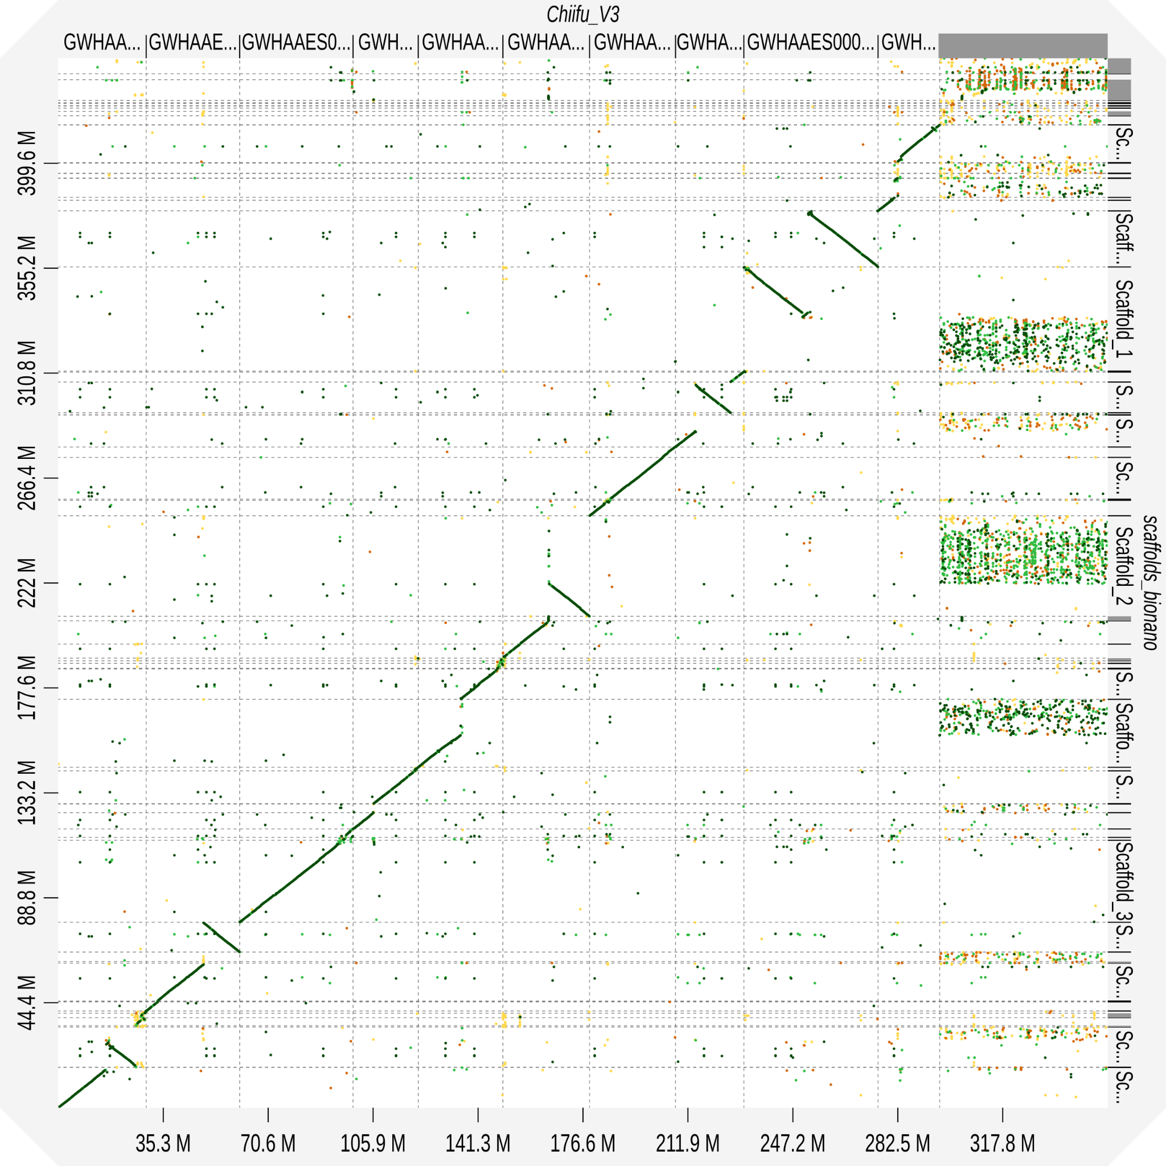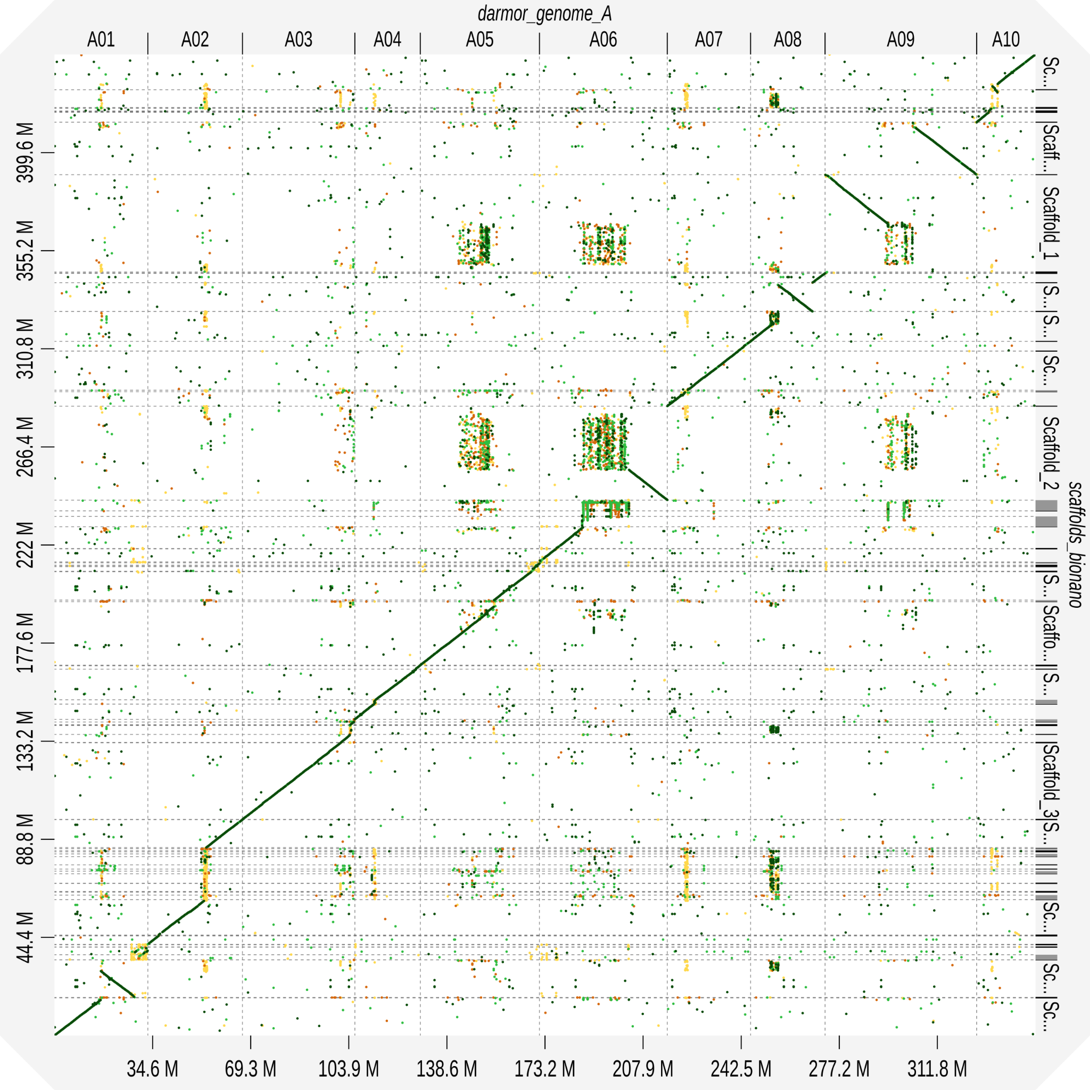

Figure S3. Dotplots of Omni-C scaffolds aligned to Brassica rapa Chiifu (left) or Brassica napus Darmor-BZH A genome (right).

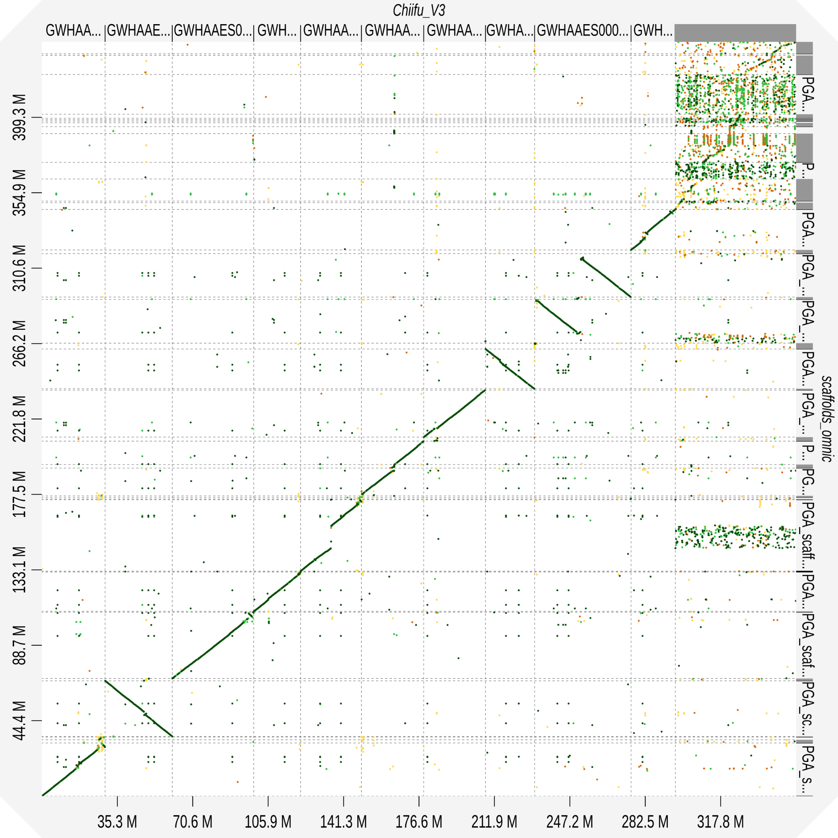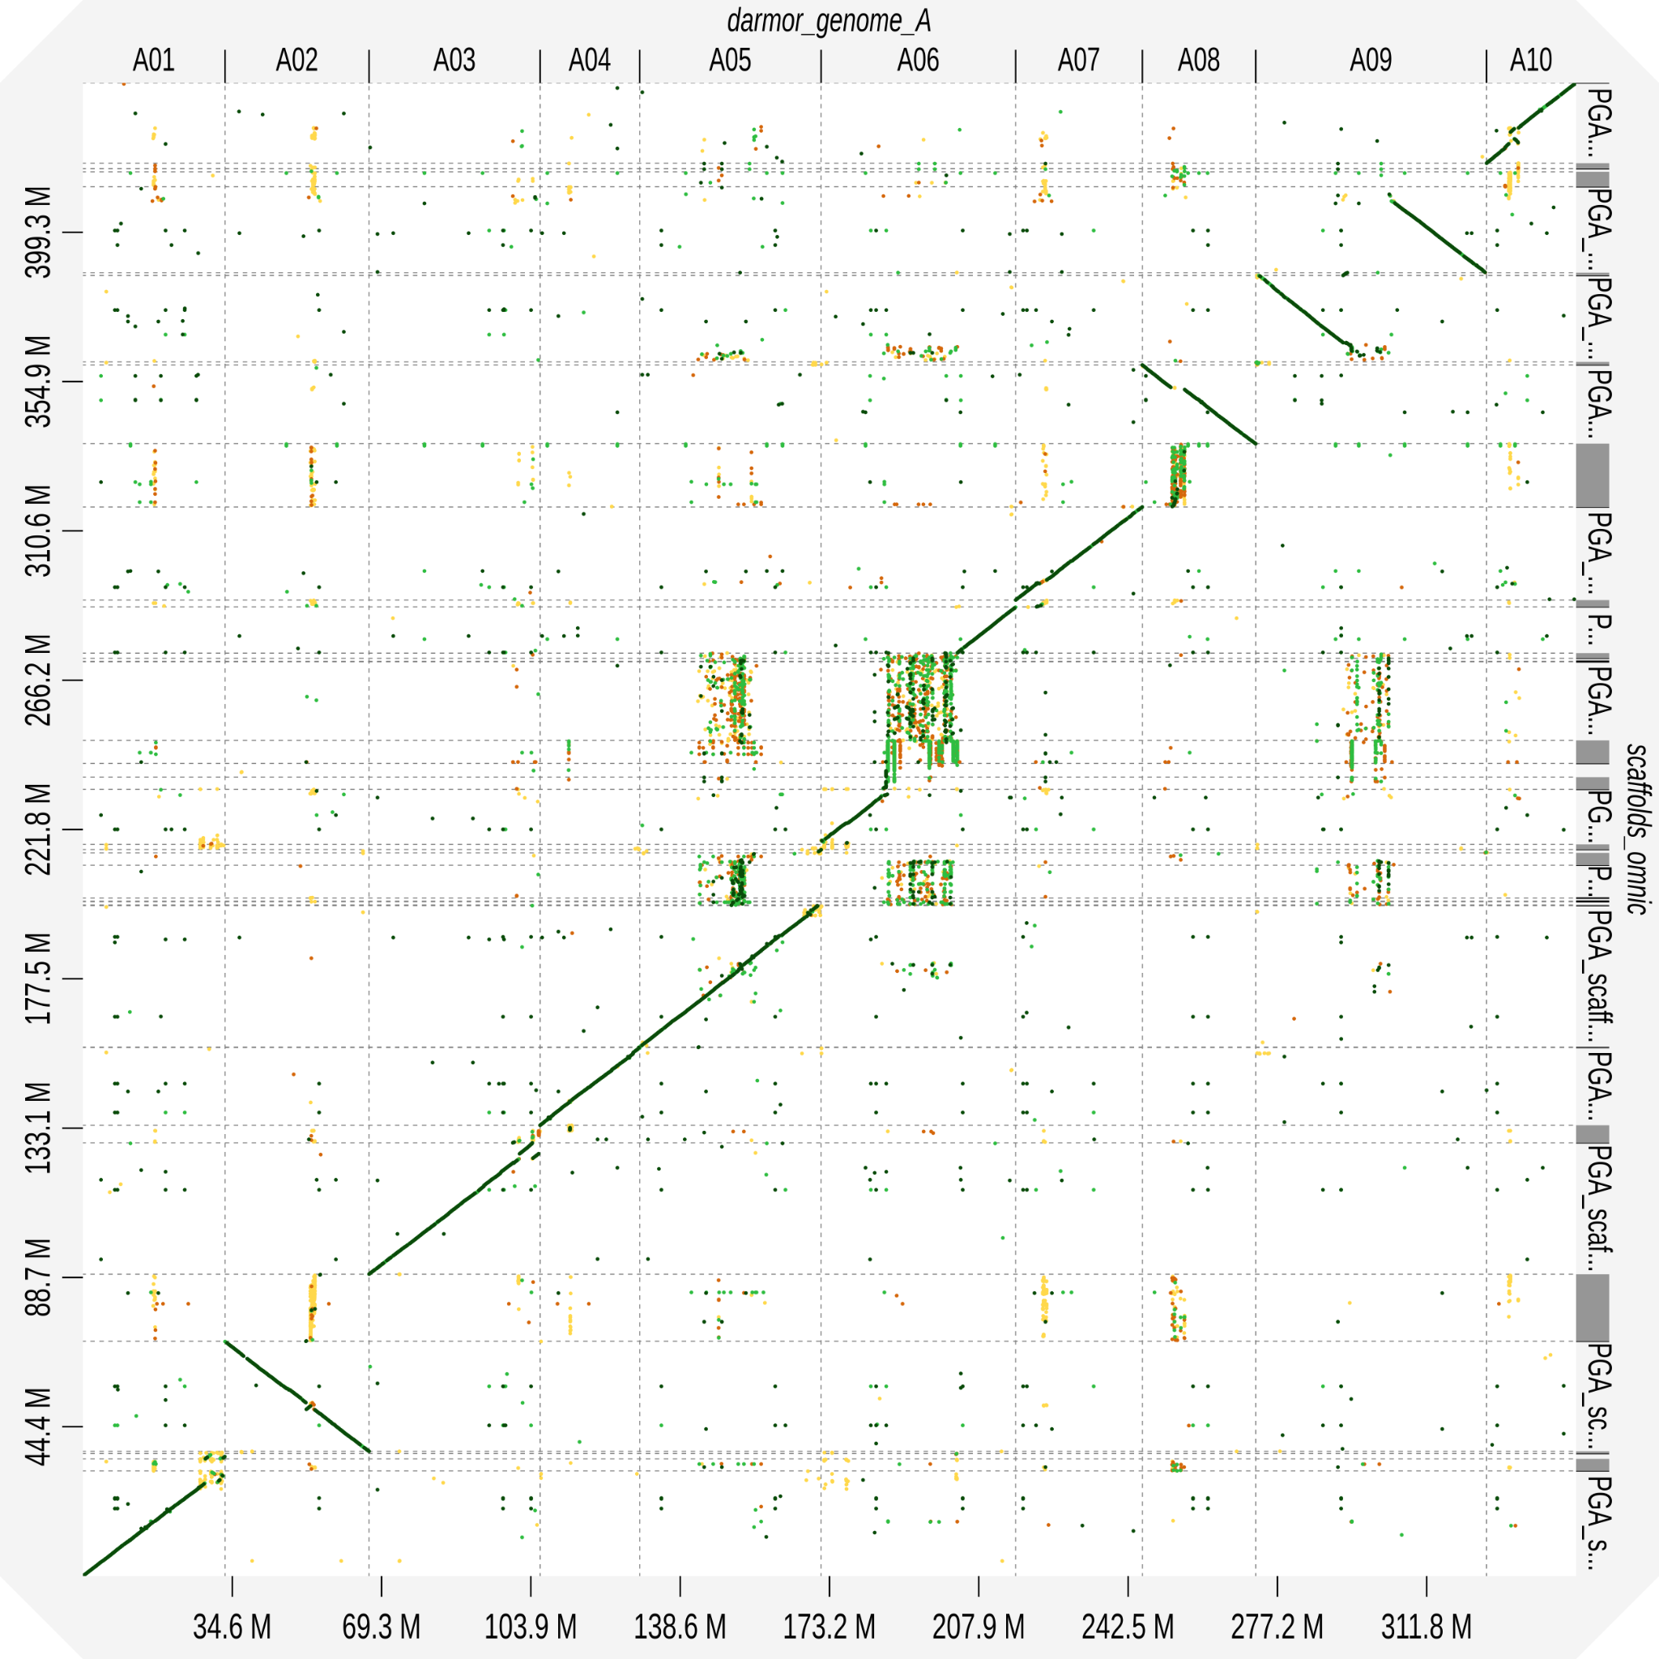

Figure S4. Dotplots of Pore-C scaffolds aligned to Brassica rapa Chiifu (left) or Brassica napus Darmor-BZH A genome (right).

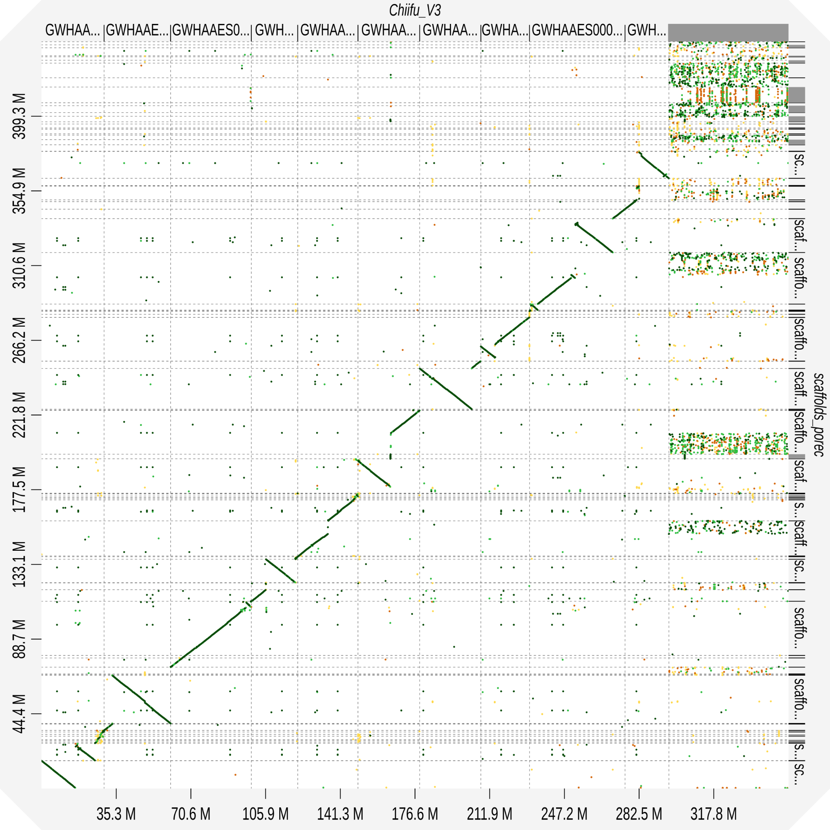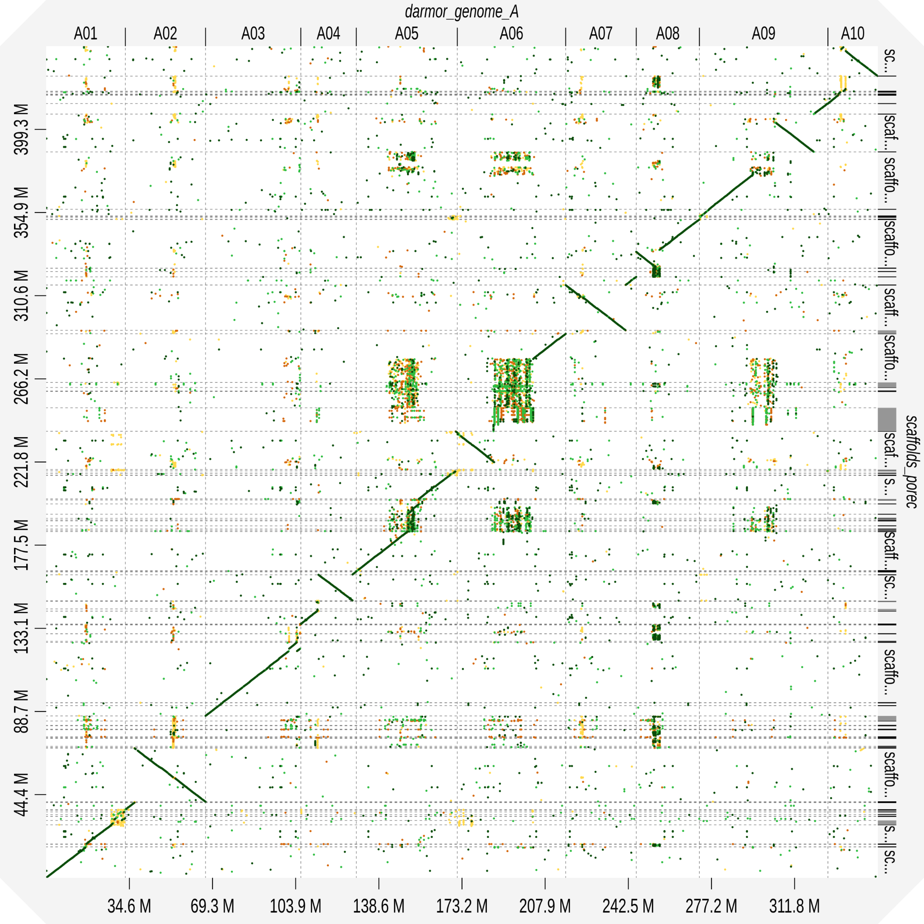

Figure S5. Dotplots of Bionano + Omni-C scaffolds aligned to Brassica rapa Chiifu (left) or Brassica napus Darmor-BZH A genome (right).

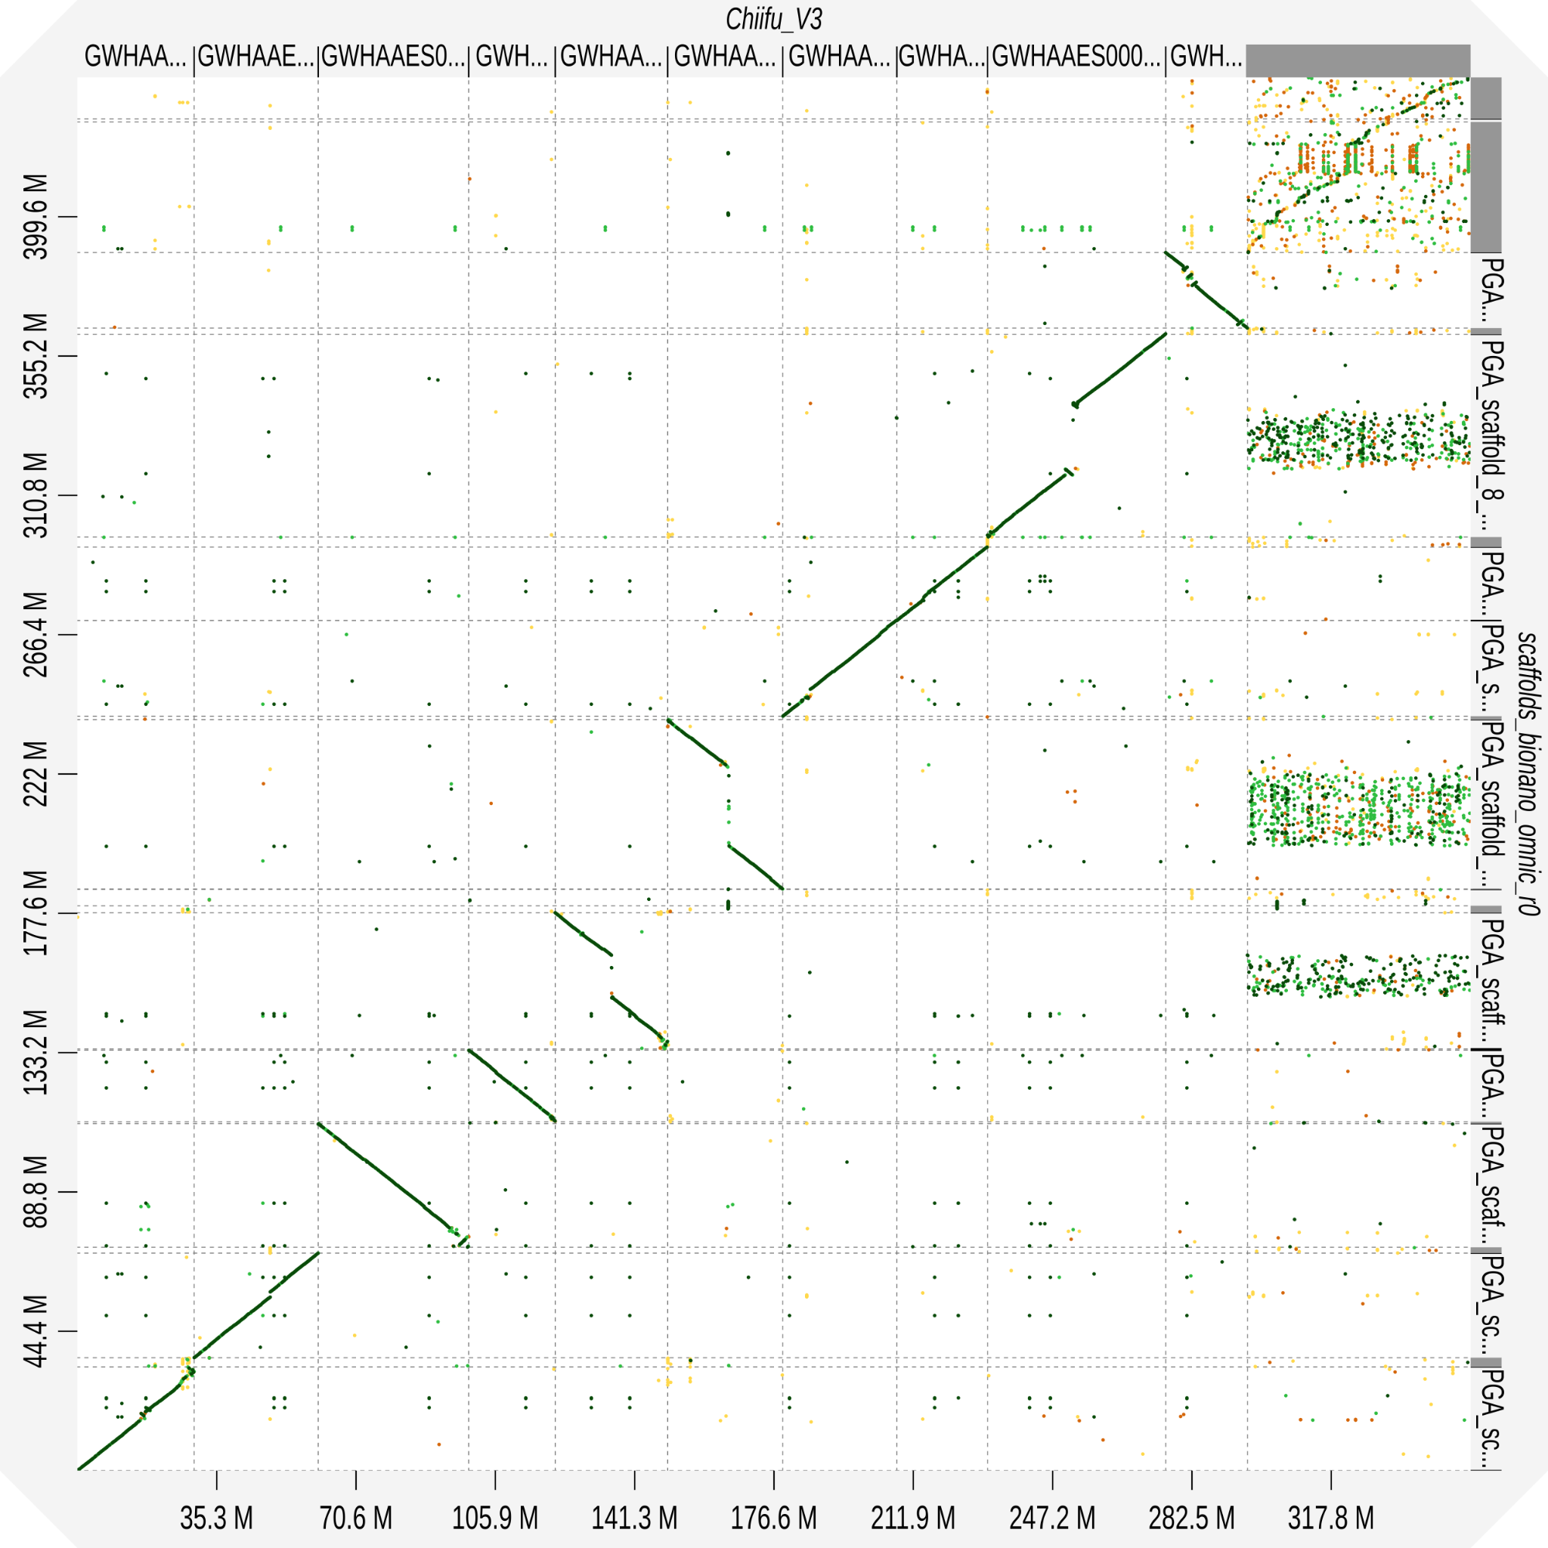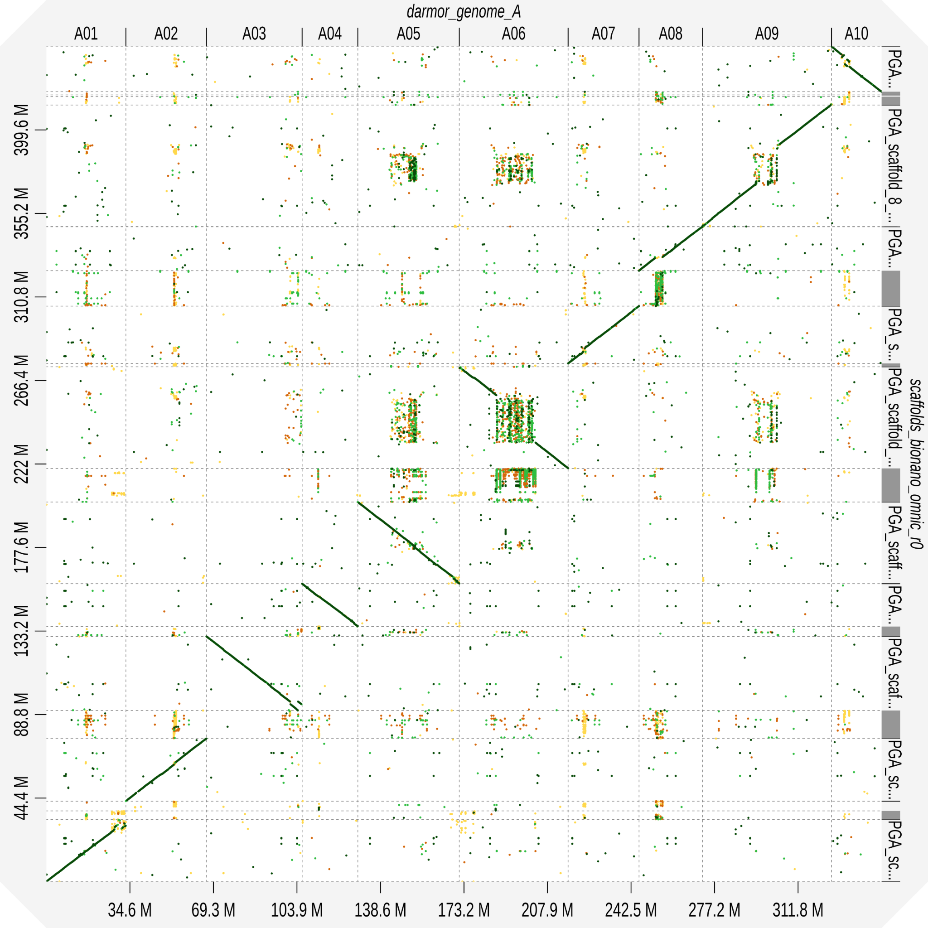

Figure S6. Dotplots of Bionano + Pore-C scaffolds aligned to Brassica rapa Chiifu (left) or Brassica napus Darmor-BZH A genome (right).

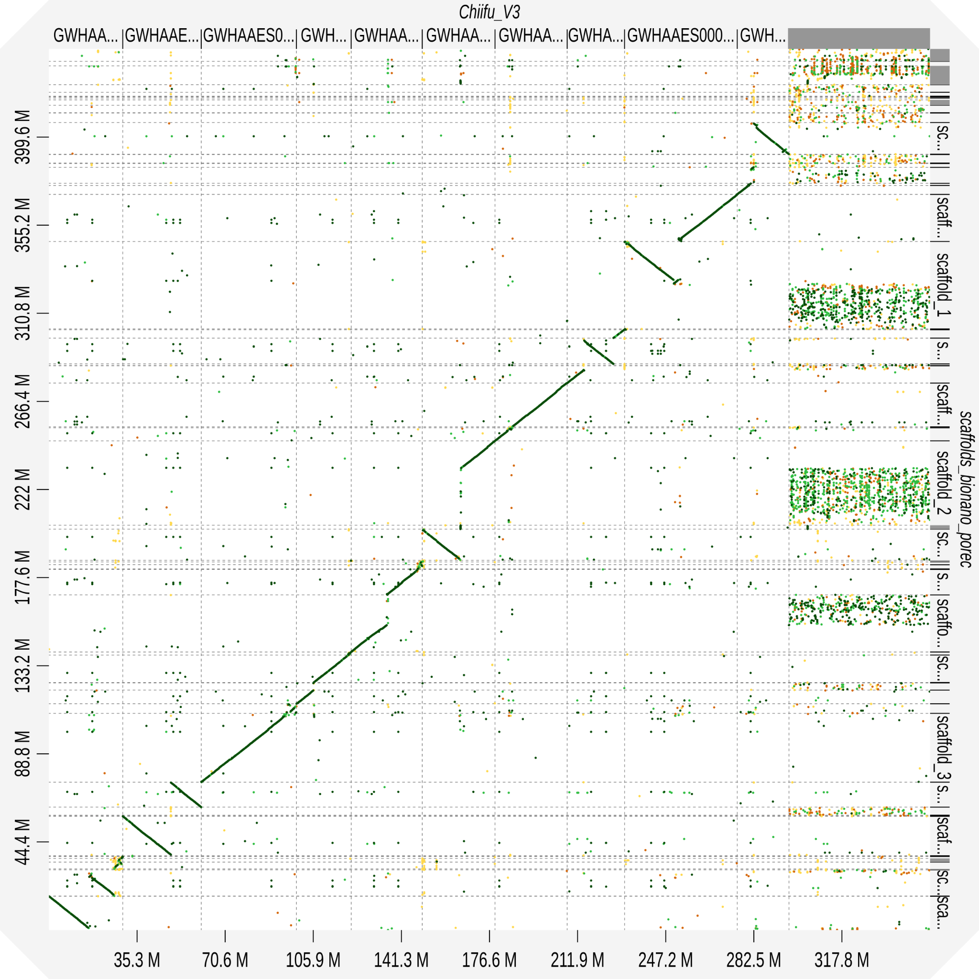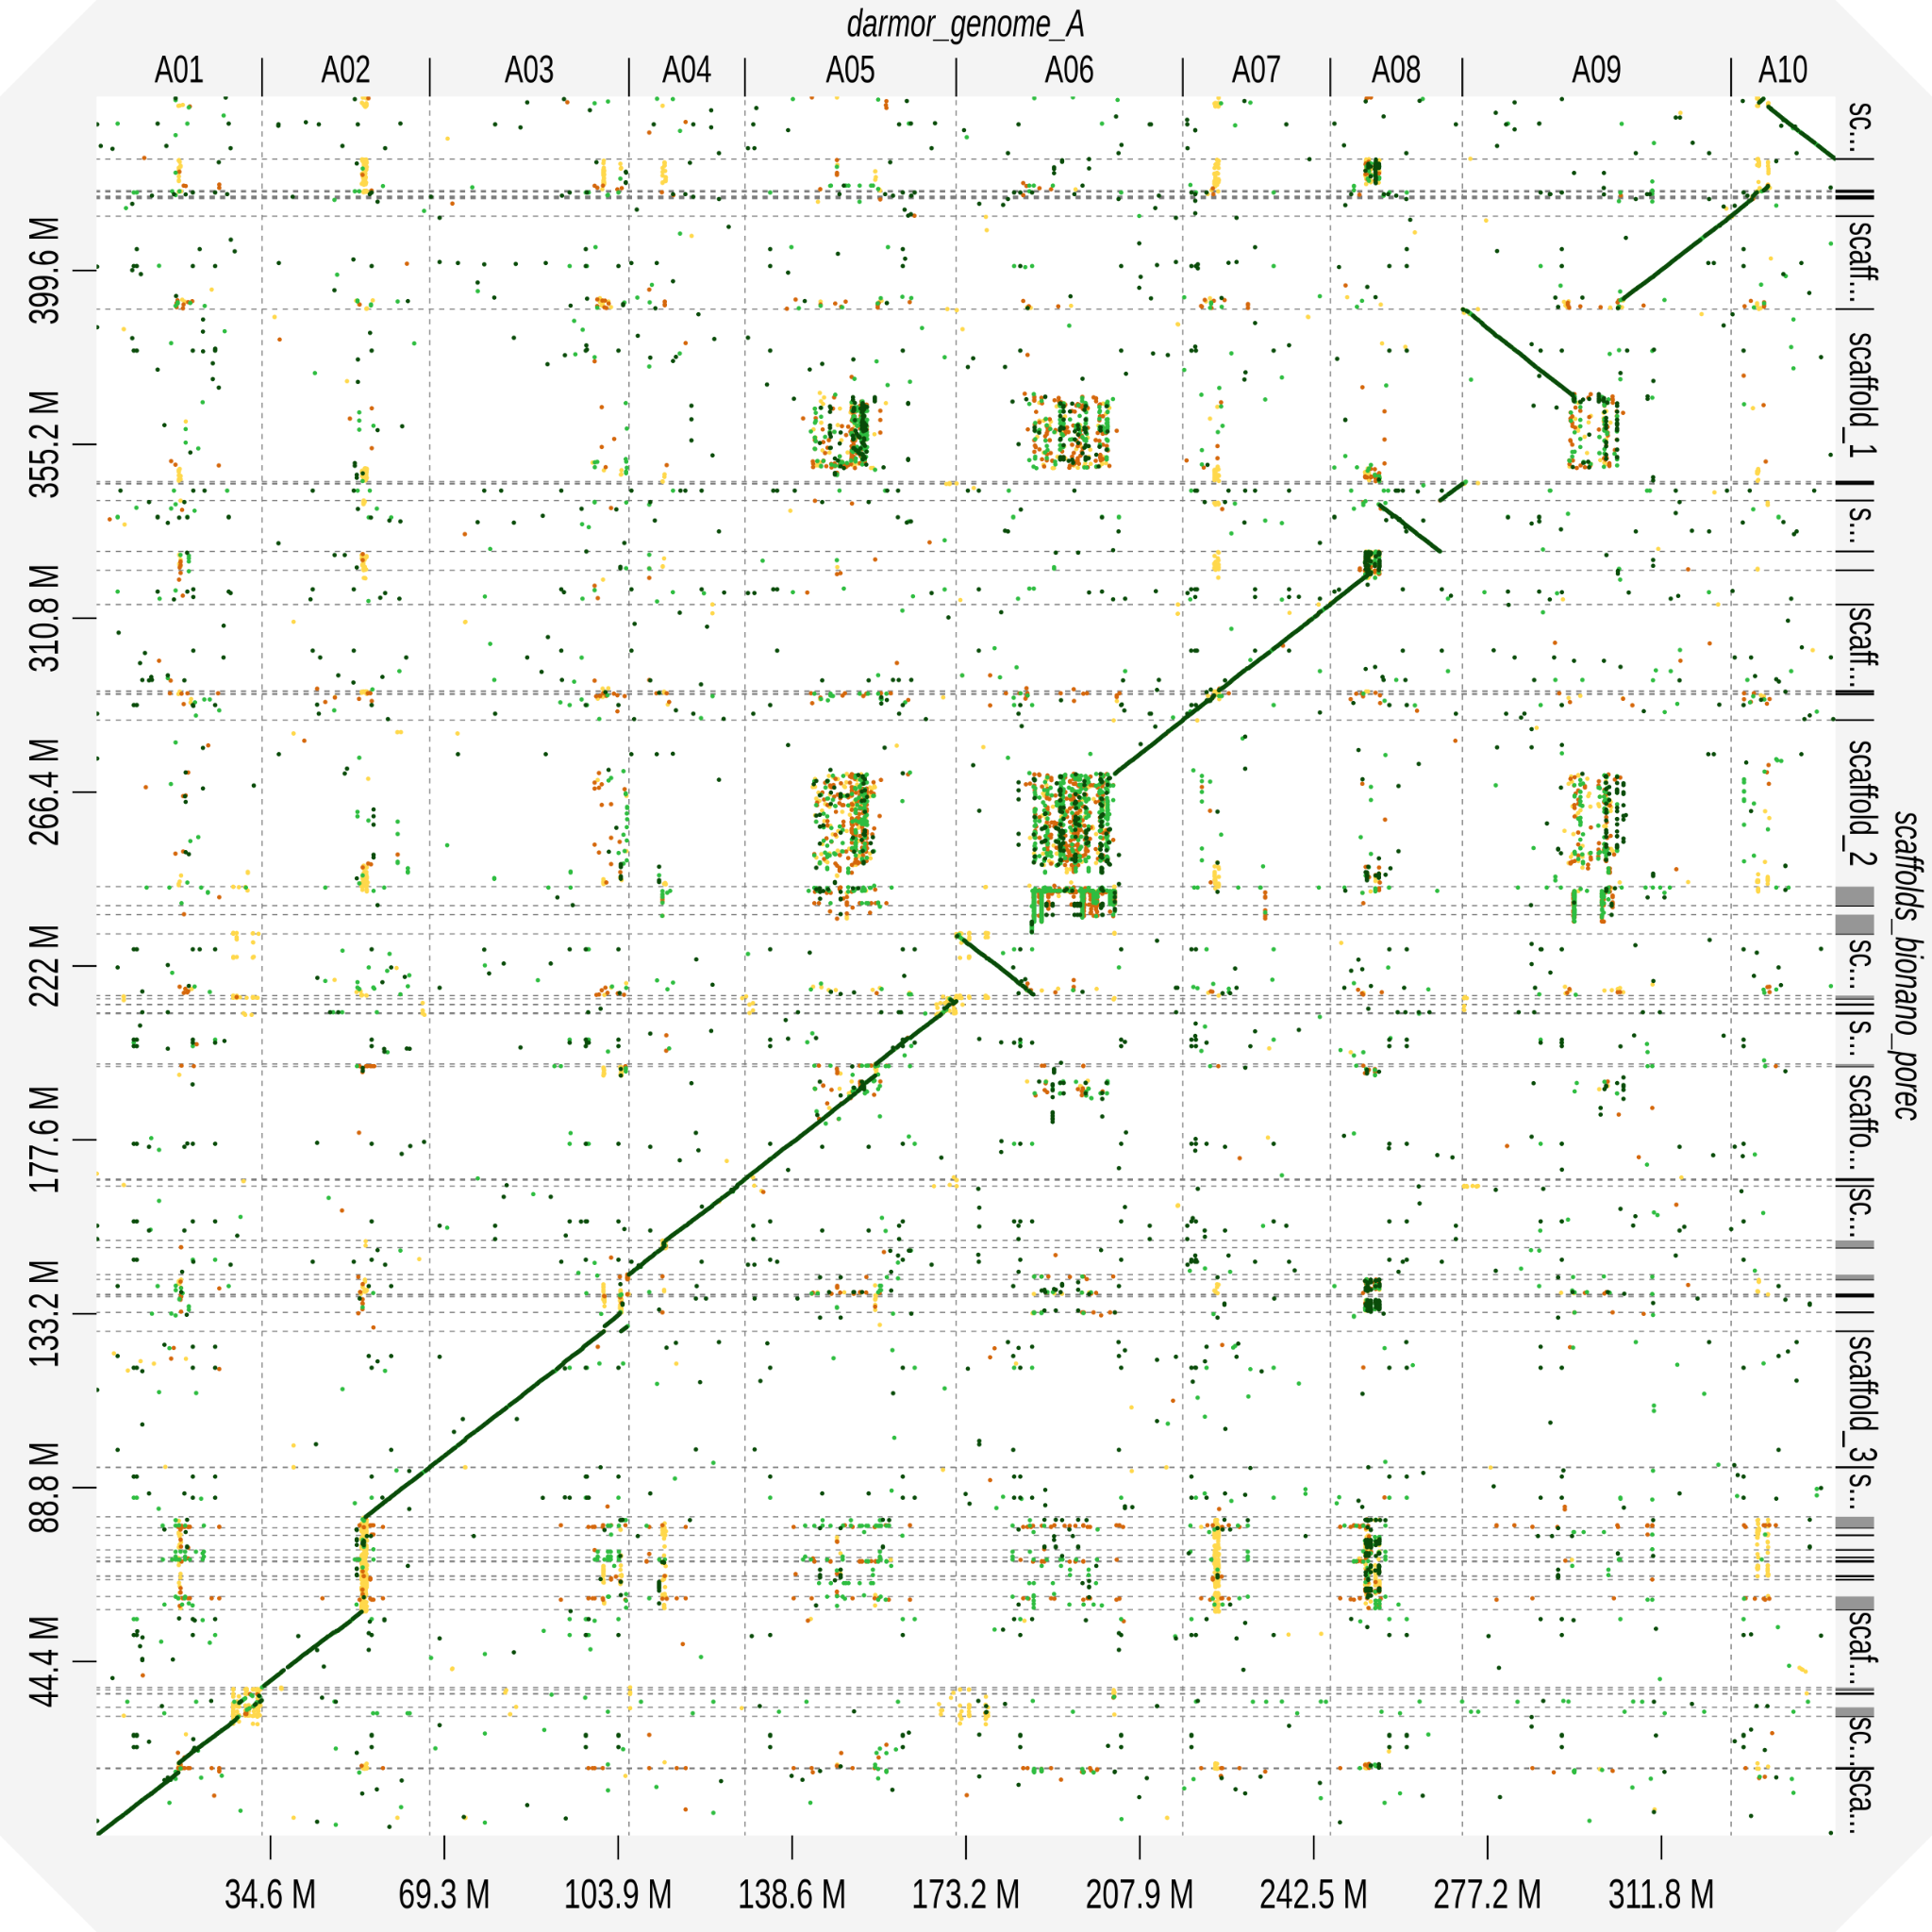

Figure S7. Dotplots of Omni-C + Bionano scaffolds aligned to Brassica rapa Chiifu (left) or Brassica napus Darmor-BZH A genome (right).

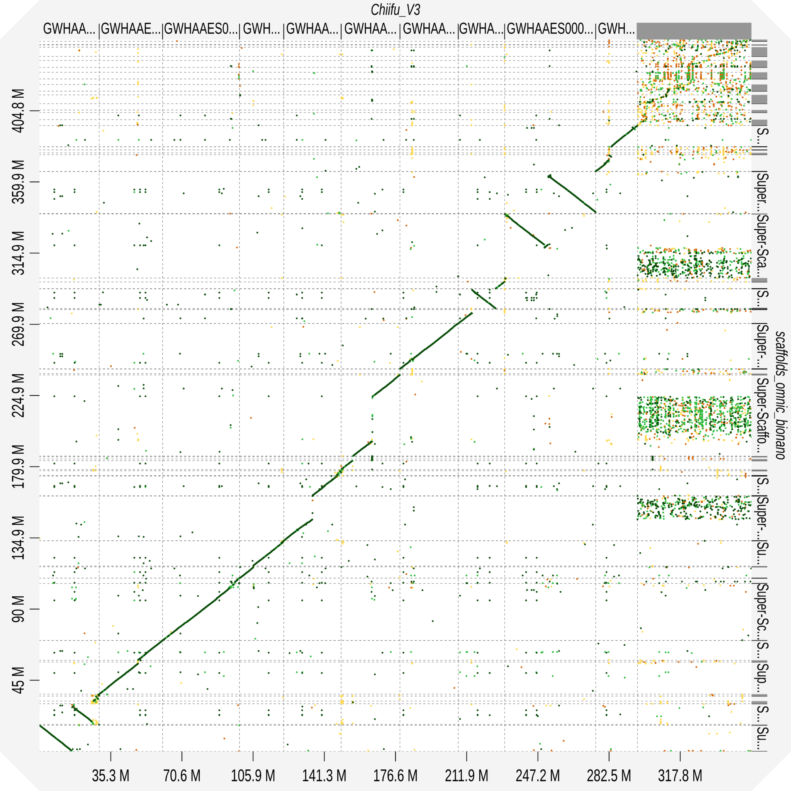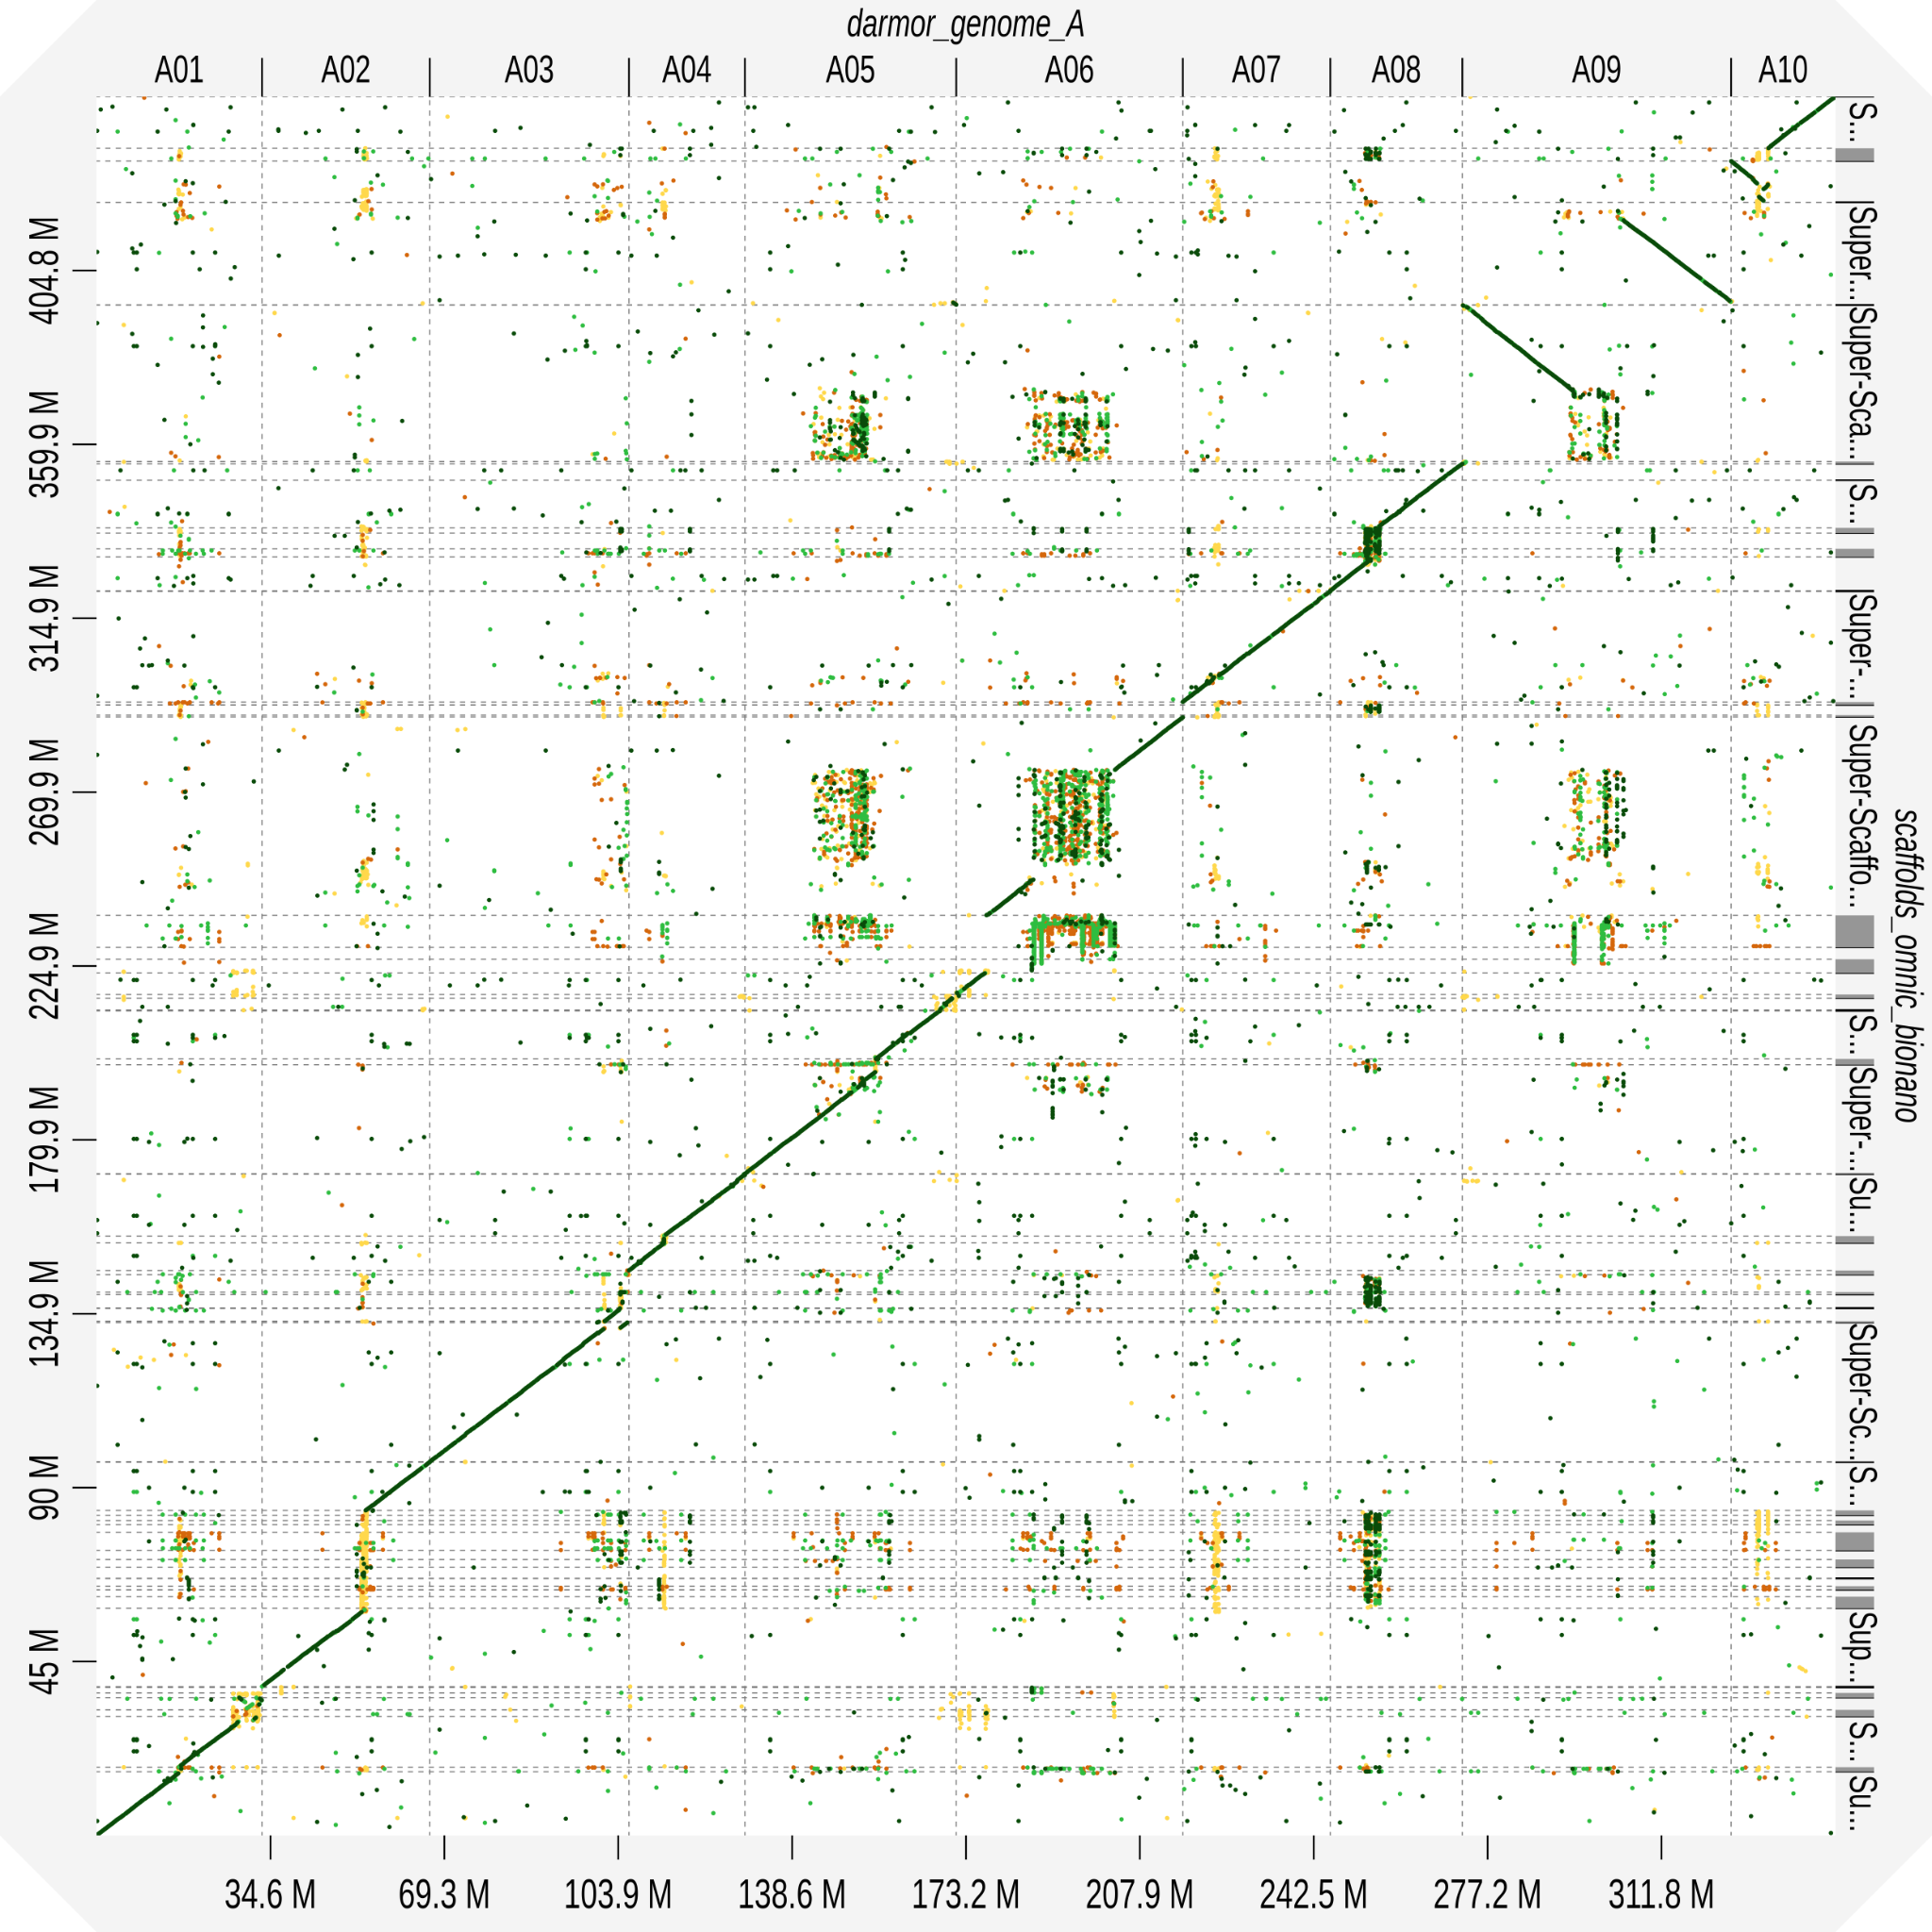

Figure S8. Dotplots of Pore-C + Bionano scaffolds aligned to Brassica rapa Chiifu (left) or Brassica napus Darmor-BZH A genome (right).

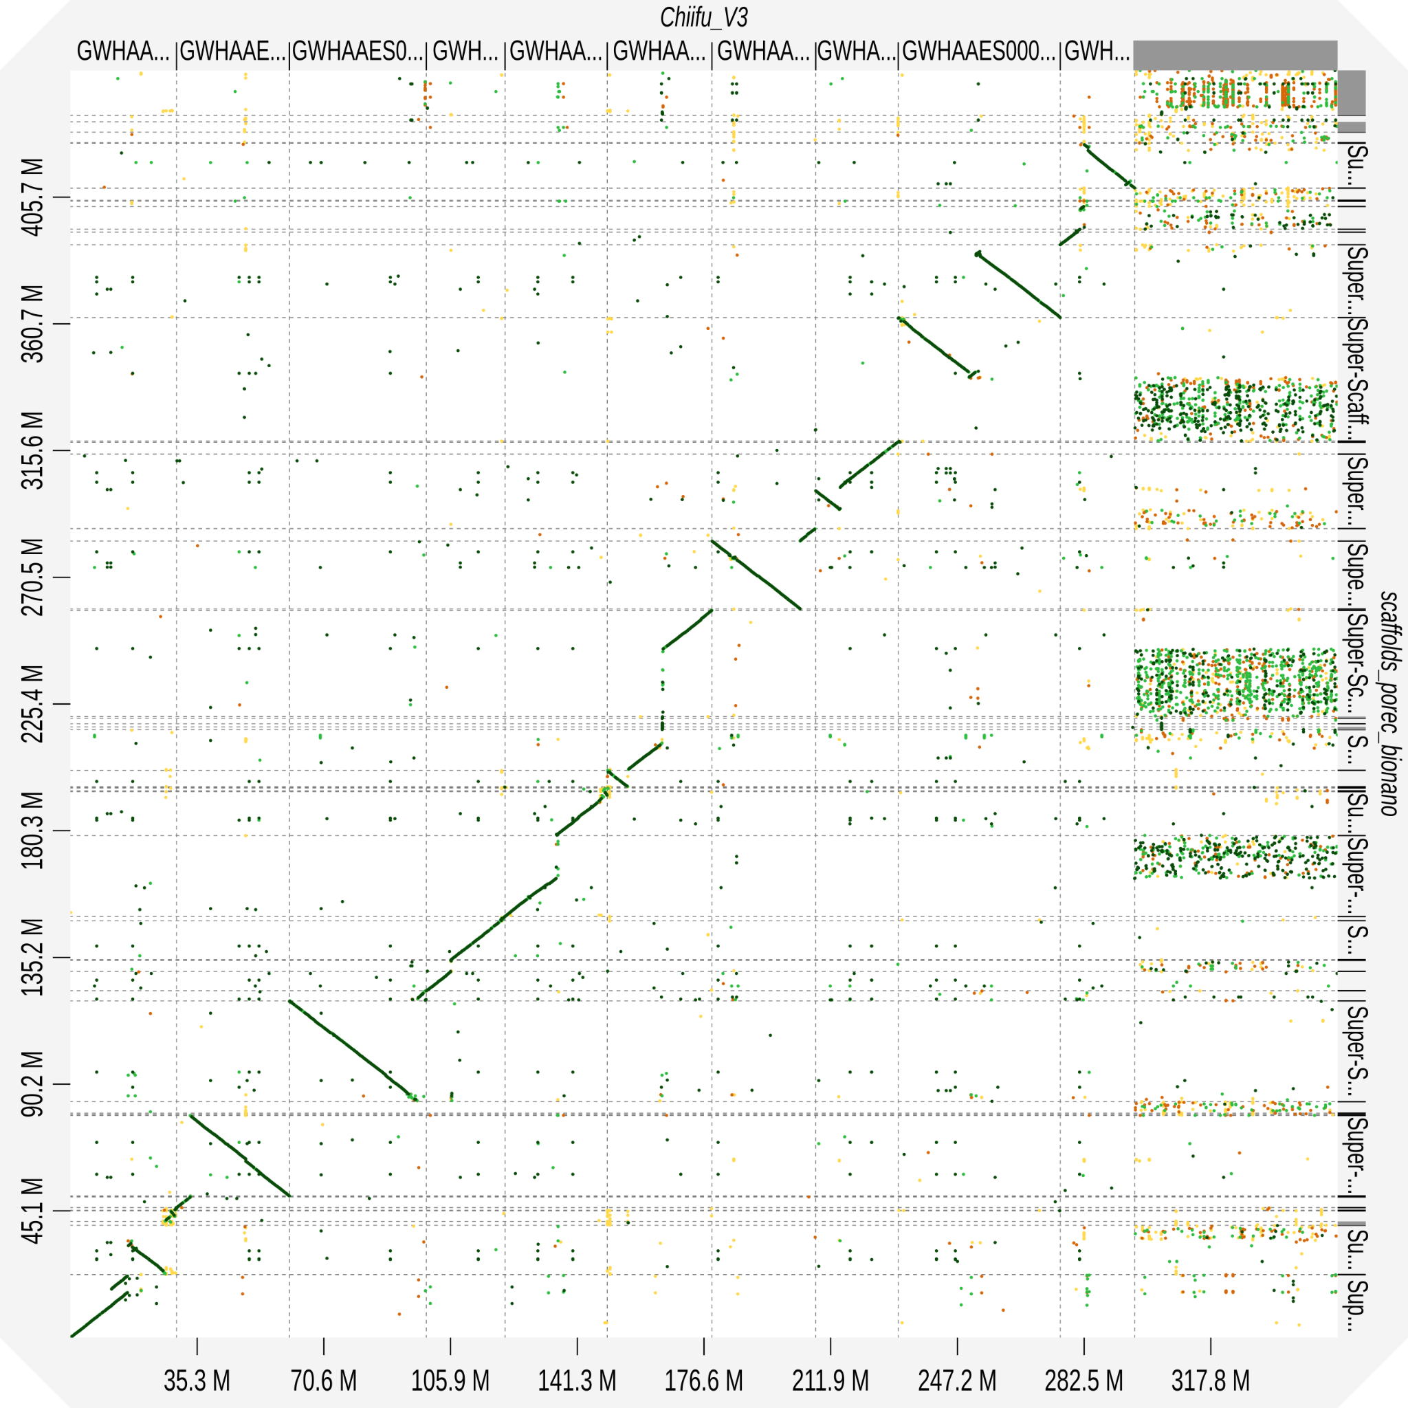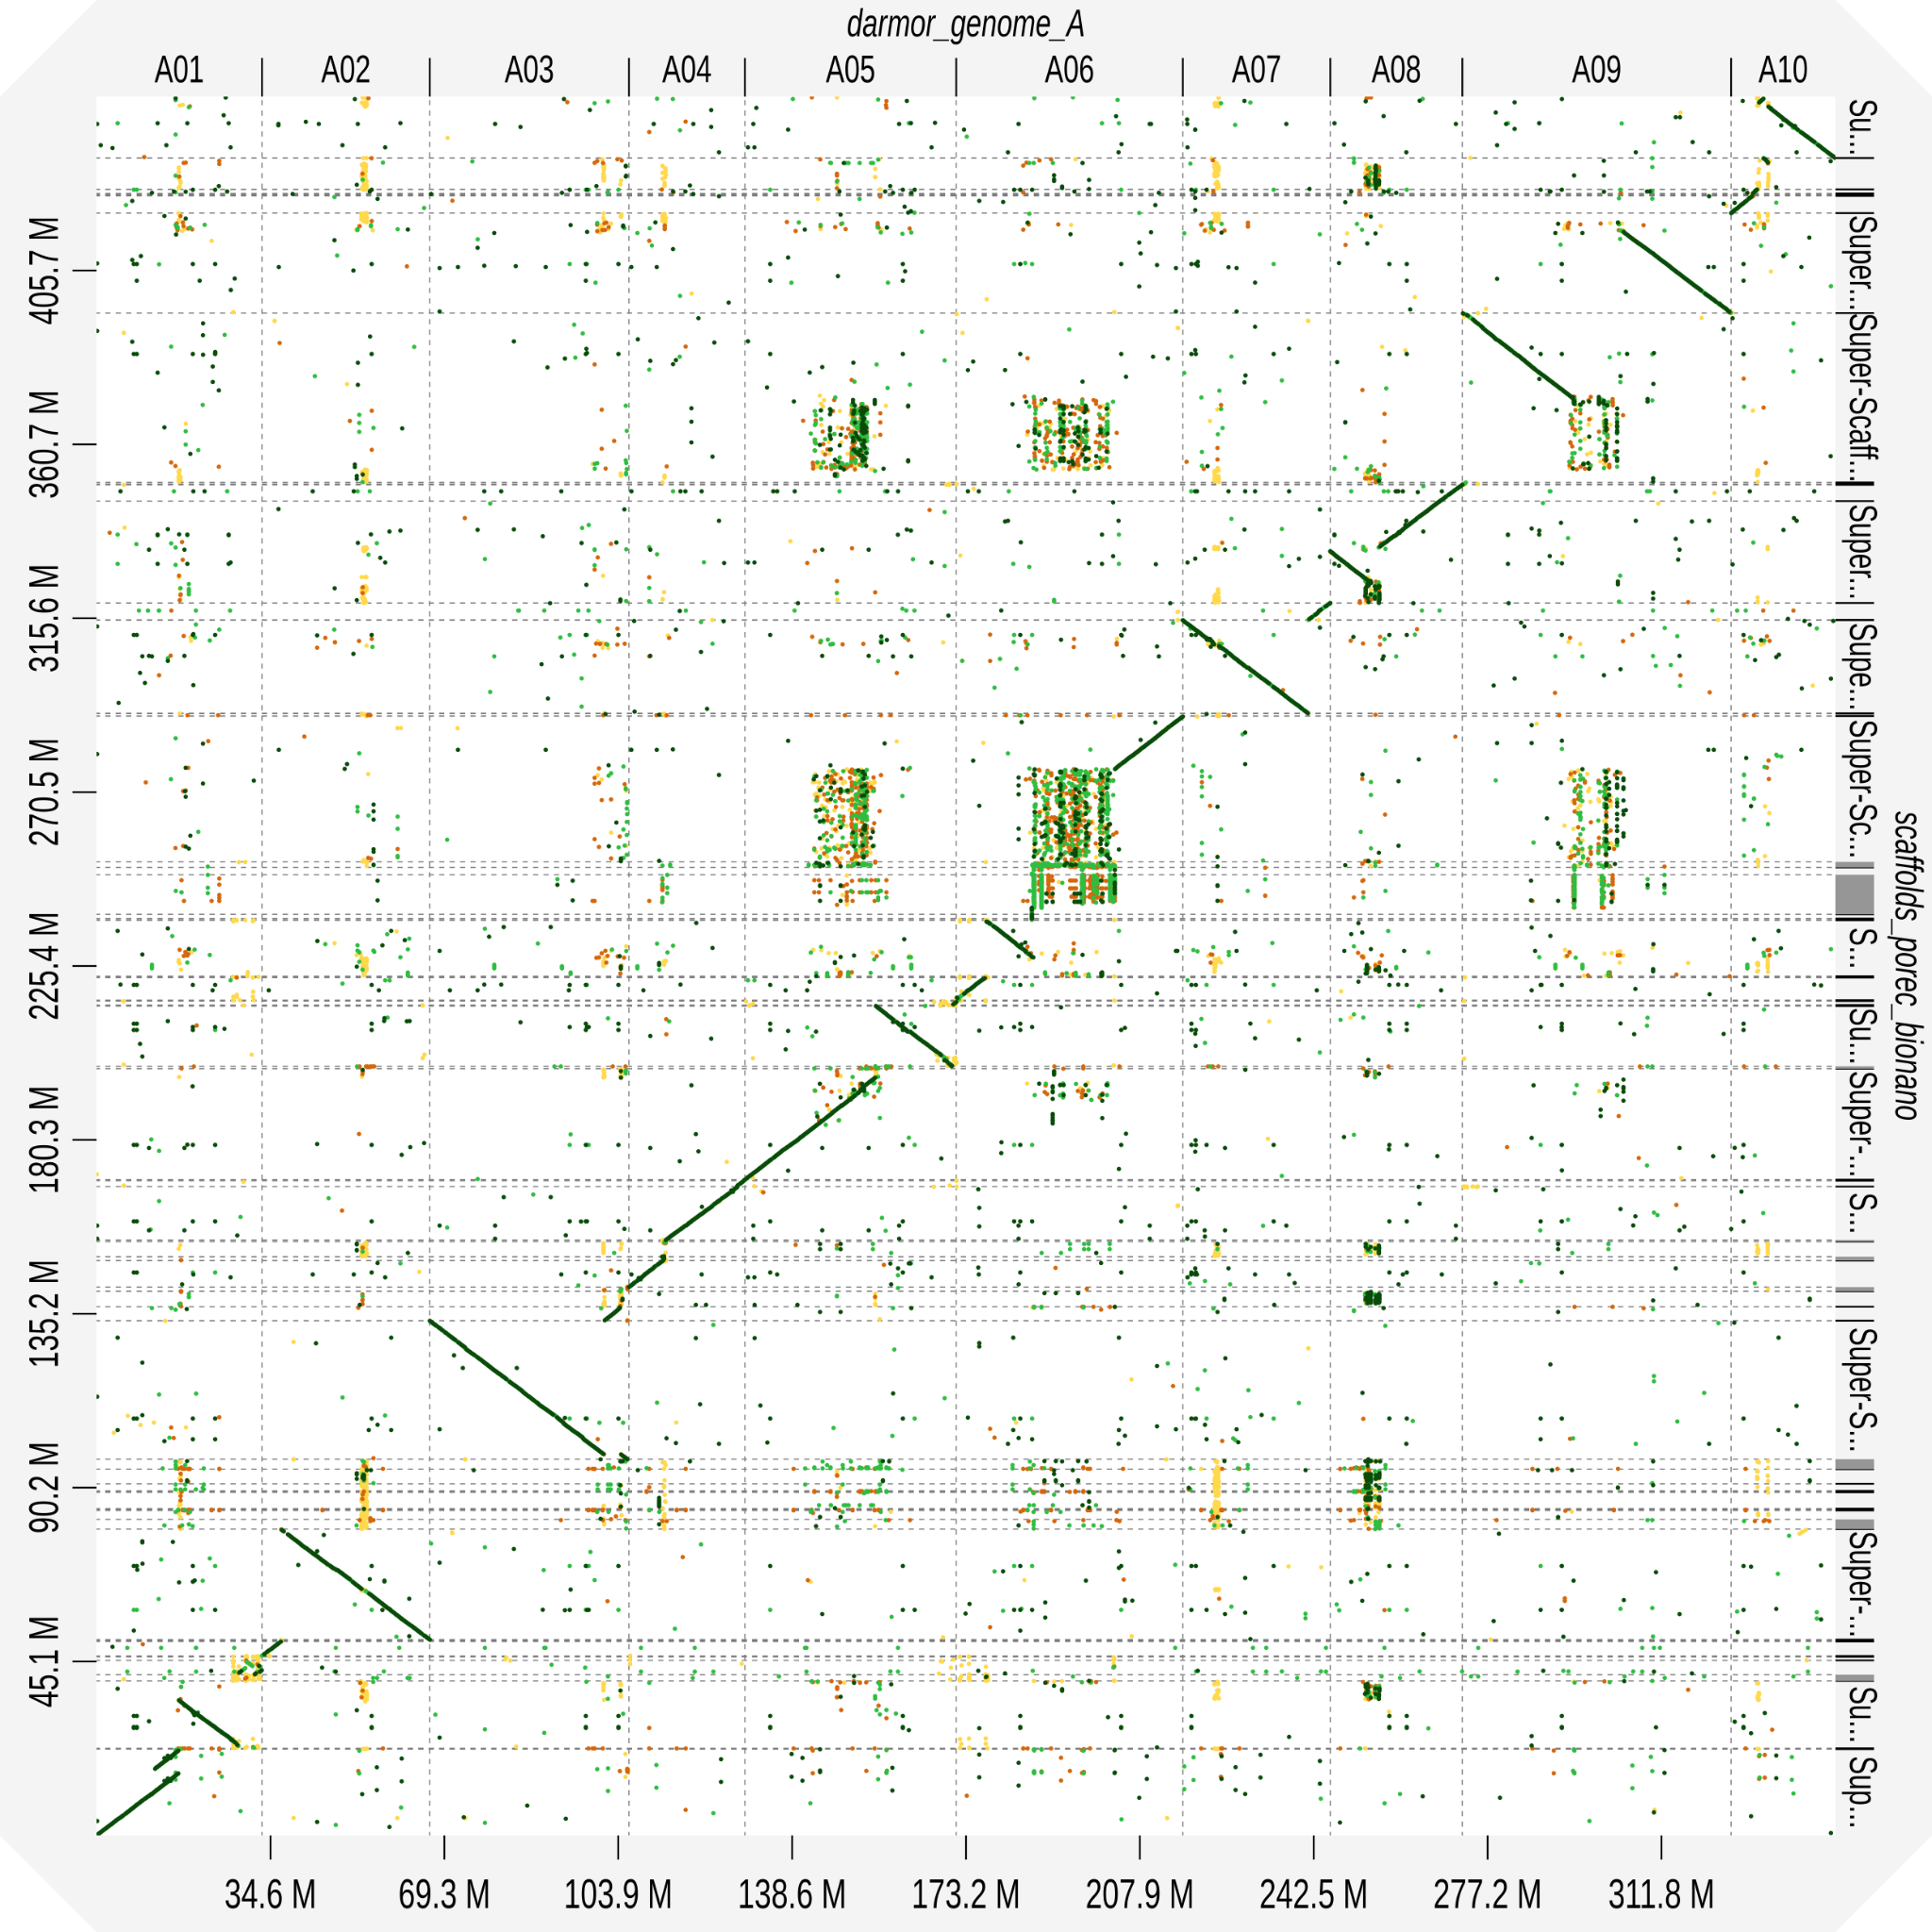

Figure S9. Contact Map generated with the Omni-C library (mapping on the nanopore contigs). The left panel shows the contact before review. The right panel shows the contact map after review.

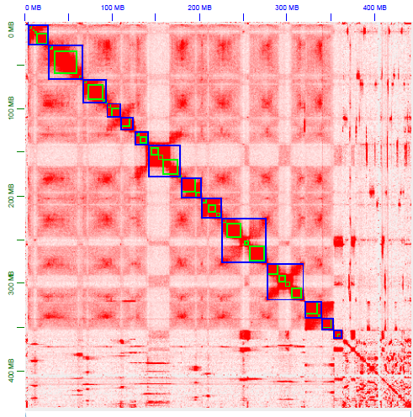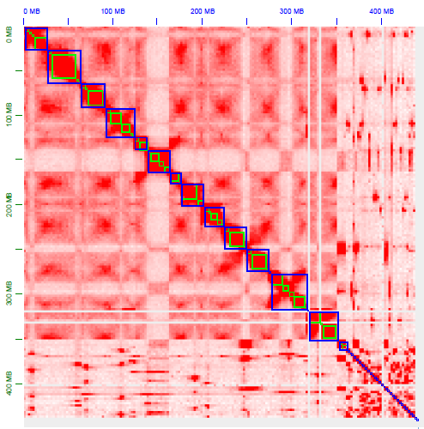

Figure S10. Contact Map generated with the Omni-C library (mapping on the bionano scaffolds). The left panel shows the contact before review. The right panel shows the contact map after review.

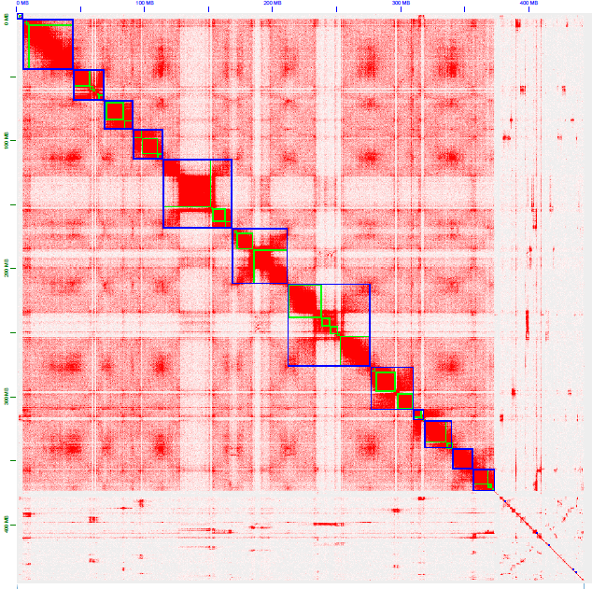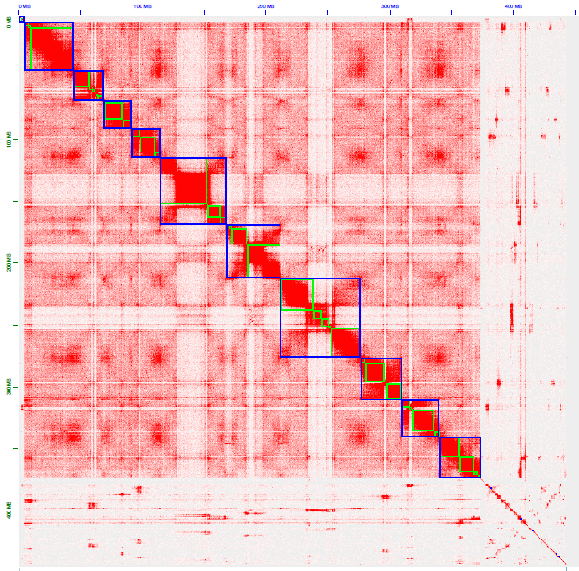

Figure S11. Conflict example detected by the optical maps on the Omni-C scaffolds. The two first lines represent the DLE-1 maps. The third line represents one Omni-C scaffold. The two last lines represent the BspQI maps. The vertical lines show the correspondence between the labels of the scaffold and the labels of the maps. In the middle, we can see a region without any correspondence which leads to a break of the scaffold.
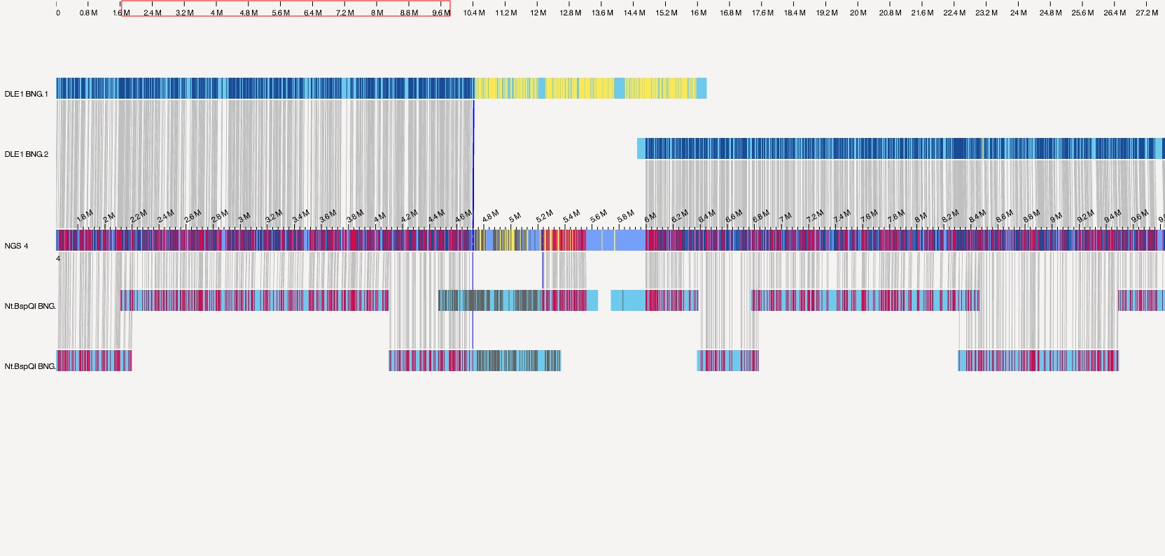

Figure S12. Conflict example detected by the optical maps on the Pore-C scaffolds. The three first lines represent the DLE-1 maps. The fourth line represents one Pore-C scaffold. The two last lines represent the BspQI maps. The vertical lines show the correspondence between the labels of the scaffold and the labels of the maps. We can see regions without any correspondence (the yellow portion of the DLE-1 maps and the grey portions of the BspQI maps) which leads to several breaks of the scaffold.
