Single cell cryo-soft X-ray tomography reveals the importance of bacteria concentration in the regulation of Chlamydia size
Patrick Phillips^{1,2,4}, James M. Parkhurst^{1,3}, Ilias Kounatidis¹, Chidinma Okolo¹, Thomas M. Fish¹, James H. Naismith^{2,3}, Martin A. Walsh^{1,2}, Maria Harkiolaki^{1,2}, Maud Dumoux^{1,2,3*}
¹ Diamond Light Source, Harwell Science and Innovation Campus, Didcot, OX11 0DE, UK
² Research Complex at Harwell, Harwell Science and Innovation Campus, Didcot, OX11, UK
³ the Rosalind Franklin Institute, Fermi Road, Didcot, OX11 0FA
⁴University of Oxford, Division of Structural biology department, Roosevelt Drive, Oxford, OX3 7BN

Supplementary figure:

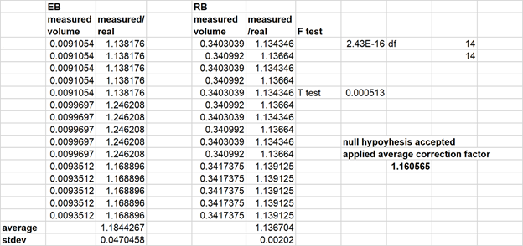
Supplementary figure 1: Statistics of the simulation data representing the EB and RB.

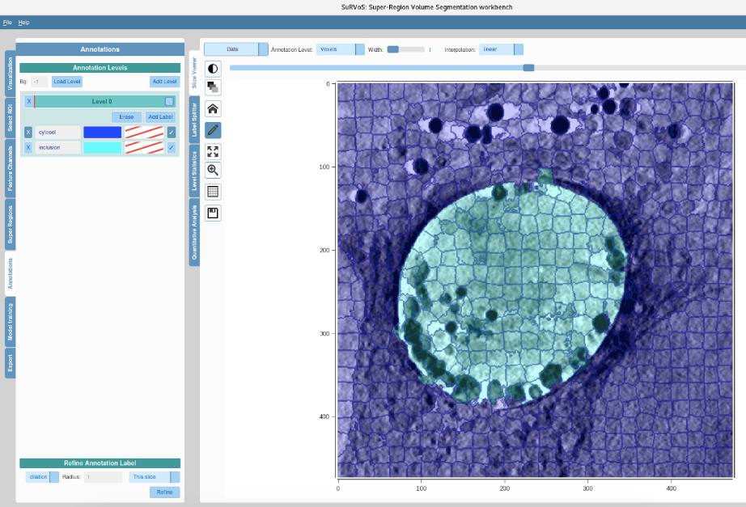
Supplementary figure 2: Super Region Volume Segmentation (SuRVoS) to segment the inclusion from the cytosol. The dark blue grid depicts the calculated supervoxels which are optimised by the user to detect the edge of the inclusion. Some of the supervoxels are then manually annotated to label the inclusion and the cytosol. Then, using the model training tab, the program predicts further annotations based on the user’s annotations to begin to automatically segment the inclusion from the cytosol throughout the entire tomogram.

Supplementary figure 3: Combination of the SuRVoS annotated inclusion and its tomogram. The tomogram is made binary and holes within the bacteria are filled (red circles). Then the SuRVoS annotation is added on top to black out the cytosol such that only the bacteria are counted and so that densities from the inclusion membrane do not contribute to the volume of the bacteria.

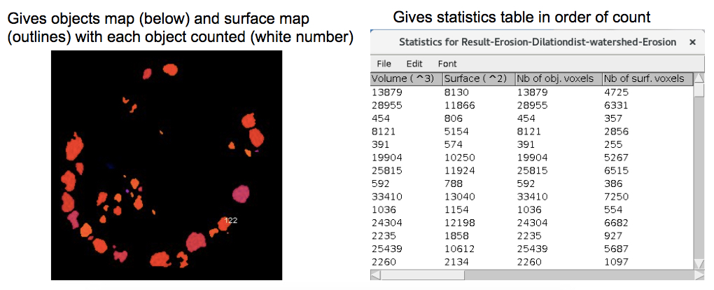
Supplementary figure 4: Output of the segmentation and volume identification using imageJ macro. After running isolating the inclusion from the rest of the cells (Sup Fig 3) the 3D-objects-counter labels the centre of each object with a white number. The statistics table with the volumes of each object is given in the order of the counted objects (object 1 is the first in the list).
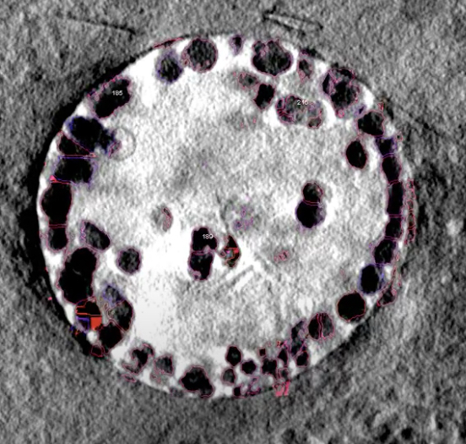
Supplementary figure 5: Output of the macro: composite of the segmented objects and the original tomogram. Merging of the surface map of objects output by the 3D-objects-counter Each object is outlined and correspond to a unique identification number allowing manual curation if necessary. Each objects is labelled with a white number which is the count.

KEY RESOURCES TABLE
REAGENT or RESOURCE | SOURCE | IDENTIFIER
Antibodies
Chlamydia trachomatis LGV2 | ATCC | VR-902B
Bacterial and Virus Strains
Chlamydia trachomatis LGVII | ATCC | VR-902B
Biological Samples
HeLa | ATCC | CCL-2
Experimental Models: Cell Lines
HeLa | ATCC | CCL-2
Software and Algorithms
survos | diamond light source | https://diamondlightsource.github.io/SuRVoS/docs/installation/
image j | NIH | https://imagej.nih.gov/ij/
Other

Supplementary information:

//Click Run and a window will open for you to select your tomogram, select the raw data tiff exported from SuRVoS

filepath = File.openDialog("Select tomogram");
open(filepath);
filename = File.getName(filepath);

// // Create dialog box - A dialogue box will pop up where you can select to enhance the contrast on your data

//Dialog.create("Enhance Contrast?");
//Dialog.addCheckbox("Run enhance contrast?", false);

// Get dialog inputs
//runEnhancecontrast = Dialog.getCheckbox();

//if (runEnhancecontrast == true) {
//run("Enhance Contrast...", "saturated=50 normalize process_all"); //enhance contrast on the data if ticked checkbox at start
//}

//selectWindow("data.tif");
//setThreshold(0, 150);
run("Convert to Mask", "method=Default background=Light calculate black"); //the tomogram will be made binary

//A window will open for you to select your survos level 0 annotation .tif file

filepath = File.openDialog("Select survos level 0 annotation");
open(filepath);
annotation = File.getName(filepath);

//Create dialog box - A dialogue box will pop up where you can select parameters
// select the radius you would like for the 'Closing' morphological filter on the SuRVoS annotation
//this will smooth the edge of the annotation and fill gaps
// select the radius you would like for the morphological filters on the objects
//this is the amount of erosion and dilation that will be used to smooth your objects
// select the dynamic for the Distance Transform Watershed 3D
//a lower dynamic will give more separations
// select the radius you would like for the ersoion of the watershed image
//the watershed image must be slightly eroded so that the 3D Objects Counter counts touching objects (default 1)
// select the circularity range
//here you can filter out objects that are not circular (e.g.speckle), 1 is a perfect circle
// choose to run a final despeckle if there is shadow and noise on the tomogram
//this prevents background intensities contributing to the volume of your objects
// select the size range of objects you want the 3D Objects Counter to count
//this will not count objects that are too small or too large to be bacteria

Dialog.create("Choose parameters");
Dialog.addNumber("Radius for Closing Filter on the SuRVoS annotation (pixels):", 2);
Dialog.addCheckbox("Fill holes on SuRVoS annotation?", false);
Dialog.addNumber("Radius for Erosion and Dilation of the objects (pixels):", 1);
Dialog.addNumber("Dynamic for Distance Transform Watershed 3D (Lower=more separations):", 1);
Dialog.addNumber("Radius for Erosion of the watershed (pixels):", 1);
Dialog.addNumber("Circularity min/max: ", 0.30);
Dialog.addToSameRow();
Dialog.addNumber("", 1.00);
Dialog.addCheckbox("Run final despeckle?", true);
Dialog.addNumber("Size min/max: ", 250);
Dialog.addToSameRow();
Dialog.addNumber("", 50000);
Dialog.show();

// Get dialog inputs
radiusValue = Dialog.getNumber();
runFillholes = Dialog.getCheckbox();
radiusValue = Dialog.getNumber();
dynamicValue = Dialog.getNumber();
radiusValue = Dialog.getNumber();
circularityMin = Dialog.getNumber();
circularityMax = Dialog.getNumber();
runDespeckle = Dialog.getCheckbox();
sizeMin = Dialog.getNumber();
sizeMax = Dialog.getNumber();

run("Make Binary", "method=Default background=Default calculate black"); //the SuRVoS annotation is made binary
run("Morphological Filters (3D)", "operation=Closing element=Cube x-radius=" + radiusValue + " y-radius=" + radiusValue + " z-radius=" + radiusValue); //smooths edges of inclusion
if (runFillholes == true) {
run("Fill Holes", "stack"); //fill holes in annotation if ticked checkbox at start
}
//not needed for 11 but helps 1

imageCalculator("AND create stack", filename, annotation); //combines the binary data and annotation to black-out the cytosol

selectWindow("Result of " + filename);
run("Fill Holes", "stack"); //fills gaps within bacteria cells

run("Morphological Filters (3D)", "operation=Erosion element=Ball x-radius=" + radiusValue + " y-radius=" + radiusValue + " z-radius=" + radiusValue);
run("Morphological Filters (3D)", "operation=Dilation element=Ball x-radius=" + radiusValue + " y-radius=" + radiusValue + " z-radius=" + radiusValue);
//erode away speckle/bumps and edge of bacteria but then dilate back to full volume of bacteria without bringing the speckle/bumps back
// this will be completed using the radius chosen at the start

run("Distance Transform Watershed 3D", "distances=[Borgefors (3,4,5)] output=[16 bits] normalize dynamic=" + dynamicValue + " connectivity=6");
//separates touching objects

run("Morphological Filters (3D)", "operation=Erosion element=Ball x-radius=" + radiusValue + " y-radius=" + radiusValue + " z-radius=" + radiusValue);
//makes the separations thicker such that touching objects are not counted as one object
Dialog.addNumber("Choose morphological radius", 1);
run("8-bit");

selectImage("Result-Erosion-Dilationdist-watershed-Erosion");
z=nSlices;
for (i=0; i>z; i++ ) {
run("Analyze Particles...", " circularity=" + circularityMin + "-" + circularityMax + " show=Masks display stack");
run("Invert LUT");
}
//removes non-circular obejcts e.g. background speckle that otherwise contributes to volume of bacteria
// this will be completed using the circularity range chosen at the start

if (runDespeckle == true) {
run("Despeckle", "stack"); //final despeckle if ticked checkbox at start
}

run("3D Objects Counter", "threshold=1 slice=76 size=" + sizeMin + "-" + sizeMax + " objects surfaces statistics summary");
//default min.=250 max.=50000
//counts objects, gives statistics window with volumes and objects map with numbered objects

//A window will open for you to select your raw tomogram for merge with the numbered surface map
filepath = File.openDialog("Reselect tomogram for Merge");
open(filepath);
filename = File.getName(filepath);

run("Merge Channels...", "c1=[Surface map of Result-Erosion-Dilationdist-watershed-Erosion] c4=data-1.tif");
//c4=data-1.tif is universal if using the raw exported data from SuRVoS as specified at start
//observe outlined and numbered bacteria

