Supplementary Information
Figure S1. Chemical structures of 1, 2, 4-Trizine and their derivatives.

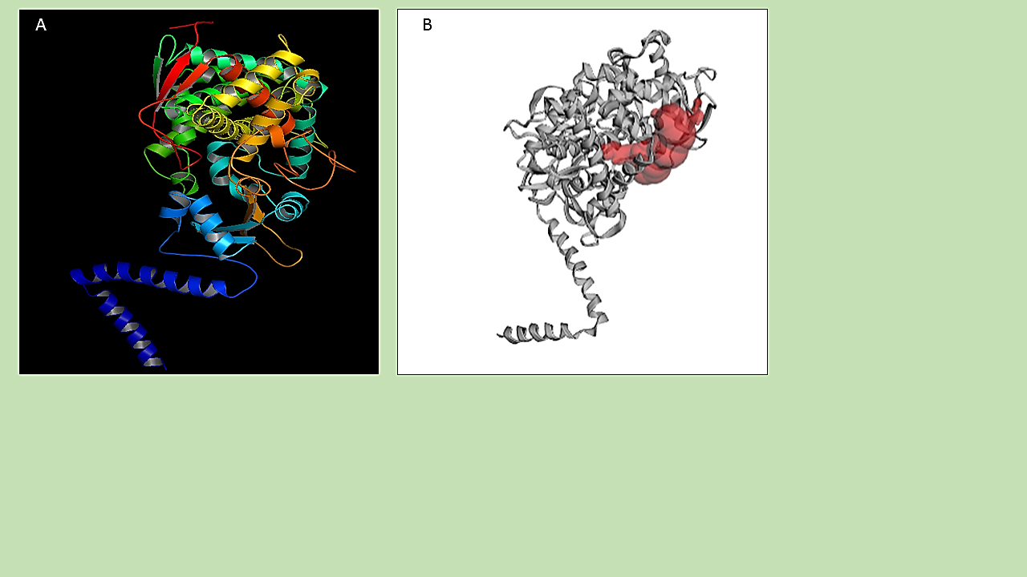
Figure S2. The Structure of Lanosterol 14 - demethylase (CYP51) (PDB id- 4LXJ) (A. Ribbon Presentation; B. Active site of ERG11).

Figure S3. Results of amino acids involved in forming active site for Lanosterol 14 - demethylase (CYP51). Letters highlighted in blue indicates active site residues.
Figure S4. Simulation cell lengths calculations of Lanosterol 14 - demethylase (CYP51) and nine molecules as a function of 10ns simulation time.
Figure S5. Total Potential Energy calculations of Lanosterol 14 - demethylase (CYP51) and nine molecules as a function of 10ns simulation time.

Figure S6. Potential Energy calculations of Lanosterol 14 - demethylase (CYP51) and nine molecules as a function of 10ns simulation time.

Figure S7. Calculations of surface area of the solute of Lanosterol 14 - demethylase (CYP51) and nine molecules as a function of 10ns simulation time.

Table S1- MM-PBSA energy (KJol/mol calculation of Lanosterol 14-𝛼-demethylase (CYP51) with nine molecules during 10ns simulation.
Time  [ns] | Molecule  1 | Molecule 2 | Molecule 3 | Molecule 4 | Molecule 5 | Molecule 6 | Molecule 7 | Molecule 8 | Molecule 9
0 | 6.32 | -8.9 | 7.339 | 108.172 | 52.378 | 94.888 | 56.124 | 102.349 | 42.113
0.25 | 52.83 | 7.5 | -8.518 | 146.774 | -55.506 | 60.119 | 134.039 | 81.975 | 70.492
0.5 | 17.454 | 25 | 72.595 | 137.413 | 14.459 | 97.198 | 98.548 | -29.978 | 38.578
0.75 | 46.329 | 17 | 68.359 | 87.228 | -58.203 | 91.99 | 161.262 | 31.712 | 153.366
1 | 54.085 | 53 | 69.185 | 169.103 | -63.189 | 103.739 | 137.772 | 24.821 | 60.289
1.25 | 47.946 | 43 | 60.874 | 148.654 | -75.265 | 105.746 | 174.819 | 0.973 | 132.332
1.5 | 61.502 | 47 | 52.417 | 147.209 | -59.148 | 54.47 | 92.573 | 66.516 | 84.676
1.75 | 31.875 | 62 | 62.29 | 113.544 | -25.85 | 115.214 | 127.909 | 21.72 | 132.219
2 | 51.341 | 69 | 85.906 | 134.098 | -71.062 | 76.155 | 73.004 | -1.788 | 77.132
2.25 | 52.229 | 57 | 63.732 | 108.764 | -66.067 | 78.55 | 88.214 | 17.474 | 80.936
2.5 | 79.757 | 75 | 74.328 | 122.45 | -25.457 | 91.593 | 88.164 | 0.619 | 120.108
2.75 | 110.242 | 45 | 46.718 | 169.503 | -46.326 | 136.549 | 75.447 | 2.416 | 128.62
3 | 61.103 | 69 | 72.429 | 137.151 | -3.832 | 89.908 | 59.781 | -10.154 | 81.753
3.25 | 73.602 | 91 | 69.88 | 178.746 | 66.506 | 112.934 | 74.112 | 3.227 | 132.391
3.5 | 81.433 | 57 | 78.716 | 112.508 | 56.898 | 119.365 | 114.676 | 53.104 | 97.732
3.75 | 71.09 | 77 | 75.523 | 121.01 | 38.84 | 82.517 | 131.789 | 68.259 | 121.277
4 | 74.04 | 73 | 89.419 | 55.598 | 35.979 | 80.204 | 146.472 | 76.138 | 156.832
4.25 | 51.682 | 83 | 88.533 | 132.632 | 9.5 | 81.93 | 155.13 | 56.284 | 146.866
4.5 | 81.591 | 71 | 83.159 | 98.949 | 33.931 | 82.871 | 164.902 | 78.189 | 146.282
4.75 | 73.438 | 62 | 84.582 | 169.28 | 75.344 | 116.975 | 130.535 | 56.502 | 123.461
5 | 56.252 | 64 | 102.004 | 73.864 | 109.219 | 87.3 | 130.32 | 80.317 | 166.293
5.25 | 85.554 | 62 | 80.804 | 163.478 | 82.272 | 86.781 | 131.764 | 91.28 | 159.71
5.5 | 82.463 | 59 | 94.725 | 146.977 | 89.977 | 67.54 | 126.637 | 86.379 | 137.845
5.75 | 66.696 | 73 | 58.284 | 149.142 | 83.025 | 112.287 | 122.82 | 93.662 | 110.309
6 | 84.404 | 72 | 42.936 | 117.117 | 95.969 | 40.046 | 106.355 | 62.809 | 135.78
6.25 | 84.88 | 76 | 28.908 | 139.494 | 65.656 | 78.283 | 100.468 | 111.939 | 132.744
6.5 | 58.446 | 85 | 55.202 | 164.207 | 84.818 | 71.067 | 127.531 | 118.344 | 104.934
6.75 | 66.502 | 62 | 71.738 | 136.38 | 63.52 | 70.126 | 98.222 | 62.139 | 143.947
7 | 104.781 | 57 | 71.834 | 144.576 | 29.917 | 72.863 | 98.988 | 119.018 | 96.082
7.25 | 80.109 | 65 | 56.225 | 147.806 | 84.215 | 127.26 | 104.533 | 129.999 | 197.473
7.5 | 107.14 | 36 | 60.884 | 108.94 | 80.36 | 180.88 | 138.359 | 116.699 | 140.982
7.75 | 65.784 | 49 | 52.507 | 152.314 | 72.582 | 81.73 | 140.704 | 112.062 | 130.318
8 | 67.225 | 76 | 62.769 | 137.859 | 90.355 | 115.929 | 141.347 | 136.34 | 146.719
8.25 | 69.908 | 69 | 55.626 | 162.634 | 76.623 | 96.203 | 125.205 | 147.145 | 177.93
8.5 | 82.342 | 93 | 79.961 | 134.241 | 47.865 | 137.018 | 153.372 | 125.397 | 161.814
8.75 | 88.764 | 71 | 73.124 | 94.082 | 44.999 | 126.188 | 146.157 | 129.887 | 133.132
9 | 94.004 | 68 | 79.891 | 126.085 | 31.726 | 123.476 | 143.899 | 89.9 | 89.297
9.25 | 92.754 | 71 | 66.273 | 117.783 | -60.505 | 136.42 | 181.276 | 120.774 | 120.313
9.5 | 77.342 | 72 | 72.63 | 110.343 | -7.103 | 92.475 | 92.652 | 115.065 | 161.726
9.75 | 98.894 | 74 | 71.744 | 122.132 | -24.946 | 106.815 | 67.761 | 89.948 | 125.751
10 | 97.742 | 85 | 49.313 | 118.622 | -4.55 | 127.444 | 144.27 | 112.634 | 174.726

