Table S1: Serology and OPF screening from farms in each province in 2015

Province | Serum Tested | Serum positive | Seropositive percentage of samples | OPF Screened (rRT-PCR) | OPF positive for FMDV RNA | Percentage OPF positive
Hà Tĩnh | 500 | 86 | 17.2 (13,21) | 112 | 0 | 0
Lạng Sơn | 484 | 20 | 4 (2,5) | 33 | 0 | 0
Phú Thọ | 500 | 50 | 10 (7,12) | 62 | 0 | 0
Bắc Kạn | na | na | na | na | na | na
Ninh Thuận | na | na | na | na | na | na
Đồng Tháp | 485 | 149 | 31 (26,34) | 139 | 36 | 25.8
Bình Phước | 514 | 84 | 16 (13,19) | 80 | 2 | 2.5
Đăk Lăk | 504 | 142 | 28 (24,32) | 142 | 3 | 2.1
TOTAL | 2,987 | 531 |  | 568 | 41 | 7.2

Table S2: Serology and OPF screening from farms in each province in 2016

Province | Serum Tested | Serum positive | Seropositive percentage of samples | OPF Screened (rRT-PCR) | OPF positive | Percentage OPF positive
Hà Tĩnh | na | na | na | na | na | na
Lạng Sơn | 236 | 31 | 13 (8,17) | 33 | 2 | 6
Phú Thọ | 253 | 34 | 13 (9,17) | 32 | 2 | 6.2
Bắc Kạn | 496 | 167 | 34 (29,37) | 165 | 32 | 19.4
Ninh Thuận | 250 | 177 | 71 (65,76) | 177 | 20 | 11.2
Đồng Tháp | 254 | 100 | 39 (33,45) | 102 | 33 | 32.3
Bình Phước | na | na | na | na | na | na
Đăk Lăk | na | na | na | na | na | na
TOTAL | 1,489 | 509 |  | 509 | 89 | 17.4

Table S3: Serology and OPF screening from farms in each province in 2017

Province | Serum  Tested | Serum positive | Seropositive percentage of samples | OPF Screened (rRT-PCR) | OPF positive for FMDV RNA | Percentage OPF positive
Hà Tĩnh | na | na | na | na | na | na
Lạng Sơn | 316 | 92 | 29 (24,34) | 92 | 0 | 0
Phú Thọ | 177 | 82 | 46 (39,53) | 77 | 0 | 0
Bắc Kạn | 982 | 447 | 46 (42,48) | 443 | 33 | 7.4
Ninh Thuận | 585 | 467 | 80 (76,83) | 461 | 49 | 10.6
Đồng Tháp | 369 | 210 | 57 (51,61) | 212 | 85 | 40
Bình Phước | na | na | na | na | na | na
Đăk Lăk | 252 | 182 | 72 (66,77) | 181 | 56 | 31
TOTAL | 2,681 | 1,480 |  | 1,466 | 223

Table S4: Serology and OPF screening from farms in each province in 2018

Province | Serum  Tested | Serum positive | Seropositive percentage of samples | OPF Screened (rRT-PCR) | OPF positive for FMDV RNA | Percentage OPF positive
Hà Tĩnh | na | na | na | na | na | na
Lạng Sơn | 351 | 65 | 19 (14,22) | 65 | 1 | 1.53
Phú Thọ | 149 | 48 | 32 (24,39) | 48 | 0 | 0
Bắc Kạn | 752 | 363 | 48 (44,51) | 347 | 3 | 0.8
Ninh Thuận | 319 | 257 | 81 (76,84) | 256 | 3 | 1.1
Đồng Tháp | 540 | 284 | 53 (48,56) | 284 | 31 | 11
Bình Phước | na | na | na | na | na | na
Đăk Lăk | 942 | 605 | 64 (61,67) | 605 | 27 | 4.4
TOTAL | 3,053 | 1,622 |  | 1,605 | 65

Table S5: Serology and OPF screening from farms in each province in 2019

Province | Serum  Tested | Serum positive | Seropositive percentage of samples | OPF Screened (rRT-PCR) | OPF positive for FMDV RNA | Percentage OPF positive
Hà Tĩnh | na | na | na | na | na | na
Lạng Sơn | na | na | na | na | na | na
Phú Thọ | 117 | 55 | 47 (38,56) | 55 | 0 | 0
Bắc Kạn | 560 | 287 | 51 (47,55) | 286 | 5 | 1.74
Ninh Thuận | 136 | 109 | 80 (73,86) | 109 | 0 | 0
Đồng Tháp | 317 | 145 | 46 (40,51) | 145 | 12 | 8.27
Bình Phước | na | na | na | na | na | na
Đăk Lăk | 475 | 304 | 64 (59,68) | 302 | 11 | 3.64
TOTAL | 1,605 | 900 |  | 897 | 28

Table S6: Slaughterhouse Serology and OPF sample collection summary Long An

Sampling Round | Serum  Tested | Number of positive 3ABC | Percentage 3ABC ELISA positive | OPF Screened (rRT-PCR) | OPF positive for FMDV RNA | Percentage OPF positive
1 | 30 | 21 | 70.0 (56,86) | 30 | 7 | 23.3
2 | 30 | 10 | 33.3 (16.5, 50) | 30 | 2 | 6.6
3 | 28 | 4 | 14.3 (1.3,27) | 28 | 0 | 0
4 | 30 | 11 | 36.7 (19,53) | 30 | 1 | 3.3
5 | 32 | 15 | 46.9 (29,64) | 32 | 4 | 12.5
6 | 30 | 10 | 33.3 (16.5,50) | 30 | 4 | 13.3
7 | 30 | 7 | 23.3 (8.2, 38) | 30 | 4 | 13.3
8 | 30 | 11 | 36.7 (19.5,53) | 30 | 3 | 10
9 | 30 | 10 | 33.3 (16.5, 50) | 30 | 4 | 13.3
10 | 24 | 13 | 54.2 (34.3, 74) | 24 | 5 | 20.8
11 | 36 | 17 | 47.2 (31,63) | 36 | 6 | 16.6
12 | 23 | 9 | 39.1 (19.2,56) | 23 | 0 | 0
13 | 37 | 11 | 29.7 (15,44) | 37 | 3 | 8.1
14 | 30 | 9 | 30.0 (13.6,46) | 30 | 1 | 3.3
15 | 20 | 11 | 55.0 (33,76 ) | 20 | 4 | 20
16 | 40 | 10 | 25.0 (11,38) | 40 | 3 | 7.5
Grand Total | 480 | 179 | 37.3 | 480 | 51

Table S7: Slaughterhouse Serology and OPF sample collection summary Tay Ninh

Sampling Round | Serum  Tested | Number of positive 3ABC | Percentage 3ABC ELISA positive | OPF Screened (rRT-PCR) | OPF positive for FMDV RNA | Percentage OPF positive
1 | 30 | 28 | 93.3 (84, 100) | 30 | 9 | 30
2 | 30 | 14 | 46.7 (29,64) | 30 | 6 | 20
3 | 30 | 21 | 70.0 (53,86) | 30 | 7 | 23.3
4 | 30 | 10 | 33.3 (16.5,50) | 30 | 5 | 16.6
5 | 30 | 14 | 46.7 (29,64) | 30 | 7 | 23.3
6 | 30 | 7 | 23.3 (8,38) | 30 | 1 | 3.3
7 | 30 | 18 | 60.0 (42,77) | 30 | 5 | 16.6
8 | 30 | 21 | 70.0 (53,86) | 30 | 4 | 13.3
9 | 30 | 8 | 26.7 (11,42) | 30 | 5 | 16.6
10 | 30 | 9 | 30.0 (13,46) | 30 | 1 | 3.3
11 | 30 | 17 | 56.7 (39,74) | 30 | 7 | 23.3
12 | 30 | 15 | 50.0 (32,74) | 30 | 2 | 6.6
13 | 30 | 11 | 36.7 (19.5, 53.8) | 30 | 2 | 6.6
14 | 30 | 20 | 66.7 (49.8,83) | 30 | 4 | 13.3
15 | 30 | 13 | 43.3 (25.6, 70) | 30 | 2 | 6.6
16 | 30 | 23 | 76.7 (61,91) | 30 | 4 | 13.3
Grand Total | 480 | 277 | 57.7 | 480 | 71

Table S8: Large cluster information of serotype O
Name | Type | Area | Dates detected | Species | MRCA | Number of sequences | Closest lineage | Within cluster GD
cluster 1 | Farm | North | 2012-05-09 to | Cattle, Buffalo | 2010.1 | 20 | O/ME-SA/PANASIA | 0.034
 |  |  | 2012-10-11 |  | (2001.77, 2028.89)
 | Farm | Central | 2012-04-23
 | Farm and | South | 2012-04-13 to
 | Outbreak |  | 2017-01-09*
cluster 2† | Farm and | North | 2017-10-01 to | Pig, Cattle, Buffalo, Goat | 2016.5 | 73 | O/ME-SA/PANASIA | 0.011
 | Outbreak |  | 2018-11-11 |  | (2014.4,2018.8)
 | Outbreak | Central | 2018-04-13 | Cattle
 | Farm and | South | 2017-01-10 to | Cattle, Buffalo
 | Slaughterhouse |  | 2018-07-01
cluster 6† | Outbreak | North | 2018-11-13 to | Pig | 2017.9 | 21 | Mya-98 | 0.021
 |  |  | 2019-01-15 |  | (2017.5, 2019.1)
 | Outbreak | Central | 2018-12-27 to
 |  |  | 2019-01-05
 | Outbreak | South | 2018-11-13 to
 |  |  | 2019-01-11
cluster 8 | Farm and | North | 2010-12-22 to | Pig, Cattle, Buffalo | 2009.5 | 34 | O/ME-SA/PANASIA | 0.021
 | Outbreak |  | 2014-07-14 |  | (2001.1,2018.9)
 | Farm and | Central | 2010-12-26 to | Pig, Buffalo
 | Outbreak |  | 2012-05-23
 | Outbreak | South | 2010-12-21 to | Pig, Cattle, Buffalo
 |  |  | 2014-07-10
cluster 9† | Outbreak | North | 2016-01-16 to |  | 2013.1 | 11 | Mya-98 B | 0.066
 |  |  | 2016-11-18 | Cattle | (2007.2,2019.2)
 | Outbreak | Central | 2013-10-07 to | Pig (2016-11-18)
 |  |  | 2016-10-14
 | Farm and | South | 2016-08-18 to
 | Slaughterhouse |  | 2017-12-15
cluster 10† | Outbreak | North | 2016-11-16 | Cattle  Pig (2015-09-10) | 2016.2 | 16 | O/ME-SA/PANASIA | 0.027
 | Farm, Outbreak and | South | 2015-09-10 to |  | (2014.1,2019.6)
 | Slaughterhouse |  | 2017-08-01

† Clusters that were circulating in southern Vietnam during period of slaughterhouse sampling
* 2017 sequence does not cluster with other sequences in cluster 1, thus this cluster was not considered to be circulating after 2012.

Table S9: Large cluster information for serotype A
Name | Type | Area | Dates detected | Species | MRCA | Number of sequences | Closest lineage | Within cluster GD
cluster9 | Farm | North | 2017-08-25 to | Cattle | 2015.3 | 56 | SEA/97 | 0.01
 |  |  | 2018-01-08 |  | (2012.2, 2019.5)
 | Farm and outbreak | Central | 2017-01-08 to
 |  |  | 2019-01-05
cluster5† | Outbreak | North | 2017-08-29 to | Cattle | 2015.8 | 20 | SEA/97 | 0.01
 |  |  | 2017-09-11 |  | (2013.1,2019.5)
 | Farm and outbreak | Central | 2017-01-08 to
 |  |  | 2017-08-05
 | Slaughterhouse | South | 2017-10-17 to
 |  |  | 2018-03-29
cluster4† | Outbreak | North | 2013-12-01 to | Cattle  Pig (2014-04-24) | 2012.4 | 21 | SEA/97 | 0.02
 |  |  | 2014-04-24 |  | (2006.4,2019.4)
 | Outbreak | Central | 2013-10-09 to | Cattle  Pig (2015-09-10)
 |  |  | 2016-10-13
 | Outbreak and | South | 2017-10-31 to | Buffalo
 | Slaughterhouse |  | 2019-06-01
cluster10† | Farm | South | 2017-01-06 to |  | 2016.8 | 12 | SEA/97 | 0.04
 |  |  | 2019-06-01 | Cattle | (2015.5,2020.1)
 | Slaughterhouse |  | 2018-01-24 to
 |  |  | 2019-02-27
† Clusters that were circulating in southern Vietnam during period of slaughterhouse sampling
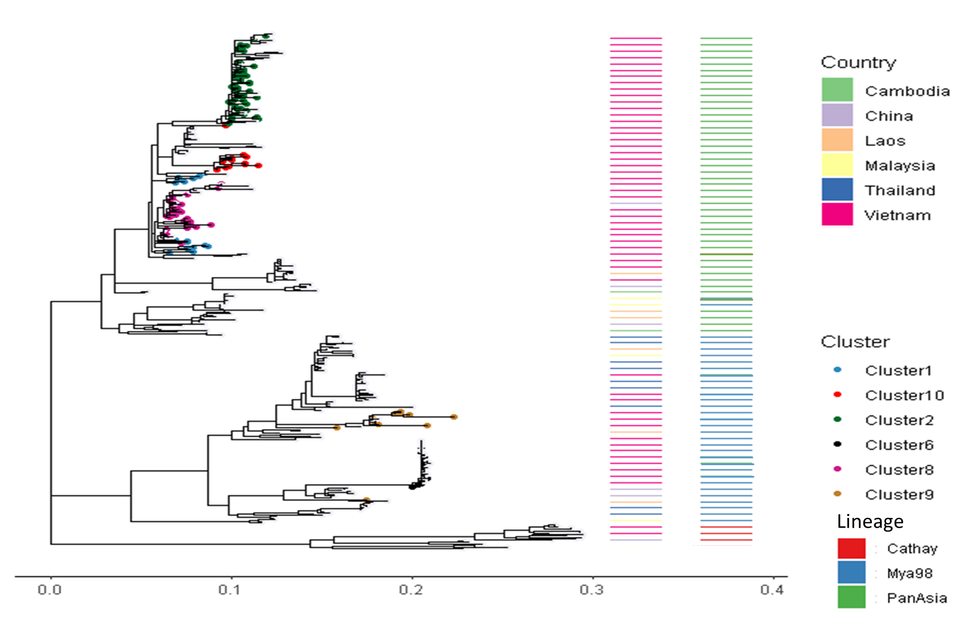
Figure S1: Serotype O clusters with other sequences from South East Asian countries Cambodia, Laos, Malaysia, Thailand.
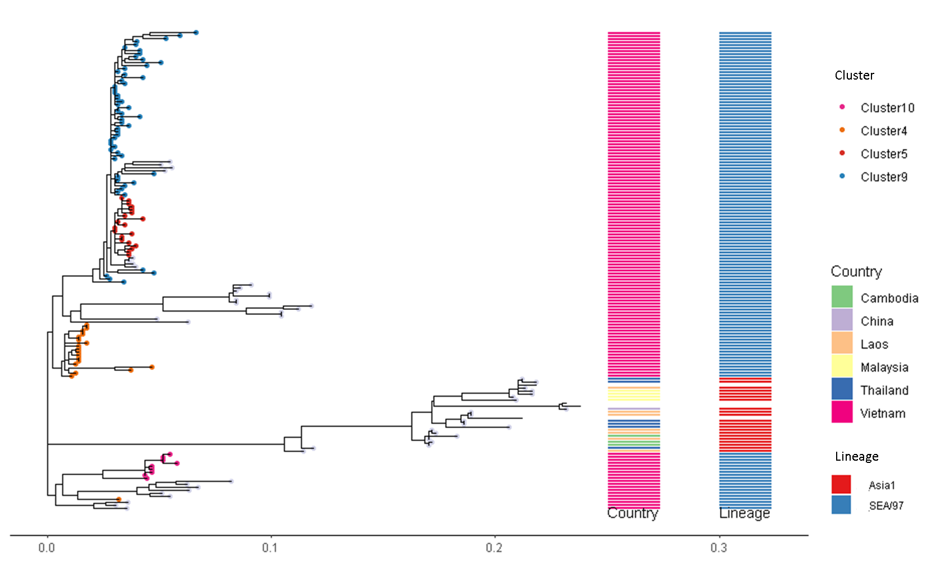
Figure S2: Serotype A clusters with other sequences from South East Asian countries Cambodia, Laos, Malaysia, Thailand.

