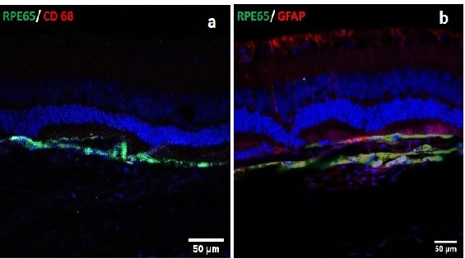
Supplementary Figure1. Representative images of immunodeficient RCS rat retinas implanted with iPSC-RPE monolayer (shown by RPE65 expression) cultured on a parylene membrane assessed at 1-month post implantation. Additional labelling of the retina sections was performed for expression of (a) CD68 (macrophages/ microglia) and (b) GFAP (glial cells).
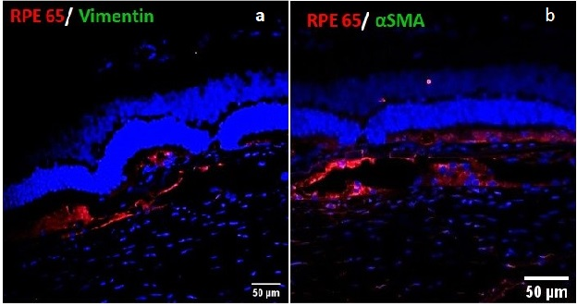
Supplementary Figure2. Representative images of immunodeficient RCS rat retinas implanted with iPSC-RPE monolayer (shown by RPE65 expression) cultured on a parylene membrane assessed at 1-month post implantation. Additional labelling of the retina sections was performed for expression of classical mesenchymal markers(a) vimentin and (b) α smooth muscle actin (α SMA).

