Total Number of Figures- 2
Total number of Chemical Structures-9
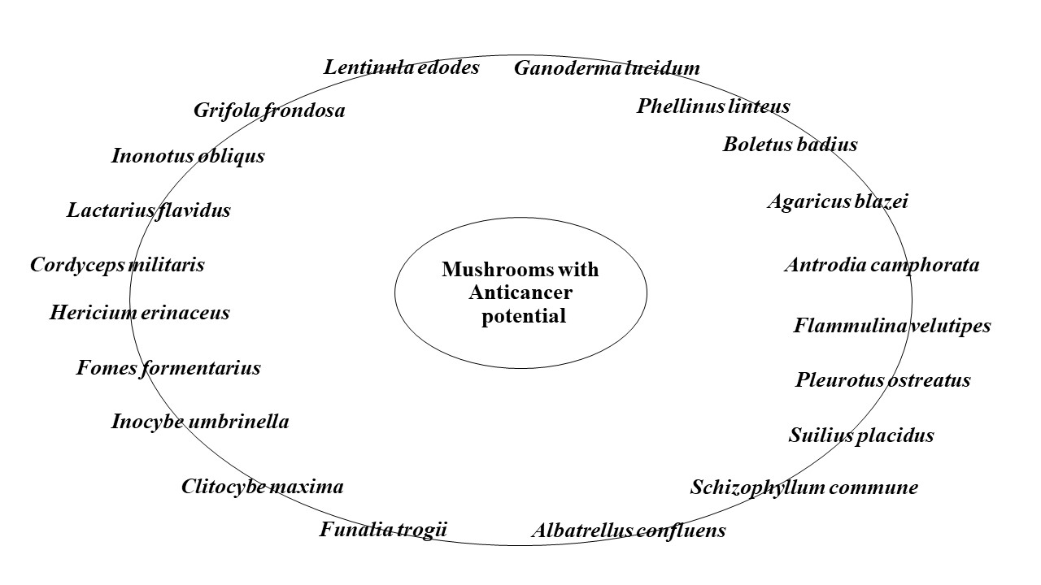
Figure 1: Medicinal mushrooms with anti-cancerous properties

Structure 1: Theanine Structure 2: Hispolon Structure 3: Illudin-S 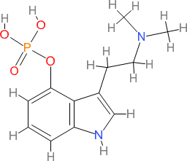
Structure 4: Psilocybin Structure 5: Gannoderric acid Structure 6: Cordycepin

Structure 7: Grifolin Structure 8: Antroquinonol Structure 9: Lentinan

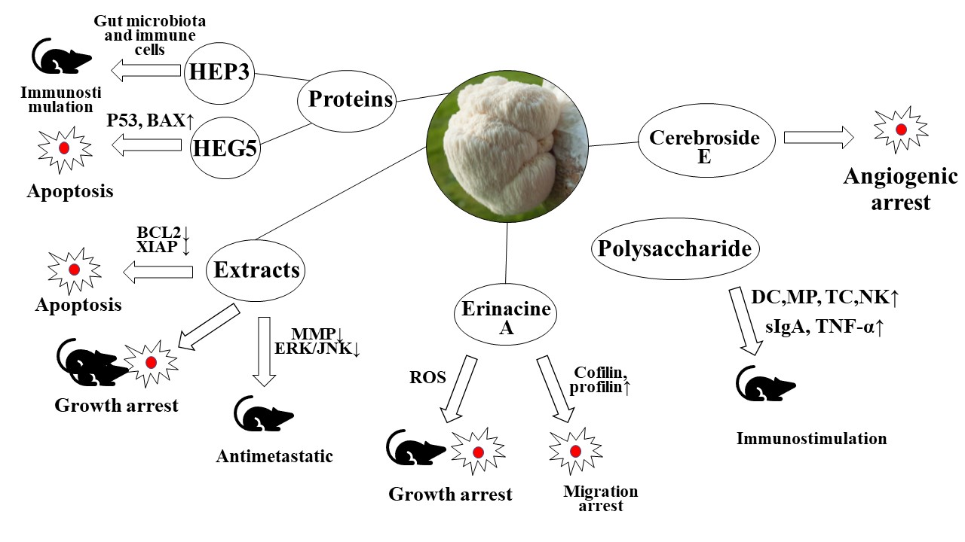
Figure 2: The anti-cancer properties of Hericium erinaceus

