Supplementary Information

Single excited dual band luminescent hybrid carbon dots-terbium chelate nanothermometer

Rustem R. Zairov, Alexey P. Dovzhenko, Kirill Sarkanich, Irek R. Nizameev, Andrey V. Luzhetskiy, Svetlana N. Sudakova, Sergey N. Podyachev, Vladimir A. Burilov, Ivan Vatsouro, Alberto Vomiero, Asiya R. Mustafina

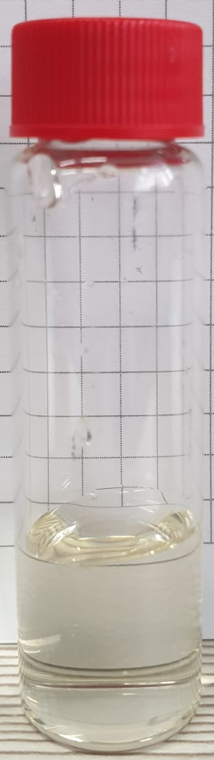
Figure S1. Image of CDs dispersion in water (C=10 μg mL⁻¹).

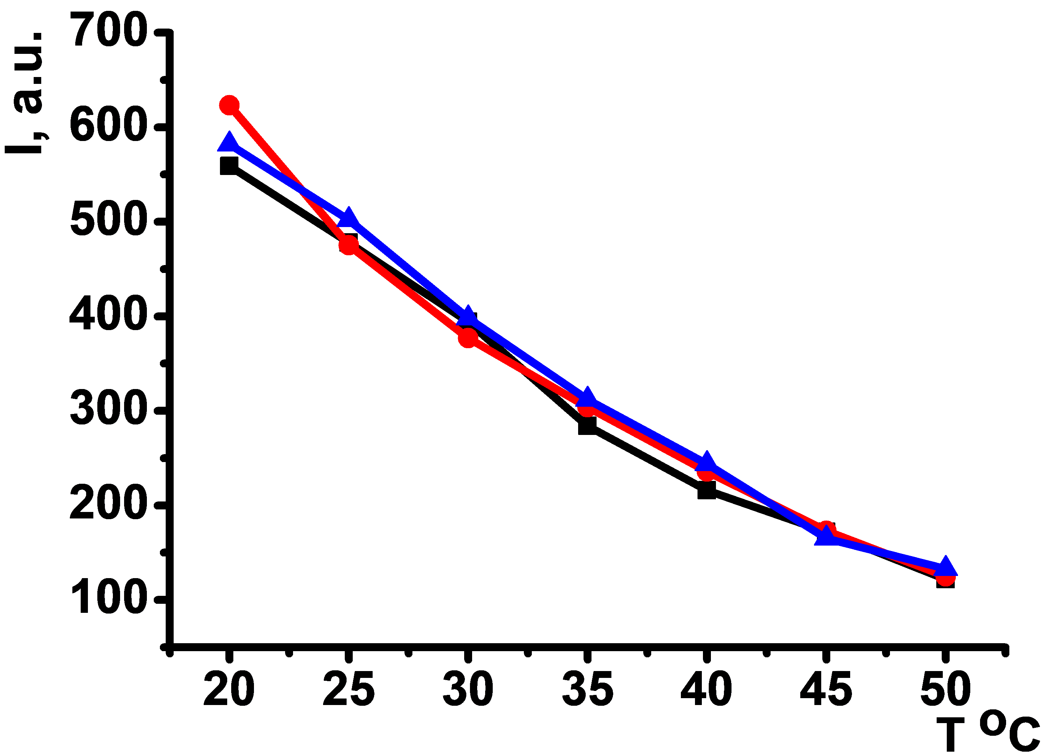
Figure S2. Luminescence intensity of [TbL]⁺ (λ_{em}=547 nm) versus temperature during heating-cooling-heating cycle in DMF (С_{L} =С_{Tb} =1⋅10⁻⁴ M).

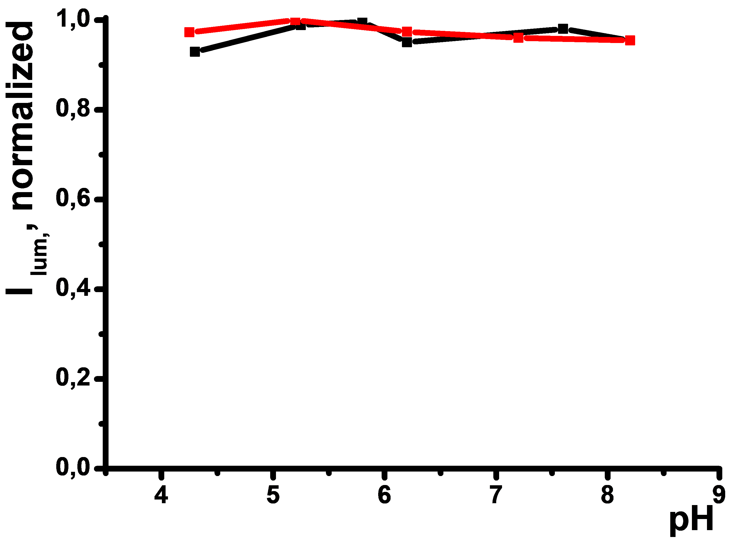
Figure S3. pH-dependency of CDs (λ_{em}=450 nm, C=0.01 g/L) in physiological range of pH=4.5-8.0.

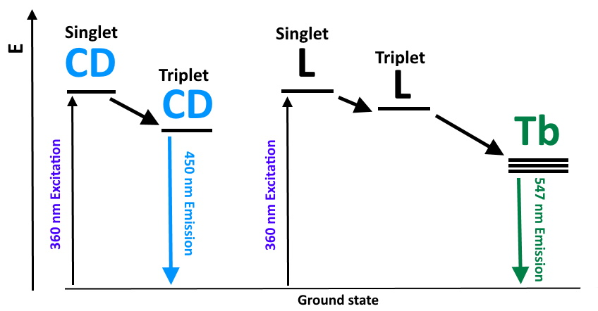
Figure S4. Tentative Jablonski diagram showing photophysical processes responsible for generation of dual band emission of PSS-{CDs-[TbL]} colloids.
Table S1. Luinescence decay exponential deconvolution data and lifetimes of [TbL]⁺ at different CDs to [TbL]⁺ ratio in DMF (C_{CD}=0.09-3.15 mg⋅L⁻¹; C_{[TbL]}=0.45 mM).
Molar quivalents of CDs | y₀ | A₁ | τ, ms
0,2 | 2,057 | 1495,2 | 0,896
0,4 | 2,076 | 1409,4 | 0,914
0,6 | 2,447 | 1449,8 | 0,920
0,8 | 2,258 | 1568,7 | 0,932
1 | 2,159 | 1560,3 | 0,964
1,2 | 2,302 | 1552,3 | 0,968
1,4 | 2,263 | 1507,7 | 0,974
1,6 | 2,416 | 1500,8 | 0,976
1,8 | 2,731 | 1566,7 | 0,989
2 | 2,999 | 1571,7 | 0,980
3 | 2,729 | 1474,6 | 1,016
4 | 3,202 | 1499,5 | 1,032
5 | 2,922 | 1499,9 | 1,048
7 | 3,102 | 1511,1 | 1,072

Table S2. Average lifetimes of Tb(III) excited state for PSS-{CDs-[TbL]} colloids obtained according to Synthesis_1 and Synthesis_2 in water.
 | A1 | t1 | A2 | t2 | t_{avg}, ms | Adj. R-Square
Synthesis_1 | 1.282 | 0.068 | 0.321 | 0.305 | 0.193 | 0.99704
Synthesis_2 | 1.161 | 0.087 | 0.356 | 0.309 | 0.203 | 0.99985

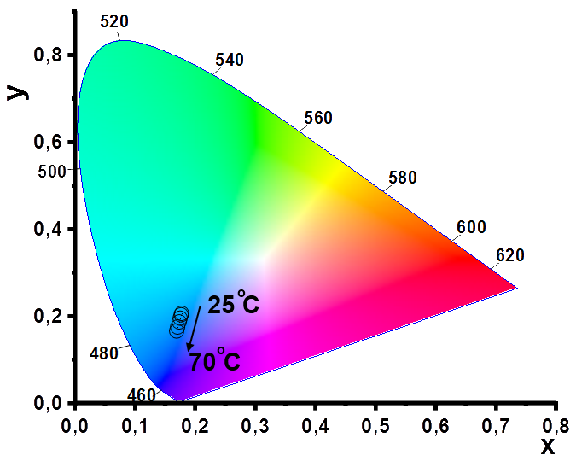
Figure S5. Chromaticity diagram for PSS-{CDs-[TbL]} (Synthesis_1) (l_{ex} =360 nm) as a function of temperature over the 25-70°C range.

