Supplementary Figure S1

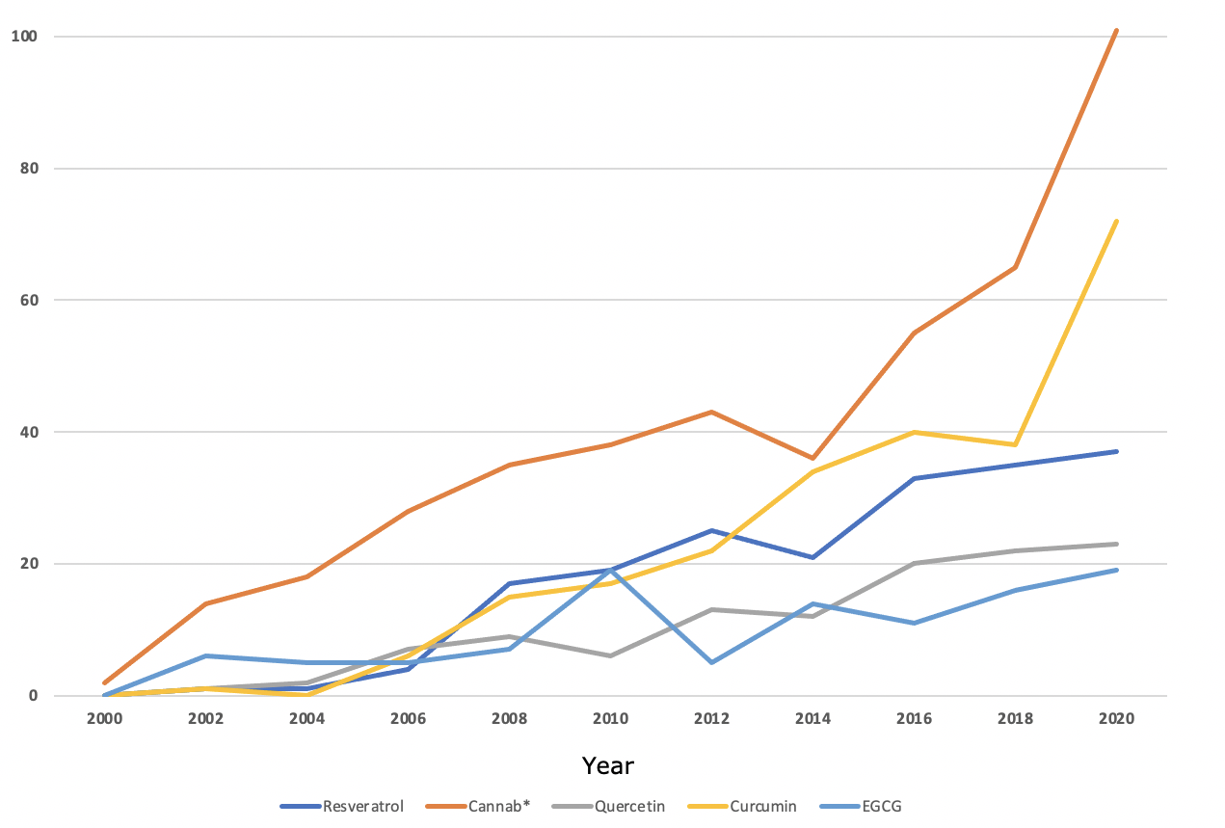
Supplementary Figure S1| Line graph showing the annual frequency of publications regarding PD and certain dietary polyphenols, according to a PubMed literature search.

Supplementary Data S2
An electronic literature search was performed using: 1) Medline (OvidSP), 2) Embase (OvidSP), 3) APA PsychINFO (OvidSP), 4) PubMed and 5) Web of Science Core Collection. The following search terms were used in selected literature databases to uncover relevant publications regarding the neuroprotective effects of CDCs and RSV, within in vivo pre-clinical studies observing PD. Boolean operators were used to broaden the search results to incorporate all potentially relevant research. Field tags such as: topic (TS), title (TI), multipurpose (m.p.) were used for more specific identification of key terms in titles and abstracts etc.
Ovid - Medline, Embase and APA PsychINFO:
- Parkinson’s Disease OR Parkinson*.mp.
- Cannab* OR Tetrahydrocannabinol OR Cannabidiol OR β-Caryophyllene OR Tetrahydrocannabivarin OR Resveratrol.mp.
- in vivo OR pre-clinical.mp.
- Animal OR Primate OR Monkey OR Rodent OR Mice OR Mouse OR Rat.mp.
- #1 AND #2 AND #3 AND #4
PubMed:
- (((Parkinson’s Disease OR Parkinson*)) AND ((Cannab* OR Tetrahydrocannabinol OR Cannabidiol OR β-Caryophyllene OR Tetrahydrocannabivarin OR Resveratrol)))
Web of Science:
- Topic (TS) = (Parkinson’s Disease OR Parkinson*)
- Title (TI) = (Parkinson’s Disease OR Parkinson*)
- #1 OR #2
- TS = (Cannab* OR Tetrahydrocannabinol OR Cannabidiol OR β-Caryophyllene OR Tetrahydrocannabivarin OR Resveratrol)
- TI = (Cannab* OR Tetrahydrocannabinol OR Cannabidiol OR β-Caryophyllene OR Tetrahydrocannabivarin OR Resveratrol)
- #4 OR #5
- TS = (Animal OR Primate OR Monkey OR Rodent OR Mice OR Mouse OR Rat)
- TI = (Animal OR Primate OR Monkey OR Rodent OR Mice OR Mouse OR Rat)
- #7 OR #8
- #3 AND #6 AND #9
The search term ‘cannab*’ was used to incorporate cannabis, cannabigerol, cannabidiols and all other cannabis-derived phytocannabinoids (CDCs).

Methodological Quality Assessment
Currently, there is no official gold standard tool for assessing bias in pre-clinical animal studies. Instead, the SYRCLE’s risk of bias tool has been developed considering aspects of the ‘Cochrane Collaboration risk of bias tool’ used in randomised controlled trials [31]. The tool has been adapted in accordance with methodology used in animal studies. The following letters (A-J) indicate which specific aspect of the methodology is being assessed.
A: Was the allocation sequence adequately generated and applied? (Selection bias)
B: Were the groups similar at baseline or were they adjusted for confounders in the analysis? (Selection bias)
C: Was the allocation adequately concealed? (Selection bias)
D: Were the animals randomly housed during the experiment? (Performance bias)
E: Were the caregivers and/or investigators blinded from knowledge of which intervention each animal received during the experiment? (Performance bias)
F: Were animals selected at random for outcome assessment? (Detection bias)
G: Was the outcome assessor blinded? (Detection bias)
H: Were incomplete outcome data adequately addressed? (Attrition bias)
I: Are reports of the study free of selective outcome reporting? (Reporting bias)
J: Was the study apparently free of other problems that could result in high risk of bias? (Other)

Supplementary Table S1| Risk of Bias (RoB) table of included studies*

Study | A | B | C | D | E | F | G | H | I | J
Ojha et al. (2016) [39] | N | Y | N | Y | UC | UC | Y | UC | Y | Y
Viveros-Paredes et al. (2017) [49] | Y | Y | N | Y | UC | UC | N | UC | Y | Y
Peres et al. (2016) [41] | N | Y | N | Y | UC | UC | Y | UC | Y | Y
Lattress Becker et al. (2005) [32] | N | Y | N | Y | UC | UC | N | UC | Y | Y
Abdel-Salam et al. (2012) [38] | N | Y | N | Y | UC | UC | N | UC | Y | Y
Garcia et al. (2011) [33] | N | Y | N | Y | UC | UC | Y | UC | Y | Y
Zhang et al. (2018) [43] | N | Y | N | Y | UC | UC | Y | UC | Y | Y
Lu et al. (2008) [48] | Y | Y | N | Y | UC | UC | N | UC | Y | Y
Anandhan et al. (2010) [46] | N | Y | N | Y | UC | UC | Y | UC | Y | Y
Lofrumento et al. (2014) [45] | N | Y | N | Y | UC | UC | N | UC | Y | Y
Guo et al. (2016) [44] | Y | Y | N | Y | Y | UC | Y | UC | Y | Y
Xia et al. (2019) [47] | N | Y | N | Y | UC | UC | N | UC | Y | Y
Jin et al. (2008) [34] | Y | Y | N | Y | UC | UC | N | UC | Y | Y
Khan et al. (2010) [35] | N | Y | N | Y | UC | UC | N | UC | Y | Y
Wang et al. (2011) [36] | Y | Y | N | Y | UC | UC | N | UC | Y | Y
Huang et al. (2019) [37] | Y | Y | N | Y | UC | UC | UC | UC | Y | Y
Gaballah et al. (2016) [40] | Y | Y | N | Y | UC | UC | N | UC | Y | Y
Palle et al. (2018) [42] | Y | Y | N | Y | UC | Y | N | UC | Y | Y
*Abbreviations: Y, Yes, low risk of bias; UC, Unclear, insufficient information to assess certain bias; N, No, high risk of bias

