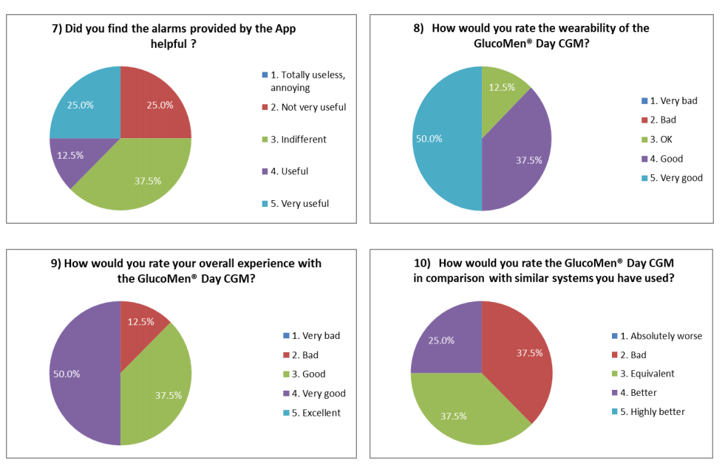
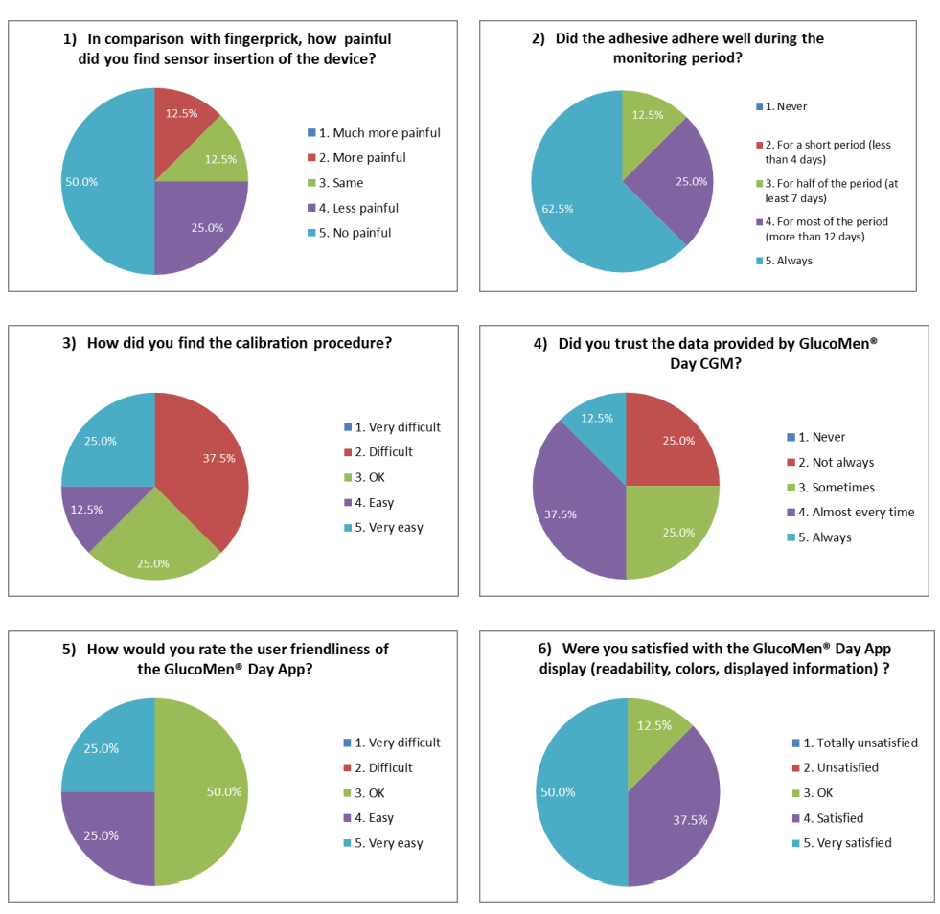
Supplementary Materials:
Figure S1: Usability Questionnaire Results (N = 8)

