Supplementary Materials
Synthesis of Novel Tamarind Gum-co-Poly(Acrylamidoglycolic Acid) based pH Responsive semi-IPN Hydrogels and their Ag Nanocomposites for Controlled Release of Chemotherapeutics and Inactivation of Multi Drug Resistance Bacteria
Kasula Nagaraja¹, Kummari S.V. Krishna Rao^{1,} *, Sunmi Zo^{2,3}, Sung Soo Han^{2,3}, Kummara Madhususdana Rao^{2,3,}*
¹ Polymer Biomaterial Design and Synthesis Laboratory, Department of Chemistry, Yogi Vemana University, Kadapa 516005, Andhra Pradesh, India; nagarajakasula33@gmail.com (K.N.)
² School of Chemical Engineering, Yeungnam University, 280 Daehak-Ro, Gyeongsan, Gyeongbuk, 38541, South of Korea;
³ Research Institute of Cell Culture, Yeungnam University, 280 Daehak-Ro, Gyeongsan, Gyeongbuk 38541, South Korea sunmizo@ynu.ac.kr (S.Z.) ; sshan@yu.ac.kr (S.S.H.)
* Correspondence: ksvkr@yogivemanauniversity.ac.in; Tel: +919704278890 (K.S.V.K.R). msraochem@gmail.com (K.M.R.)

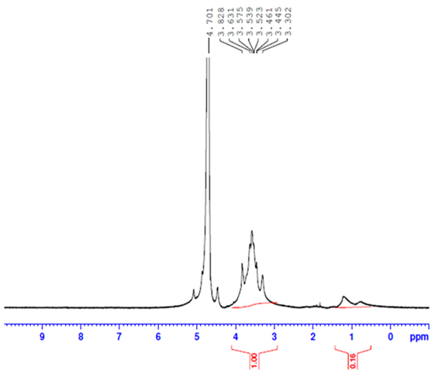
Figure S1: ¹HNMR spectroscopy of pure tamarind gum polysaccharide
The TMG polysaccharide was isolated from TM seeds and confirmed by ¹HNMR spectroscopy using D₂O as a solvent. The characterization peaks for TM showed a narrow region at 4.4 to 3.3 ppm indicating the anomeric proton peaks of the glucose, xylose, and galactose backbone.

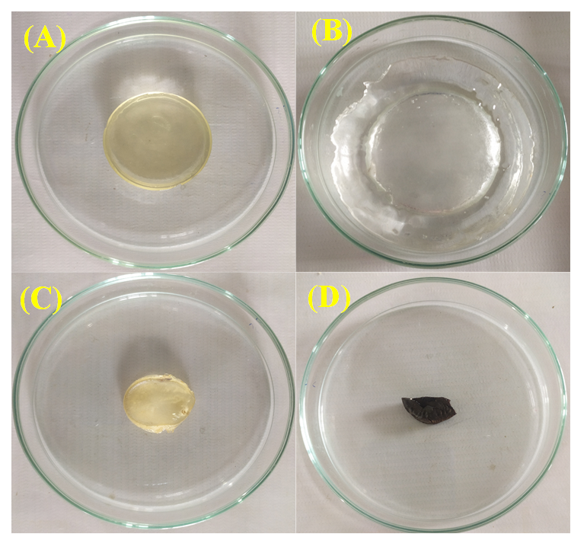

Figure S2: Digital photographic images of TMGA hydrogels (A) Fresh gel (B) Swollen gel (C) dried gel (D) TMGA-Ag hydrogel

Table S1: In-vitro drug release data of TMGA hydrogel
Time (h) | pH-1.2 (%) |  | pH-7.4 (%)
 | TMGA-3 | TMGA-4 | TMGA-3 | TMGA-4
3 | 35.31 | 26.68 | 48.88 | 32.40
5 | 53.41 | 33.42 | 63.51 | 49.58
7 | 61.74 | 47.09 | 75.25 | 65.91
12 | 72.12 | 71.46 | 84.23 | 84.23
24 | 89.27 | 84.16 | 95 | 88.68
48 | 93.12 | 85.12 | 97.72 | 91.02

Table-S2: Drug release kinetics of various kinetics models

Sample code | Zero order |  | First order |  | Higuchi |  | Hixson-Crowell |  | Korsmeyer- peppas
 |  |  |  |  |  |  |  |  | pH-1.2 |  |  | pH-7.4
 | R | K₀ | R | K₁ | R | K_{h} | R | K_{hc} | k | n | r | k | n | r
TMGA-1 | 0.982 | 2.215 | 0.978 | 2.145 | 0.991 | 0.102 | 0.963 | 1.215 | 2.51 | 0.98 | 0.977 | 2.33 | 0.64 | 0.984
TMGA -2 | 0.965 | 4.325 | 0.961 | 3.215 | 0.997 | 0.295 | 0.980 | 1.784 | 1.33 | 0.79 | 0.994 | 3.56 | 0.95 | 0.984
TMGA -3 | 0.989 | 1.849 | 0.988 | 1.478 | 0.974 | 0.380 | 0.991 | 1.235 | 2.35 | 0.67 | 0.981 | 1.47 | 0.91 | 0.991
TMGA -4 | 0.978 | 3.457 | 0.977 | 1.213 | 0.964 | 1.264 | 0.974 | 0.984 | 2.14 | 0.78 | 0.995 | 4.12 | 0.76 | 0.986

