Use of X-ray mutagenesis to increase genetic diversity of Zantedeschia aethiopica for early flowering, improved tolerance to bacterial soft rot and higher yield
Noam Reznik ¹*, Bijaya Sharma Subedi ^{1, 2}, Shoshana Weisman ³, Gavriel Friesem ¹, Nir Carmi ⁴, Iris Yedidia ^{1,}* and Michal Sharon-Cohen ⁵

Supplementary File

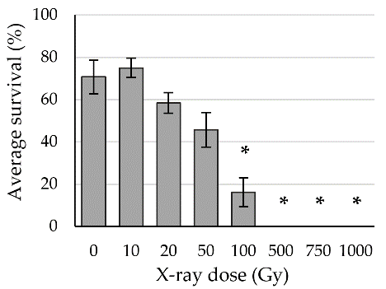

Figure S1. Calibration of the radiation dose for Zantedeschia aethiopica seeds. The bars represent average survival of the germinating seedlings, with standard errors. Significant doses are marked with an asterisk (p < 0.05). Gy = Gray.

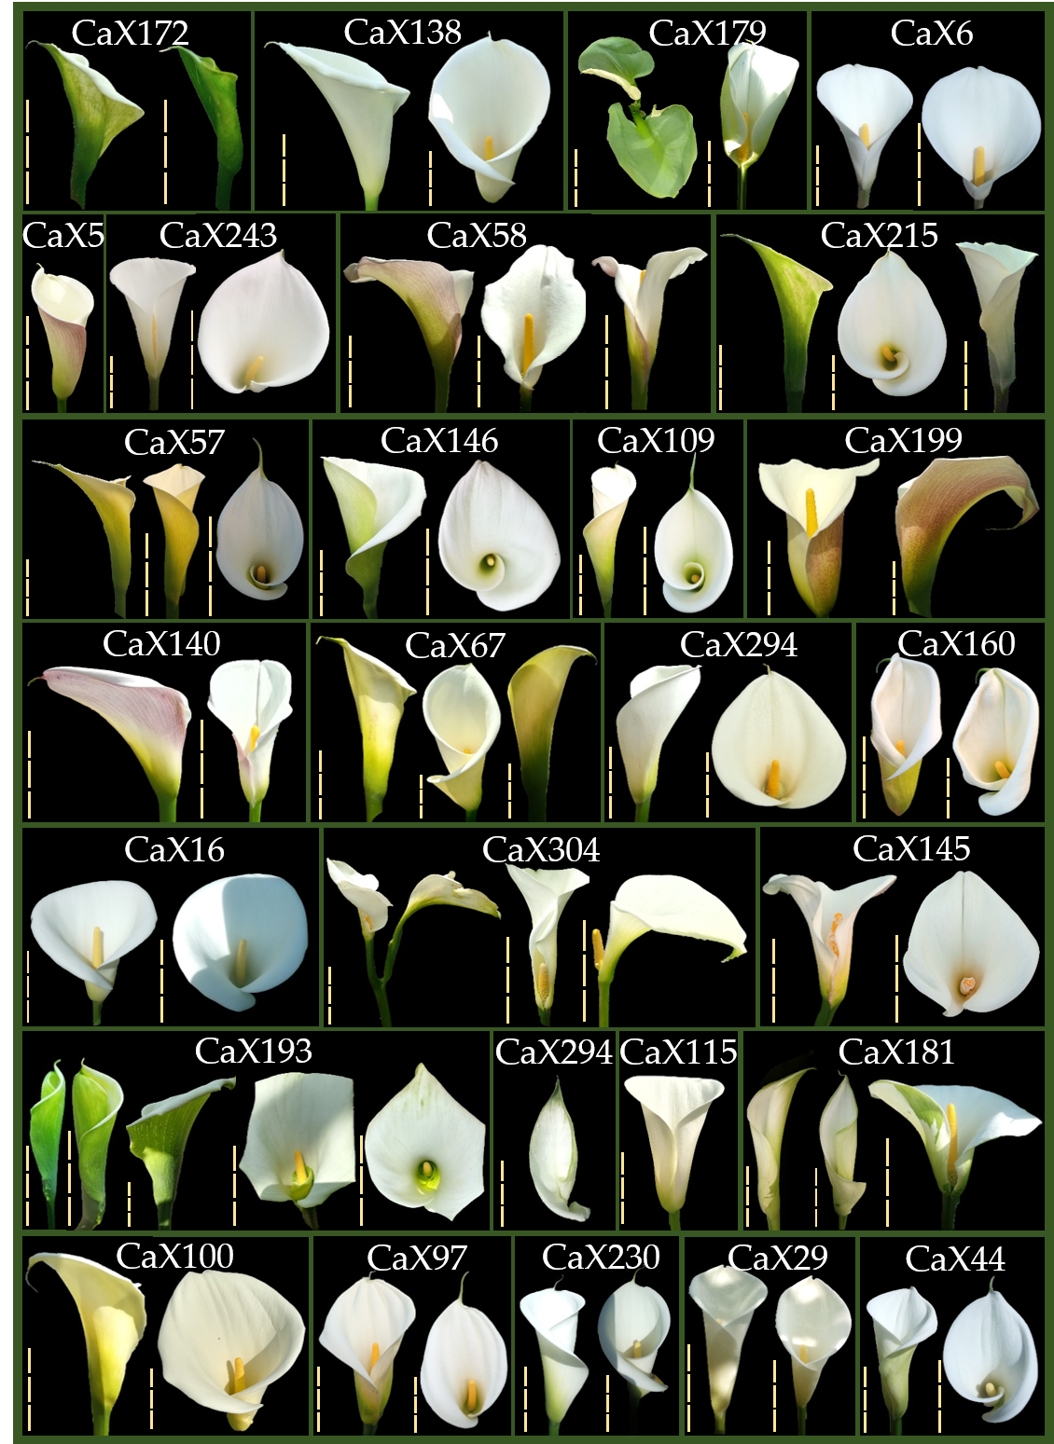

Figure S2. Flower diversity of mutated lines (CaX) during two growing seasons (2018-2020). The line labels are marked above the flowers. The vertical yellow dashed bar on the left of each image represents a length of 6 cm.

