Supplementary Figures 1 and 2

Aceltransferases GCN5 and PCAF are required for B cell maturation in mice
Valentyn Oksenych^{1,2,3,4,5,}*
Citation:
Academic Editor: Firstname Lastname
Received: date
Accepted: date
Published: date
Publisher’s Note: MDPI stays neutral with regard to jurisdictional claims in published maps and institutional affiliations.
Copyright: © 2021 by the authors. Submitted for possible open access publication under the terms and conditions of the Creative Commons Attribution (CC BY) license (https://creativecommons.org/licenses/by/4.0/).
¹ Department for Cancer Research and Molecular Medicine (IKOM), Norwegian University of Science and Technology, Laboratory Center, Erling Skjalgssons gate 1, 7491 Trondheim, Norway; valentyn.oksenych@ntnu.no
² KG Jebsen Centre for B Cell Malignancies, Institute of Clinical Medicine, University of Oslo, N-0316 Oslo, Norway;
³ Institute of Clinical Medicine, University of Oslo, 0318 Oslo, Norway; valentyn.oksenych@medisin.uio.no
⁴ The NNF Center for Protein Research, Faculty of Health and Medical Sciences, University of Copenhagen, Blegdamsvej 3B, 2200 Copenhagen, Denmark
⁵ Department of Biosciences and Nutrition (BioNut), Karolinska Institutet, 14183 Huddinge, Sweden
* Correspondence: Valentyn Oksenych valentyn.oksenych@medisin.uio.no

*Corresponding author: valentyn.oksenych@medisin.uio.no (Valentyn Oksenych)

Supplementary Figure S1. Detection of GCN5, PCAF and histones using western blot
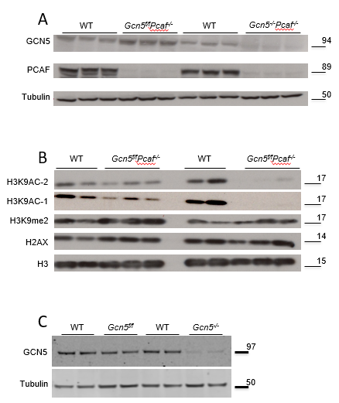
Supplementary Figure S1. Detection of GCN5, PCAF and histones.
(A) Detection of GCN5 and PCAF in primary murine B cells of indicated genotype. GCN5 signal is absent in the Gcn5^{-/-} cells. PCAF signal is absent in the Pcaf^{-/-} cells. Tubulin was used as a loading control.
(B) Western blot detecting Histones H3, H2AX, H3K9me2, H3K9ac (two different antibodies). H3K9Ac signal is missing in the cells lacking both GCN5 and PCAF.
(C) Detection of GCN5 and PCAF in primary murine B cells of indicated genotype. GCN5 signal is absent in the Gcn5^{-/-} cells.
Supplementary Figure S2. Detection of developing B cells in mice of indicated genotypes using flow cytometry
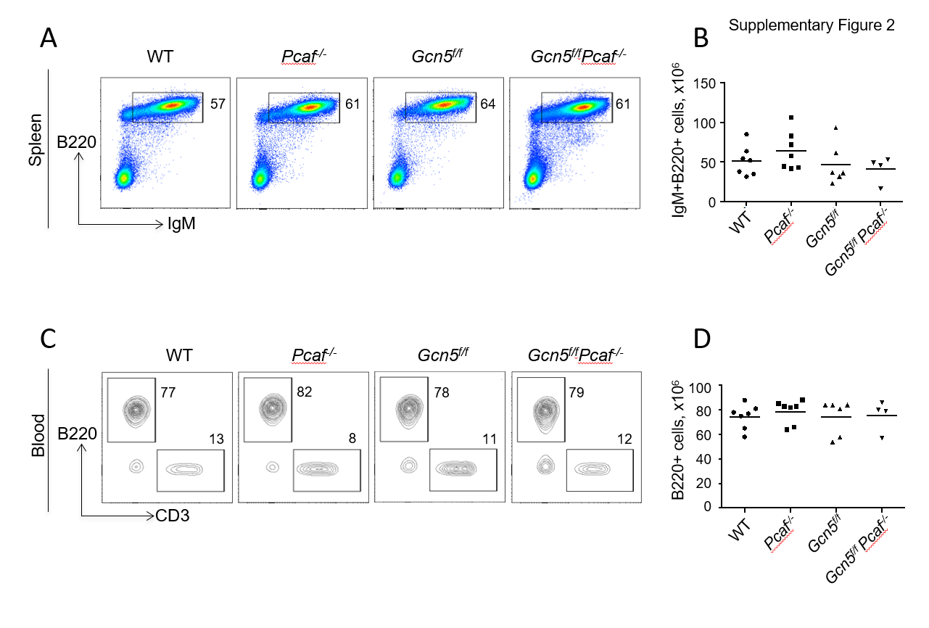

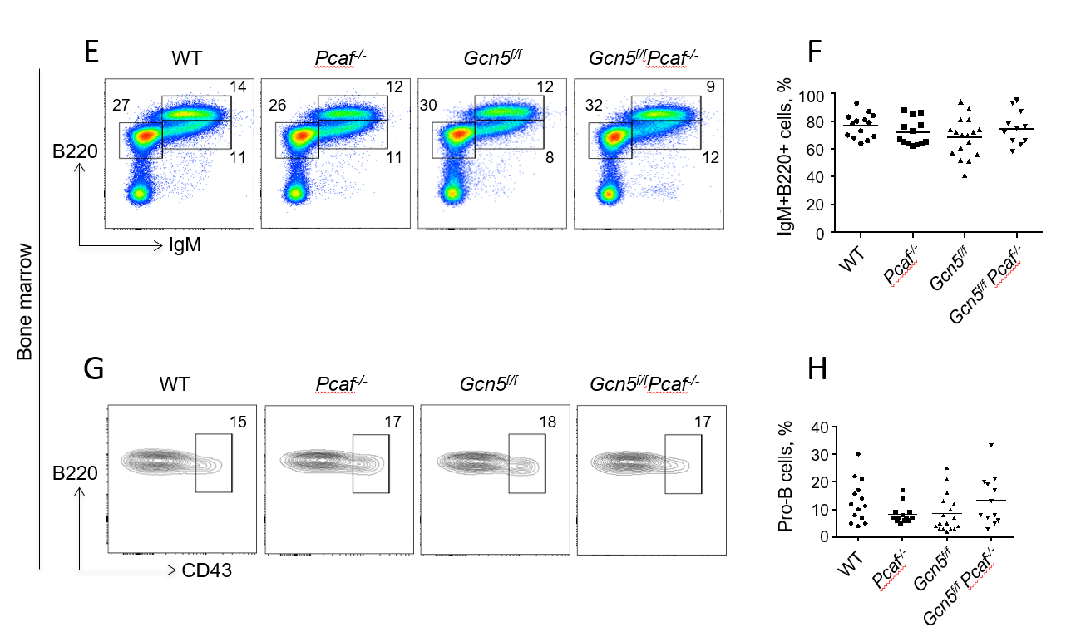
Supplementary Figure S2. Detection of developing B cells in mice of indicated genotypes using flow cytometry
(A) Example of flow cytometry detecting B220+IgM+ mature B cells in spleen.
(B) Summary of several experiments shown in (A).
(C) Example of flow cytometry detecting B220+ B cells and CD3+ T cells in blood.
(D) Summary of several experiments shown in (C).
(E) Example of flow cytometry detecting B220+IgM- and B200+IgM+ developing B cells in bone marrow.
(F) Summary of several experiments shown in (E).
(G) Example of flow cytometry detecting B220+IgM-CD43+ pro-B cells and B220+IgM-CD43- pre-B cells in bone marrow.
(H) Summary of several experiments shown in (G).

Supplementary Figure S3. Count of WT, Pcaf-deficient, Gcn5-deficient, and Gcn5/Pcaf double-deficient pro-B cells in bone marrow (million cells); n.s. p>0.3830
