Variable | Patient 1 | Patient 2 | Patient 3 | Patient 4
Age (years) | 91 | 91 | 72 | 75
Sex | Male | Male | Female | Female
Charlson index | 1 | 0 | 7 | 0
Chronic heart failure | No | No | Yes | No
Natural cardiac valve disease | No | No | No | No
Prosthetic heart valve disease | No | No | No | No
CIED | No | No | No | No
Hemodialysis | No | No | No | No
Liver cirrhosis | No | No | No | No
Intravenous drug user | No | No | No | No
Previous IE | No | No | No | No
Acquisition | Nosocomial | Nosocomial | Nosocomial | Community
Primary source | PVC related | PVC related | Unknown* | Unknown
Symptoms duration prior to ATB | 48 hours | 24 hours | 24 hours | 48 hours
Sepsis/shock | No | No | No | No
Fever defervescence within 48h | Yes | Yes | Yes | Yes
Septic emboli | No | No | No | No
Thrombophlebitis | No | No | No | No
Acute cardiac failure | No | No | No | No
Time to positivity | 18 hours | 17 hours | 13 hours | 16 hours
Persistent bacteriemia | No | No | No | No
Early source control (if necessary) | Yes | Yes | Yes* | -
TTE | Positive | Positive | Negative | Not done
TEE | Not done | Not done | Positive | Positive
Outcome | IE-related death | IE-related death | Alive  No relapse | Alive  No relapse
PREDICT score classification | Low risk | Low risk | Low risk | High risk
POSITIVE score classification | Low risk | Low risk | Low risk | Low risk
*Patient 3 had a central venous catheter which was presumed to be the probable source of infection, although it could not be demonstrate. The catheter was retired 1 week previously to symptoms onset.
Table S1: Individual characteristics of patients identified as low risk of IE by means of VIRSTA score but who finally were diagnosed of IE. IE: infective endocarditis. CIED: Cardiac implantable electronic device, PVC: peripheral venous catheter. ATB: antibiotic. TTE: transthoracic echocardiography, TEE: transesophageal echocardiography

Variable |  |  | Total (n=335) | Survivor (n=281) | Non survivor (n=54) | p | Missing
Demographic and comorbidity
Age |  |  | 70 (56-81) | 68 (54-80) | 77 (64-90) | <0.001 | 0
Sex (female) |  |  | 31.9% (107) | 32.0% (90) | 31.5% (17) | 1.000 | 0
Charlson index |  |  | 2 (1-5) | 2 (0-4) | 4 (2-6) | 0.001 | 2
Age-adjusted Charlson index |  |  | 5 (3-7) | 5 (2-7) | 7 (5-8) | <0.001 | 2
Arterial hypertension |  |  | 52.8% (177) | 50.9% (143) | 63.0% (34) | 0.136 | 0
Diabetes mellitus |  |  | 27.8% (93) | 28.5% (80) | 24.1% (13) | 0.619 | 0
Chronic heart failure |  |  | 27.5% (92) | 25.3% (71) | 38.9% (21) | 0.046 | 0
Ischemic heart disease |  |  | 17.3% (58) | 15.7% (44) | 25.9% (14) | 0.078 | 0
Natural cardiac valve disease |  |  | 14.3% (48) | 12.8% (36) | 22.2% (12) | 0.088 | 0
Prosthetic heart valve disease |  |  | 3.0% (10) | 2.8% (8) | 3.7% (2) | 0.667 | 0
CIED |  |  | 4.8% (16) | 5.3% (15) | 1.9% (1) | 0.334 | 0
Chronic renal failure |  |  | 21.5% (72) | 19.9% (56) | 29.6% (16) | 0.146 | 0
Hemodialysis |  |  | 6.9% (23) | 7.2% (20) | 5.6% (3) | 0.789 | 0
Liver cirrhosis |  |  | 3.0% (10) | 2.5% (7) | 5.6% (3) | 0.209 | 0
Solid organ malignancy |  |  | 22.2% (74) | 21.8% (61) | 24.1% (13) | 0.722 | 1
Parenteral drug user |  |  | 0.9% (3) | 1.1% (3) | 0 | 1.000 | 1
Clinical presentation
Acquisition |  | Nosocomial | 53.1% (178) | 53.7% (151) | 50.0% (27) | Ref. | 0
 |  | Healthcare associated | 17.6% (59) | 16.4% (46) | 24.1% (13) | 0.224
 |  | Community | 29.3% (98) | 29.9% (84) | 25.9% (14) | 0.843
Source of infection | Catheter-related |  | 35.5% (119) | 37.0% (104) | 27.8%% (15) | ref | 0
 | Primary-Unknown |  | 24.5% (80) | 20.8% (57) | 43.8% (23) | 0.001
 | Other |  | 40.6% (136) | 42.7% (120) | 29.6% (16) | 0.837
Fever |  |  | 89.8% (300) | 88.9% (249) | 94.4% (51) | 0.325 | 1
Sepsis/septic shock |  |  | 23.1% (77) | 18.9% (53) | 44.4% (24) | <0.001 | 1
Fever defervescence within 72 hours |  |  | 82.3% (276) | 83.2% (234) | 72.2% (39) | 0.305 | 29
Septic emboli |  |  | 9.0% (30) | 9.3% (26) | 7.4% (4) | 0.799 | 0
Acute kidney injury |  |  | 36.0% (119) | 32.5% (90) | 53.7% (29) | 0.003 | 4
Acute cardiac failure |  |  | 15.0% (50) | 12.5% (35) | 27.8% (15) | 0.007 | 2
Pitt’s bacteremia score |  |  | 0 (0-1) | 0 (0-1) | 1 (0-3) | <0.001 | 1
SOFA |  |  | 2 (0-4) | 1 (0-3) | 4 (2-5) | <0.001 | 2
Microbiology
Time to positivity |  |  | 12 (10-16) | 12 (10-16) | 12 (9-17) | 0.423 | 0
Persistent bacteriemia |  |  | 26.9% (71) | 25.0% (58) | 40.6% (13) | 0.087 | 71
Meticilin-resistant SAB |  |  | 20.6% (69) | 18.9% (53) | 29.6% (16) | 0.057 | 0
Diagnostic work-up
TTE and/or TEE |  |  | 72.0% (237) | 75.9% (211) | 51.0% (26) | <0.001 | 6
TTE |  |  | 62.3% (207) | 66.4% (186) | 40.4% (21) | 0.001 | 3
TEE |  |  | 28.0% (11) | 29.1% (81) | 21.6% (11) | 0.311 | 6
PET-CT |  |  | 8.1% (27) | 8.9% (25) | 3.8% (2) | 0.279 | 3
Complicated SAB |  |  | 28.1% (93) | 26.1% (73) | 39.2% (20) | 0.042 | 4
VIRSTA score (high risk) |  |  | 49.0% (164) | 45.2% (127) | 68.5% (37) | 0.002 | 0
Source control necessary and not performed |  |  | 11.3% (38) | 10.7% (30) | 14.8% (8) | 0.252 | 0
Table S2: Univariate analysis of 30-day mortality in patients with no diagnosed with infective endocarditis and who survived the first 48 hours after the index blood culture extraction. Qualitative variables are expressed as percentage (absolute number) and compared by means of chi-square (or Fisher exact test when necessary). Quantitative variables are expressed as median (interquartile range) and compared by means of Mann-Whitney’s U. CIED: Cardiac implantable electronic device. SAB: Staphylococcus aureus bacteriemia

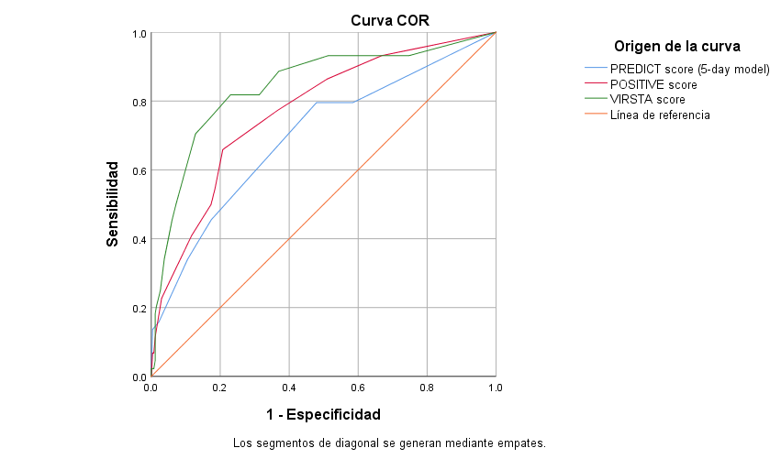

Figure 1: Receiving-Operator Curve of different clinical prediction rules. AUC for PREDICT score (5-day model) was 0.699 (IC 95% 0.609-0.788). AUC for POSITIVE score was 0.771 (95% CI 0.696-0.846). AUC for VIRSTA score was 0.842 (0.771-0.912). AUC: Area Under de Curve.

