Genomic insights on the functional capabilities of the cyanosphere of edible Andean Nostoc macrocolonies (Llayta)

Claudia Vilo¹, Alexandra Galetovic¹, Qunfeng Dong², Benito Gómez-Silva^{1*}
¹ Laboratory of Biochemistry, Biomedical Department, Health Sciences Faculty and Centre for Biotechnology and Bioengineering (CeBiB), Universidad de Antofagasta, Antofagasta, Chile; claudiavilo@gmail.com; alexandra.galetovic@uantof.cl; benito.gomez@uantof.cl
² Center for Biomedical Informatics, Department of Medicine, Stritch School of Medicine, Loyola University of Chicago, Maywood, Illinois, USA; qdong@luc.edu

* Correspondence: benito.gomez@uantof.cl

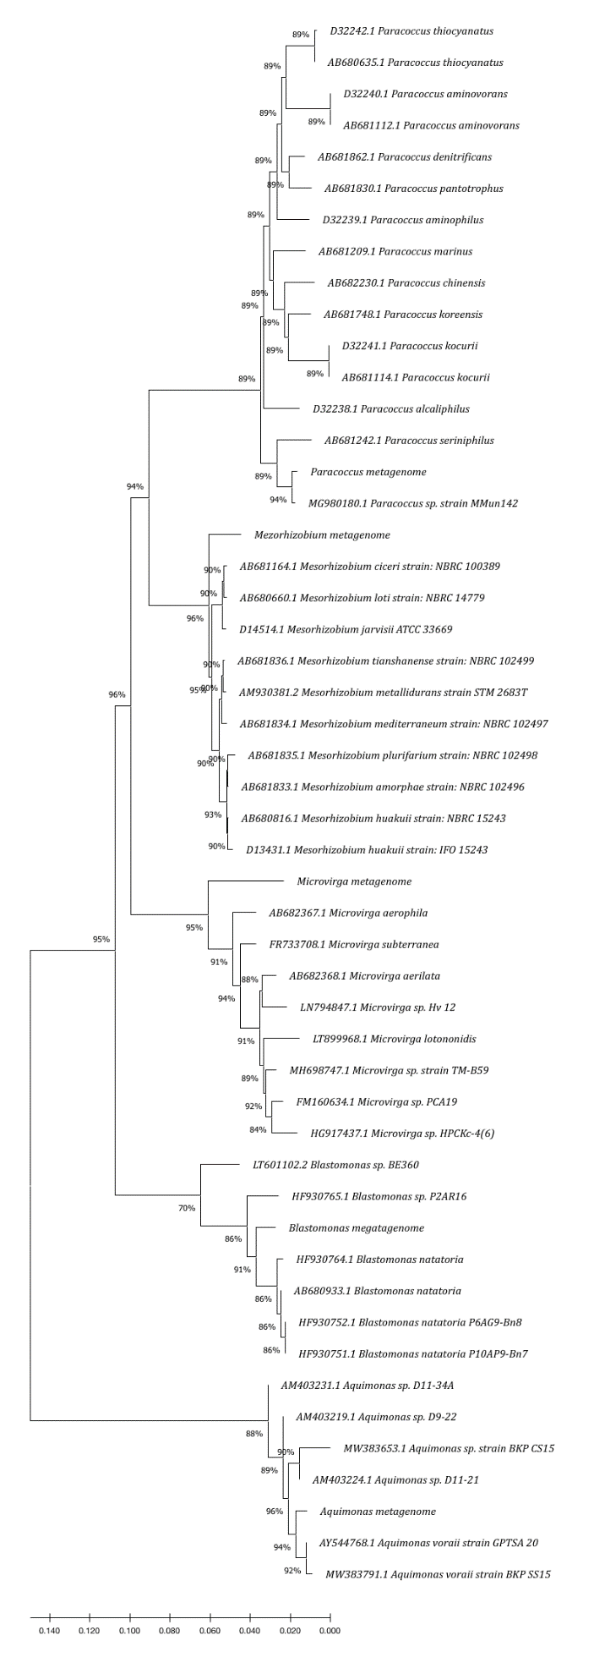
Paracoccus
Mezorhizobium
Microvirga
Blastomonas
Aquimonas

Supplementary Figure S1. Phylogenetic tree of 16S rRNA gene depicting clades of the five assembled bacteria genera, Aquimonas, Blastomonas, Microvirga, Mezorhizobium, and Paracoccus.

