Review
Supporting Information

Severe Acute Respiratory Syndrome Coronavirus 2 Variants of Concern: a perspective for the emerging strains more transmissible, infectible and resistant to vaccines

Anacleto Silva de Souza¹, Vitor Martins de Freitas Amorim¹, Gabriela D A Guardia², Filipe F dos Santos^{2,4}, Henning Ulrich⁴, Pedro A F Galante², Robson Francisco de Souza¹ ,Cristiane Rodrigues Guzzo¹,*

¹Department of Microbiology, Institute of Biomedical Sciences, University of São Paulo, São Paulo, Brazil.
²Centro de Oncologia Molecular, Hospital Sírio Libanes, São Paulo, Brazil.
³Programa Interunidades em Bioinformática, University of São Paulo, São Paulo, Brazil.
⁴Department of Biochemistry, Institute of Chemistry, University of São Paulo, São Paulo, Brazil.

* Corresponding author
E-mail: crisguzzo@usp.br and crisguzzo@gmail.com

Running title: Impacts of SARS-CoV-2 variants of concern

To whom correspondence should be addressed:

Cristiane R. Guzzo, Ph.D, Department of Microbiology, Institute of Biomedical Sciences, University of São Paulo, Av. Prof. Lineu Prestes, 1374, Cidade Universitária, 5508-900, São Paulo/SP, Brazil, +55 11 3091-7298; E-mail: crisguzzo@usp.br

Keywords: SARS-CoV-2 variants, transmissibility, viral load, sensitivity to antisera.

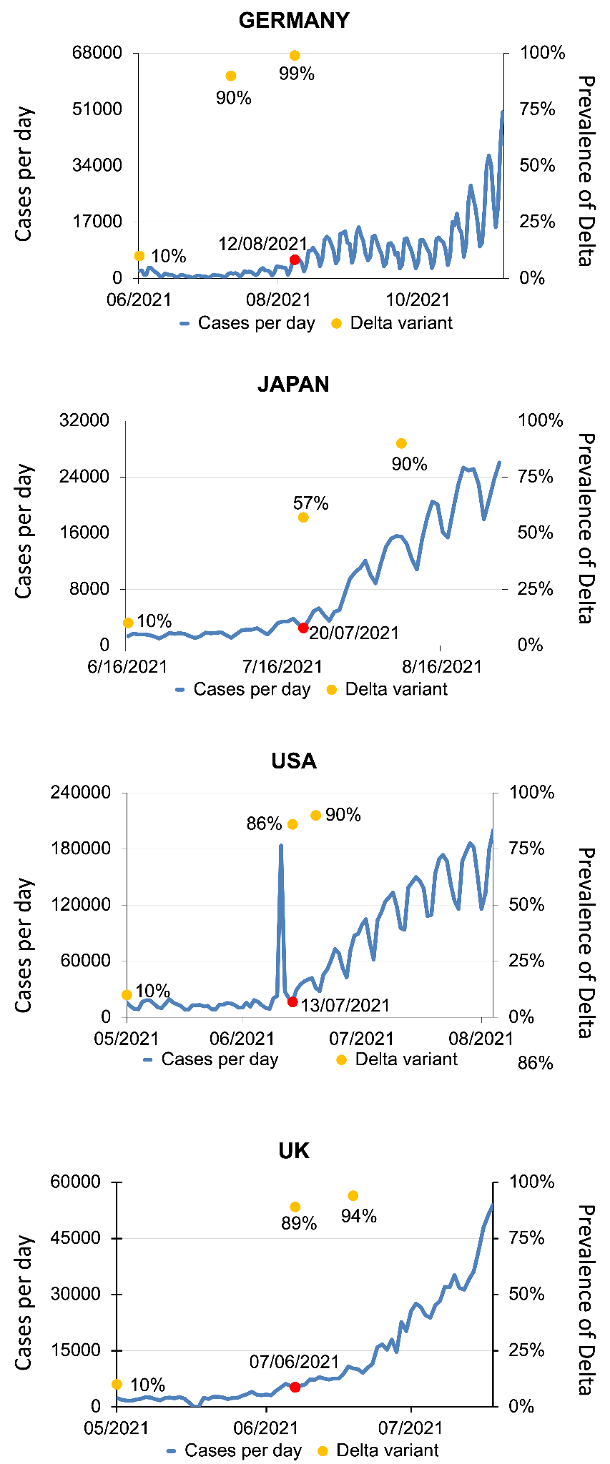
Figure S1. Number of COVID-19 cases and the prevalence of the SARS-CoV-2 Delta variant in the UK, Japan, USA, and Germany. Graphs of the number of cases (blue line) and the percentage of the Delta variant (orange circles) as a function of time. Red circles show the beginning of a new COVID-19 peak case. All data were obtained from World in Data, WHO, CDC, UK Gov and Outbreak [140–144].

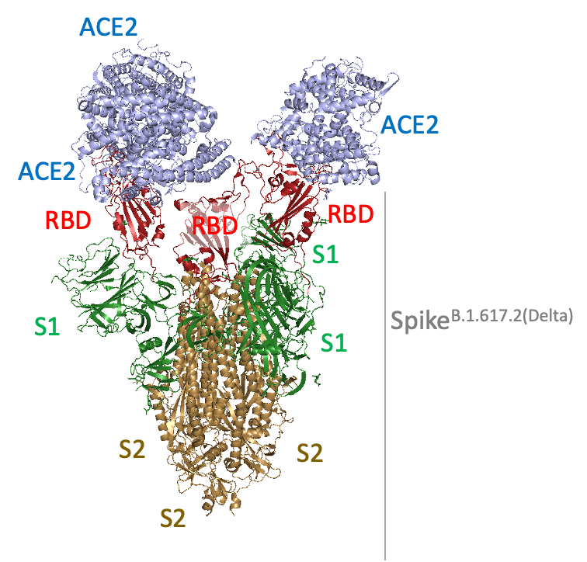

Figure S2. Cryo-EM structure of SARS-CoV-2 Spike^{B.1.617.2(Delta)} in complex with Angiotensin-converting enzyme 2 (ACE2) ectodomain. ACE2 is colored in blue, Spike protein structure in red (RBD domain), green (S1 subunit not considering the RBD domain) and brown (S2 domain) (protein data bank, PDB, 7V8A, not published).

A
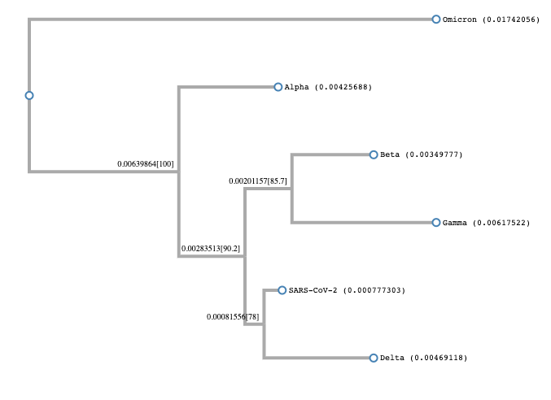

B

SARS-CoV-2 MFVFLVLLPLVSSQCVNLTTRTQLPPAYTNSFTRGVYYPDKVFRSSVLHSTQDLFLPFFS 60
Delta/B.1.617.2 MFVFLVLLPLVSSQCVNLRTRTQLPPAYTNSFTRGVYYPDKVFRSSVLHSTQDLFLPFFS 60
Omicron/B.1.1.529 MFVFLVLLPLVSSQCVNLTTRTQLPPAYTNSFTRGVYYPDKVFRSSVLHSTQDLFLPFFS 60
Alpha/B.1.1.7 MFVFLVLLPLVSSQCVNLTTRTQLPPAYTNSFTRGVYYPDKVFRSSVLHSTQDLFLPFFS 60
P.1/Gamma MFVFLVLLPLVSSQCVNFTNRTQLPSAYTNSFTRGVYYPDKVFRSSVLHSTQDLFLPFFS 60
Beta/B.1.351 MFVFLVLLPLVSSQCVNFTTRTQLPPAYTNSFTRGVYYPDKVFRSSVLHSTQDLFLPFFS 60
*****************: .***** **********************************

SARS-CoV-2 NVTWFHAIHVSGTNGTKRFDNPVLPFNDGVYFASTEKSNIIRGWIFGTTLDSKTQSLLIV 120
Delta/B.1.617.2 NVTWFHAIHVSGTNGTKRFDNPVLPFNDGVYFASTEKSNIIRGWIFGTTLDSKTQSLLIV 120
Omicron/B.1.1.529 NVTWFHVI--SGTNGTKRFDNPVLPFNDGVYFASIEKSNIIRGWIFGTTLDSKTQSLLIV 118
Alpha/B.1.1.7 NVTWFHAI--SGTNGTKRFDNPVLPFNDGVYFASTEKSNIIRGWIFGTTLDSKTQSLLIV 118
P.1/Gamma NVTWFHAIHVSGTNGTKRFDNPVLPFNDGVYFASTEKSNIIRGWIFGTTLDSKTQSLLIV 120
Beta/B.1.351 NVTWFHAIHVSGTNGTKRFANPVLPFNDGVYFASTEKSNIIRGWIFGTTLDSKTQSLLIV 120
******.* ********* **************.*************************

SARS-CoV-2 NNATNVVIKVCEFQFCNDPFLGVYYHKNNKSWMESEFRVYSSANNCTFEYVSQPFLMDLE 180
Delta/B.1.617.2 NNATNVVIKVCEFQFCNDPFLDVYYHKNNKSWMESG--VYSSANNCTFEYVSQPFLMDLE 180
Omicron/B.1.1.529 NNATNVVIKVCEFQFCNDPFLD---HKNNKSWMESEFRVYSSANNCTFEYVSQPFLMDLE 175
Alpha/B.1.1.7 NNATNVVIKVCEFQFCNDPFLGVY-HKNNKSWMESEFRVYSSANNCTFEYVSQPFLMDLE 177
P.1/Gamma NNATNVVIKVCEFQFCNYPFLGVYYHKNNKSWMESEFRVYSSANNCTFEYVSQPFLMDLE 180
Beta/B.1.351 NNATNVVIKVCEFQFCNDPFLGVYYHKNNKSWMESEFRVYSSANNCTFEYVSQPFLMDLE 180
***************** ***. ********** **********************

SARS-CoV-2 GKQGNFKNLREFVFKNIDGYFKIYSKHTPINL--VRDLPQGFSALEPLVDLPIGINITRF 238
Delta/B.1.617.2 GKQGNFKNLREFVFKNIDGYFKIYSKHTPINL--VRDLPQGFSALEPLVDLPIGINITRF 238
Omicron/B.1.1.529 GKQGNFKNLREFVFKNIDGYFKIYSKHTPIIVREPEDLPQGFSALEPLVDLPIGINITRF 235
Alpha/B.1.1.7 GKQGNFKNLREFVFKNIDGYFKIYSKHTPINL--VRDLPQGFSALEPLVDLPIGINITRF 235
P.1/Gamma GKQGNFKNLSEFVFKNIDGYFKIYSKHTPINL--VRDLPQGFSALEPLVDLPIGINITRF 238
Beta/B.1.351 GKQGNFKNLREFVFKNIDGYFKIYSKHTPINL--VRGLPQGFSALEPLVDLPIGINITRF 238
********* ******************** : ..***********************

SARS-CoV-2 QTLLALHRSYLTPGDSSSGWTAGAAAYYVGYLQPRTFLLKYNENGTITDAVDCALDPLSE 298
Delta/B.1.617.2 QTLLALHRSYLTPGDSSSGWTAGAAAYYVGYLQPRTFLLKYNENGTITDAVDCALDPLSE 298
Omicron/B.1.1.529 QTLLALHRSYLTPGDSSSGWTAGAAAYYVGYLQPRTFLLKYNENGTITDAVDCALDPLSE 295
Alpha/B.1.1.7 QTLLALHRSYLTPGDSSSGWTAGAAAYYVGYLQPRTFLLKYNENGTITDAVDCALDPLSE 295
P.1/Gamma QTLLALHRSYLTPGDSSSGWTAGAAAYYVGYLQPRTFLLKYNENGTITDAVDCALDPLSE 298
Beta/B.1.351 QT---LHRSYLTPGDSSSGWTAGAAAYYVGYLQPRTFLLKYNENGTITDAVDCALDPLSE 295
** *******************************************************

SARS-CoV-2 TKCTLKSFTVEKGIYQTSNFRVQPTESIVRFPNITNLCPFGEVFNATRFASVYAWNRKRI 358
Delta/B.1.617.2 TKCTLKSFTVEKGIYQTSNFRVQPTESIVRFPNITNLCPFGEVFNATRFASVYAWNRKRI 358
Omicron/B.1.1.529 TKCTLKSFTVEKGIYQTSNFRVQPTESIVRFPNITNLCPFDEVFNATRFASVYAWNRKRI 355
Alpha/B.1.1.7 TKCTLKSFTVEKGIYQTSNFRVQPTESIVRFPNITNLCPFGEVFNATRFASVYAWNRKRI 355
P.1/Gamma TKCTLKSFTVEKGIYQTSNFRVQPTESIVRFPNITNLCPFGEVFNATRFASVYAWNRKRI 358
Beta/B.1.351 TKCTLKSFTVEKGIYQTSNFRVQPTESIVRFPNITNLCPFGEVFNATRFASVYAWNRKRI 355
****************************************.*******************

SARS-CoV-2 SNCVADYSVLYNSASFSTFKCYGVSPTKLNDLCFTNVYADSFVIRGDEVRQIAPGQTGKI 418
Delta/B.1.617.2 SNCVADYSVLYNSASFSTFKCYGVSPTKLNDLCFTNVYADSFVIRGDEVRQIAPGQTGKI 418
Omicron/B.1.1.529 SNCVADYSVLYNLAPFFTFKCYGVSPTKLNDLCFTNVYADSFVIRGDEVRQIAPGQTGNI 415
Alpha/B.1.1.7 SNCVADYSVLYNSASFSTFKCYGVSPTKLNDLCFTNVYADSFVIRGDEVRQIAPGQTGKI 415
P.1/Gamma SNCVADYSVLYNSASFSTFKCYGVSPTKLNDLCFTNVYADSFVIRGDEVRQIAPGQTGTI 418
Beta/B.1.351 SNCVADYSVLYNSASFSTFKCYGVSPTKLNDLCFTNVYADSFVIRGDEVRQIAPGQTGNI 415
************ * * *****************************************.*

SARS-CoV-2 ADYNYKLPDDFTGCVIAWNSNNLDSKVGGNYNYLYRLFRKSNLKPFERDISTEIYQAGST 478
Delta/B.1.617.2 ADYNYKLPDDFTGCVIAWNSNNLDSKVGGNYNYRYRLFRKSNLKPFERDISTEIYQAGSK 478
Omicron/B.1.1.529 ADYNYKLPDDFTGCVIAWNSNKLDSKVSGNYNYLYRLFRKSNLKPFERDISTEIYQAGNK 475
Alpha/B.1.1.7 ADYNYKLPDDFTGCVIAWNSNNLDSKVGGNYNYLYRLFRKSNLKPFERDISTEIYQAGST 475
P.1/Gamma ADYNYKLPDDFTGCVIAWNSNNLDSKVGGNYNYLYRLFRKSNLKPFERDISTEIYQAGST 478
Beta/B.1.351 ADYNYKLPDDFTGCVIAWNSNNLDSKVGGNYNYLYRLFRKSNLKPFERDISTEIYQAGST 475
*********************:*****.***** ************************..

⬇
SARS-CoV-2 PCNGVEGFNCYFPLQSYGFQPTNGVGYQPYRVVVLSFELLHAPATVCGPKKSTNLVKNKC 538
Delta/B.1.617.2 PCNGVEGFNCYFPLQSYGFQPTNGVGYQPYRVVVLSFELLHAPATVCGPKKSTNLVKNKC 538
Omicron/B.1.1.529 PCNGVAGFNCYFPLRSYSFRPTYGVGHQPYRVVVLSFELLHAPATVCGPKKSTNLVKNKC 535
Alpha/B.1.1.7 PCNGVEGFNCYFPLQSYGFQPTYGVGYQPYRVVVLSFELLHAPATVCGPKKSTNLVKNKC 535
P.1/Gamma PCNGVKGFNCYFPLQSYGFQPTYGVGYQPYRVVVLSFELLHAPATVCGPKKSTNLVKNKC 538
Beta/B.1.351 PCNGVKGFNCYFPLQSYGFQPTYGVGYQPYRVVVLSFELLHAPATVCGPKKSTNLVKNKC 535
***** ********:**.*:** ***:*********************************

SARS-CoV-2 VNFNFNGLTGTGVLTESNKKFLPFQQFGRDIADTTDAVRDPQTLEILDITPCSFGGVSVI 598
Delta/B.1.617.2 VNFNFNGLTGTGVLTESNKKFLPFQQFGRDIADTTDAVRDPQTLEILDITPCSFGGVSVI 598
Omicron/B.1.1.529 VNFNFNGLKGTGVLTESNKKFLPFQQFGRDIADTTDAVRDPQTLEILDITPCSFGGVSVI 595
Alpha/B.1.1.7 VNFNFNGLTGTGVLTESNKKFLPFQQFGRDIDDTTDAVRDPQTLEILDITPCSFGGVSVI 595
P.1/Gamma VNFNFNGLTGTGVLTESNKKFLPFQQFGRDIADTTDAVRDPQTLEILDITPCSFGGVSVI 598
Beta/B.1.351 VNFNFNGLTGTGVLTESNKKFLPFQQFGRDIADTTDAVRDPQTLEILDITPCSFGGVSVI 595
********.********************** ****************************
⬇
SARS-CoV-2 TPGTNTSNQVAVLYQDVNCTEVPVAIHADQLTPTWRVYSTGSNVFQTRAGCLIGAEHVNN 658
Delta/B.1.617.2 TPGTNTSNQVAVLYQGVNCTEVPVAIHADQLTPTWRVYSTGSNVFQTRAGCLIGAEHVNN 658
Omicron/B.1.1.529 TPGTNTSNQVAVLYQGVNCTEVPVAIHADQLTPTWRVYSTGSNVFQTRAGCLIGAEYVNN 655
Alpha/B.1.1.7 TPGTNTSNQVAVLYQGVNCTEVPVAIHADQLTPTWRVYSTGSNVFQTRAGCLIGAEHVNN 655
P.1/Gamma TPGTNTSNQVAVLYQGVNCTEVPVAIHADQLTPTWRVYSTGSNVFQTRAGCLIGAEYVNN 658
Beta/B.1.351 TPGTNTSNQVAVLYQGVNCTEVPVAIHADQLTPTWRVYSTGSNVFQTRAGCLIGAEHVNN 655
***************.****************************************:***
S1/S2
▽
SARS-CoV-2 SYECDIPIGAGICASYQTQTNSPRRARSVASQSIIAYTMSLGAENSVAYSNNSIAIPTNF 718
Delta/B.1.617.2 SYECDIPIGAGICASYQTQTNSRRRARSVASQSIIAYTMSLGAENSVAYSNNSIAIPTNF 718
Omicron/B.1.1.529 SYECDIPIGAGICASYQTQTKSHRRARSVASQSIIAYTMSLGAENSVAYSNNSIAIPTNF 715
Alpha/B.1.1.7 SYECDIPIGAGICASYQTQTNSHRRARSVASQSIIAYTMSLGAENSVAYSNNSIAIPINF 715
P.1/Gamma SYECDIPIGAGICASYQTQTNSPRRARSVASQSIIAYTMSLGAENSVAYSNNSIAIPTNF 718
Beta/B.1.351 SYECDIPIGAGICASYQTQTNSPRRARSVASQSIIAYTMSLGVENSVAYSNNSIAIPTNF 715
********************:* *******************.************** **

SARS-CoV-2 TISVTTEILPVSMTKTSVDCTMYICGDSTECSNLLLQYGSFCTQLNRALTGIAVEQDKNT 778
Delta/B.1.617.2 TISVTTEILPVSMTKTSVDCTMYICGDSTECSNLLLQYGSFCTQLNRALTGIAVEQDKNT 778
Omicron/B.1.1.529 TISVTTEILPVSMTKTSVDCTMYICGDSTECSNLLLQYGSFCTQLKRALTGIAVEQDKNT 775
Alpha/B.1.1.7 TISVTTEILPVSMTKTSVDCTMYICGDSTECSNLLLQYGSFCTQLNRALTGIAVEQDKNT 775
P.1/Gamma TISVTTEILPVSMTKTSVDCTMYICGDSTECSNLLLQYGSFCTQLNRALTGIAVEQDKNT 778
Beta/B.1.351 TISVTTEILPVSMTKTSVDCTMYICGDSTECSNLLLQYGSFCTQLNRALTGIAVEQDKNT 775
*********************************************:**************
S2,
▽
SARS-CoV-2 QEVFAQVKQIYKTPPIKDFGGFNFSQILPDPSKPSKRSFIEDLLFNKVTLADAGFIKQYG 838
Delta/B.1.617.2 QEVFAQVKQIYKTPPIKDFGGFNFSQILPDPSKPSKRSFIEDLLFNKVTLADAGFIKQYG 838
Omicron/B.1.1.529 QEVFAQVKQIYKTPPIKYFGGFNFSQILPDPSKPSKRSFIEDLLFNKVTLADAGFIKQYG 835
Alpha/B.1.1.7 QEVFAQVKQIYKTPPIKDFGGFNFSQILPDPSKPSKRSFIEDLLFNKVTLADAGFIKQYG 835
P.1/Gamma QEVFAQVKQIYKTPPIKDFGGFNFSQILPDPSKPSKRSFIEDLLFNKVTLADAGFIKQYG 838
Beta/B.1.351 QEVFAQVKQIYKTPPIKDFGGFNFSQILPDPSKPSKRSFIEDLLFNKVTLADAGFIKQYG 835
***************** ******************************************

SARS-CoV-2 DCLGDIAARDLICAQKFNGLTVLPPLLTDEMIAQYTSALLAGTITSGWTFGAGAALQIPF 898
Delta/B.1.617.2 DCLGDIAARDLICAQKFNGLTVLPPLLTDEMIAQYTSALLAGTITSGWTFGAGAALQIPF 898
Omicron/B.1.1.529 DCLGDIAARDLICAQKFKGLTVLPPLLTDEMIAQYTSALLAGTITSGWTFGAGAALQIPF 895
Alpha/B.1.1.7 DCLGDIAARDLICAQKFNGLTVLPPLLTDEMIAQYTSALLAGTITSGWTFGAGAALQIPF 895
P.1/Gamma DCLGDIAARDLICAQKFNGLTVLPPLLTDEMIAQYTSALLAGTITSGWTFGAGAALQIPF 898
Beta/B.1.351 DCLGDIAARDLICAQKFNGLTVLPPLLTDEMIAQYTSALLAGTITSGWTFGAGAALQIPF 895
*****************:******************************************

SARS-CoV-2 AMQMAYRFNGIGVTQNVLYENQKLIANQFNSAIGKIQDSLSSTASALGKLQDVVNQNAQA 958
Delta/B.1.617.2 AMQMAYRFNGIGVTQNVLYENQKLIANQFNSAIGKIQDSLSSTASALGKLQNVVNQNAQA 958
Omicron/B.1.1.529 AMQMAYRFNGIGVTQNVLYENQKLIANQFNSAIGKIQDSLSSTASALGKLQDVVNHNAQA 955
Alpha/B.1.1.7 AMQMAYRFNGIGVTQNVLYENQKLIANQFNSAIGKIQDSLSSTASALGKLQDVVNQNAQA 955
P.1/Gamma AMQMAYRFNGIGVTQNVLYENQKLIANQFNSAIGKIQDSLSSTASALGKLQDVVNQNAQA 958
Beta/B.1.351 AMQMAYRFNGIGVTQNVLYENQKLIANQFNSAIGKIQDSLSSTASALGKLQDVVNQNAQA 955
***************************************************:***:****

SARS-CoV-2 LNTLVKQLSSNFGAISSVLNDILSRLDKVEAEVQIDRLITGRLQSLQTYVTQQLIRAAEI 1018
Delta/B.1.617.2 LNTLVKQLSSNFGAISSVLNDILSRLDKVEAEVQIDRLITGRLQSLQTYVTQQLIRAAEI 1018
Omicron/B.1.1.529 LNTLVKQLSSKFGAISSVLNDIFSRLDKVEAEVQIDRLITGRLQSLQTYVTQQLIRAAEI 1015
Alpha/B.1.1.7 LNTLVKQLSSNFGAISSVLNDILARLDKVEAEVQIDRLITGRLQSLQTYVTQQLIRAAEI 1015
P.1/Gamma LNTLVKQLSSNFGAISSVLNDILSRLDKVEAEVQIDRLITGRLQSLQTYVTQQLIRAAEI 1018
Beta/B.1.351 LNTLVKQLSSNFGAISSVLNDILSRLDKVEAEVQIDRLITGRLQSLQTYVTQQLIRAAEI 1015
**********:***********::************************************

SARS-CoV-2 RASANLAATKMSECVLGQSKRVDFCGKGYHLMSFPQSAPHGVVFLHVTYVPAQEKNFTTA 1078
Delta/B.1.617.2 RASANLAATKMSECVLGQSKRVDFCGKGYHLMSFPQSAPHGVVFLHVTYVPAQEKNFTTA 1078
Omicron/B.1.1.529 RASANLAATKMSECVLGQSKRVDFCGKGYHLMSFPQSAPHGVVFLHVTYVPAQEKNFTTA 1075
Alpha/B.1.1.7 RASANLAATKMSECVLGQSKRVDFCGKGYHLMSFPQSAPHGVVFLHVTYVPAQEKNFTTA 1075
P.1/Gamma RASANLAAIKMSECVLGQSKRVDFCGKGYHLMSFPQSAPHGVVFLHVTYVPAQEKNFTTA 1078
Beta/B.1.351 RASANLAATKMSECVLGQSKRVDFCGKGYHLMSFPQSAPHGVVFLHVTYVPAQEKNFTTA 1075
******** ***************************************************

SARS-CoV-2 PAICHDGKAHFPREGVFVSNGTHWFVTQRNFYEPQIITTDNTFVSGNCDVVIGIVNNTVY 1138
Delta/B.1.617.2 PAICHDGKAHFPREGVFVSNGTHWFVTQRNFYEPQIITTDNTFVSGNCDVVIGIVNNTVY 1138
Omicron/B.1.1.529 PAICHDGKAHFPREGVFVSNGTHWFVTQRNFYEPQIITTDNTFVSGNCDVVIGIVNNTVY 1135
Alpha/B.1.1.7 PAICHDGKAHFPREGVFVSNGTHWFVTQRNFYEPQIITTHNTFVSGNCDVVIGIVNNTVY 1135
P.1/Gamma PAICHDGKAHFPREGVFVSNGTHWFVTQRNFYEPQIITTDNTFVSGNCDVVIGIVNNTVY 1138
Beta/B.1.351 PAICHDGKAHFPREGVFVSNGTHWFVTQRNFYEPQIITTDNTFVSGNCDVVIGIVNNTVY 1135
***************************************.********************

SARS-CoV-2 DPLQPELDSFKEELDKYFKNHTSPDVDLGDISGINASVVNIQKEIDRLNEVAKNLNESLI 1198
Delta/B.1.617.2 DPLQPELDSFKEELDKYFKNHTSPDVDLGDISGINASVVNIQKEIDRLNEVAKNLNESLI 1198
Omicron/B.1.1.529 DPLQPELDSFKEELDKYFKNHTSPDVDLGDISGINASVVNIQKEIDRLNEVAKNLNESLI 1195
Alpha/B.1.1.7 DPLQPELDSFKEELDKYFKNHTSPDVDLGDISGINASVVNIQKEIDRLNEVAKNLNESLI 1195
P.1/Gamma DPLQPELDSFKEELDKYFKNHTSPDVDLGDISGINASFVNIQKEIDRLNEVAKNLNESLI 1198
Beta/B.1.351 DPLQPELDSFKEELDKYFKNHTSPDVDLGDISGINASVVNIQKEIDRLNEVAKNLNESLI 1195
*************************************.**********************

SARS-CoV-2 DLQELGKYEQYIKWPWYIWLGFIAGLIAIVMVTIMLCCMTSCCSCLKGCCSCGSCCKFDE 1258
Delta/B.1.617.2 DLQELGKYEQYIKWPWYIWLGFIAGLIAIVMVTIMLCCMTSCCSCLKGCCSCGSCCKFDE 1258
Omicron/B.1.1.529 DLQELGKYEQYIKWPWYIWLGFIAGLIAIVMVTIMLCCMTSCCSCLKGCCSCGSCCKFDE 1255
Alpha/B.1.1.7 DLQELGKYEQYIKWPWYIWLGFIAGLIAIVMVTIMLCCMTSCCSCLKGCCSCGSCCKFDE 1255
P.1/Gamma DLQELGKYEQYIKWPWYIWLGFIAGLIAIVMVTIMLCCMTSCCSCLKGCCSCGSCCKFDE 1258
Beta/B.1.351 DLQELGKYEQYIKWPWYIWLGFIAGLIAIVMVTIMLCCMTSCCSCLKGCCSCGSCCKFDE 1255
************************************************************

SARS-CoV-2 DDSEPVLKGVKLHYT 1273
Delta/B.1.617.2 DDSEPVLKGVKLHYT 1273
Omicron/B.1.1.529 DDSEPVLKGVKLHYT 1270
Alpha/B.1.1.7 DDSEPVLKGVKLHYT 1270
P.1/Gamma DDSEPVLKGVKLHYT 1273
Beta/B.1.351 DDSEPVLKGVKLHYT 1270
***************

Figure S3. Multiple sequence alignment and construction of the phylogenetic tree of SARS-CoV-2 VOCs. A) Phylogenetic tree of SARS-CoV-2 Spike protein VOCs. B) Multiple sequence alignment of the Spike protein VOCs. The domains are colored as: signal peptide (orange); N-terminal domain (green), RBD (red), SD1 (pink) and SD2 (purple), cleavage sites (S1/S2 and S2' are colored in black) the fusion peptide (brown), HR1 (cyan and blue), HR2 (dark green), a transmembrane domain (grey), and cytoplasm domain (not colored) ^{5,6}. The predominant residues D614G and N501Y are pointed using arrows. The residues of the Spike protein involved in hACE2 interaction are highlighted: E1 region in yellow (corresponds to residues 417, 455-456, 470-490) and E2 region in light blue (made up of residues 444-454 and 493-505)⁷. Multiple sequence alignment and the phylogenetic tree were performed using the ClustalW server ⁸.

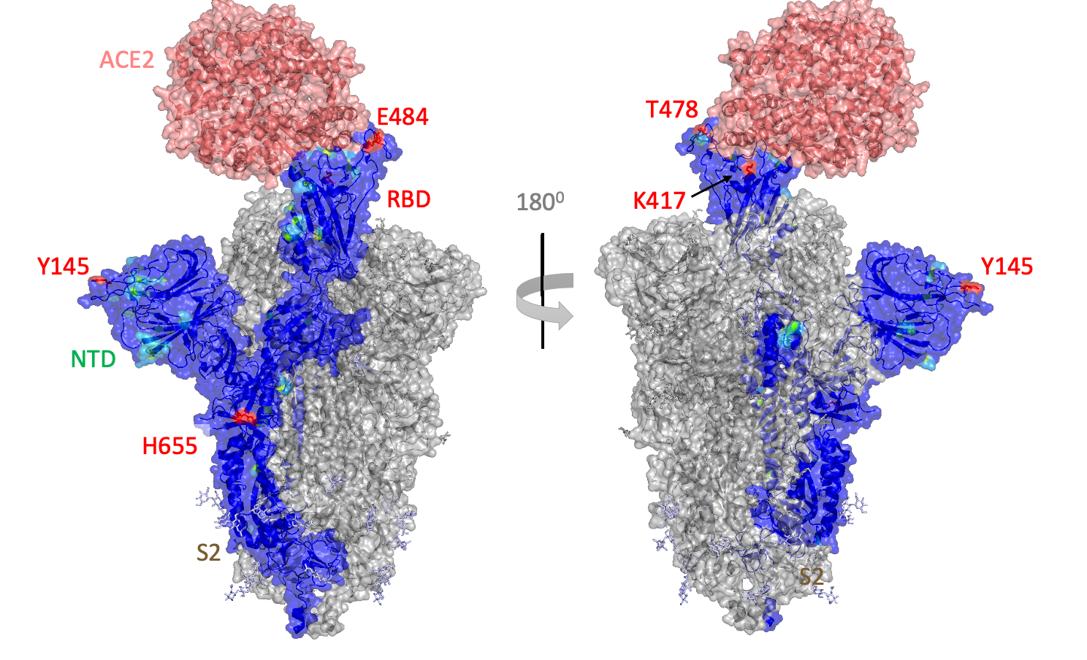

Figure S4. Conservation profile of the Spike protein among VOCs. The surface of the structure of the Spike^{WT} protein in complex with ACE2 (PDB ID: 7DF4¹¹) is colored based on the conservation profile. The ACE2 structure is colored in salmon, and the chains A and C in the trimeric form of Spike protein are colored in grey. The residues Y145, K417, T478, E484 and H655 are colored in red and correspond to the residues in the SARS-CoV-2 VOCs with more variability.

Table S1. Conservation score in the Consurf Server analysis^{9,10}. The Spike protein residues with the highest values are listed. High values meaning not conserved residues in the Spike protein among SARS-CoV-2 VOCs.
Spike Residue | Conservation Score
L18 | 4.5
T19 | 4.0
P26 | 4.4
H69 | 4.1
D80 | 4.2
T95 | 4.0
D138 | 4.2
Y145 | 7.5
H146 | 4.3
E156 | 4.3
R190 | 4.2
N211 | 4.3
L212 | 4.5
V213 | 4.7
R214 | 5.0
D215 | 4.2
G339 | 4.6
S371 | 4.2
G339 | 4.6
S371 | 4.2
S373 | 4.0
S375 | 4.1
K417 | 8.6
N440 | 4.1
G446 | 4.4
L452 | 4.5
S477 | 3.9
T478 | 7.2
E484 | 7.3
Q493 | 4.3
G496 | 4.4
Q498 | 4.3
N501 | 4.5
Y505 | 4.4
T547 | 4.2
D614 | 4.5
H655 | 7.2
A701 | 4.0
T716 | 4.0
N764 | 4.1
D796 | 4.4
N856 | 4.1
D950 | 4.1
Q954 | 4.2
N969 | 4.1
L981 | 4.5
S982 | 3.9
T1027 | 4.0
D1118 | 4.2

REFERENCES
1. Matsuyama, S. et al. Efficient activation of the severe acute respiratory syndrome coronavirus spike protein by the transmembrane protease TMPRSS2. J. Virol. 84, 12658–12664 (2010).
2. Shulla, A. et al. A transmembrane serine protease is linked to the severe acute respiratory syndrome coronavirus receptor and activates virus entry. J. Virol. 85, 873–882 (2011).
3. Djomkam, A. L. Z., Olwal, C. O., Sala, T. B. & Paemka, L. Commentary: SARS-CoV-2 Cell Entry Depends on ACE2 and TMPRSS2 and Is Blocked by a Clinically Proven Protease Inhibitor. Frontiers in oncology vol. 10 1448 (2020).
4. Hoffmann, M. et al. SARS-CoV-2 Cell Entry Depends on ACE2 and TMPRSS2 and Is Blocked by a Clinically Proven Protease Inhibitor. Cell 181, 271–280.e8 (2020).
5. Wrapp, D. et al. Cryo-EM structure of the 2019-nCoV spike in the prefusion conformation. Science 367, 1260–1263 (2020).
6. Walls, A. C. et al. Structure, Function, and Antigenicity of the SARS-CoV-2 Spike Glycoprotein. Cell 183, 1735 (2020).
7. Silva de Souza, A. et al. Molecular Dynamics Reveals Complex Compensatory Effects of Ionic Strength on the Severe Acute Respiratory Syndrome Coronavirus 2 Spike/Human Angiotensin-Converting Enzyme 2 Interaction. J. Phys. Chem. Lett. 11, 10446–10453 (2020).
8. Madeira, F. et al. The EMBL-EBI search and sequence analysis tools APIs in 2019. Nucleic Acids Res. 47, W636–W641 (2019).
9. Landau, M. et al. ConSurf 2005: the projection of evolutionary conservation scores of residues on protein structures. Nucleic Acids Res. 33, W299–302 (2005).
10. Glaser, F. et al. ConSurf: identification of functional regions in proteins by surface-mapping of phylogenetic information. Bioinformatics 19, 163–164 (2003).
11. Xu, C. et al. Conformational dynamics of SARS-CoV-2 trimeric spike glycoprotein in complex with receptor ACE2 revealed by cryo-EM. Sci Adv 7, (2021).

