Assessment of perivascular space filtering methods using a three-dimensional computational model: supplementary material

3 Results

3.2 Effect of imaging considerations

3.2.1 Slice thickness
Segmentation performance decreases with thicker slices (Figure S1). While k-space sampling hinders quantification, precision-recall curves suggest it is no source of variability (thin, almost imperceptible confidence intervals around the mean value).
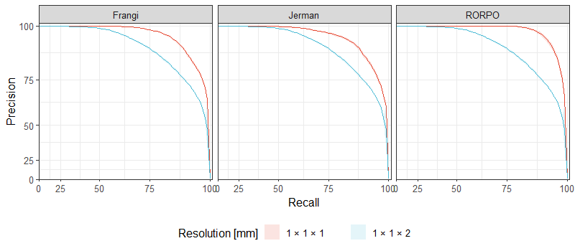
Figure S1. Precision-recall curve obtained by the Frangi, Jerman, and RORPO filters on a 4-mm length and 2-mm width PVS after sampling. Lines and shadowed areas represent mean precision-recall curves and their confidence interval, respectively. We selected a PVS with such dimensions as it was found an average size in the study of reference (Ballerini et al., 2020).

High in-plane resolution but thicker slices
We considered an additional experiment with even thicker slices and higher in-plane resolution, 0.5 x 0.5 x 5 mm, as often found in clinical settings. Our experimental results suggest such configuration is not ideal for 3D PVS segmentation (Figure S2). We noted that in most cases the portion of the PVS that laid in plane was segmented appropriately, but not that running diagonal to it.
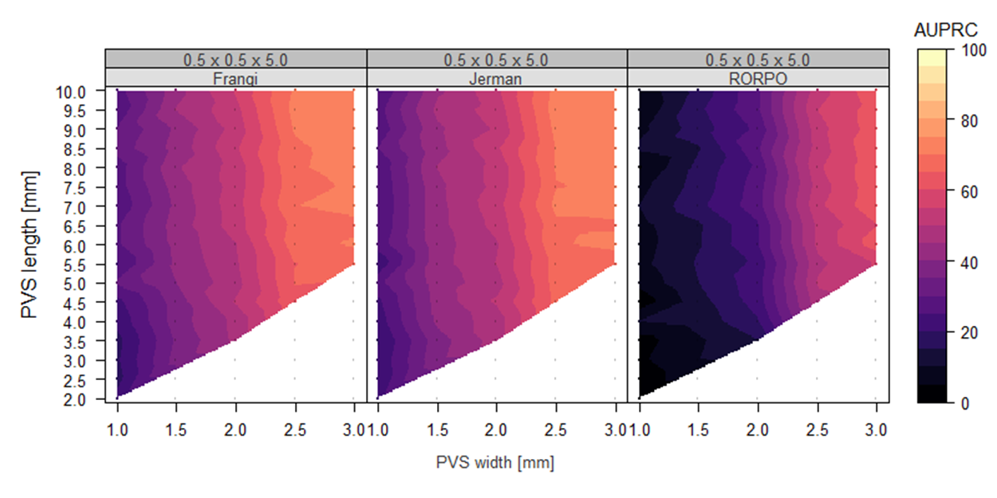
Figure S2. High in-plane resolution but thicker slices is not convenient for 3D PVS quantification. White regions represent cases that were not considered (width >= length, eccentricity < 0.8, or lack of PVS visibility). Similar to our previous findings with 1 × 1 × 1 and 1 × 1 × 2 mm scans, PVS with lengths and widths less than 2 and 1 mm, respectively, cannot be properly quantified (bottom left corner of each panel). Also, the performance of each filter tended to increase with the size of a PVS (in each panel, AURPC scores tended to rise from left to right and bottom to top). Imaging considerations: k-space sampling.

3.2.2 Motion artefacts
Segmentation performance decreases with motion artefacts (Figure S3). Precision-recall curves suggest motion is indeed a source of variability.

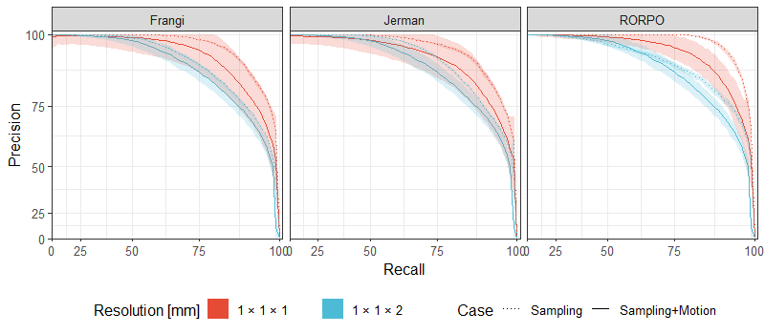
Figure S3. Precision-recall curve obtained by the Frangi, Jerman, and RORPO filters on a 4-mm length and 2-mm width PVS after sampling and incorporating motion artefacts. Lines and shadowed areas represent mean precision-recall curves and their confidence interval, respectively. We selected a PVS with such dimensions as it was found an average size in the study of reference (Ballerini et al., 2020).

3.2.3 Rician noise
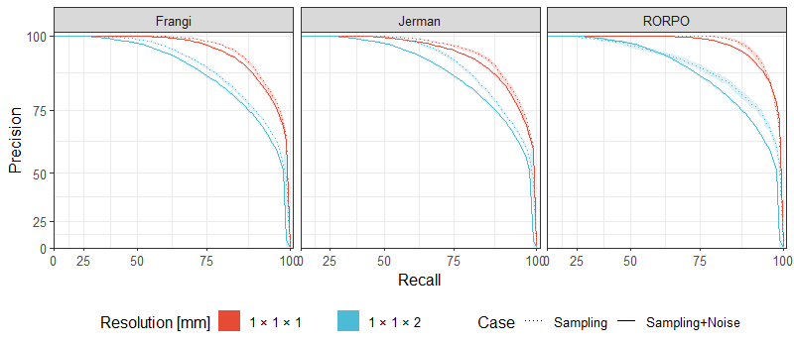
Figure S4. Precision-recall curve obtained by the Frangi, Jerman, and RORPO filters on a 4-mm length and 2-mm width PVS after sampling and adding Rician noise. Lines and shadowed areas represent mean precision-recall curves and their confidence interval, respectively. We selected a PVS with such dimensions as it was found an average size in the study of reference (Ballerini et al., 2020).

3.3 Effect of pathological regions

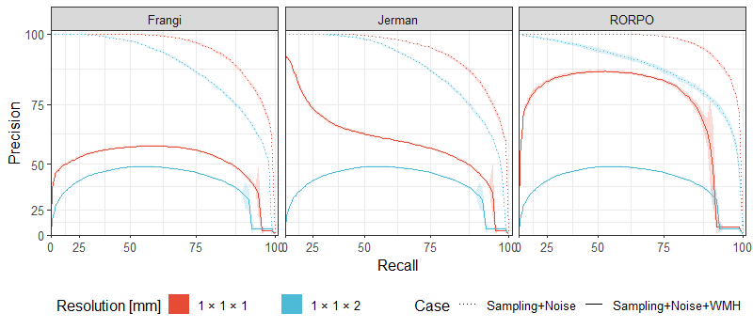
Figure S5. Precision-recall curve obtained by the Frangi, Jerman, and RORPO filters on a 4-mm length and 2-mm width PVS after sampling, noise, and WMH. Lines and shadowed areas represent mean precision-recall curves and their confidence interval, respectively. We selected a PVS with such dimensions as it was found an average size in the study of reference (Ballerini et al., 2020).
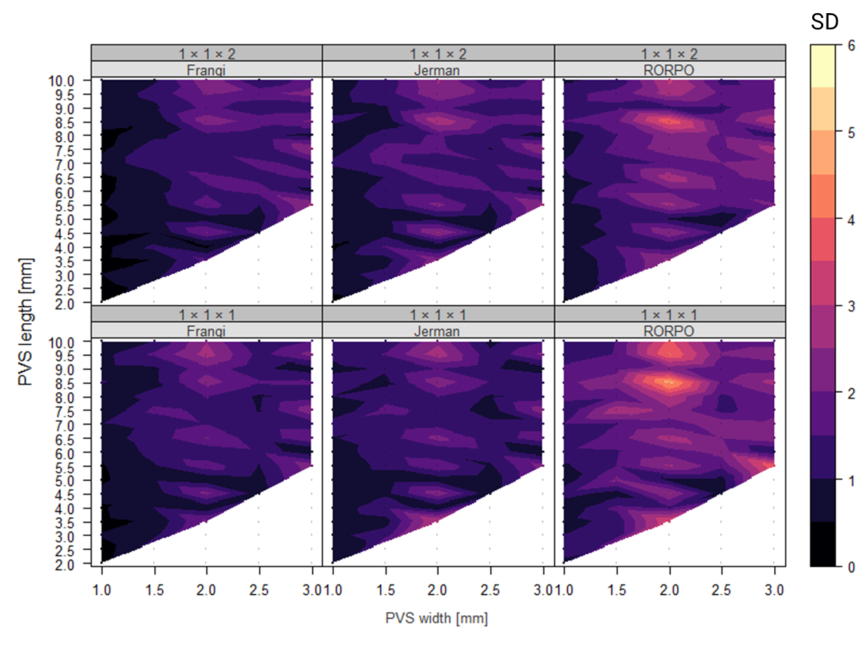
Figure S6. Standard deviation of AUPRC (colour bar) in relation to PVS dimensions (width: x-axis; height: y-axis), slice thickness (bottom row: 1 mm; top row: 2 mm), and white matter hyperintensities. White regions represent cases that were not considered (width >= length, eccentricity < 0.8, or lack of PVS visibility). The introduction of WMH caused variability in AUPRC values (observe, for example, pockets of higher standard deviations in PVS with approximately 2mm width, increasing at higher lengths). Imaging considerations: k-space sampling.

References
Ballerini, L., Booth, T., Valdés Hernández, M. del C., Wiseman, S., Lovreglio, R., Muñoz Maniega, S., … Wardlaw, J. (2020). Computational quantification of brain perivascular space morphologies: Associations with vascular risk factors and white matter hyperintensities. A study in the Lothian Birth Cohort 1936. NeuroImage: Clinical, 25(November 2019), 102120. https://doi.org/10.1016/j.nicl.2019.102120

