Supplemental Figure 1. Tacrolimus trough level after belatacept discontinuation (n = 25)
Each dot representing mean tacrolimus trough level at corresponding time point, and error bar standard deviation.

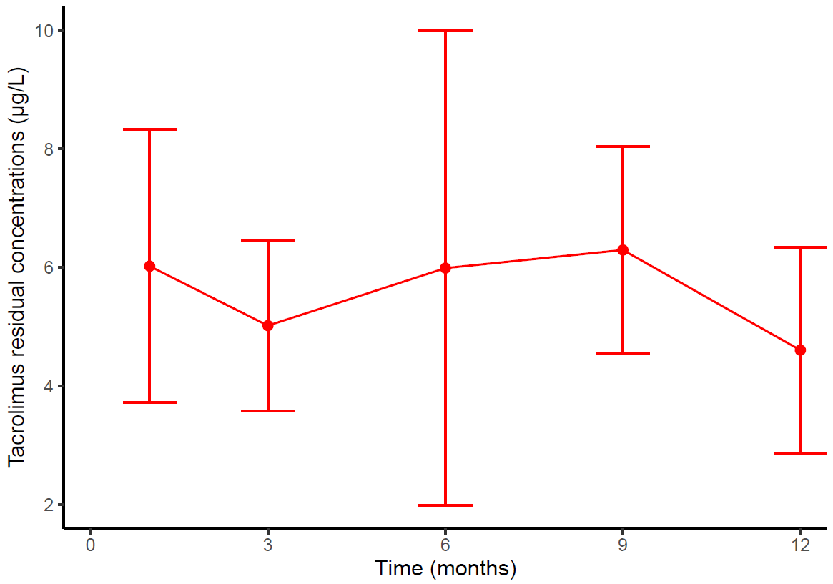

Supplemental Figure 2. Gene Ontology enrichment analysis (biological process) of Differential Expressed Genes between Day 0 and 3-months post belatacept withdrawal.

