Mechanically Enhanced Hydrophobic Metal Surfaces Enabled by
3D Gradient Structures
(Supplementary Materials)
Xiaohan Zhangª, Jian Liuª, Min Xia^{c}, Yaowu Hu^{a,b,}*
ªThe Institute of Technological Sciences, Wuhan University, Wuhan, 430072, China
^{b}School of Power and Mechanical Engineering, Wuhan University, Wuhan, 430072, China
^{c}Department of Engineering, Lancaster University, Lancaster, LA1 4YW, United Kingdom
*Corresponding author: Yaowu Hu
E-mail: yaowuhu@whu.edu.cn
1. Thin metal mesh that acts as an optical mask and momentum transport layer
Fig.S1 showed the thin metal mesh that acted as an optical mask and momentum transport layer. The pulsed laser passed through the material of the confinement layer, and part of it directly irradiated the surface of the thin metal mesh. At this time, the thin metal mesh acted as a power transmission layer, and the pressure wave propagated along with the metal mesh to the material's surface. The other part was directly irradiated to the surface of the base material through the mesh of the thin metal mesh. Here the thin metal mesh acted as an optical mask, dispersing the pulsed laser beam.
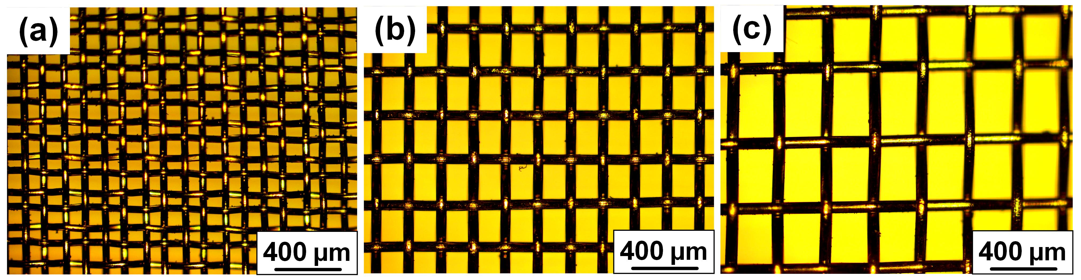
Fig.S1 Thin metal mesh that acts as an optical mask and momentum transport layer
2.Process of laser shock-induced generation of micro-nano structures
Fig.S2 showed the process of laser shock-induced generation of micro-nano structures. Rapid material evaporation and phase explosion led to the formation of the laser-induced plume. The atmospheric environment limited the free expansion of the laser-induced cylindrical plume, which led to intensified collisions between the products of laser ablation and surrounding matter. Vigorous collisions between species further led to the aggregation and oxidation of these laser-ablated species and the formation of complex nanoaggregates. These nanoaggregates reacted with the surface molten layer and eventually re-deposited back to the substrate surface, forming a crater-like structure.
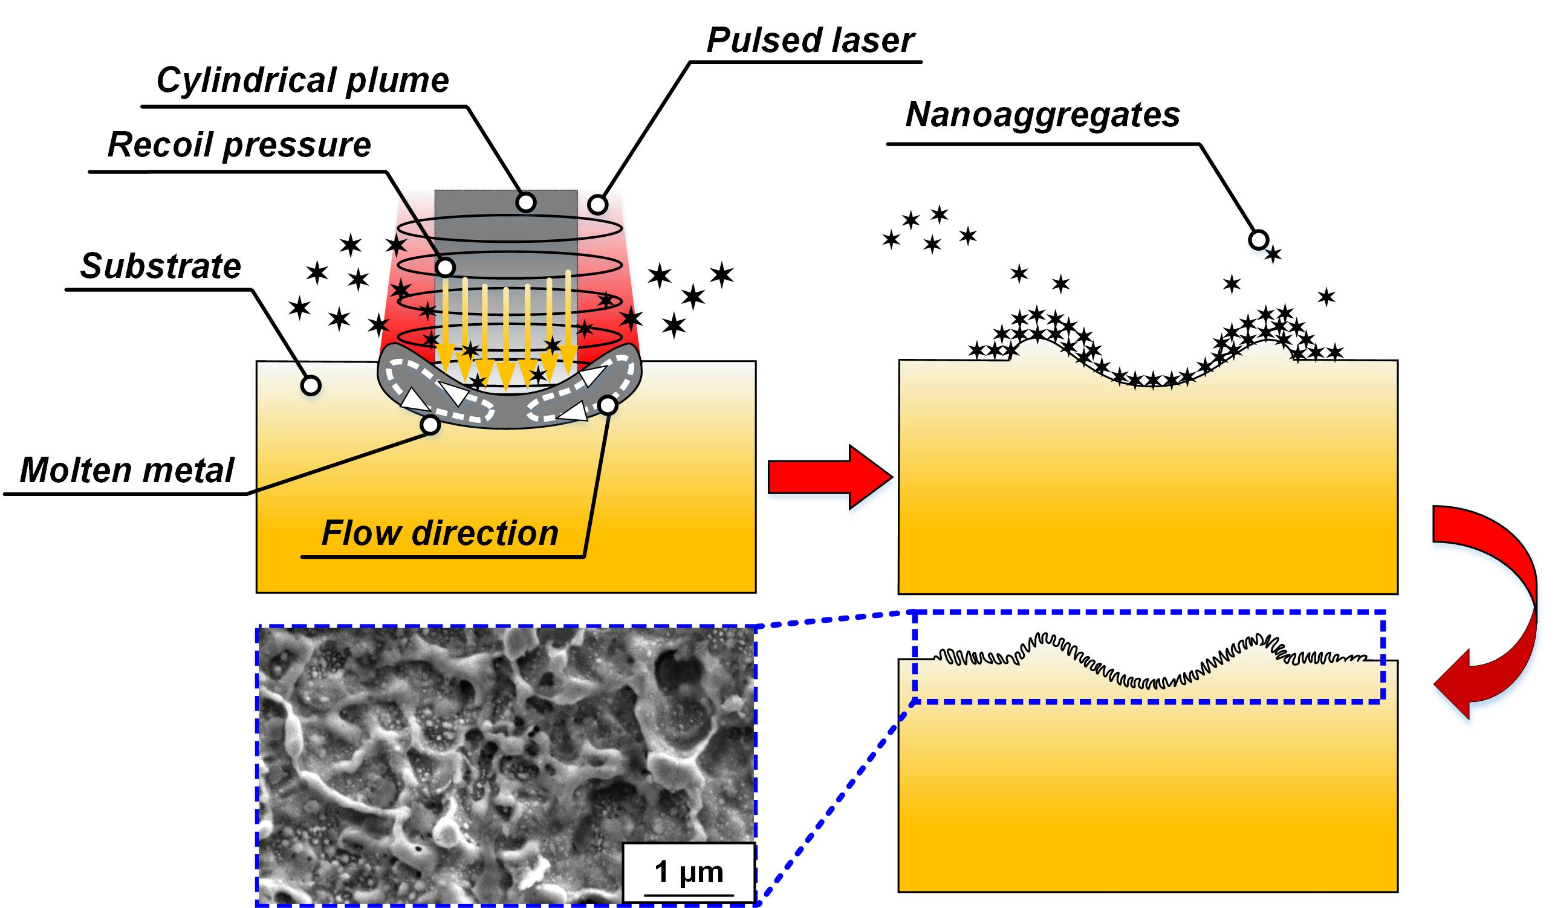
Fig.S2. Process of laser shock-induced generation of micro-nano structures
3. Surface morphologies of samples prepared by selective laser shock peening(SLSP)
Fig.S3 showed the 2D profiles of the samples under different processing conditions. The extraction path of each curve in Fig.S1 is the corresponding black dotted line in each sub-graph in Fig.4. Fig.S3 could more quantitatively reflect the situation of the sample surface under different processing conditions.
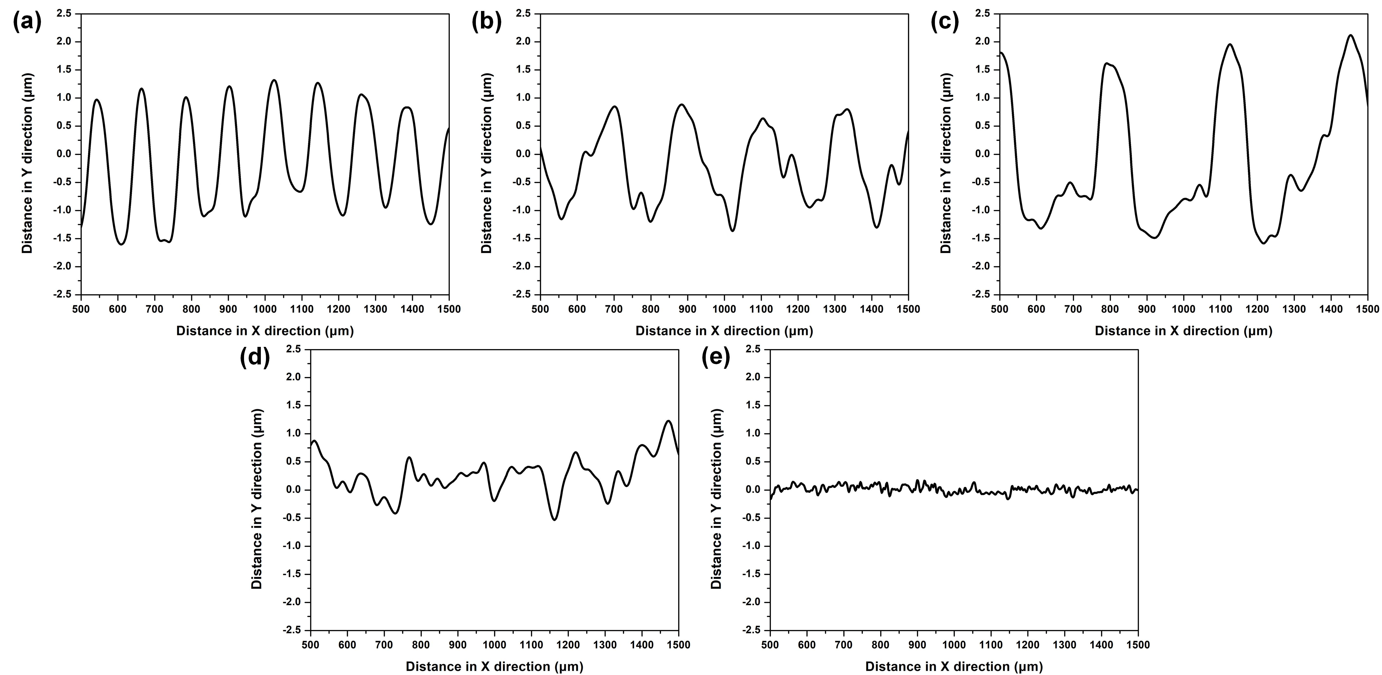
Fig.S3. 2D profiles of the samples under different processing conditions
((a) SLSP/case 1; (b) SLSP/case 2;(c) SLSP/case 3;(d) ALSP;(e) NLSP)
4. Wear morphologies of samples under different processing conditions
Fig.S4 showed wear scar morphology and EDS element content of samples prepared under different processing conditions. Combining Fig.S3 with Fig.14, we can further analyze the wear mechanism of the samples.
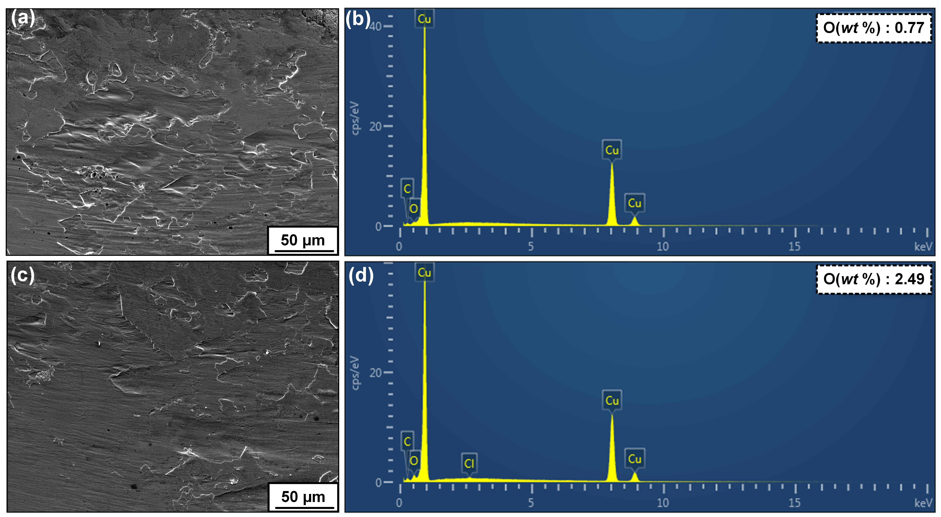
Fig.S4. Wear scar morphology and EDS element content of samples prepared under different processing conditions
((a) SEM morphology of wear scars of NLSP sample; (b) EDS element content of NLSP sample; (c) SEM morphology of wear scars of SLSP sample; (d) EDS element content of SLSP sample)
5. Simulation of local field enhancement effect on the surface of materials prepared by LSP
Finite-difference time-domain(FDTD) was a method for simulating electromagnetic wave propagation in complex geometric models using the discretized form of Maxwell's equations in time and space. In this paper, Ansys Lumerical FDTD simulation software was used to study the electric field distribution around the micro-nano structure on the material's surface under the condition of light irradiation after the interaction between the pulsed laser and the surface of copper(Fig.S5). In the actual simulation, the Lorentz-Drude model was used. The copper material was selected as the calculation object, and the optical constants of the copper material refer to the optical constants manual and the work of Palik[1]. The roughness (RMS) of the model surface was set to 600 nm. The period of the computational domain was 1700 nm. The incident light wave used a periodic plane wave source, and the wavelengths of the incident light were 532 nm, 635 nm and 1060 nm, respectively.
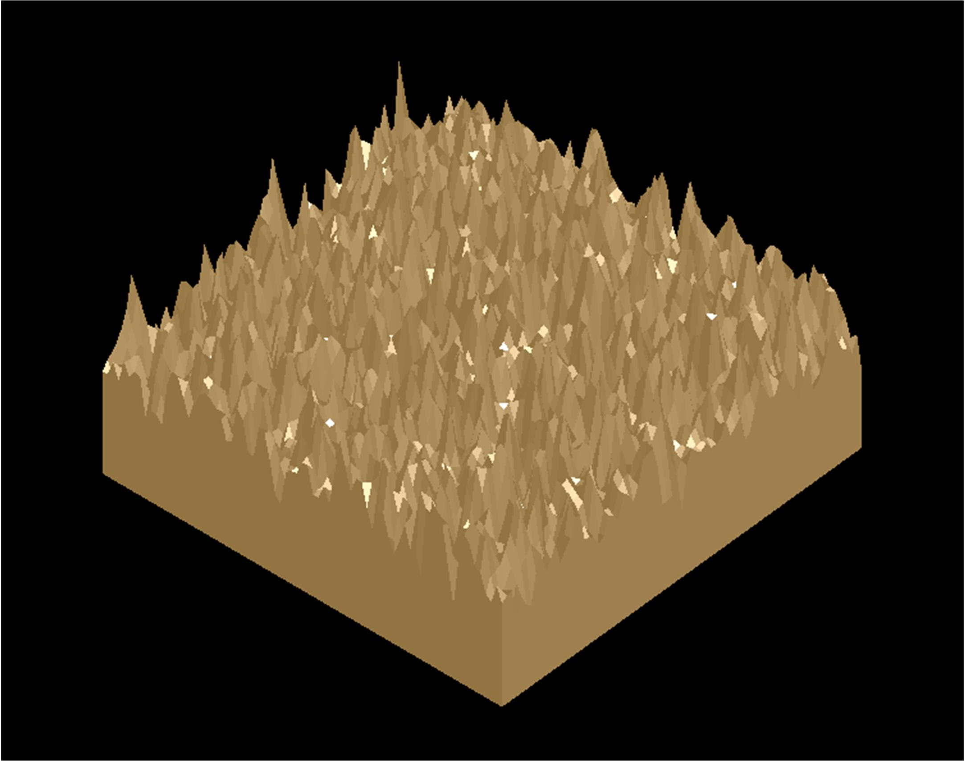
Fig.S5. The initial model for calculating pulsed laser interaction with copper
Fig.S6 showed the distribution of electric field modes on the surface of metal materials under different wavelengths of incident light irradiation. When the laser interacted with the surface of the material, an exciting high-temperature plasma was induced, and under the confinement of the surface confinement layer, a GPa-level stress shock wave would be generated. Under the combined action of the two, micro-level and nano-level ablation topography would be generated on the material's surface. We figuratively compared these structures to peaks and valleys. There would be an apparent regional field enhancement phenomenon in the valley area.
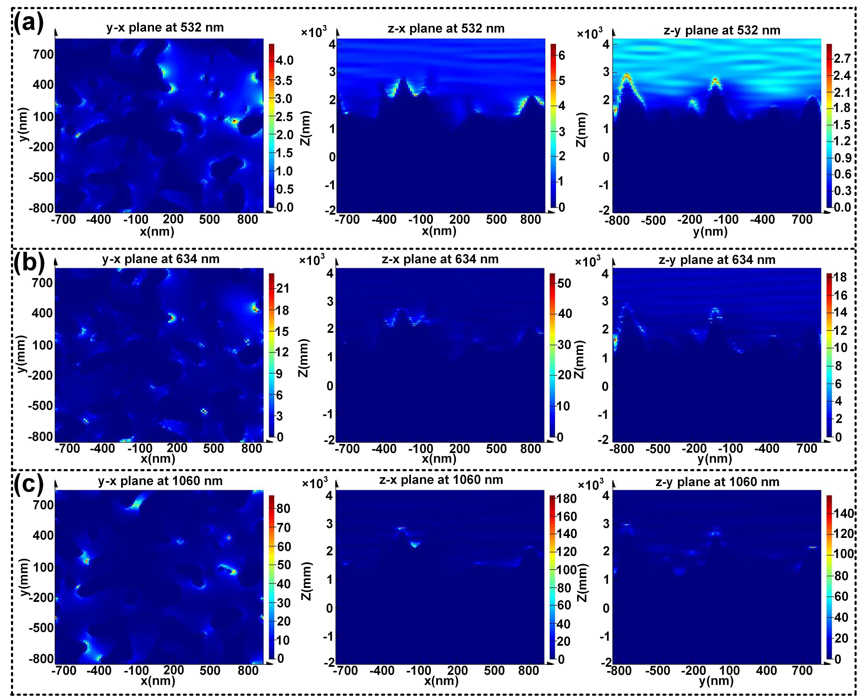
Fig.S6. Distribution of electric field modes on the surface of metal materials under different wavelengths of incident light irradiation
((a) The wavelength of the plane wave is 532 nm; (b) The wavelength of the plane wave is 635 nm; (c) The wavelength of the plane wave is 1060 nm)
6. Simulation of residual stresses of the sample prepared by SLSP
ABAQUS/Explicit was an ideal program for solving complex nonlinear dynamical and quasi-static problems, especially for simulating shocks and other highly discontinuous events. The process of laser shock wave strengthening belonged to high pressure and high strain rate. In this paper, based on the elastic-plastic theory, a numerical model for selective laser shock peening of copper was established. Fig.S7 presented the finite element model of the copper metal treated by SLSP. The model was divided into two parts: a single stainless steel woven mesh and the metal target below it. The mesh size of the stainless steel woven mesh was 0.425 mm × 0.25 mm, and the depth direction of the mesh was 0.8 mm. The size of the metal target was 0.585 mm×0.41 mm×0.2 mm. Due to the small size of the model, the model was divided into an overall mesh, and the size of the mesh element after the division was 10 μm. The distribution of laser-induced shock waves in the spatial and temporal domains greatly impacted the simulation results. A flat-top pulsed laser was used in the experimental process, so it was assumed that the laser-induced shock wave pressure was uniformly distributed in the entire spot range. The simulation calculation adopted the solution formula of the pulsed laser load proposed by Fabbro[2]:
(1)
Where: P_{max} was the peak pressure of the shock wave induced by the pulsed laser. α was the interaction efficiency between the laser and the metal target. Z was the resultant acoustic impedance (see Expression 2).
(2)
where Z₁ was the impact acoustic impedance of the material, and Z₂ was the impact acoustic impedance of the confinement layer material. The power density of the incident laser is defined as:
(3)
In the formula, E was the single pulse energy of the laser; d was the diameter of the laser spot; τ was the pulse width of the laser. Due to the existence of the confinement layer material, the action time of the laser shock wave could be extended by 2 to 3 times, so the loading time of the shock wave load in the actual simulation calculation was 21 ns. The parameters of copper used for simulation calculation are shown in Table S1. The Parameters of stainless steel used for simulation calculation are shown in Table S2. The Laser shock parameters for simulation calculation process parameters are shown in Table S3.
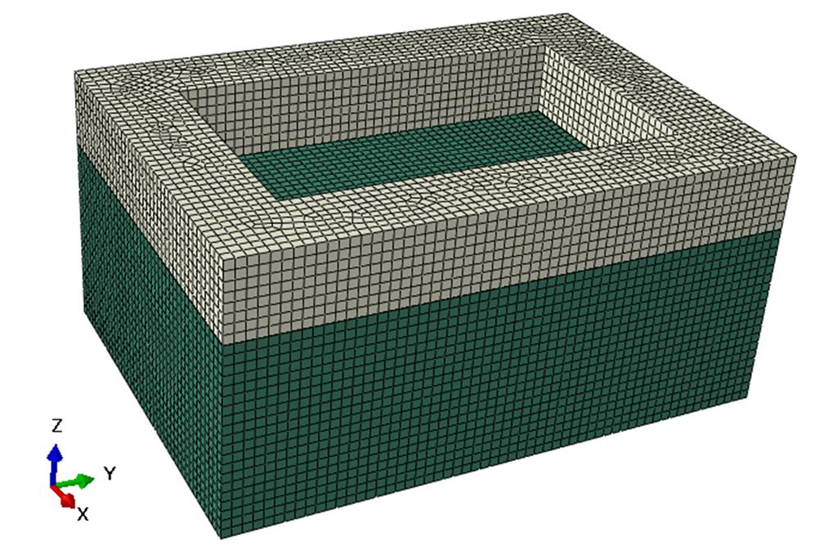
Fig.S7. The finite element model of the copper metal treated by SLSP

Table S1 Parameters of copper used for simulation calculation
Parameters | value
Density (Kg·m⁻³) | 8940
Young’s Modulus (MPa) | 1640
Poisson’s Ratio | 0.35
A | 90
B | 292
n | 0.31
m | 1.09
c | 0.025
ε₀/s⁻¹ | 1
Table S2 Parameters of stainless steel used for simulation calculation
Parameters | value
Density (Kg·m⁻³) | 7570
Young’s Modulus (MPa) | 1670
Poisson’s Ratio | 0.33
A (MPa) | 454
B (MPa) | 1962
n | 0.725
m | 0.699
c | 0.1732
ε₀/s⁻¹ | 1
Table S3 Laser shock parameters for simulation calculation
Process parameters | value
α | 0.15
Z₁ (g·cm⁻²·s⁻¹) | 3.26×10⁶
Z₂ (g·cm⁻²·s⁻¹) | 0.15×10⁶
Z (g·cm⁻²·s⁻¹) | 2.87×10⁵
E (J) | 1
d (mm) | 1.5
τ (ns) | 7
I₀ (GW·cm⁻²) | 6
P_{max} (GPa) | 3
In laser shock strengthening, the strain rate of the material was close to 1. At such high strain rates, the material's response to pressure differed from its quasi-static counterpart. Permanent plastic deformation occurred when the peak pressure of the laser-induced plasma pressure shock wave exceeded the Hugoniot elastic limit (HEL) of materials under one-dimensional strain conditions. The HEL was determined by the following equation:
(4)
In the formula: υ was the Poisson's ratio of the material and was the dynamic yield strength of the material at a strain rate of 10⁶s⁻¹. This paper used the Johnson-cook material parameters to simulate the process of laser shock wave strengthening of copper. The expression of the Johnson-Cook model was as follows[3]:
(5)
where was the plastic strain; was the plastic strain rate; was the reference plastic strain rate; A, B, C, n, and m were the strain-hardening characteristics of the material; T was the absolute temperature; T_{r} was the room temperature; T_{m} was the melting point of the material. In order to simplify the calculation, the temperature change of the material surface layer generated during the laser shock process was not considered. Therefore, the formula Johnson-Cook model could be simplified to the following formula:
(6)
7. Numerical simulation of tensile test of the sample prepared by SLSP
The finite element method was an effective method to predict and evaluate the mechanical behavior of materials. ABAQUS was a powerful finite element software for engineering simulation, which could analyze complex structural mechanics problems and solve complex nonlinear problems. With the help of ABAQUS simulation software, based on the ductile damage model, a uniaxial tensile numerical model of the samples prepared by selective laser shock peening was established. This model was suitable for uniaxial tensile experiments at low strain rates. The uniaxial tensile experiments of samples corresponding to ALSP, NLSP, regular surface structure prepared by SLSP (RSLSP), and irregular surface structure prepared by SLSP (IRSLSP) were simulated, respectively. The tensile properties of the prepared samples under different processing conditions were evaluated.
Fig.S8 showed the finite element model of the uniaxial tensile test. The experimental material was pure copper. The SLSP process generated alternating regions of soft and hard phases on the surface of the metal material. In ABAQUS, when simulating uniaxial tensile testing of RSLSP and IRSLSP samples, a single small cube acted as a hard phase embedded in a cuboid (soft phase). The surface structure with hard phase and soft phase dual-phase distribution prepared by SLSP under actual working conditions was simulated. The size of the cuboid was 1.4 mm×0.5 mm×0.2 mm, and the size of a single small cube embedded in the cuboid was 0.1 mm×0.1 mm×0.1 mm. When simulating the uniaxial tensile test of the ALSP sample, it was necessary to keep the mechanical performance parameters of the cuboid and each small cube consistent. Moreover, when simulating the uniaxial tensile test of the NLSP sample, it was necessary to keep the mechanical performance parameters of each small cube and cuboid consistent. Stress triaxiality, equivalent strain rate, fracture energy, and failure displacement were the critical parameters for simulating uniaxial tensile tests. Therefore, we gave the specific expressions of each parameter in the following:
(1) Stress triaxiality
When the stress state of the material was different, the degree of plastic deformation and stress concentration inside the material was also different, so the fracture mechanism of the material also changed. In order to reflect the complex stress state when the material was stressed, the stress triaxiality was used as the complex stress state parameter, and its expression was as follows:
(7)
where η was the stress triaxiality; σ₁, σ₂, and σ₃ were the principal stresses in the x, y, and z directions, respectively, σ_{H} was the average stress (hydrostatic pressure), as the Von Mises equivalent stress.
(2) Strain rate
The expression for the strain rate was as follows:
(8)
where L₀ was the original length of the sample, L(t) was the length of the sample corresponding to time t; v was the tensile rate.
(3) Failure displacement
Damage was defined as the energy required to break (fracture energy) after the damage occurs. Among them, the expression of fracture energy was as follows:
(9)
where G_{f} is the fracture energy, was the tensile stress, and were the strain rates corresponding to the necking moment and the final fracture moment, respectively, L was the characteristic element length. For a hexahedral eight-node element, the element length of the characteristic element was the ratio of the element volume to the most prominent face area. Displacement damage evolution defined damage as a function of total or plastic displacement after damage begins. Among them, the expression of failure displacement was as follows:
(10)
where was the failure displacement of the material; was the ultimate tensile strength of the material.
The mechanical property parameters of hard phase and soft phase materials are shown in Table S4. The stress-strain parameters of the hard and soft phase materials for the plastic deformation stage are shown in Fig.S9. Due to the small size of the model, the model was divided into an overall mesh, and the mesh element size was 10 μm. ABAQUS had the ABAQUS/Standard general implicit analysis module and the ABAQUS/Explicit dynamic analysis module. Since the explicit dynamics method was easier to formulate the contact conditions, it was suitable for analyzing complex problems involving many independent objects in contact with each other and could better simulate the mechanism of material degradation and failure. In the analysis and calculation stage, we chose the dynamic explicit solver ABAQUS/Explicit to solve the stress behavior of the material during uniaxial tension. The total simulation time was 0.1 s, and the time step increment was 5e-7 s. Fig.S10 showed the initial tensile state of the samples corresponding to different processing conditions.
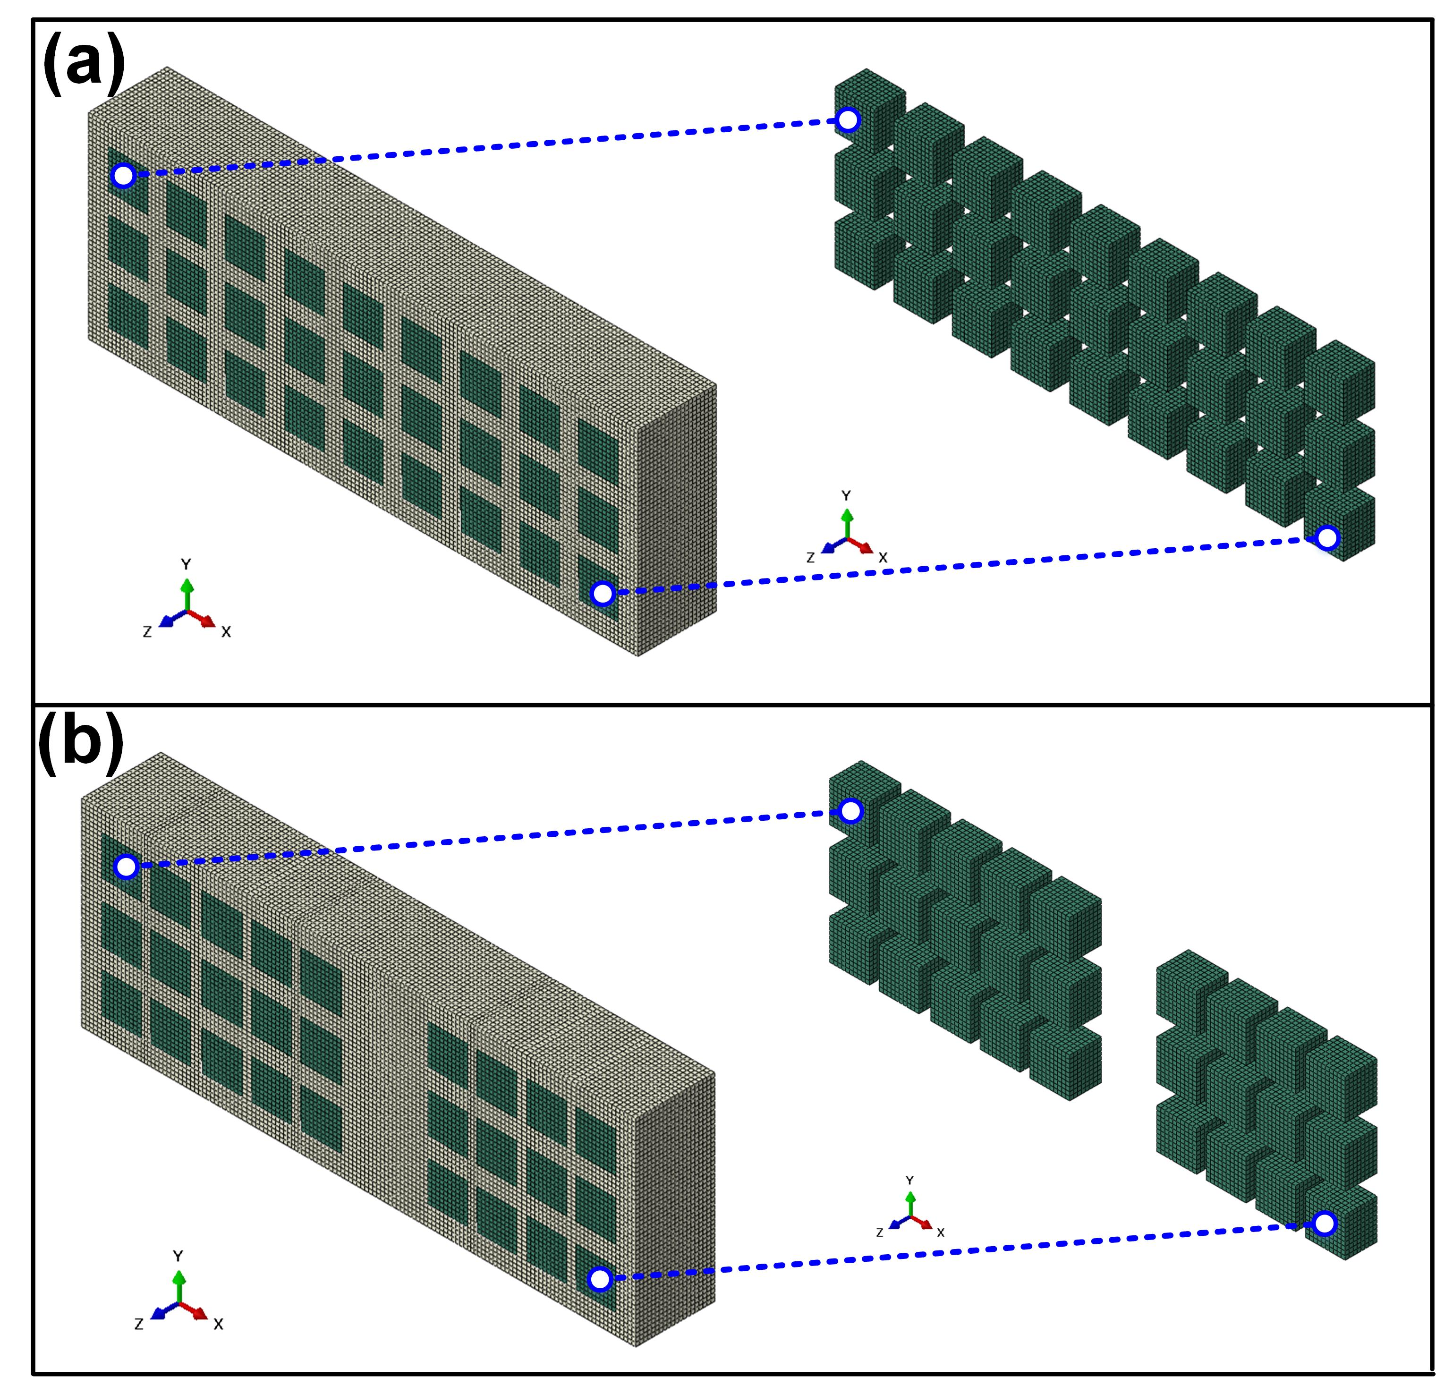
Fig.S8 Finite element model of the uniaxial tensile test
((a) Regular 3D structure; (b) Irregular 3D structure)
Table S4 Mechanical property parameters of hard phase and soft phase materials
Mechanical properties parameters | Hard phase | Soft phase
Fracture strain | 0.35765 | 0.44645
Stress triaxiality | 0.33 | 0.33
Strain rate | 0.1 | 0.1
Fracture energy(N·mm⁻¹) | 2.89 | 5.76
Displacement at fracture(mm) | 0.0264 | 0.0528
Mass density(Kg·m⁻³) | 8930 | 8930
Young’s modulus(MPa) | 119 | 119
Poisson's ratio | 0.326 | 0.326
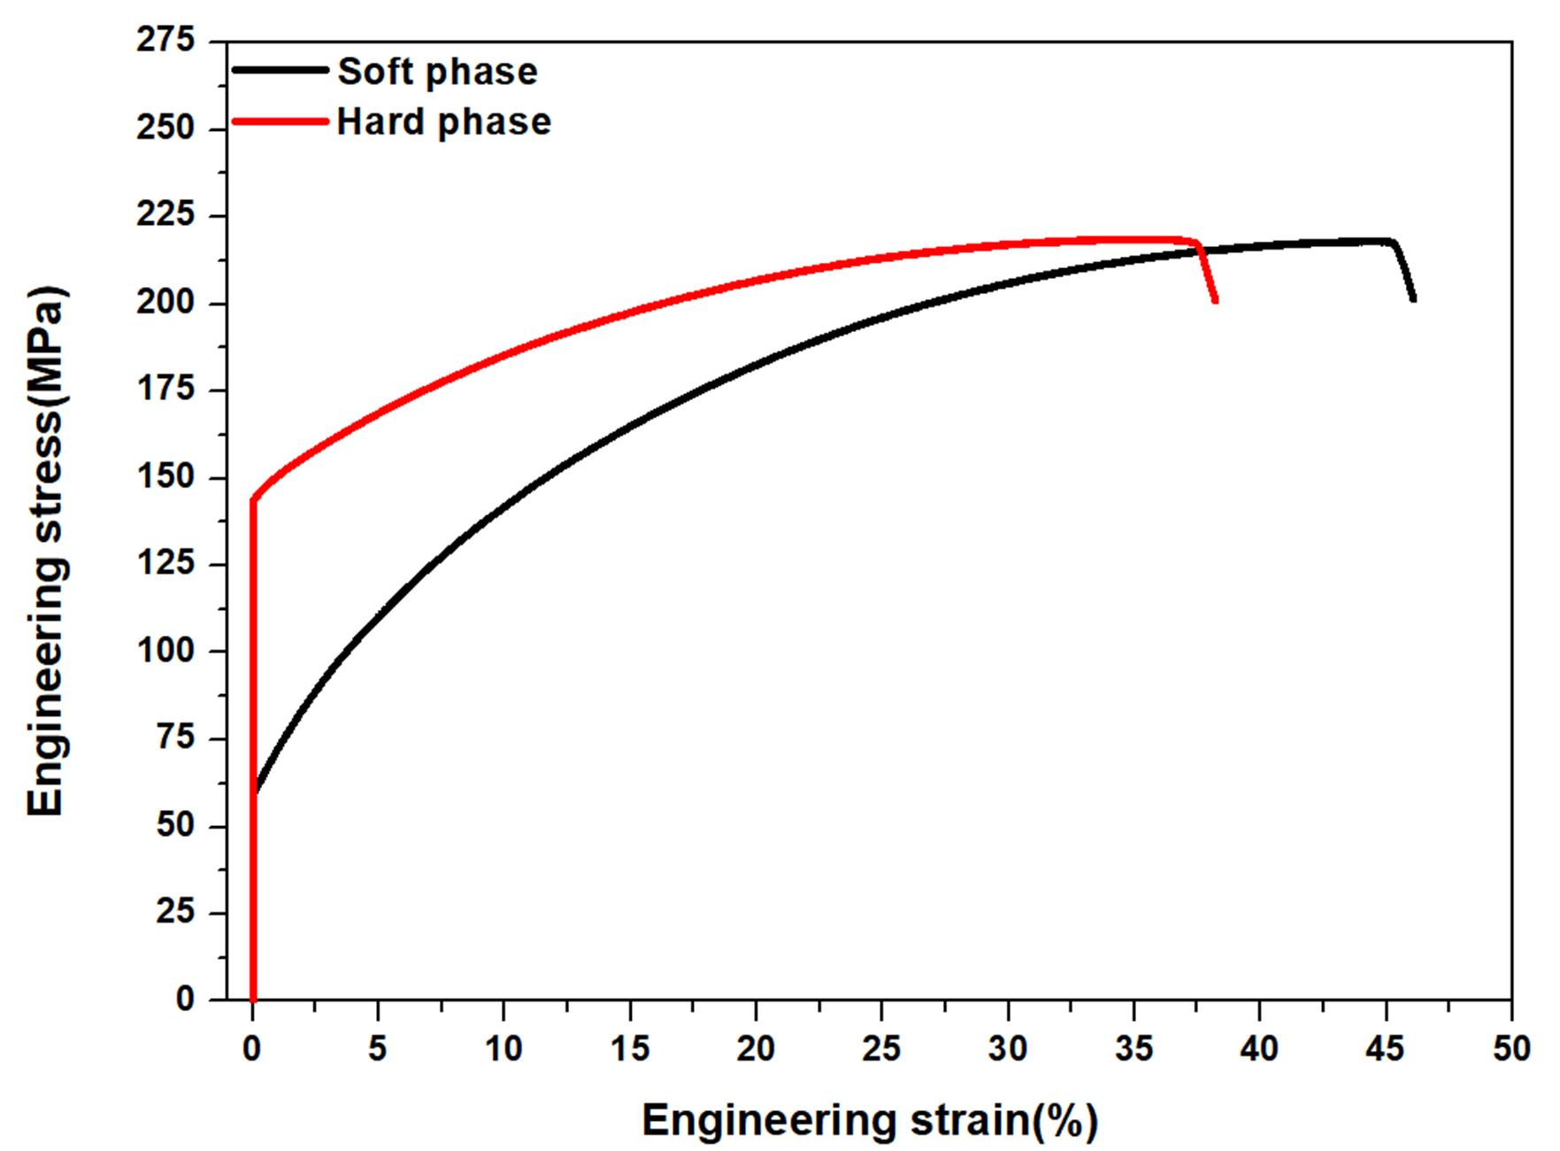
Fig.S9 Stress-strain parameters of the hard and soft phase materials for the plastic deformation
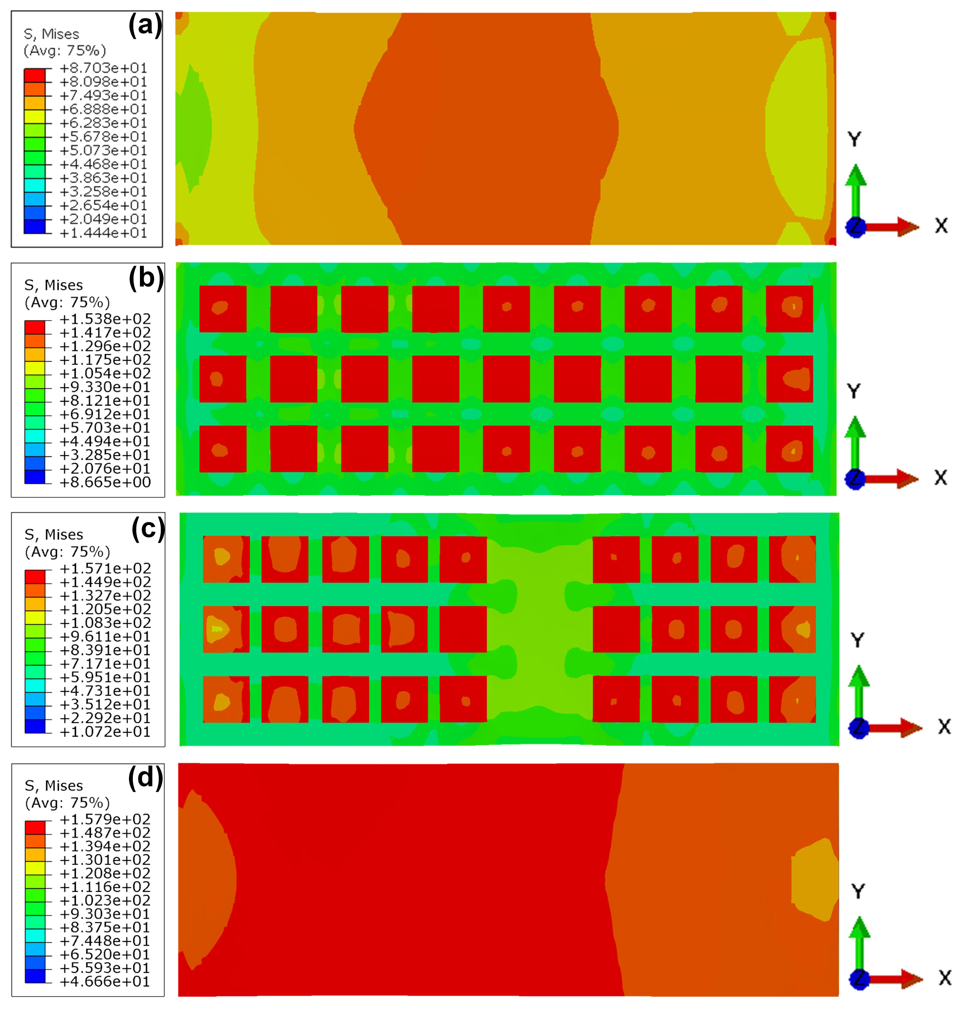
Fig.S10 Initial tensile state of the samples corresponding to different processing conditions
((a) All soft phase;(b) Regular distribution;(c) Irregular distribution;(d) All hard phase)
Reference
[1] Palik, Edward D . Handbook of optical constants of solids /[M]. Academic Press, 1985.
[2] R. Fabbro, J. Fournier, P. Ballard, D. Devaux, J. Virmont, Physical study of laser-produced plasma in confined geometry, J. Appl. Phys. 68 (1990) 775–784. https://doi.org/10.1063/1.346783.
[3] F. Zhang, Z. Liu, Y. Wang, P. Mao, X. Kuang, Z. Zhang, Y. Ju, X. Xu, The modified temperature term on Johnson-Cook constitutive model of AZ31 magnesium alloy with {0002} texture, J. Magnes. Alloy. 8 (2020) 172–183. https://doi.org/10.1016/j.jma.2019.05.013.

