Calibration of PurpleAir monitors.

Lance Wallace, Neil Klepeis, and Tongke Zhao

Supplementary Information

Daily outdoor PM2.5 values from 9347 PurpleAir PA-II sites in the states of California, Washington, and Oregon are pictured by date in Figure S1. The time period runs from Jan 1, 2017 to September 8, 2021. Most peak concentrations are due to wildfires.

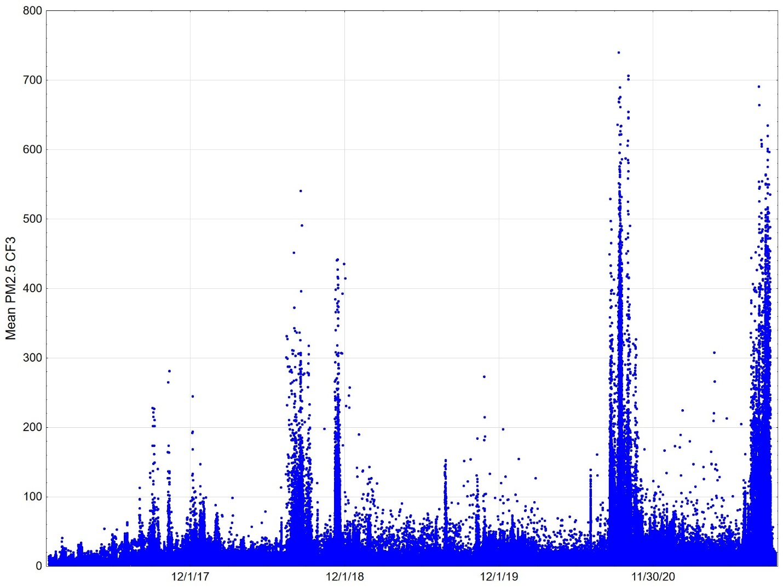

Figure S1. All daily PurpleAir PA-II outdoor PM2.5 concentrations (µg/m³) between 1/1/17 and 9/8/21 at 9347 sites in three states. Included are 3.5 million daily averages.

Mean daily outdoor PM_{2.5} concentrations as measured by all national and state regulatory sites within 20 km of at least one PurpleAir site are shown by date in Figure S2. The FEM/FRM data consisted of 66,978 daily averaged measurements at 95 sites in the three states.

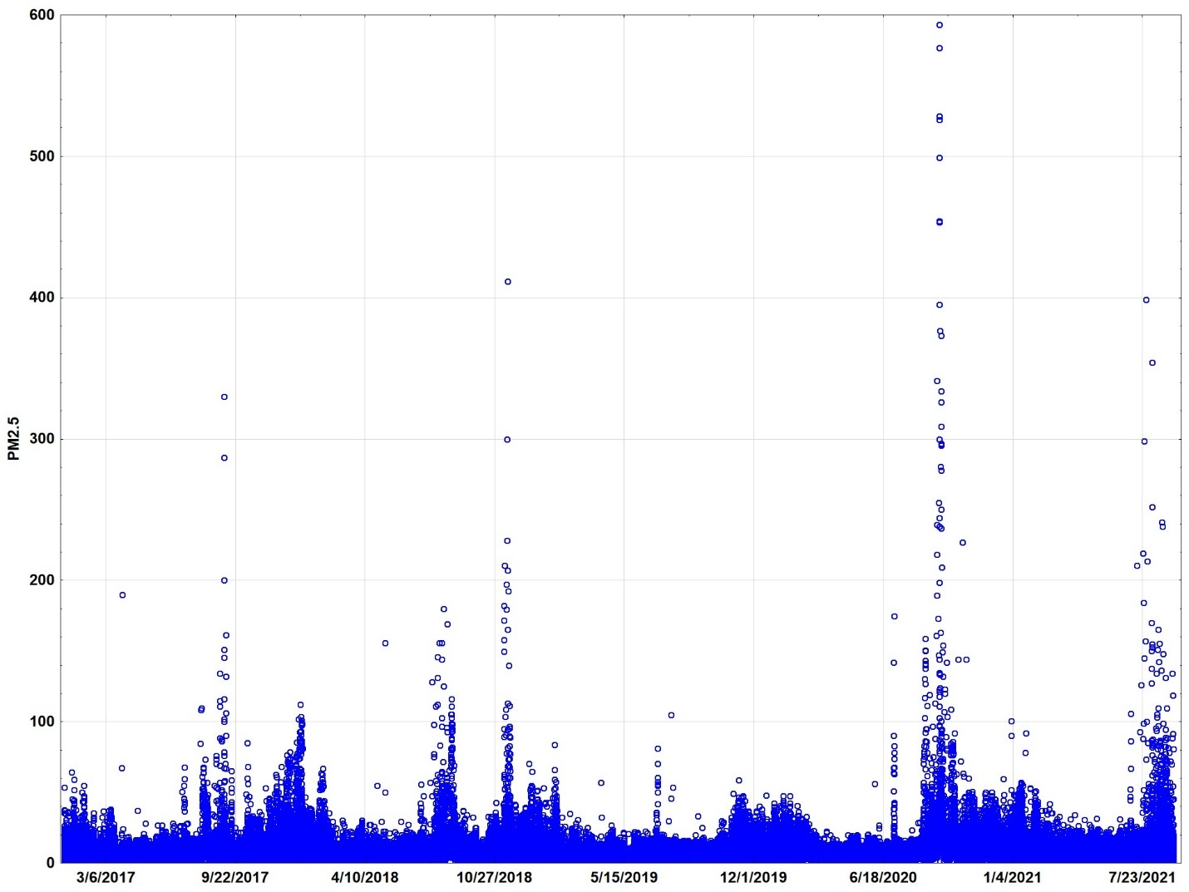
Figure S2. All FEM/FRM daily outdoor PM_{2.5} concentrations (µg/m³) from 1/1/17 through 9/8/21 at 95 sites in three states. N = 66,978 daily averages.

The daily outdoor mean PM_{2.5} concentrations and related statistics from the PurpleAir and Air Quality System regulatory network in three states over 4.7 years are provided (Table S1). The PurpleAir estimates are based on the ALT-CF3 algorithm (CF=3.0). These are the complete datasets, not matched by geographic proximity, so should not be compared directly.

Table S1. Outdoor Daily PM_{2.5} concentrations (µg/m³)
 | N sites | Mean  PM_{2.5} | Std. Dev. | 10th %tile | Lower quartile | Geom. Mean | Median | Upper quartile | 90th %tile | Max
Outdoor PA-II | 9347 | 8.3 | 4.6 | 4.5 | 5.7 | 7.5 | 7.4 | 9.6 | 12.6 | 740
FEM/FRM | 95 | 10.0 | 3.2 | 6.2 | 7.9 | 9.5 | 9.7 | 11.9 | 14.2 | 590

The median length of time monitored is 305 days for the PurpleAir monitors and 537 days for the regulatory FRM sites (Table S2).

Table S2. Days monitored
 | N sites | Mean days | Std. Dev. | Min | 10th %tile | Lower quartile | Median | Upper quartile | 90th %tile | Max
Outdoor PA-II | 9347 | 377 | 289 | 30 | 96 | 175 | 305 | 439 | 860 | 1516
FEM/FRM | 95 | 705 | 469 | 31 | 207 | 380 | 537 | 939 | 1613 | 1705

