Table S1. Mean values (±1SE) of the total, bacteria, actinomycetes (ACT), fungi, gram-positive bacteria (GP), gram-negative bacteria (GN), arbuscular mycorrhizal fungi (AMF) PLFAs, and the ratio of fungi to bacteria (F:B ratio) across the two soil depths under the four cropping years. Y0: continuous maize-wheat rotation in recent decades; Y3: mugwort cropping for 3 years (since 2017); Y6: mugwort cropping for 6 years (since 2014); Y20: mugwort cropping for 20 years. Different letters indicate significant differences among the four cropping years at P < 0.05.
Cropping years | Total | Bacteria | ACT | Fungi | GP | GN | AMF | F:B ratio
Y0 | 26.68±1.45ab | 15.29±0.79a | 3.45±0.13b | 0.55±0.06ab | 7.24±0.37a | 8.05±0.44a | 0.73±0.04a | 0.04±0.00a
Y3 | 31.02±1.88a | 17.69±1.19a | 4.12±0.22a | 0.83±0.09a | 7.94±0.47a | 9.76±0.75a | 0.82±0.07a | 0.05±0.00a
Y6 | 26.41±1.81ab | 15.23±1.06a | 3.70±0.27ab | 0.61±0.11ab | 7.27±0.42a | 7.96±0.75a | 0.66±0.05ab | 0.04±0.00a
Y20 | 21.18±1.99b | 11.77±1.03b | 2.07±0.18c | 0.52±0.10b | 5.89±0.47b | 5.87±0.62b | 0.54±0.07b | 0.04±0.01a

Figure S1. The variations of microbial composition of gram-positive bacteria (GP), gram-negative bacteria (GN), fungi, actinomycetes (ACT), and general FAME under the four different cropping years of mugwort. Y0: continuous maize-wheat rotation; Y3: mugwort cropping for 3 years; Y6: mugwort cropping for 6 years; Y20: mugwort cropping for 20 years.
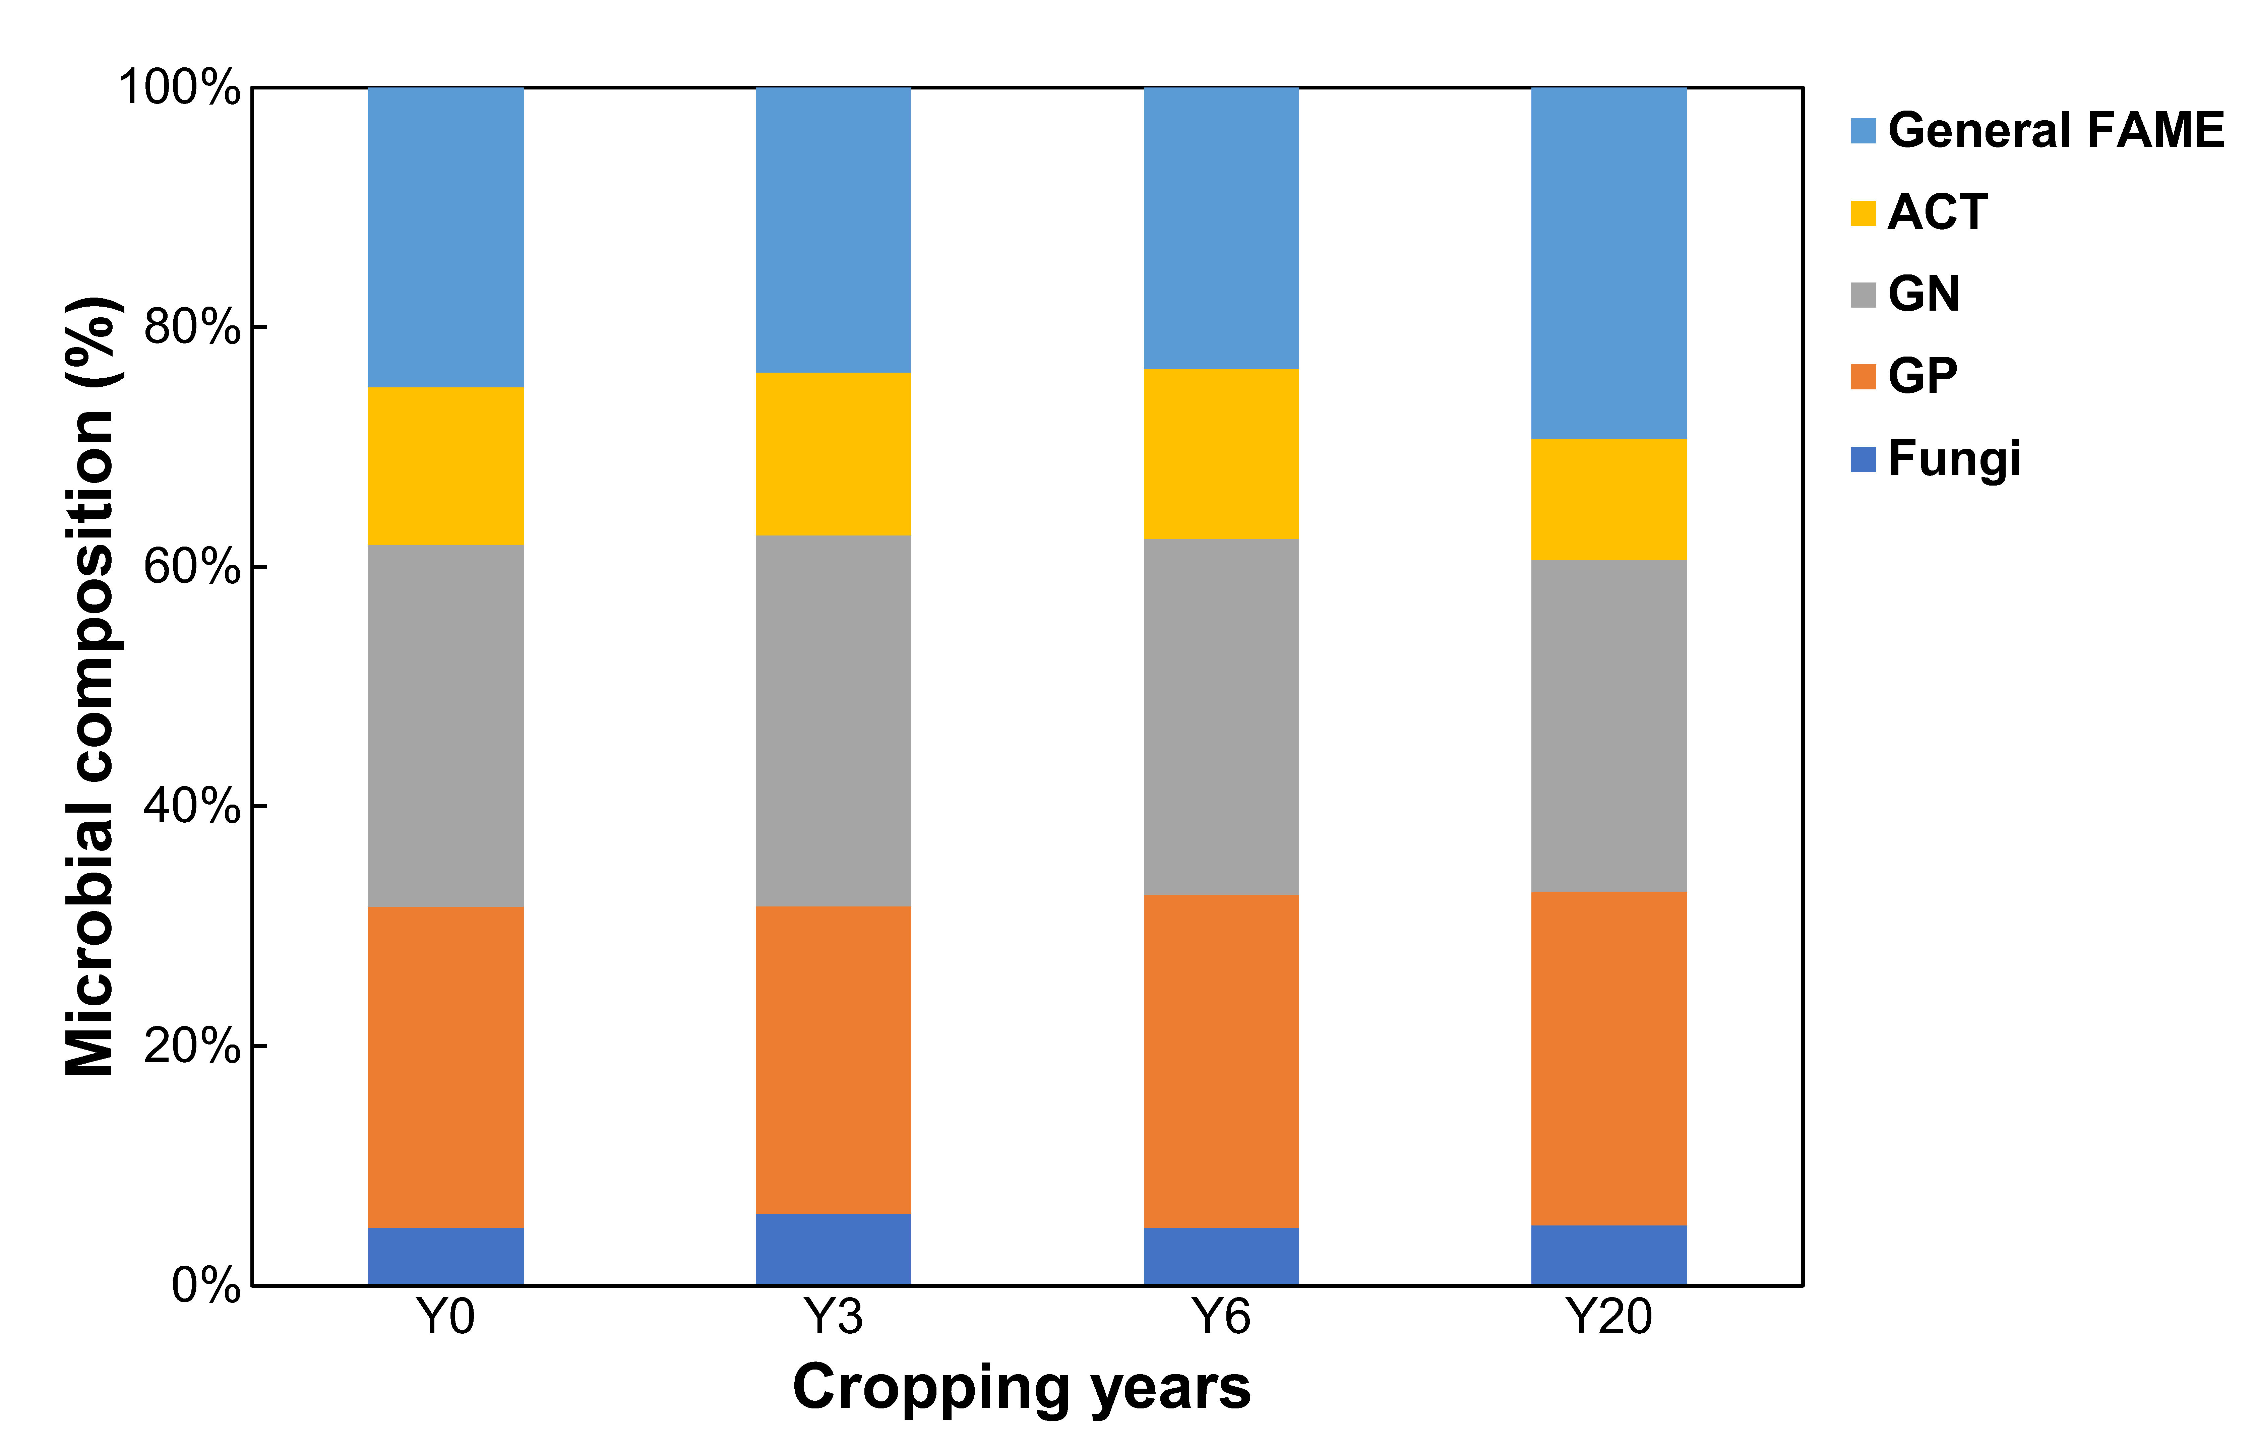

Figure S2. Relationships of PLFAs with root biomass. See abbreviations in Table S1.
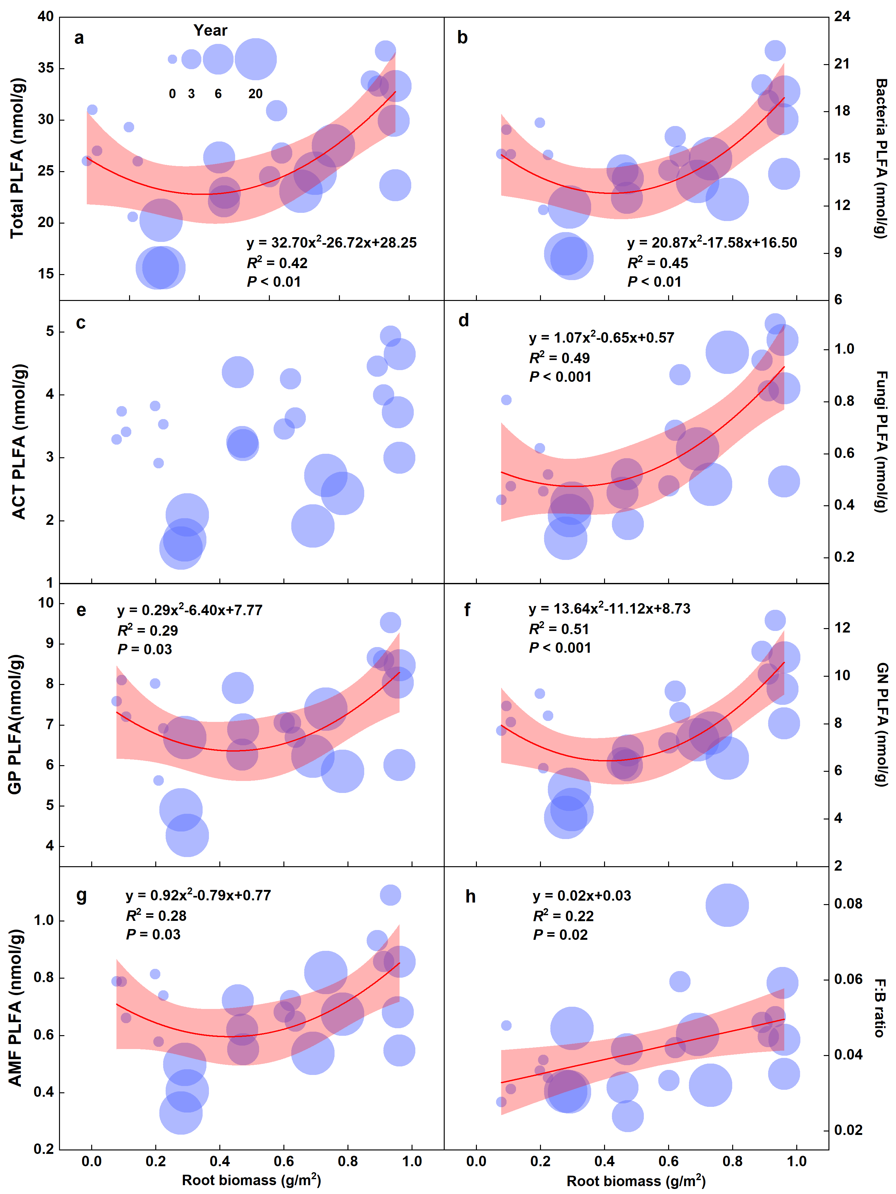

Figure S3. Changes in PLFAs along the chronosequences. See abbreviations in Table S1.
