**SUPPLEMENTARY FIGURES AND TABLES**

**Figure S1**



**Figure S1. Correlation between RNA-seq and Taqman.** The scatter plot shows the log2 values of the Transcripts Per Kilobase Million (TPM) on the x-axis and the △Ct values from TaqMan (y-axis). A linear correlation is fitted with the confidence intervals.

**Figure S2**

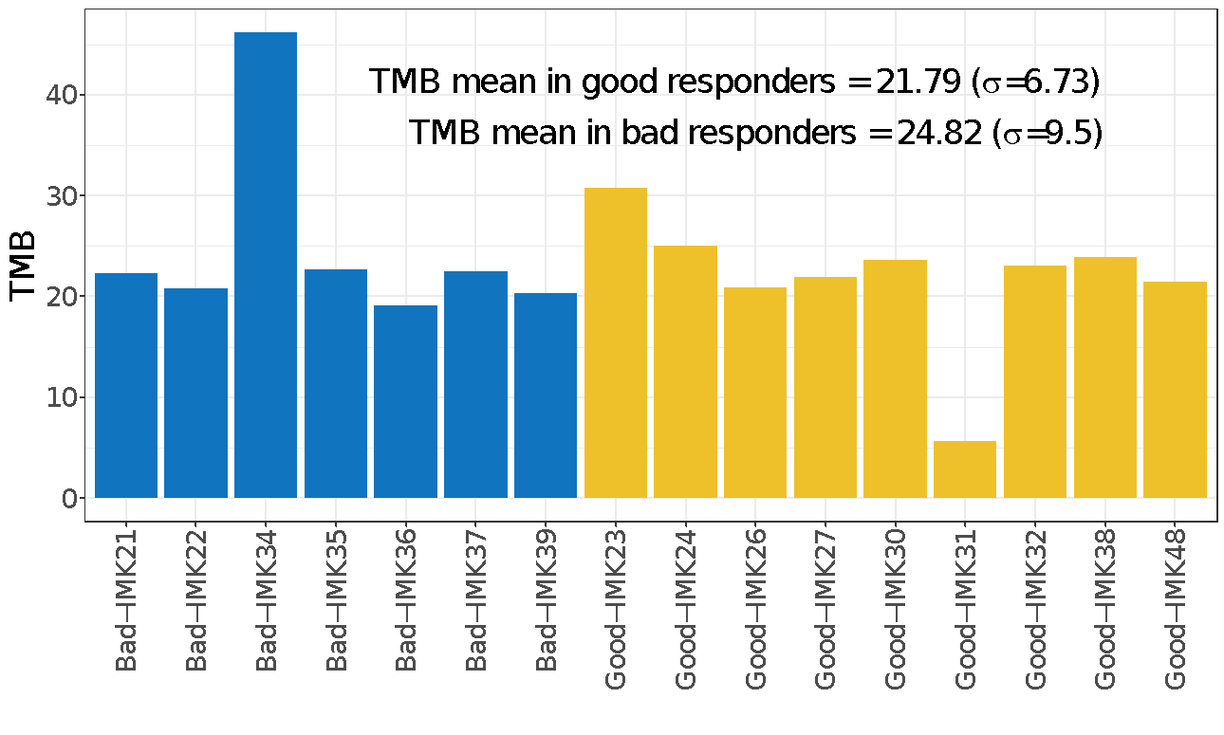

(**a**)

(**b**)

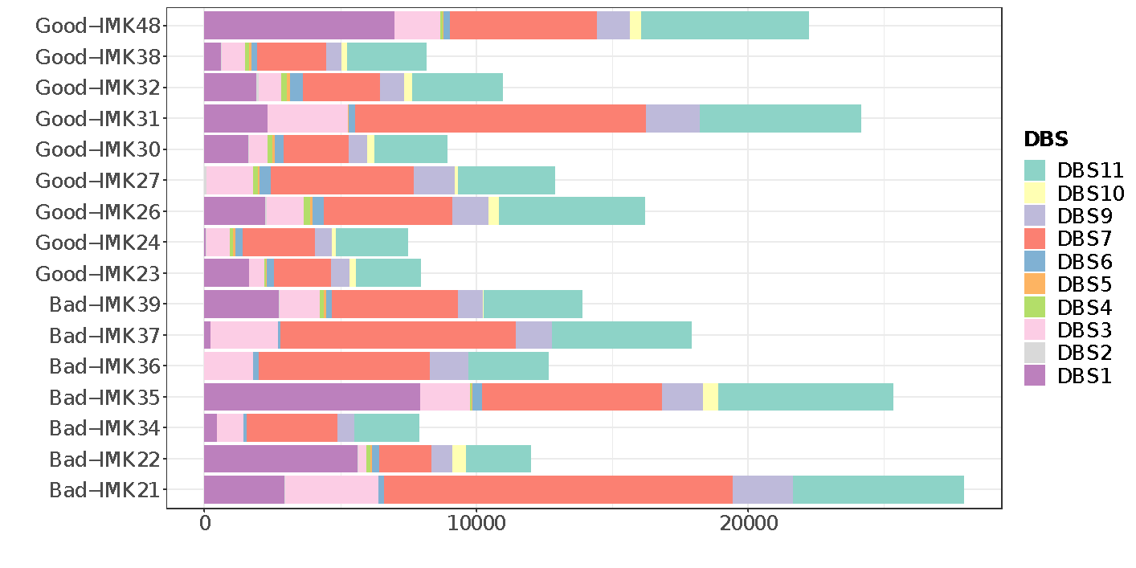

**Figure S2. TMB and somatic mutational signature quantification and comparison in the cutaneous metastatic melanoma patients. (a)** Bar plot per sample with TMB as height. Blue and yellow stratified the response by bad responders and good responders. Mean and standard deviation ($σ$) was computed for each group. **(b)** Doublet base substitutions are mutational signatures annotated in COSMIC. DBS1 {Ultraviolet light exposure}, DBS2 {Tobacco smoking, other mutagens, and clock-like}, DBS3 {polymerase epsilon exonuclease domain mutations}, DBS4 {unknown, correlated with clock-like} DBS5 {platinum chemotherapy treatment}, DBS6 {unknown}, DBS7 {defective DNA mismatch repair}, DBS8 {unknown}, DBS9 {unknown}, DBS10 {defective DNA mismatch repair} and DBS11 {possibly related to APOBEC mutagenesis}.

**Figure S3**

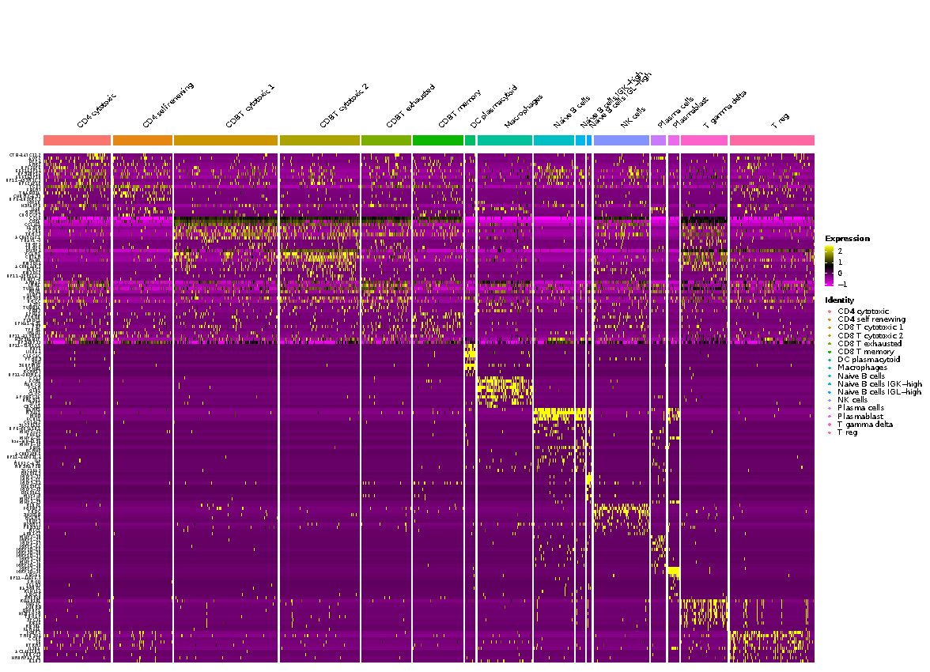

**Figure S3. Expression marker heatmap based on scRNA-seq.** Top 10 genes markers based on adj p-value for each cell line type established from the single cell RNA-seq analysis. Top markers were identified by differential expression analysis between cell types.

**Figure S4**

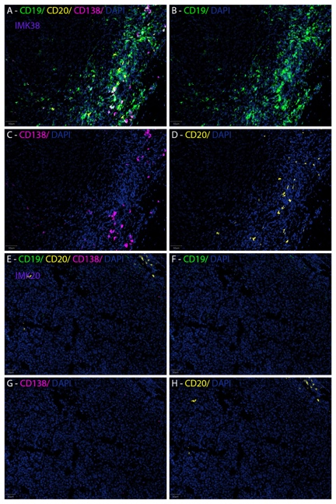

(**a**)

(**b**)

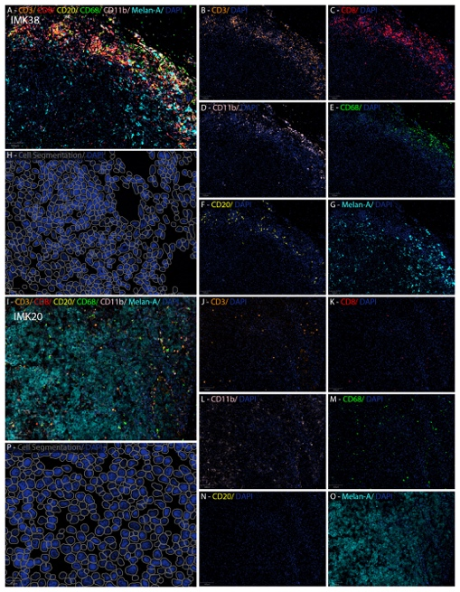

**Figure S4. Multispectral Immunofluorescence tissue imaging comparing good and bad responder cases stratified by fluorescence panels.** Fluorescence panels images of each of the markers CD11b, CD68, CD3, CD8, CD20, MELAN-A in **(a)** and CD19, CD20 and C138 in **(b)** of the patient IMK-20 (Bad responder) and IMK-38 (Good responder).

**Figure S5**



(**b**)



(**a**)

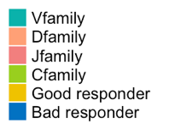

**Figure S5. Diversity of the BCR families and HLA loci per patient. (a)** The connecting lines indicate the BCR clonotypes with each patient presents. The width of the line indicates the total amount of the clonotype. Each plot depicts a different BCR family: Vfamily, Dfamily, Jfamily and Cfamily. The patients in yellow are the good responders, and in blue, the bad responders. **(b)** The connecting lines indicate the amount of HLA loci that each patient presents. Depicted in yellow, the good responders, and in blue, the bad responders.

**Figure S6**

(**a**)

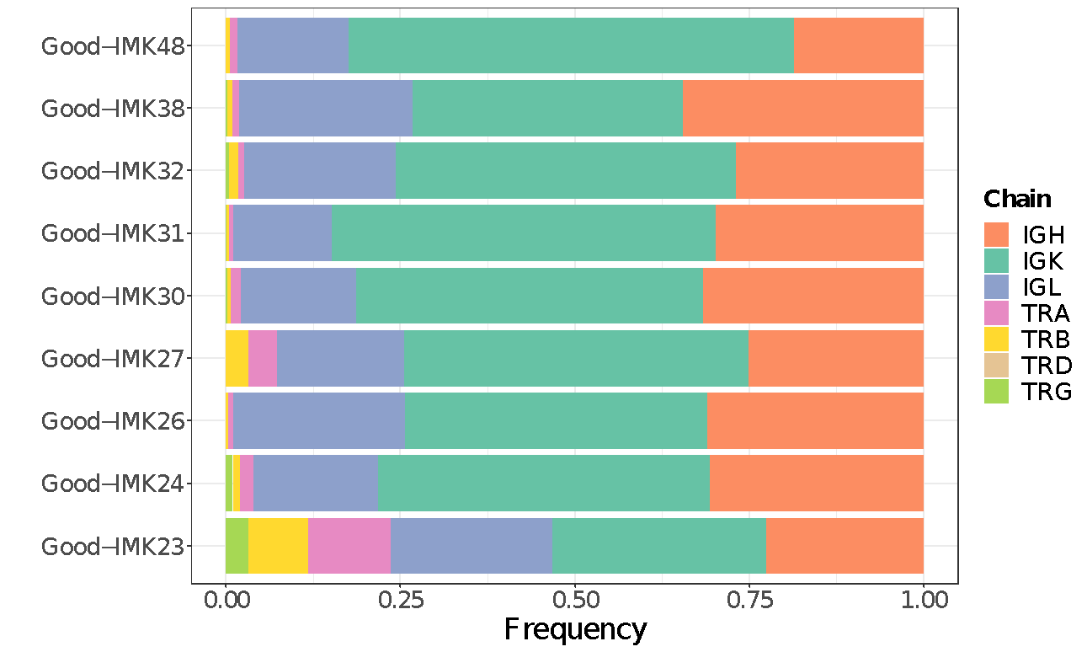

(**b**)

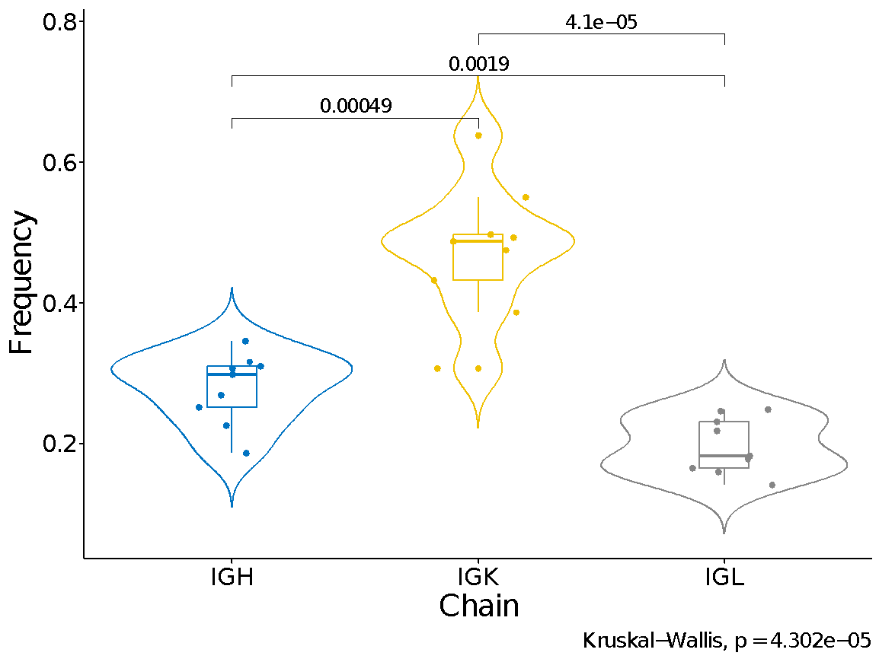

**Figure S6. Diversity of the BCR/TCR chains in good responders. (a)** Distribution of BCR and TCR chain in good responders. **(b)** Comparison of the abundance between BCR chains in good responders.

**Table S1. Univariate analysis of the clinicopathological variables.**

|  |  |  |  |  |  |  |
| --- | --- | --- | --- | --- | --- | --- |
| **Variables** | **Likelihood ratio Test** | | **Logrank p-value**  **OS Survival** | | **Logrank p-value**  **PFS Survival** | |
| **Melanoma cohort** | **Cutaneous melanoma cohort** | **Melanoma cohort** | **Cutaneous melanoma cohort** | **Melanoma cohort** | **Cutaneous melanoma cohort** |
| **Age at start IT** | 0.7022 | 0.3063 | 0.8268 | 0.1071 | 0.8544 | 0.2548 |
| **Sex** | 0.8188 | 1 | 0.697 | 0.8784 | 0.7858 | 0.9696 |
| ***Stage at diagnosis*** | *0.0109* | *0.0573* | *0.0358* | *0.0708* | *0.0389* | *0.1376* |
| **Diabetes** | 1 | 1 | 0.5512 | 0.5692 | 0.525 | 0.5805 |
| **Dyslipidemia** | 0.2105 | 0.2125 | 0.4015 | 0.4269 | 0.2844 | 0.2792 |
| **Hypertension** | 0.3698 | 0.1262 | 0.401 | 0.0864 | 0.3735 | 0.1215 |
| **BRAF** | 0.3034 | 0.2615 | 0.1781 | 0.45236 | 0.2204 | 0.4589 |
| ***Lung metastasis*** | *0.0075* | *0.035* | *0.0015* | *0.0036* | *0.0038* | *0.0166* |
| ***Lymph node metastasis*** | *0.387* | *0.1451* | *0.0804* | *0.0395* | *0.231* | *0.1255* |
| **CNS metastasis** | 1 | 1 | 0.3663 | 0.2434 | 0.4043 | 0.2918 |
| **No. metastasis** | 0.8272 | 0.683 | 0.8274 | 0.6751 | 0.5292 | 0.4021 |
| **LDH first metastasis** | 0.1645 | 0.1645 | 0.9178 | 0.9178 | 0.4637 | 0.4637 |
| **LDH previous to IT** | 0.6842 | 0.5368 | 0.9436 | 0.7277 | 0.6274 | 0.7277 |
| **Lymphocytes previous to IT** | 0.2271 | 0.2049 | 0.0583 | 0.0533 | 0.1825 | 0.9654 |
| **Neutrophiles previous to IT** | 0.4265 | 0.385 | 0.9606 | 0.273 | 0.8281 | 0.5646 |
| **Platelets previous to IT** | 0.1393 | 0.2474 | 0.7643 | 0.7641 | 0.1845 | 0.1108 |
| **No. Previous lines** | 0.2423 | 0.2559 | 0.1344 | 0.2073 | 0.3041 | 0.4024 |
| ***IT toxicity*** | *0.0237* | *0.1058* | *0.0133* | *0.0858* | *0.0225* | *0.156* |
| **Maximum toxicity grade** | 0.4545 | 0.7 | 0.1848 | 0.2339 | 0.6754 | 0.5217 |

The cohort was analyzed utilizing the cutaneous, ocular, and mucosal histological subtypes (melanoma cohort), and on the other hand using only the cutaneous subtype (cutaneous melanoma cohort). The Likelihood ratio Test was used to do a univariate analysis based on the dichotomous 3-month response variable: good and bad responder. Overall survival (OS) and progression-free survival (PFS) have been used in the logrank test.

**Table S2. Univariate Cox proportional hazards regression analysis of OS and PFS.**

|  |  |  |  |  |  |  |  |  |  |
| --- | --- | --- | --- | --- | --- | --- | --- | --- | --- |
| **Variable** | **Category** | **Melanoma (OS)** | | **Cutaneous melanoma (OS)** | | **Melanoma (PFS)** | | **Cutaneous melanoma (PFS)** | |
|  |  | **HR (CI %)** | **p-value** | **HR (CI %)** | **p-value** | **HR (CI %)** | **p-value** | **HR (CI %)** | **p-value** |
| **Age at start IT** |  | 1.0006 (0.9663 - 1.0361) | 0.9725 | 0.9923 (0.961 - 1.0246) | 0.6363 | 0.9996 (0.9676 - 1.0327) | 0.9814 | 0.9913 (0.9628 - 1.0208) | 0.56 |
| **Sex** | *Female (Ref)* |  |  |  |  |  |  |  |  |
|  | *Male* | 1.2321 (0.43 - 3.5298) | 0.6976 | 1.0979 (0.3315 - 3.636) | 0.8785 | 1.151 (0.4152 - 3.1907) | 0.7869 | 0.978 (0.3118 - 3.0678) | 0.9696 |
| **Stage at diagnosis** | *I (Ref)* |  |  |  |  |  |  |  |  |
|  | *II* | 2.0166 (0.2182 - 18.6337) | 0.5364 | 2.0428 (0.2212 - 18.861) | 0.5288 | 1.4249 (0.1583 - 12.8284) | 0.7521 | 1.4471 (0.1607 - 13.0288) | 0.7417 |
|  | *III* | 1.0166 (0.1049 - 9.8558) | 0.9887 | 1.0522 (0.1084 - 10.217) | 0.965 | 1.0225 (0.1057 - 9.8931) | 0.9847 | 1.0544 (0.1089 - 10.2122) | 0.9635 |
|  | *IV* | 7.8907 (0.7907 - 78.7385) | 0.0784 | 9.291 (0.7787 - 110.8539) | 0.078 | 7.6559 (0.7518 - 77.9631) | 0.0856 | 6.6925 (0.5821 - 76.9498) | 0.1271 |
| **Diabetes** | *No (Ref)* |  |  |  |  |  |  |  |  |
|  | *Yes* | 0.5431 (0.0707 - 4.1722) | 0.5573 | 0.5539 (0.0703 - 4.3616) | 0.5747 | 0.5326 (0.0698 - 4.0609) | 0.5433 | 0.565 (0.0726 - 4.3978) | 0.5856 |
| **Dyslipidemia** | *No (Ref)* |  |  |  |  |  |  |  |  |
|  | *Yes* | 0.5278 (0.1158 - 2.4055) | 0.4089 | 0.5364 (0.1128 - 2.5504) | 0.4337 | 0.4463 (0.0989 - 2.013) | 0.2938 | 0.4365 (0.0935 - 2.0386) | 0.2918 |
| **Hypertension** | *No (Ref)* |  |  |  |  |  |  |  |  |
|  | *Yes* | 0.5952 (0.2065 - 1.7153) | 0.3366 | 0.308 (0.0906 - 1.0468) | 0.0592 | 0.7055 (0.2542 - 1.9579) | 0.503 | 0.4068 (0.128 - 1.2926) | 0.1273 |
| **BRAF** | *No (Ref)* |  |  |  |  |  |  |  |  |
|  | *Yes* | 2.1927 (0.6796 - 7.0747) | 0.189 | 1.6607 (0.4362 - 6.3226) | 0.4571 | 2.0341 (0.6416 - 6.4488) | 0.2278 | 1.6357 (0.4391 - 6.0932) | 0.4633 |
| **Lung metastasis** | *No (Ref)* |  |  |  |  |  |  |  |  |
|  | *Yes* | 0.18 (0.0559 - 0.5801) | 0.0041 | 0.1726 (0.0464 - 0.6418) | 0.0087 | 0.224 (0.0762 - 0.658) | 0.0065 | 0.2586 (0.0797 - 0.839) | 0.0243 |
| **Lymph node metastasis** | *No (Ref)* |  |  |  |  |  |  |  |  |
|  | *Yes* | 2.7182 (0.8463 - 8.7299) | 0.093 | 4.5411 (0.9508 - 21.6883) | 0.0579 | 1.8915 (0.6443 - 5.5531) | 0.2461 | 2.6982 (0.7213 - 10.0934) | 0.1403 |
| **CNS metastasis** | *No (Ref)* |  |  |  |  |  |  |  |  |
|  | *Yes* | 2.0185 (0.4262 - 9.5597) | 0.3761 | 2.5199 (0.5046 - 12.5849) | 0.26 | 1.9221 (0.4128 - 8.9501) | 0.4051 | 2.2844 (0.4708 - 11.0855) | 0.3053 |
| **No. Metastasis** |  | 0.9316 (0.5484 - 1.5827) | 0.7933 | 0.9136 (0.513 - 1.6271) | 0.7589 | 1.0061 (0.6158 - 1.644) | 0.9805 | 0.9995 (0.5902 - 1.6926) | 0.9986 |
| **LDH first metastasis** |  | 0.9974 (0.989 - 1.0059) | 0.5437 | 0.9974 (0.989 - 1.0059) | 0.5437 | 0.9985 (0.9921 - 1.0048) | 0.6354 | 0.9985 (0.9921 - 1.0048) | 0.6354 |
| **LDH previous to IT** |  | 0.9996 (0.9952 - 1.0041) | 0.8696 | 0.9998 (0.9952 - 1.0044) | 0.9258 | 0.9999 (0.9958 - 1.0039) | 0.9461 | 1 (0.9958 - 1.0043) | 0.9969 |
| **Lymphocytes previous to IT** |  | 0.9989 (0.9978 - 1) | 0.0564 | 0.9988 (0.9976 - 1.0001) | 0.0614 | 0.9991 (0.998 - 1.0001) | 0.0849 | 0.999 (0.9978 - 1.0001) | 0.0857 |
| **Neutrophiles previous to IT** |  | 1.0001 (1 - 1.0003) | 0.1365 | 1.0001 (1 - 1.0003) | 0.0837 | 1.0001 (0.9999 - 1.0002) | 0.3792 | 1.0001 (0.9999 - 1.0002) | 0.3199 |
| **Platelets previous to IT** |  | 1.0001 (1.0000 - 1.0001) | 0.0708 | 1.0001 (0.9999 - 1.0001) | 0.4784 | 1.0001 (1.0001 - 1.0002) | 0.0489 | 1.0001 (0.9999 - 1.0001) | 0.2607 |
| **No. Previous lines** |  | 1.4154 (0.798 - 2.5105) | 0.2348 | 1.4243 (0.7728 - 2.6249) | 0.2569 | 1.2717 (0.7121 - 2.2712) | 0.4165 | 1.2933 (0.6918 - 2.4176) | 0.4204 |
| **Toxicity IT** | *No (Ref)* |  |  |  |  |  |  |  |  |
|  | *Yes* | 0.2755 (0.0931 - 0.8157) | 0.0199 | 0.3443 (0.0969 - 1.2235) | 0.0993 | 0.3067 (0.1059 - 0.8883) | 0.0294 | 0.4233 (0.1248 - 1.4364) | 0.1679 |
| **Maximum toxicity grade** |  | 1.8851 (0.7112 - 4.9967) | 0.2024 | 2.0736 (0.7163 - 6.0028) | 0.1787 | 0.9489 (0.3966 - 2.2701) | 0.9061 | 0.9428 (0.3743 - 2.375) | 0.9006 |

**Table S3. 22 genes DE signature in good responders of all types of metastatic melanoma and 140 DE genes in good responders of metastatic cutaneous melanoma.**

|  |  |  |
| --- | --- | --- |
| **DE all types of melanoma** | | |
| **Gene** | **log2FoldChange** | **Adj p value** |
| *ALDH1A2* | -4.240 | 0.0008 |
| *EMCN* | -2.478 | 0.010 |
| *FRRS1L* | -4.068 | 0.010 |
| *PDE8B* | -2.589 | 0.014 |
| *OPRD1* | 4.854 | 0.014 |
| *MMP3* | 5.453 | 0.014 |
| *ADAMTS9-AS1* | -3.419 | 0.014 |
| *SYPL2* | -2.020 | 0.016 |
| *LRFN5* | -2.967 | 0.019 |
| *HPSE2* | -4.554 | 0.019 |
| *RIMS1* | -3.570 | 0.031 |
| *NUDT11* | -2.760 | 0.033 |
| *AC051619.7* | 3.375 | 0.034 |
| *IGHV1-69-2* | 6.504 | 0.034 |
| *LGR5* | -3.760 | 0.036 |
| *RNA5SP150* | -12.180 | 0.036 |
| *KCNA1* | -3.210 | 0.036 |
| *RP11-254F19.2* | -3.303 | 0.040 |
| *BAAT* | -4.743 | 0.042 |
| *ACSS3* | -2.967 | 0.046 |
| *SPHKAP* | -4.804 | 0.046 |
| *LRRC17* | -3.132 | 0.048 |
|  |  |  |
| **DE cutaneous melanoma** | | |
| **Gene** | **log2FoldChange** | **Adj p value** |
| *IGHV3-21* | 8.285 | 4.51E-07 |
| *IGKV4-1* | 6.313 | 2.02E-05 |
| *IGLV3-21* | 7.037 | 4.80E-04 |
| *IGHV4-59* | 6.858 | 7.29e-07 |
| *IGLV6-57* | 7.853 | 7.43E-04 |
| *IGLV3-1* | 6.463 | 7.92E-04 |
| *IGKV3-11* | 6.644 | 9.08E-04 |
| *FDCSP* | 7.481 | 1.02E-03 |
| *IGHV1-18* | 5.599 | 1.02E-03 |
| *IGHV4-39* | 5.939 | 1.42E-03 |
| *IGKV3-15* | 6.374 | 1.42E-03 |
| *IGHV4-31* | 5.713 | 3.18E-03 |
| *IGLV1-44* | 6.218 | 8.27E-03 |
| *TNFRSF11B* | 3.058 | 9.56E-03 |
| *IGKV3-20* | 6.053 | 1.17E-02 |
| *IGHGP* | 6.498 | 2.13E-02 |
| *IGLV2-14* | 5.584 | 2.93E-02 |
| *IGHG2* | 5.551 | 2.93E-02 |
| *IGHG1* | 5.414 | 2.93E-02 |
| *IGKV1-12* | 8.047 | 2.93E-02 |
| *IGHG4* | 5.714 | 3.48E-02 |
| *IGKV1-5* | 5.210 | 3.48E-02 |
| *IGLV2-23* | 5.790 | 5.76E-02 |
| *IGLV3-25* | 6.191 | 5.98E-02 |
| *AL445647.1* | -8.312 | 7.49E-02 |
| *IGKV3D-20* | 6.489 | 7.49E-02 |
| *IGHG3* | 6.304 | 7.49E-02 |
| *IGHV1-46* | 5.474 | 7.92E-02 |
| *IGKV1-9* | 6.309 | 7.92E-02 |
| *IGHV5-10-1* | 8.249 | 7.92E-02 |
| *IGHV1-69D* | 5.870 | 8.11E-02 |
| *IGHV1-69* | 8.232 | 8.49E-02 |
| *IGHV3-30* | 5.431 | 8.77E-02 |
| *IGHV1-24* | 7.390 | 8.88E-02 |
| *IGHV3-15* | 5.717 | 8.91E-02 |
| *PRDM7* | 7.640 | 0.0001 |
| *IGLC3* | 5.982 | 0.00012 |
| *IGKV3D-11* | 7.179 | 0.00013 |
| *IGHV3-73* | 7.382 | 0.00014 |
| *IGHV3-23* | 5.159 | 0.00014 |
| *LRFN5* | -3.622 | 0.00016 |
| *IGHV3-74* | 5.672 | 0.00018 |
| *IGHA1* | 5.293 | 0.0002 |
| *IGHV3-33* | 5.458 | 0.00023 |
| *IGLV1-40* | 5.986 | 0.00024 |
| *IGHV2-70D* | 8.089 | 0.00036 |
| *IGHV3-13* | 7.717 | 0.00038 |
| *IGKC* | 5.157 | 0.0005 |
| *IGHV6-1* | 6.956 | 0.00052 |
| *FRRS1L* | -4.038 | 0.00058 |
| *MMP3* | 6.696 | 0.00065 |
| *IGLV1-47* | 4.633 | 0.00068 |
| *IGLV1-51* | 5.385 | 0.00071 |
| *IGLC2* | 4.800 | 0.00071 |
| *IGHA2* | 4.606 | 0.00071 |
| *IGHV3-66* | 5.899 | 0.00071 |
| *CD177* | 4.951 | 0.000711 |
| *IGLV7-46* | 7.388 | 0.000711 |
| *AC051619.7* | 3.970 | 0.000711 |
| *GRIA1* | -5.828 | 0.00077 |
| *IGKV2-30* | 4.887 | 0.00078 |
| *POU2AF1* | 4.180 | 0.00082 |
| *IGHV1-3* | 5.883 | 0.00082 |
| *IGHM* | 4.791 | 0.0009 |
| *MEST* | -4.380 | 0.00093 |
| *AL136298.1* | 5.099 | 0.00093 |
| *ADAMTS9-AS1* | -2.992 | 0.00122 |
| *IGKV1-27* | 5.745 | 0.00128 |
| *MMP1* | 5.032 | 0.00199 |
| *IGHV2-5* | 4.276 | 0.00212 |
| *IGHV3-11* | 5.302 | 0.00231 |
| *EPHA7* | -4.039 | 0.0027 |
| *IGLV3-19* | 5.014 | 0.0029 |
| *PTN* | -4.187 | 0.0031 |
| *IGLV2-11* | 5.498 | 0.0034 |
| *IGHV3-48* | 4.687 | 0.0035 |
| *MZB1* | 4.425 | 0.0038 |
| *IGLV4-60* | 7.148 | 0.0038 |
| *TNFRSF12A* | 1.780 | 0.0040 |
| *ACOXL* | 3.702 | 0.0046 |
| *IGHV1-69-2* | 7.427 | 0.0050 |
| *IGHJ4* | 4.346 | 0.0050 |
| *IGKV1-6* | 4.164 | 0.0051 |
| *MKRN9P* | -5.762 | 0.0051 |
| *AC233755.1* | 5.532 | 0.0062 |
| *IGHV4-28* | 5.779 | 0.0064 |
| *IGLV7-43* | 7.648 | 0.0066 |
| *JCHAIN* | 3.672 | 0.0070 |
| *SPHKAP* | -5.047 | 0.0079 |
| *CLUL1* | -4.313 | 0.008 |
| *B4GALNT2* | -4.595 | 0.009 |
| *LDB2* | -1.852 | 0.0096 |
| *IGHV2-70* | 4.476 | 0.0104 |
| *MTMR7* | -4.773 | 0.0105 |
| *FZD1* | -1.952 | 0.0105 |
| *IGLV2-8* | 4.497 | 0.0105 |
| *AC007938.3* | -4.319 | 0.0108 |
| *KCNA1* | -3.562 | 0.0108 |
| *FCRL5* | 3.786 | 0.0108 |
| *ADCY8* | -5.651 | 0.0112 |
| *CACNA1G* | -4.043 | 0.0123 |
| *LINC01579* | -4.998 | 0.0123 |
| *TNFRSF17* | -3.279 | 0.0123 |
| *SLC8A3* | 4.589 | 0.0123 |
| *NUGGC* | 3.417 | 0.0126 |
| *HPN-AS1* | 5.849 | 0.0131 |
| *AC087762.2* | -6.978 | 0.0132 |
| *LINC02302* | -3.582 | 0.0150 |
| *IGLL5* | 4.165 | 0.0161 |
| *IGHJ3P* | 4.167 | 0.0166 |
| *CD19* | 3.982 | 0.0170 |
| *IGHV4-61* | 5.857 | 0.0188 |
| *SYPL2* | -2.216 | 0.0197 |
| *S1PR4* | 2.650 | 0.0199 |
| *LGR5* | -3.959 | 0.0208 |
| *VIPR2* | -4.692 | 0.0217 |
| *IGHV3-53* | 4.610 | 0.0218 |
| *OPRD1* | 4.253 | 0.0232 |
| *CCL21* | 3.588 | 0.0251 |
| *AMZ1* | 3.278 | 0.0251 |
| *CLEC4E* | 2.179 | 0.0269 |
| *AC084082.1* | 2.948 | 0.0270 |
| *WNT2* | 2.481 | 0.0271 |
| *FAM30A* | 3.557 | 0.0298 |
| *CEMIP* | 2.141 | 0.0303 |
| *DOK6* | -2.258 | 0.0312 |
| *HKDC1* | 3.708 | 0.0319 |
| *CCN3* | 3.747 | 0.0327 |
| *IGHV3-20* | 5.455 | 0.0327 |
| *RN7SL471P* | 3.365 | 0.0336 |
| *CD22* | 3.016 | 0.0343 |
| *SNHG18* | -2.635 | 0.0347 |
| *U62631.1* | 3.075 | 0.0366 |
| *FUT9* | -5.691 | 0.0374 |
| *UPP1* | -1.763 | 0.0374 |
| *MIR4697HG* | 1.600 | 0.0374 |
| *LINC01013* | -3.039 | 0.0382 |
| *OR7E7P* | -1.533 | 0.0386 |
| *IGHD* | 4.341 | 0.0427 |
| *BLK* | 3.167 | 0.0448 |

**Table S4. Gene Ontology enrichment in good responder patients with metastatic cutaneous melanoma.**

|  |  |  |
| --- | --- | --- |
| **GO biological process** | **Count** | **Adj p value** |
| complement activation, classical pathway | 61 | 3.21E-88 |
| regulation of complement activation | 41 | 1.33E-56 |
| B cell receptor signaling pathway | 41 | 3.6E-55 |
| phagocytosis, recognition | 39 | 3.84E-54 |
| Fc-gamma receptor signaling pathway involved in phagocytosis | 40 | 1.64E-52 |
| phagocytosis, engulfment | 39 | 1.25E-51 |
| positive regulation of B cell activation | 39 | 1.05E-47 |
| Fc-epsilon receptor signaling pathway | 37 | 7.9E-44 |
| receptor-mediated endocytosis | 41 | 5.28E-43 |
| leukocyte migration | 44 | 5.81E-43 |
| immunoglobulin production | 28 | 4.07E-31 |
| innate immune response | 43 | 1.99E-29 |
| organelle organization | 2 | 0.00018 |
| glomerular filtration | 4 | 0.000181 |
| antibacterial humoral response | 5 | 0.000623 |
| positive regulation of respiratory burst | 3 | 0.00366 |
| regulation of gene expression | 8 | 0.00696 |
| nucleic acid metabolic process | 1 | 0.00782 |
| regulation of protein oligomerization | 4 | 0.0211 |
| gene expression | 1 | 0.0393 |
| regulation of RNA metabolic process | 7 | 0.0452 |
| protein transport | 0 | 0.0477 |
| **GO molecular function** | **Count** | **Adj p value** |
| antigen binding | 68 | 7.9E-95 |
| immunoglobulin receptor binding | 40 | 1.25E-56 |
| signalling receptor binding | 51 | 2E-22 |
| binding | 106 | 7.85E-05 |
| organic cyclic compound binding | 10 | 0.000131 |
| heterocyclic compound binding | 10 | 0.000175 |
| nucleic acid binding | 4 | 0.000452 |
| metal ion binding | 6 | 0.00487 |
| cation binding | 8 | 0.0438 |
| **GO cellular component** | **Count** | **Adj p value** |
| external side of plasma membrane | 41 | 1.36E-36 |
| blood microparticle | 21 | 5.75E-21 |
| membrane-enclosed lumen | 5 | 5.26E-07 |
| intracellular organelle lumen | 5 | 5.49E-07 |
| organelle lumen | 5 | 5.74E-07 |
| monomeric IgA immunoglobulin complex | 4 | 4.04E-06 |
| cytosol | 6 | 7.65E-06 |
| nuclear lumen | 3 | 8.82E-06 |
| nucleoplasm | 2 | 2.55E-05 |
| secretory dimeric IgA immunoglobulin complex | 3 | 0.00014 |
| pentameric IgM immunoglobulin complex | 3 | 0.000151 |
| integral component of postsynaptic density membrane | 4 | 0.0103 |
| extracellular exosome | 24 | 0.0156 |
| cytoskeletal part | 1 | 0.0471 |

**Table S5. Person correlation between TPM values from RNA-seq and △Ct values from TaqMan.**

|  |  |  |
| --- | --- | --- |
| **Gene** | **Pearson correlation** | **P-value** |
| *TNFRSF11B* | 0.80795 | 0.05179 |
| *IGLV6-57* | 0.81485 | 0.09293 |
| *IGHA1* | 0.94815 | 0.00397 |
| *GRIA1* | 0.99773 | 0.00013 |
| Overall | 0.78756 | 0.00001 |

**Table S6. List of the genes of the transcriptomic response signature of the metastatic cutaneous melanoma cohort associated with PFS and OS**

|  |  |  |  |  |
| --- | --- | --- | --- | --- |
| **Gene** | **Logrank OS** | **HR OS** | **Logrank PFS** | **HR PFS** |
| *IGHV3-21* | 3,00E-04 | Ref low | 0,0025 | Ref low |
|  |  | med: 0 (CI: 0-Inf) |  | med: 0.0907 (CI: 0.0119-0.6928) |
|  |  | high: 0.0976 (CI: 0.018-0.5309) |  | high: 0.0907 (CI: 0.0159-0.5175) |
| *IGKV4-1* | 0 | Ref low | 5,00E-04 | Ref low |
|  |  | med: 1.0241e9 (CI: 0-Inf) |  | med: 3.8757 (CI: 0.3557-42.2305) |
|  |  | high: 0.2009 (CI: 0.0182-2.2195) |  | high: 0.2031 (CI: 0.0184-2.2428) |
| *IGLV3-21* | 0,0079 | Ref low | 0,0179 | Ref low |
|  |  | med: 0.091 (CI: 0.0131-0.633) |  | med: 0.1445 (CI: 0.0253-0.8248) |
|  |  | high: 0.1484 (CI: 0.0296-0.7435) |  | high: 0.1513 (CI: 0.0299-0.7664) |
| *IGHV4-59* | 0,0251 | Ref low | 0,2206 | Ref low |
|  |  | med: 0.117 (CI: 0.0184-0.7427) |  | med: 0.5048 (CI: 0.1324-1.9239) |
|  |  | high: 0.2199 (CI: 0.0453-1.0672) |  | high: 0.2953 (CI: 0.0684-1.2752) |
| *IGLV6-57* | 2,00E-04 | Ref low | 4,00E-04 | Ref low |
|  |  | med: 0.0267 (CI: 0.0024-0.2924) |  | med: 0.0505 (CI: 0.0055-0.461) |
|  |  | high: 0.0539 (CI: 0.0053-0.5456) |  | high: 0.0323 (CI: 0.0027-0.3925) |
| *IGLV3-1* | 0,0078 | Ref low | 0,0019 | Ref low |
|  |  | med: 0.1632 (CI: 0.0289-0.9222) |  | med: 0.3252 (CI: 0.0691-1.5314) |
|  |  | high: 0.1043 (CI: 0.0192-0.5671) |  | high: 0.0464 (CI: 0.0061-0.3525) |
| *FDCSP* | 0,0752 | Ref low | 0,0344 | Ref low |
|  |  | med: 0.2611 (CI: 0.0309-2.2089) |  | med: 1.0625 (CI: 0.2011-5.6146) |
|  |  | high: 0.2605 (CI: 0.07-0.969) |  | high: 0.2094 (CI: 0.0559-0.7837) |
| *IGKV3-15* | 0,0082 | Ref low | 0,0151 | Ref low |
|  |  | med: 0.1051 (CI: 0.0184-0.6) |  | med: 0.1792 (CI: 0.0367-0.876) |
|  |  | high: 0.1508 (CI: 0.0278-0.8169) |  | high: 0.1097 (CI: 0.0182-0.6631) |
| *IGLV1-44* | 0,0042 | Ref low | 0,0135 | Ref low |
|  |  | med: 0.0444 (CI: 0.004-0.4925) |  | med: 0.164 (CI: 0.0323-0.8325) |
|  |  | high: 0.1615 (CI: 0.0295-0.8832) |  | high: 0.1396 (CI: 0.0267-0.7298) |
| *TNFRSF11B* | 0,0261 | Ref low | 0,04 | Ref low |
|  |  | med: 0.2121 (CI: 0.0443-1.0154) |  | med: 0.207 (CI: 0.0438-0.9782) |
|  |  | high: 0.0655 (CI: 0.0057-0.755) |  | high: 0.1178 (CI: 0.0159-0.8733) |
| *IGKV3-20* | 0,0441 | Ref low | 0,1061 | Ref low |
|  |  | med: 0.3113 (CI: 0.0442-2.192) |  | med: 0.3549 (CI: 0.0507-2.4867) |
|  |  | high: 0.1679 (CI: 0.0352-0.7998) |  | high: 0.2156 (CI: 0.0459-1.0124) |
| *IGHGP* | 3,00E-04 | Ref low | 8,00E-04 | Ref low |
|  |  | med: 5.6525 (CI: 0.4817-66.3249) |  | med: 6.57 (CI: 0.5474-78.8574) |
|  |  | high: 0.1117 (CI: 0.0201-0.6222) |  | high: 0.1832 (CI: 0.0398-0.844) |
| *IGKV1-12* | 0,0076 | Ref low | 0,1134 | Ref low |
|  |  | med: 0.0516 (CI: 0.0048-0.5529) |  | med: 0.2809 (CI: 0.0701-1.1265) |
|  |  | high: 0.1194 (CI: 0.0121-1.1808) |  | high: 0.3339 (CI: 0.0668-1.6696) |
| *IGHG4* | 0,017 | Ref low | 0,0377 | Ref low |
|  |  | med: 1.3105 (CI: 0.2095-8.1953) |  | med: 1.4902 (CI: 0.2295-9.6758) |
|  |  | high: 0.186 (CI: 0.0295-1.1712) |  | high: 0.271 (CI: 0.0462-1.589) |
| *IGKV1-5* | 0,0192 | Ref low | 0,0442 | Ref low |
|  |  | med: 1.0869 (CI: 0.175-6.7529) |  | med: 0.7264 (CI: 0.1149-4.5917) |
|  |  | high: 0.167 (CI: 0.0265-1.054) |  | high: 0.1735 (CI: 0.0291-1.0364) |
| *IGLV2-23* | 0,0084 | Ref low | 0,0169 | Ref low |
|  |  | med: 0.161 (CI: 0.0248-1.0446) |  | med: 0.1791 (CI: 0.031-1.0358) |
|  |  | high: 0.1103 (CI: 0.0206-0.5915) |  | high: 0.1341 (CI: 0.0267-0.6733) |
| *IGLV3-25* | 0,03 | Ref low | 0,0992 | Ref low |
|  |  | med: 0.168 (CI: 0.0275-1.0266) |  | med: 0.7662 (CI: 0.1982-2.9619) |
|  |  | high: 0.17 (CI: 0.0341-0.8481) |  | high: 0.2289 (CI: 0.0529-0.9913) |
| *IGHG3* | 4,00E-04 | Ref low | 0 | Ref low |
|  |  | med: 6.8185 (CI: 0.5044-92.1811) |  | med: 6.8692e8 (CI: 0-Inf) |
|  |  | high: 0.1903 (CI: 0.0312-1.1593) |  | high: 0.2594 (CI: 0.0428-1.5702) |
| *IGHV1-46* | 0,0089 | Ref low | 0,0176 | Ref low |
|  |  | med: 0.1228 (CI: 0.0246-0.6133) |  | med: 0.1542 (CI: 0.0325-0.7323) |
|  |  | high: 0.1335 (CI: 0.0191-0.9324) |  | high: 0.1314 (CI: 0.0184-0.938) |
| *IGKV1-9* | 0,4467 | Ref low | 0,0271 | Ref low |
|  |  | med: 0.425 (CI: 0.0937-1.9271) |  | med: 0.2044 (CI: 0.0424-0.9858) |
|  |  | high: 0.4843 (CI: 0.1183-1.9832) |  | high: 0.1406 (CI: 0.0254-0.7797) |
| *IGHV1-69D* | 0,0163 | Ref low | 0,0446 | Ref low |
|  |  | med: 0.1092 (CI: 0.0174-0.6836) |  | med: 0.2567 (CI: 0.0589-1.1177) |
|  |  | high: 0.2089 (CI: 0.0433-1.0076) |  | high: 0.1727 (CI: 0.0344-0.8678) |
| *IGHV1-69* | 0,0091 | Ref low | 0,0668 | Ref low |
|  |  | med: 0.0696 (CI: 0.0071-0.682) |  | med: 0.4625 (CI: 0.132-1.6209) |
|  |  | high: 0.0832 (CI: 0.0076-0.9065) |  | high: 0.1189 (CI: 0.014-1.011) |
| *IGHV3-15* | 0,0082 | Ref low | 0,0151 | Ref low |
|  |  | med: 0.1051 (CI: 0.0184-0.6) |  | med: 0.1792 (CI: 0.0367-0.876) |
|  |  | high: 0.1508 (CI: 0.0278-0.8169) |  | high: 0.1097 (CI: 0.0182-0.6631) |
| *LRFN5* | 6,00E-04 | Ref low | 0,0019 | Ref low |
|  |  | med: 0.0454 (CI: 0.0024-0.8437) |  | med: 0.0542 (CI: 0.0038-0.7703) |
|  |  | high: 0.9946 (CI: 0.1073-9.2177) |  | high: 0.5815 (CI: 0.0589-5.742) |
| *IGHV3-74* | 0,0185 | Ref low | 0,0201 | Ref low |
|  |  | med: 0.1854 (CI: 0.0372-0.9241) |  | med: 0.338 (CI: 0.0844-1.3537) |
|  |  | high: 0.1319 (CI: 0.023-0.755) |  | high: 0.0915 (CI: 0.0139-0.6032) |
| *IGHA1* | 2,00E-04 | Ref low | 3,00E-04 | Ref low |
|  |  | med: 9.6440e8 (CI: 0-Inf) |  | med: 4.9093e8 (CI: 0-Inf) |
|  |  | high: 0.262 (CI: 0.0474-1.4495) |  | high: 0.3402 (CI: 0.0618-1.8736) |
| *IGLV1-40* | 0,3826 | Ref low | 0,0167 | Ref low |
|  |  | med: 0.6225 (CI: 0.1349-2.8728) |  | med: 0.2755 (CI: 0.0582-1.3038) |
|  |  | high: 0.3789 (CI: 0.0924-1.5542) |  | high: 0.1045 (CI: 0.0182-0.5998) |
| *FRRS1L* | 2,00E-04 | Ref low | 0 | Ref low |
|  |  | med: 41.3199 (CI: 3.132-545.1214) |  | med: 5.8939e9 (CI: 0-Inf) |
|  |  | high: 9.2464 (CI: 0.5781-147.8784) |  | high: 9.4868 (CI: 0.5928-151.8167) |
| *IGLV1-47* | 0,0072 | Ref low | 0,0173 | Ref low |
|  |  | med: 0.0947 (CI: 0.0164-0.5481) |  | med: 0.1612 (CI: 0.0327-0.7952) |
|  |  | high: 0.1689 (CI: 0.0316-0.9026) |  | high: 0.129 (CI: 0.0216-0.7726) |
| *IGLV1-51* | 0,0118 | Ref low | 0,0206 | Ref low |
|  |  | med: 0.098 (CI: 0.0144-0.6673) |  | med: 0.1802 (CI: 0.034-0.9555) |
|  |  | high: 0.1132 (CI: 0.0159-0.8064) |  | high: 0.0988 (CI: 0.0147-0.6654) |
| *AC051619.8* | 0,0188 | Ref low | 0,0305 | Ref low |
|  |  | med: 0.404 (CI: 0.1045-1.561) |  | med: 0.5936 (CI: 0.1756-2.0062) |
|  |  | high: 0.065 (CI: 0.0067-0.6305) |  | high: 0.0861 (CI: 0.01-0.7419) |
| *IGKV2-30* | 0,0076 | Ref low | 0,113 | Ref low |
|  |  | med: 0.0599 (CI: 0.0064-0.5624) |  | med: 0.2865 (CI: 0.0809-1.0148) |
|  |  | high: 0.1744 (CI: 0.0118-2.5842) |  | high: 0.3726 (CI: 0.0439-3.1621) |
| *IGHV1-3* | 0,0088 | Ref low | 0,0097 | Ref low |
|  |  | med: 0.1298 (CI: 0.0254-0.6627) |  | med: 0.1958 (CI: 0.0419-0.9151) |
|  |  | high: 0.1187 (CI: 0.0191-0.736) |  | high: 0.0715 (CI: 0.0096-0.5328) |
| *IGHM* | 0,0482 | Ref low | 0,1216 | Ref low |
|  |  | med: 0.3421 (CI: 0.0338-3.4658) |  | med: 0.1878 (CI: 0.017-2.08) |
|  |  | high: 0.1695 (CI: 0.035-0.8213) |  | high: 0.2433 (CI: 0.0532-1.1137) |
| *AL136298.1* | 0,0213 | Ref low | 0,0195 | Ref low |
|  |  | med: 0.1921 (CI: 0.0403-0.9147) |  | med: 0.2301 (CI: 0.0607-0.873) |
| *ADAMTS9-AS1* | 9,00E-04 | Ref low | 0,0058 | Ref low |
|  |  | med: 9.0733 (CI: 1.6194-50.837) |  | med: 8.1941 (CI: 1.4537-46.1881) |
|  |  | high: 42.5152 (CI: 2.0044-901.7862) |  | high: 18.8478 (CI: 1.2622-281.4478) |
| *IGKV1-27* | 2,00E-04 | Ref low | 4,00E-04 | Ref low |
|  |  | med: 0.0395 (CI: 0.0044-0.3566) |  | med: 0.0488 (CI: 0.0056-0.4289) |
|  |  | high: 0.0281 (CI: 0.0016-0.4909) |  | high: 0.0244 (CI: 0.0014-0.4352) |
| *IGHV2-5* | 0,0305 | Ref low | 0,0185 | Ref low |
|  |  | med: 0.2043 (CI: 0.0401-1.0405) |  | med: 0.1754 (CI: 0.0348-0.8839) |
|  |  | high: 0.1358 (CI: 0.0241-0.7638) |  | high: 0.1265 (CI: 0.023-0.695) |
| *IGHV3-11* | 0,0196 | Ref low | 0,046 | Ref low |
|  |  | med: 0.158 (CI: 0.0333-0.7508) |  | med: 0.2383 (CI: 0.0583-0.9746) |
|  |  | high: 0.1603 (CI: 0.0249-1.0327) |  | high: 0.1678 (CI: 0.0275-1.0248) |
| *EPHA7* | 0,0128 | Ref low | 0,0278 | Ref low |
|  |  | med: 2.1752 (CI: 0.5307-8.9153) |  | med: 1.6648 (CI: 0.4342-6.3833) |
|  |  | high: 9.5815 (CI: 1.7125-53.6074) |  | high: 7.4869 (CI: 1.4033-39.9447) |
| *PTN* | 0,0034 | Ref low | 0,0044 | Ref low |
|  |  | med: 0.1001 (CI: 0.008-1.2542) |  | med: 0.0868 (CI: 0.0072-1.05) |
|  |  | high: 1.0269 (CI: 0.1086-9.7083) |  | high: 0.6459 (CI: 0.0636-6.5572) |
| *IGLV2-11* | 0,0064 | Ref low | 0,0078 | Ref low |
|  |  | med: 0.108 (CI: 0.0162-0.7187) |  | med: 0.2359 (CI: 0.0528-1.0528) |
|  |  | high: 0.1044 (CI: 0.0162-0.6724) |  | high: 0.0737 (CI: 0.0107-0.5089) |
| *IGHV3-48* | 0,0082 | Ref low | 0,0151 | Ref low |
|  |  | med: 0.1051 (CI: 0.0184-0.6) |  | med: 0.1792 (CI: 0.0367-0.876) |
|  |  | high: 0.1508 (CI: 0.0278-0.8169) |  | high: 0.1097 (CI: 0.0182-0.6631) |
| *SPHKAP* | 0,0325 | Ref low | 0,0906 | Ref low |
|  |  | med: 5.9837 (CI: 1.3146-27.237) |  | med: 4.3077 (CI: 1.0158-18.2671) |
|  |  | high: 3.0111 (CI: 0.3286-27.5901) |  | high: 2.7262 (CI: 0.3056-24.3194) |
| *B4GALNT2* | 0 | Ref low | 0 | Ref low |
|  |  | med: 2.6671e9 (CI: 0-Inf) |  | med: 4.2404e18 (CI: 0-Inf) |
|  |  | high: 37718e9 (CI: 0-Inf) |  | high: 1.4774e9 (CI: 0-Inf) |
| *MTMR7* | 9,00E-04 | Ref low | 0,0058 | Ref low |
|  |  | med: 9.0733 (CI: 1.6194-50.837) |  | med: 8.1941 (CI: 1.4537-46.1881) |
|  |  | high: 42.5152 (CI: 2.0044-901.7862) |  | high: 18.8478 (CI: 1.2622-281.4478) |
| *AC007938.3* | 0,051 | Ref low | 0,0344 | Ref low |
|  |  | med: 0.9315 (CI: 0.1797-4.8296) |  | med: 0.3664 (CI: 0.0451-2.9784) |
|  |  | high: 5.4337 (CI: 1.1441-25.8071) |  | high: 4.8387 (CI: 1.0384-22.5464) |
| *KC1* | 0 | Ref low | 0 | Ref low |
|  |  | med: 8.144 (CI: 1.5969-41.5347) |  | med: 8.144 (CI: 1.5969-41.5347) |
|  |  | high: 7735124113.7234 (CI: 0-Inf) |  | high: 7735124047.9921 (CI: 0-Inf) |
| *ADCY8* | 1,00E-04 | Ref low | 0,0017 | Ref low |
|  |  | med: 0.9686 (CI: 0.1993-4.707) |  | med: 0.8569 (CI: 0.1805-4.0681) |
|  |  | high: 2244862651.0162 (CI: 0-Inf) |  | high: 21.3621 (CI: 1.8564-245.8251) |
| *CAC1G* | 0,0051 | Ref low | 0,026 | Ref low |
|  |  | med: 1.4203 (CI: 0.2705-7.4573) |  | med: 1.0259 (CI: 0.2428-4.3347) |
|  |  | high: 10.9107 (CI: 1.5374-77.4311) |  | high: 6.3787 (CI: 1.058-38.4582) |
| *NUGGC* | 0,174 | Ref low | 0,0379 | Ref low |
|  |  | med: 0.4773 (CI: 0.1047-2.1754) |  | med: 1.3702 (CI: 0.3687-5.0919) |
|  |  | high: 0.2089 (CI: 0.0371-1.1753) |  | high: 0.1917 (CI: 0.0339-1.0841) |
| *HPN-AS1* | 0,6337 | Ref low | 0,0481 | Ref low |
|  |  | med: 1.0894 (CI: 0.241-4.924) |  | med: 0.6679 (CI: 0.1574-2.8339) |
|  |  | high: 0.5719 (CI: 0.1415-2.311) |  | high: 0.1839 (CI: 0.0421-0.8037) |
| *AC087762.2* | 0,0253 | Ref low | 0,1386 | Ref low |
|  |  | med: 2.5884 (CI: 0.6896-9.7156) |  | med: 1.2293 (CI: 0.3451-4.3788) |
|  |  | high: 11.7773 (CI: 1.4101-98.3621) |  | high: 5.1146 (CI: 0.8628-30.3179) |
| *LINC02302* | 0,0515 | Ref low | 0,0142 | Ref low |
|  |  | med: 1.579 (CI: 0.4211-5.9204) |  | med: 4.793 (CI: 1.1473-20.0242) |
|  |  | high: 9.1712 (CI: 1.1495-73.1698) |  | high: 11.6396 (CI: 1.5512-87.3381) |
| *SYPL2* | 0,0069 | Ref med | 0,0024 | Ref med |
|  |  | high: 6.271 (CI: 1.3764-28.5708) |  | high: 7.5818 (CI: 1.6504-34.8297) |
| *S1PR4* | 0,0114 | Ref low | 0,0256 | Ref low |
|  |  | med: 0.1448 (CI: 0.0302-0.6943) |  | med: 0.1901 (CI: 0.0411-0.8801) |
|  |  | high: 0.0767 (CI: 0.0066-0.8868) |  | high: 0.0757 (CI: 0.0065-0.8818) |
| *LGR5* | 0 | Ref low | 0 | Ref low |
|  |  | med: 0.5269 (CI: 0.1045-2.657) |  | med: 0.6149 (CI: 0.1531-2.4696) |
|  |  | high: 2361281642.1492 (CI: 0-Inf) |  | high: 2.4803e9 (CI: 0-Inf) |
| *AMZ1* | 0,0267 | Ref low | 0,0301 | Ref low |
|  |  | med: 0.1504 (CI: 0.0234-0.9656) |  | med: 0.1933 (CI: 0.0367-1.0176) |
|  |  | high: 0.0817 (CI: 0.0089-0.746) |  | high: 0.0948 (CI: 0.0122-0.7365) |
| *AC084082.1* | 0,0011 | Ref low | 0,002 | Ref low |
|  |  | med: 2.5332 (CI: 0.4184-15.337) |  | med: 3.6881 (CI: 0.6344-21.4393) |
|  |  | high: 0.096 (CI: 0.0087-1.0632) |  | high: 0.3249 (CI: 0.054-1.9541) |
| *CEMIP* | 0,0646 | Ref med | 0,0122 | Ref med |
|  |  | high: 0.1432 (CI: 0.013-1.5805) |  | high: 0.069 (CI: 0.0043-1.1037) |
| *DOK6* | 0,0412 | Ref med | 0,058 | Ref med |
|  |  | high: 3.4016 (CI: 0.988-11.7111) |  | high: 3.0235 (CI: 0.9205-9.9315) |
| *CD22* | 0,0154 | Ref med | 0,0356 | Ref med |
|  |  | high: 0.2081 (CI: 0.0514-0.8431) |  | high: 0.2649 (CI: 0.0702-1.0001) |
| *SNHG18* | 0,0312 | Ref low | 0,0529 | Ref low |
|  |  | med: 0.1685 (CI: 0.0158-1.7974) |  | med: 0.1265 (CI: 0.0111-1.4407) |
|  |  | high: 1.0678 (CI: 0.1041-10.9579) |  | high: 0.607 (CI: 0.0561-6.5726) |
| *U62631.1* | 0,0402 | Ref low | 0,0406 | Ref low |
|  |  | med: 0.2167 (CI: 0.0492-0.9554) |  | med: 0.3405 (CI: 0.0831-1.3947) |
|  |  | high: 0.1297 (CI: 0.0182-0.9247) |  | high: 0.0678 (CI: 0.0062-0.7429) |
| *FUT9* | 1,00E-04 | Ref low | 0,0013 | Ref low |
|  |  | med: 2.7133 (CI: 0.3024-24.3479) |  | med: 2.6985 (CI: 0.3008-24.2078) |
|  |  | high: 2385660655.1196 (CI: 0-Inf) |  | high: 24.8065 (CI: 2.1301-288.8926) |
| *LINC01013* | 0,0065 | Ref low | 0,0794 | Ref low |
|  |  | med: 1.320e8 (CI: 0-Inf) |  | med: 0.494 (CI: 0.0575-4.2452) |
|  |  | high: 1.3594e9 (CI: 0-Inf) |  | high: 2.8981 (CI: 0.2388-35.1671) |
| *OR7E7P* | 0 | Ref low | 5,00E-04 | Ref low |
|  |  | med: 1.3352e8 (CI: 0-Inf) |  | med: 1.1713e8 (CI: 0-Inf) |
|  |  | high: 3.7417e18 (CI: 0-Inf) |  | high: 1.5156e9 (CI: 0-Inf) |

**Table S7. Association of the stromal immune cells to response to anti-PD1 treatment in the single-cell RNA-seq validation cohort and bulk deconvolution.**

|  |  |  |
| --- | --- | --- |
| **Stromal immune cell type in scRNA-seq** | **Wilcoxon test** | **Response association** |
| B cells | 0.04069 | Good |
| CD4 cytotoxic | 0.17695 | - |
| CD4 self renewing | 0.32569 | - |
| CD8 T cytotoxic 1 | 0.41401 | - |
| CD8 T cytotoxic 2 | 0.41277 | - |
| CD8 T exhausted | 0.32612 | - |
| CD8 T memory | 0.93455 | - |
| DC plasmacytoid | 0.01027 | Bad |
| NK cells | 0.56745 | - |
| Plasma cells | 0.46202 | - |
| Macrophages | 0.02939 | Bad |
| T gamma delta | 0.01556 | Bad |
| T reg | 0.43713 | - |
|  |  |  |
| **B cell type-related in scRNA-seq** | **Wilcoxon test** |  |
| Naive B cells | 0.040428 | Good |
| Naive B cells IGK+ | 0.03202 | Good |
| Naive B cells IGL+ | 0.05769 | - |
| Plasmablasts | 0.72838 | - |
| Plasma cells | 0.46202 | - |
|  |  |  |
| **Estimation of cell type - MCPcounter** | **Wilcoxon test** | **Response association** |
| T cells | 0.25227 | - |
| CD8 T cells | 0.46975 | - |
| Cytotoxic lymphocytes | 0.68059 | - |
| B lineage | 0.04173 | Good |
| NK cells | 0.21048 | - |
| Monocytic lineage | 0.21048 | - |
| Myeloid dendritic cells | 0.40786 | - |
| Neutrophils | 0.91818 | - |
| Endothelial cells | 0.91818 | - |
| Fibroblasts | 1 | - |
|  |  |  |
| **Estimation of cell type - CIBERSORTx** | **Wilcoxon test** | **Response association** |
| CD4 cytotoxic | 0.45538 | - |
| CD4 self renewing | 0.23165 | - |
| CD8 T cytotoxic 1 | 0.120478 | - |
| CD8 T cytotoxic 2 | 1 | - |
| CD8 T exhausted | 0.68059 | - |
| CD8 T memory | 0.11778 | - |
| DC plasmacytoid | 0.62646 | - |
| NK cells | 0.44969 | - |
| Macrophages | 0.29912 | - |
| T gamma delta | 0.75769 | - |
| T reg | 0.29912 | - |
| Naive B cells | 0.07110 | - |
| Naive B cells IGK+ | 0.53452 | - |
| Naive B cells IGL+ | 0.13807 | - |
| Plasmablasts | 0.12047 | - |
| Plasma cells | 0.04178 | Good |

**Table S8. Common genes DE in good responders in the bulk RNA-seq and the scRNA-seq cohorts of metastatic melanoma patients treated with anti-PD1.**

|  |  |  |
| --- | --- | --- |
| **Genes** | **Bulk RNA-seq adj p-value** | **scRNA-seq adj p-value** |
| *CD19* | 8.503637e-05 | 7.609444e-50 |
| *IGHM* | 2.507395e-06 | 2.022739e-36 |
| *CD22* | 2.082801e-04 | 7.161602e-33 |
| *IGHG3* | 7.897861e-08 | 1.671405e-32 |
| *IGHGP* | 1.405069e-08 | 4.514980e-29 |
| *IGHG2* | 2.309965e-08 | 2.297382e-25 |
| *POU2AF1* | 2.201943e-06 | 2.910002e-10 |
| *UPP1* | 2.373111e-04 | 1.136566e-08 |

**Table S9. Spearman correlation between events values of the Multispectral Immunoflourescence validation and the deconvolution proportion inferred from RNA-seq.**

|  |  |  |  |
| --- | --- | --- | --- |
| **Immunofluorescence** | **Deconvolution** | **Spearman correlation** | **P-value** |
| Plasma cell-like | Plasma cells | 0.80511 | 0.01590 |
| CD19 | Naive B cells IGL+ | 0.87426 | 0.00451 |
| CD19 | Naive B cells IGK+ | 0.89821 | 0.00243 |
| CD19 | Plasma cells | 0.72891 | 0.04022 |
| CD20 | Naive B cells | 0.79090 | 0.03418 |

**Table S10. Ranking of counts of the 100 clonotypes that are enriched in good responders to Nivolumab.**

|  |  |  |
| --- | --- | --- |
| **Sample ID** | **Response** | **Clonotypes counts** |
| IMK26 | Good | 11317 |
| IMK31 | Good | 9169 |
| IMK38 | Good | 3971 |
| IMK30 | Good | 1845 |
| IMK36 | Bad | 1732 |
| IMK27 | Good | 561 |
| IMK24 | Good | 233 |
| IMK32 | Good | 164 |
| IMK48 | Good | 146 |
| IMK22 | Bad | 126 |
| IMK23 | Good | 78 |
| IMK35 | Bad | 40 |
| IMK34 | Bad | 39 |
| IMK37 | Bad-severe | 16 |
| IMK39 | Bad-severe | 8 |
| IMK21 | Bad-severe | 0 |

**Table S11. Predictive evaluation of models in external cohorts.**

|  |  |  |  |  |  |  |
| --- | --- | --- | --- | --- | --- | --- |
| Cohort | # Good responders | # Bad responders | Treatment | TIDE | IMK-140 | IMK-RF |
| Gide et al., Cancer Cell 2019 (PD1+antiCTLA4) | 21 | 11 | Anti-PD1+anti-CTLA4 | 0.62 | 0.66 | 0.69 |
| Gide et al., Cancer Cell 2019 (PD1) | 19 | 22 | Anti-PD1 | 0.60 | 0.72 | 0.81 |
| Hugo et al., Cell 2016 | 14 | 12 | Anti-PD1 | 0.84 | 0.7 | 0.62 |
| Nathanson et al., Cancer Immunol Res 2017 | 8 | 16 | Anti-CTLA4 | 0.45 | 0.52 | 0.8 |
| Riaz et al., Cell 2017 (naive) | 6 | 19 | Anti-PD1 | 0.45 | 0.46 | 0.61 |
| Riaz et al., Cell 2017 (prior CTLA4) | 4 | 22 | Anti-PD1 | 0.23 | 0.71 | 0.84 |
| Liu et al., Nat Medicine 2019 (naive) | 27 | 47 | Anti-PD1 | 0.4 | 0.55 | 0.64 |
| Liu et al., Nat Medicine 2019 (prior CTLA4) | 17 | 30 | Anti-PD1 | 0.4 | 0.64 | 0.52 |

**Table S12. Clinicopathological characteristics of the Discovery cohort.**

|  |  |  |  |  |
| --- | --- | --- | --- | --- |
| **Parameter** | **Value** | **Good responders** | **Bad responders** | **Lost values** |
| **Age at start IT** | 56.39 [19.1 - 76.5] | 62.41 [19.1 - 74.38] | 56.39 [36.65 - 76.5] | 1 (5%) |
| **Sex** |  |  |  | 0 (0%) |
| Female | 10 (47.62 %) | 6 (54.55 %) | 4 (40 %) |  |
| Male | 11 (52.38 %) | 5 (45.45 %) | 6 (60 %) |  |
| **Stage at diagnosis** |  |  |  | 3 (0.14%) |
| Stage I | 2 (11.11 %) | 1 (12.5 %) | 1 (10 %) |  |
| Stage II | 6 (33.33 %) | 3 (37.5 %) | 3 (30 %) |  |
| Stage III | 4 (22.22 %) | 4 (50 %) |  |  |
| Stage IV | 6 (33.33 %) |  | 6 (60 %) |  |
| **Diagnosis subtype** |  |  |  | 0 (0%) |
| Cutaneous | 16 (76.19 %) | 9 (81.82 %) | 7 (70 %) |  |
| Mucosal | 2 (9.52 %) |  | 2 (20 %) |  |
| Uveal | 3 (14.29 %) | 2 (18.18 %) | 1 (10 %) |  |
| **Diabetes** |  |  |  | 1 (0.05%) |
| ***No*** | 18 (90 %) | 9 (90 %) | 9 (90 %) |  |
| ***Yes*** | 2 (10 %) | 1 (10 %) | 1 (10 %) |  |
| **Dyslipidemia** |  |  |  | 1 (0.05%) |
| No | 17 (85 %) | 7 (70 %) | 10 (100 %) |  |
| Yes | 3 (15 %) | 3 (30 %) |  |  |
| **Hypertension** |  |  |  | 1 (0.05%) |
| No | 9 (45 %) | 3 (30 %) | 6 (60 %) |  |
| Yes | 11 (55 %) | 7 (70 %) | 4 (40 %) |  |
| **BRAF** |  |  |  | 1 (0.05%) |
| Wild-type | 15 (75 %) | 9 (90 %) | 6 (60 %) |  |
| Mutated | 5 (25 %) | 1 (10 %) | 4 (40 %) |  |
| **Lung metastasis** |  |  |  | 0 (0%) |
| No | 8 (38.1 %) | 1 (9.09 %) | 7 (70 %) |  |
| Yes | 13 (61.9 %) | 10 (90.91 %) | 3 (30 %) |  |
| ***Lymph node metastasis*** |  |  |  | 0 (0%) |
| No | 9 (42.9 %) | 6 (54.5 %) | 3 (30 %) |  |
| Yes | 12 (57.1 %) | 5 (45.5 %) | 7 (70 %) |  |
| **CNS metastasis** |  |  |  | 0 (0%) |
| No | 9 (42.86 %) | 6 (54.55 %) | 3 (30 %) |  |
| Yes | 12 (57.14 %) | 5 (45.45 %) | 7 (70 %) |  |
| **No. metastasis** | 2 [1 - 4] | 2.5 [1 - 4] | 2 [1 - 4] | 4 (0.19%) |
| **LDH first metastasis (U/L)** | 167 [107 - 498] | 215 [164 - 498] | 148.5 [107 - 330] | 11 (0.52%) |
| **LDH previous to IT (U/L)** | 254.5 [107 - 801] | 260 [208 - 498] | 249 [107 - 801] | 9 (0.43%) |
| **Lymphocytes previous to IT (counts x 106/L)** | 1000 [370 - 2300] | 1580 [370 - 2300] | 900 [500 - 1520] | 5 (0.24%) |
| **Neutrophiles previous to IT (counts x 106/L)** | 5635 [2650 - 18800] | 4300 [2650 - 11600] | 6800 [3490 - 18800] | 3 (0.14%) |
| **Platelets previous to IT (counts x 106/L)** | 269500 [148000 - 544000] | 233000 [159000 - 330000] | 281000 [148000 - 544000] | 3 (0.14%) |
| **No. Previous lines** | 0 [0 - 3] | 0 [0 - 2] | 1 [0 - 3] | 4 (0.19%) |
| **Toxicity IT** |  |  |  | 0 (0%) |
| No | 7 (33.33 %) | 1 (9.09 %) | 6 (60 %) |  |
| Yes | 14 (66.67 %) | 10 (90.91 %) | 4 (40 %) |  |
| **Maximum toxicity grade** | 2 [1 - 3] | 2 [1 - 3] | 2 [2 - 3] | 10 (0.48%) |

L=Litres; U/L=Units per litre