Supplementary Materials
A combined cell-worm approach to search for compounds counteracting the toxicity of tau oligomers in vivo
Carmina Natale ¹, Maria Monica Barzago ¹, Luca Colnaghi ^{1,2}, Ada De Luigi ¹, Franca Orsini ³, Luana Fioriti ^{3,} *, Luisa Diomede ^{1,} *
Citation: Lastname, F.; Lastname, F.; Lastname, F. Title. Int. J. Mol. Sci. 2022, 23, x. https://doi.org/10.3390/xxxxx
Academic Editor: Firstname Lastname
Received: date
Accepted: date
Published: date
Publisher’s Note: MDPI stays neutral with regard to jurisdictional claims in published maps and institutional affiliations.
Copyright: © 2022 by the authors. Submitted for possible open access publication under the terms and conditions of the Creative Commons Attribution (CC BY) license (https://creativecommons.org/licenses/by/4.0/).
¹ Department of Molecular Biochemistry and Pharmacology, Istituto di Ricerche Farmacologiche Mario Negri IRCCS, Via Mario Negri 2, 20156, Milan, Italy; carmina.natale@marionegri.it (C.N.) ; mariamonica.barzago@marionegri.it (M.M.B.)
² Current address: Division of Neuroscience, IRCCS San Raffaele Scientific Institute, Via Olgettina 60, 20132 Milan, Italy; School of Medicine, Vita-Salute San Raffaele University, Via Olgettina 58, 20132 Milan, Italy;
colnaghi.luca@hsr.it (L.C.)
³ Department of Neuroscience, Istituto di Ricerche Farmacologiche Mario Negri IRCCS, Via Mario Negri 2, 20156, Milan, Italy; franca.orsini@marionegri.it (F.O.)
* Correspondence: luisa.diomede@marionegri.it (L.D.); luana.fioriti@marionegri.it (L.F.)

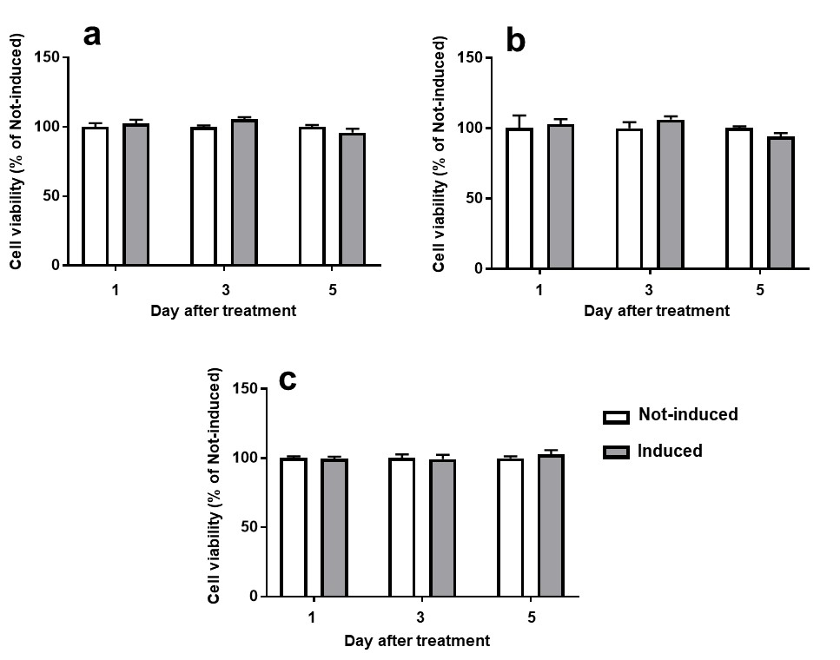

Figure S1. Tau P301L expression did not affect cell viability. HEK T-Rex cells were treated with 1.0 µg/mL doxycycline to induce the expression of human tau P301L (Induced) or with the same volume of 10 mM PBS, pH 7.4 (Not-induced). Cell viability was recorded 1, 3 and 5 days after treatment,with (a) MTT, (b) LDH and (c) Alamar blue assays. Data are expressed as values normalized on the mean of Not-induced cells from three technical replicates of three independent experiments.

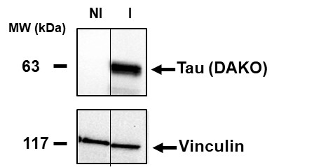

Figure S2. Western blot of cell lysates prior to immunoprecipitation and used for the input. Cell lysates were prepared from HEK T-REx cells induced (I) or Not-induced (NI) for 5 days to express tau P301L. Equal amounts of proteins (30µg) were loaded in each lane of gel and immunoblotted with anti-tau antibody (DAKO) or anti-vinculin antibody.

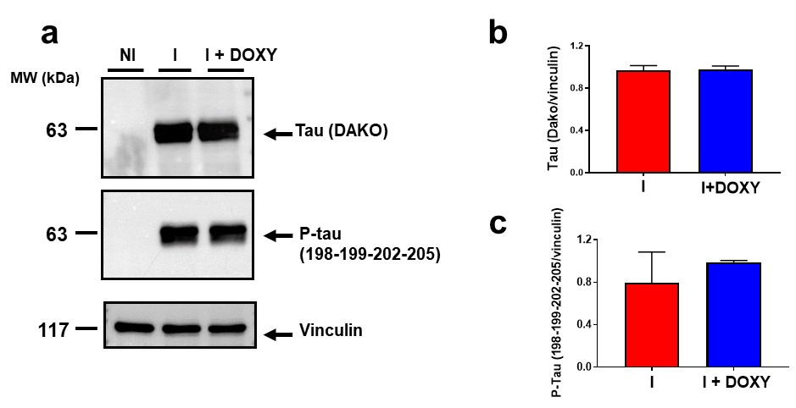

Figure S3. Effect of Doxy on tau expression. Representative Western blot of (a) total tau and phosphorylated tau (P-Tau) in lysates of HEK T-REx cells induced or not-induced (NI) for 5 days to express Tau_{P301L}. Cell lysates of Induced cells (30 µg) were incubated for 2 h with 50 μM Doxy (I+ DOXY) or the same volume of 10 mM PBS, pH 7.4 (I). Equal amounts of proteins (30 µg) were loaded in each gel lane and immunoblotted with (a) anti-tau antibody (DAKO), anti P-tau (198-199-202-205) antibody or anti-vinculin antibody. (b) Total tau and (c) P-tau quantification expressed as the mean volume of the immunoreactive band/vinculin. Data are mean ± SD (N=3).

