Supplementary data
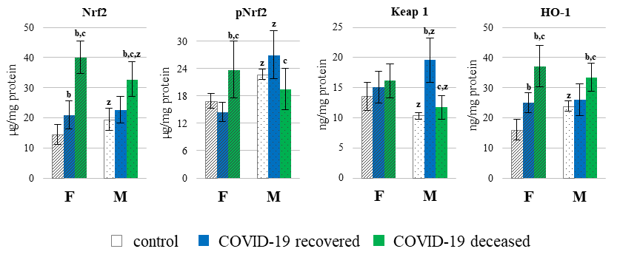
Figure 1A. The levels of Nrf2, phosphorylated Nrf2 (p-Nrf2) and its inhibitor Kelch-like ECH-associated protein 1 (Keap1) as well as heme oxygenase 1 (HO-1) in the granulocytes of patients divided into female and man with COVID-19, including those who recovered (n_{F}=7 and n_{M}=9) and those who deceased (n_{F}= 8 and n_{M}=8) as well as healthy subjects (n_{F}=7 and n_{M}=9). Data points represent the mean ± SD; b – significant differences in relation to healthy people (among women (hatched bars)/men (dotted bars), p < 0.05; c – significant differences in relation to recovered people with COVID-19 (female/man), p < 0.05; z – significant differences between females and males in group of healthy people, patients with COVID-19 recovered and patients with COVID-19 deceased, p < 0.05.

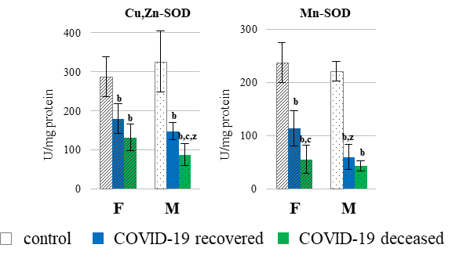
Figure 2A. The activity of superoxide dismutase (cytosolic - Cu,Zn-SOD and mitochondrial - Mn-SOD) in granulocytes of patients divided into female and man with COVID-19, including those who recovered (n_{F}=7 and n_{M}=9) and those who deceased (n_{F}= 8 and n_{M}=8) as well as healthy subjects (n_{F}=7 and n_{M}=9). Data points represent the mean ± SD; b – significant differences in relation to healthy people (among women (hatched bars)/men (dotted bars), p < 0.05; c – significant differences in relation to recovered people with COVID-19 (female/man), p < 0.05; z – significant differences between females and males in group of healthy people, patients with COVID-19 recovered and patients with COVID-19 deceased, p < 0.05.
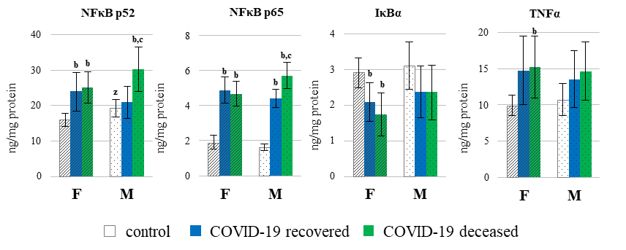
Figure 3A. The level of proteins playing essential role in development of inflammation, such as two family members of nuclear factor kappa-light-chain-enhancer of activated B cells (NFκB p52 and NFκB p65) as well as tumor necrosis factor alpha (TNF-α), in the granulocytes of patients divided into female and man with COVID-19, including those who recovered (n_{F}=7 and n_{M}=9) and those who deceased (n_{F}= 8 and n_{M}=8) as well as healthy subjects (n_{F}=7 and n_{M}=9). Data points represent the mean ± SD; b – significant differences in relation to healthy people (among women (hatched bars)/men (dotted bars), p < 0.05; c – significant differences in relation to recovered people with COVID-19 (female/man), p < 0.05; z – significant differences between females and males in group of healthy people, patients with COVID-19 recovered and patients with COVID-19 deceased, p < 0.05.

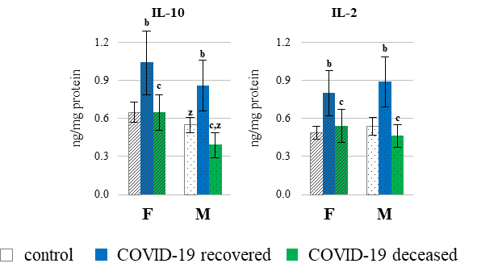
Figure 4A. The level of anti-inflammatory interleukin 10 (IL-10) and pro-inflammatory interleukin 2 (IL-2) and interleukin 6 (IL-6) in the granulocytes of patients divided into female and man with COVID-19, including those who recovered (n_{F}=7 and n_{M}=9) and those who deceased (n_{F}= 8 and n_{M}=8) as well as healthy subjects (n_{F}=7 and n_{M}=9). Data points represent the mean ± SD; b – significant differences in relation to healthy people (among women (hatched bars)/men (dotted bars), p < 0.05; c – significant differences in relation to recovered people with COVID-19 (female/man), p < 0.05; z – significant differences between females and males in group of healthy people, patients with COVID-19 recovered and patients with COVID-19 deceased, p < 0.05.

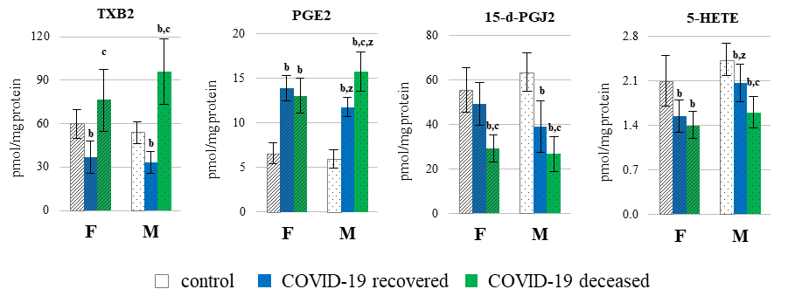
Figure 5A. The level of pro-inflammatory eicosanoids (A): thromboxane B2 (TXB₂) and prostaglandin E2 (PGE₂) and anti-inflammatory eicosanoids (B): 15-deoxy-delta12,14-prostaglandin J2 (15d-PGJ2) and 5-hydroxyeicosatetraenoic acid (5-HETE) in the granulocytes of patients divided into female and man with COVID-19, including those who recovered (n_{F}=7 and n_{M}=9) and those who deceased (n_{F}= 8 and n_{M}=8) as well as healthy subjects (n_{F}=7 and n_{M}=9). Data points represent the mean ± SD; b – significant differences in relation to healthy people (among women (hatched bars)/men (dotted bars), p < 0.05; c – significant differences in relation to recovered people with COVID-19 (female/man), p < 0.05; z – significant differences between females and males in group of healthy people, patients with COVID-19 recovered and patients with COVID-19 deceased, p < 0.05.

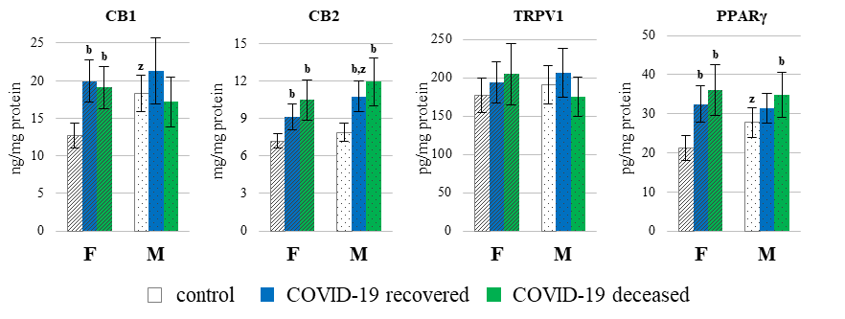
Figure 6A. The level of receptors involved in oxidative and inflammatory reactions of granulocytes from patients divided into female and man with COVID-19, including those who recovered (n_{F}=7 and n_{M}=9) and those who deceased (n_{F}=8 and n_{M}=8) as well as healthy subjects (n_{F}=7 and n_{M}=9). CB1 and CB2 - cannabinoid receptors 1 and 2; TRPV1 - the transient receptor potential cation channel subfamily V member 1; PPARγ - peroxisome proliferator-activated receptor gamma. Data points represent the mean ± SD; b – significant differences in relation to healthy people (among women (hatched bars)/men (dotted bars), p < 0.05; c – significant differences in relation to recovered people with COVID-19 (female/man), p < 0.05; z – significant differences between females and males in group of healthy people, patients with COVID-19 recovered and patients with COVID-19 deceased, p < 0.05.

