Supplementary information
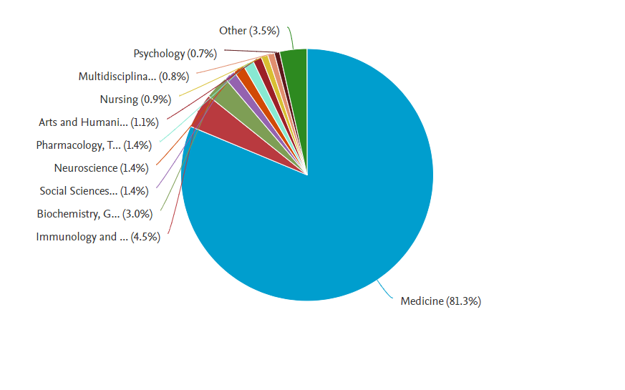
Figure S1: Shows the distribution of the different thematic areas of publications.

Table S1: Shows the top 20 authors syphilis paper published 1921-2021.
Sr No | AUTHOR's NAME | No. of Publications | %(N=1460) | citations | h-index
1 | Klausner, J.D. | 109 | 7.46 | 15151 | 63
2 | Lukehart, S.A | 107 | 7.32 | 7763 | 50
3 | Vaisman, A. | 92 | 6.3 | 85 | 5
4 | Fairley, C.K. | 84 | 5.75 | 21342 | 68
5 | Chen, X.S. | 82 | 5.61 | 3758 | 32
6 | Radolf, J.D. | 81 | 5.54 | 16857 | 72
7 | Mabey, D. | 81 | 5.54 | 21543 | 74
8 | Peeling, R.W. | 78 | 5.34 | 18346 | 69
9 | Dupin, N. | 77 | 5.27 | 9572 | 48
10 | Hook, E.W. | 72 | 4.93 | 17393 | 74
11 | Peterman, T.A. | 65 | 4.45 | 8699 | 47
12 | Šmajs, D. | 64 | 4.38 | 2907 | 32
13 | Janier, M. | 63 | 4.31 | 3021 | 31
14 | Strathdee, S.A. | 61 | 4.17 | 31367 | 86
15 | Marra, C.M. | 60 | 4.1 | 15606 | 59
16 | Tucker, J.D. | 59 | 4.04 | 4272 | 35
17 | Vermund, S.H. | 57 | 3.9 | 17142 | 63
18 | Holmes, K.K. | 56 | 3.83 | 38573 | 98
19 | Norgard, M.V. | 56 | 3.83 | 11507 | 58
20 | Tang, W. | 56 | 3.83 | 2817 | 28
 | Total | 1460
Table S2: Showed the top 20 institutions depicting the publication of syphilis
Sr No | Institutions | No. of Publications | %(N=1460)
1 | Centers for Disease Control and Prevention, USA | 1108 | 17.65
2 | National Center for HIV/AIDS, Viral hepatitis, STD, and TB Prevent, USA | 592 | 9.43
3 | University of Washington, USA | 461 | 7.34
4 | London School of Hygiene & Tropical Medicine, UK | 389 | 6.19
5 | University of California, San Francisco, USA | 360 | 5.73
6 | The University of North Carolina at Chapel Hill, USA | 338 | 5.38
7 | Johns Hopkins University, USA | 272 | 4.33
8 | Harvard Medical School, USA | 258 | 4.11
9 | Organisation Mondiale de la Santé, FRANCE | 256 | 4.07
10 | Johns Hopkins School of Medicine, USA | 233 | 3.71
11 | Universidade de São Paulo, BRAZIL | 221 | 3.52
12 | Johns Hopkins Bloomberg School of Public Health, USA | 220 | 3.5
13 | UNSW Sydney, AUSTRALIA | 214 | 3.41
14 | David Geffen School of Medicine at UCLA, USA | 214 | 3.41
15 | University College London, UK | 208 | 3.31
16 | Chinese Center for Disease Control and Prevention, PR CHINA | 200 | 3.18
17 | Baylor College of Medicine, USA | 191 | 3.04
18 | Columbia University, USA | 183 | 2.91
19 | The University of Alabama at Birmingham, USA | 182 | 2.78
20 | University of California, San Diego, USA | 175 | 1.67
 | Total | 6275

Table S3: Showed the top 20 funding institutes.
Sl No | Funding Institutions | No. of Publications | %(N=5690)
1 | National Institute of Health | 1226 | 21.54
2 | National Institute of Allergy and Infectious Diseases | 1128 | 19.82
3 | U.S. Department of Health and Human Services | 818 | 14.37
4 | National Institute of Mental Health | 288 | 5.06
5 | Fogarty International Center | 360 | 5.73
6 | National Institute on Drug Abuse | 262 | 4.6
7 | National Natural Science Foundation of China | 220 | 3.86
8 | Centers for Disease Control and Prevention | 212 | 3.72
9 | Eunice Kennedy Shriver National Institute of Child Health and Human Development | 198 | 3.47
10 | Medical Research Council | 128 | 2.24
11 | Bill and Melinda Gates Foundation | 105 | 1.84
12 | National Cancer Institute | 98 | 1.72
13 | Gilead Sciences | 96 | 1.68
14 | Conselho Nacional de Desenvolvimento Científico e Tecnológico | 91 | 1.59
15 | National Center for Advancing Translational Sciences | 89 | 1.56
16 | U.S. Public Health Service | 87 | 1.52
17 | UK Research and Innovation | 79 | 1.38
18 | Wellcome Trust | 76 | 1.33
19 | Coordenação de Aperfeiçoamento de Pessoal de Nível Superior | 70 | 1.23
20 | National Center for Research Resources | 64 | 1.12
 | Total | 5690

