Supplementary Files:
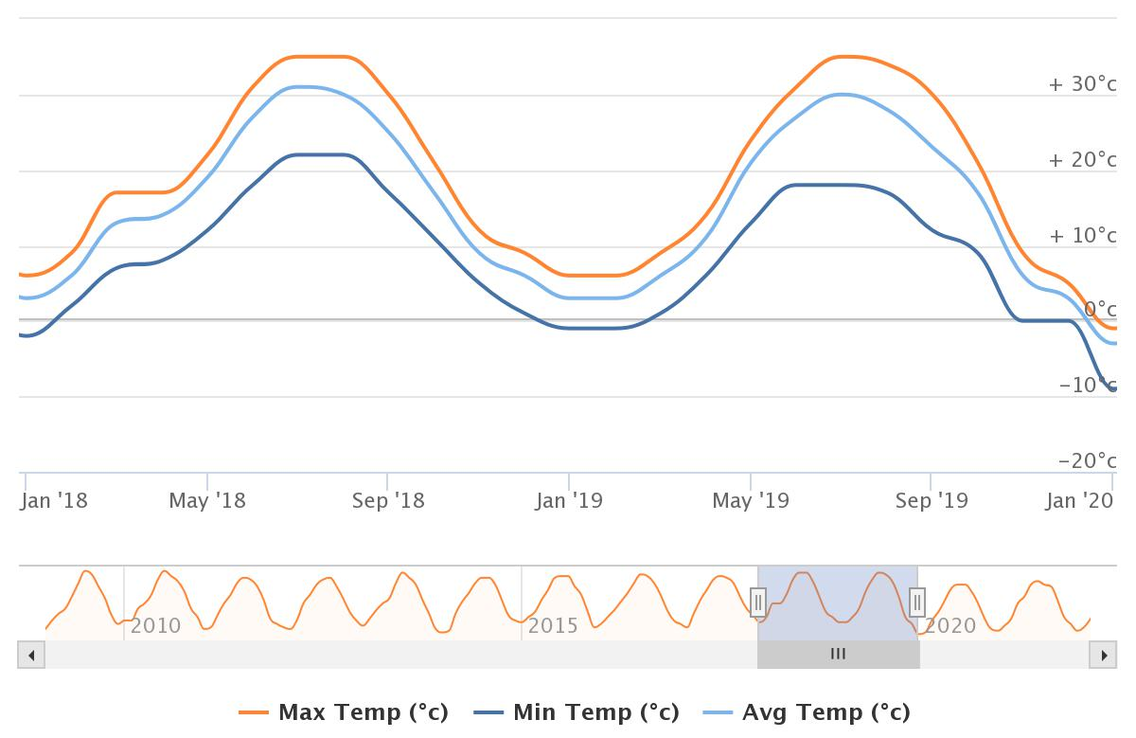
Fig S1a. Diagram of Maximum, Minimum and Average temperature of Tuyserkan in 2018 and 2019.
Source: https://www.worldweatheronline.com

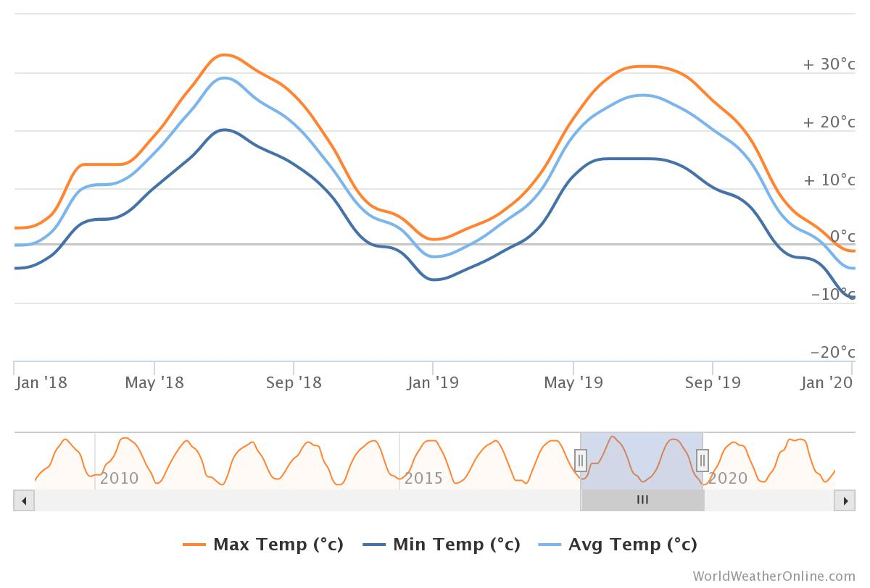
Fig S1b. Diagram of Maximum, Minimum and Average temperature of Razan in 2018 and 2019.
Source: https://www.worldweatheronline.com

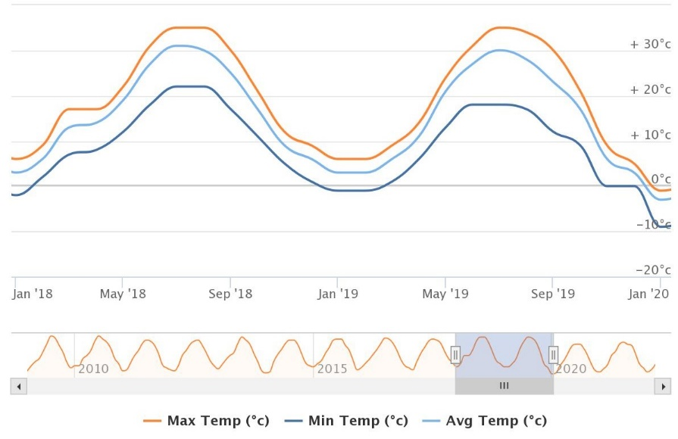
Fig S1c. Diagram of Maximum, Minimum and Average temperature of Kurzan in 2018 and 2019.
Source: https://www.worldweatheronline.com

