Supplementary Information

Streptavidin-Modified Iron Oxide Hybrid Nanozymes for Magnetic Enrichment and Bioelectrocatalytic Sensing of Circulating Tumor RNA

Kevin M. Koo^{1,2,*}

¹The University of Queensland Centre for Clinical Research (UQCCR), QLD 4029, Australia

²XING Applied Research & Assay Development (XARAD) Division, XING Technologies Pty Ltd, QLD 4073, Australia

Correspondence: maisheng.koo@uqconnect.edu.au

Table S1 Primer sequences.
Oligos | 5'-Sequence-3'
T2:ERG Forward Primer | Bio-C6-CGGCAGGAAGCCTTATCA
T2:ERG Reverse Primer | GTTACATTCCATTTTGAT
PCA3 Forward Primer | Bio-C6-CCTGATGATACAGAGGTGAG
PCA3 Reverse Primer | GCACAGGGCGAGGCTCATCG
KLK2 Forward Primer | Bio-C6-GGGGGTCCACTTGTCTGTAA
KLK2 Reverse Primer | GGTGAGTTCCAAGCTTCAGG
Key: Bio-C6-, Biotin modification with 6-carbon spacer.
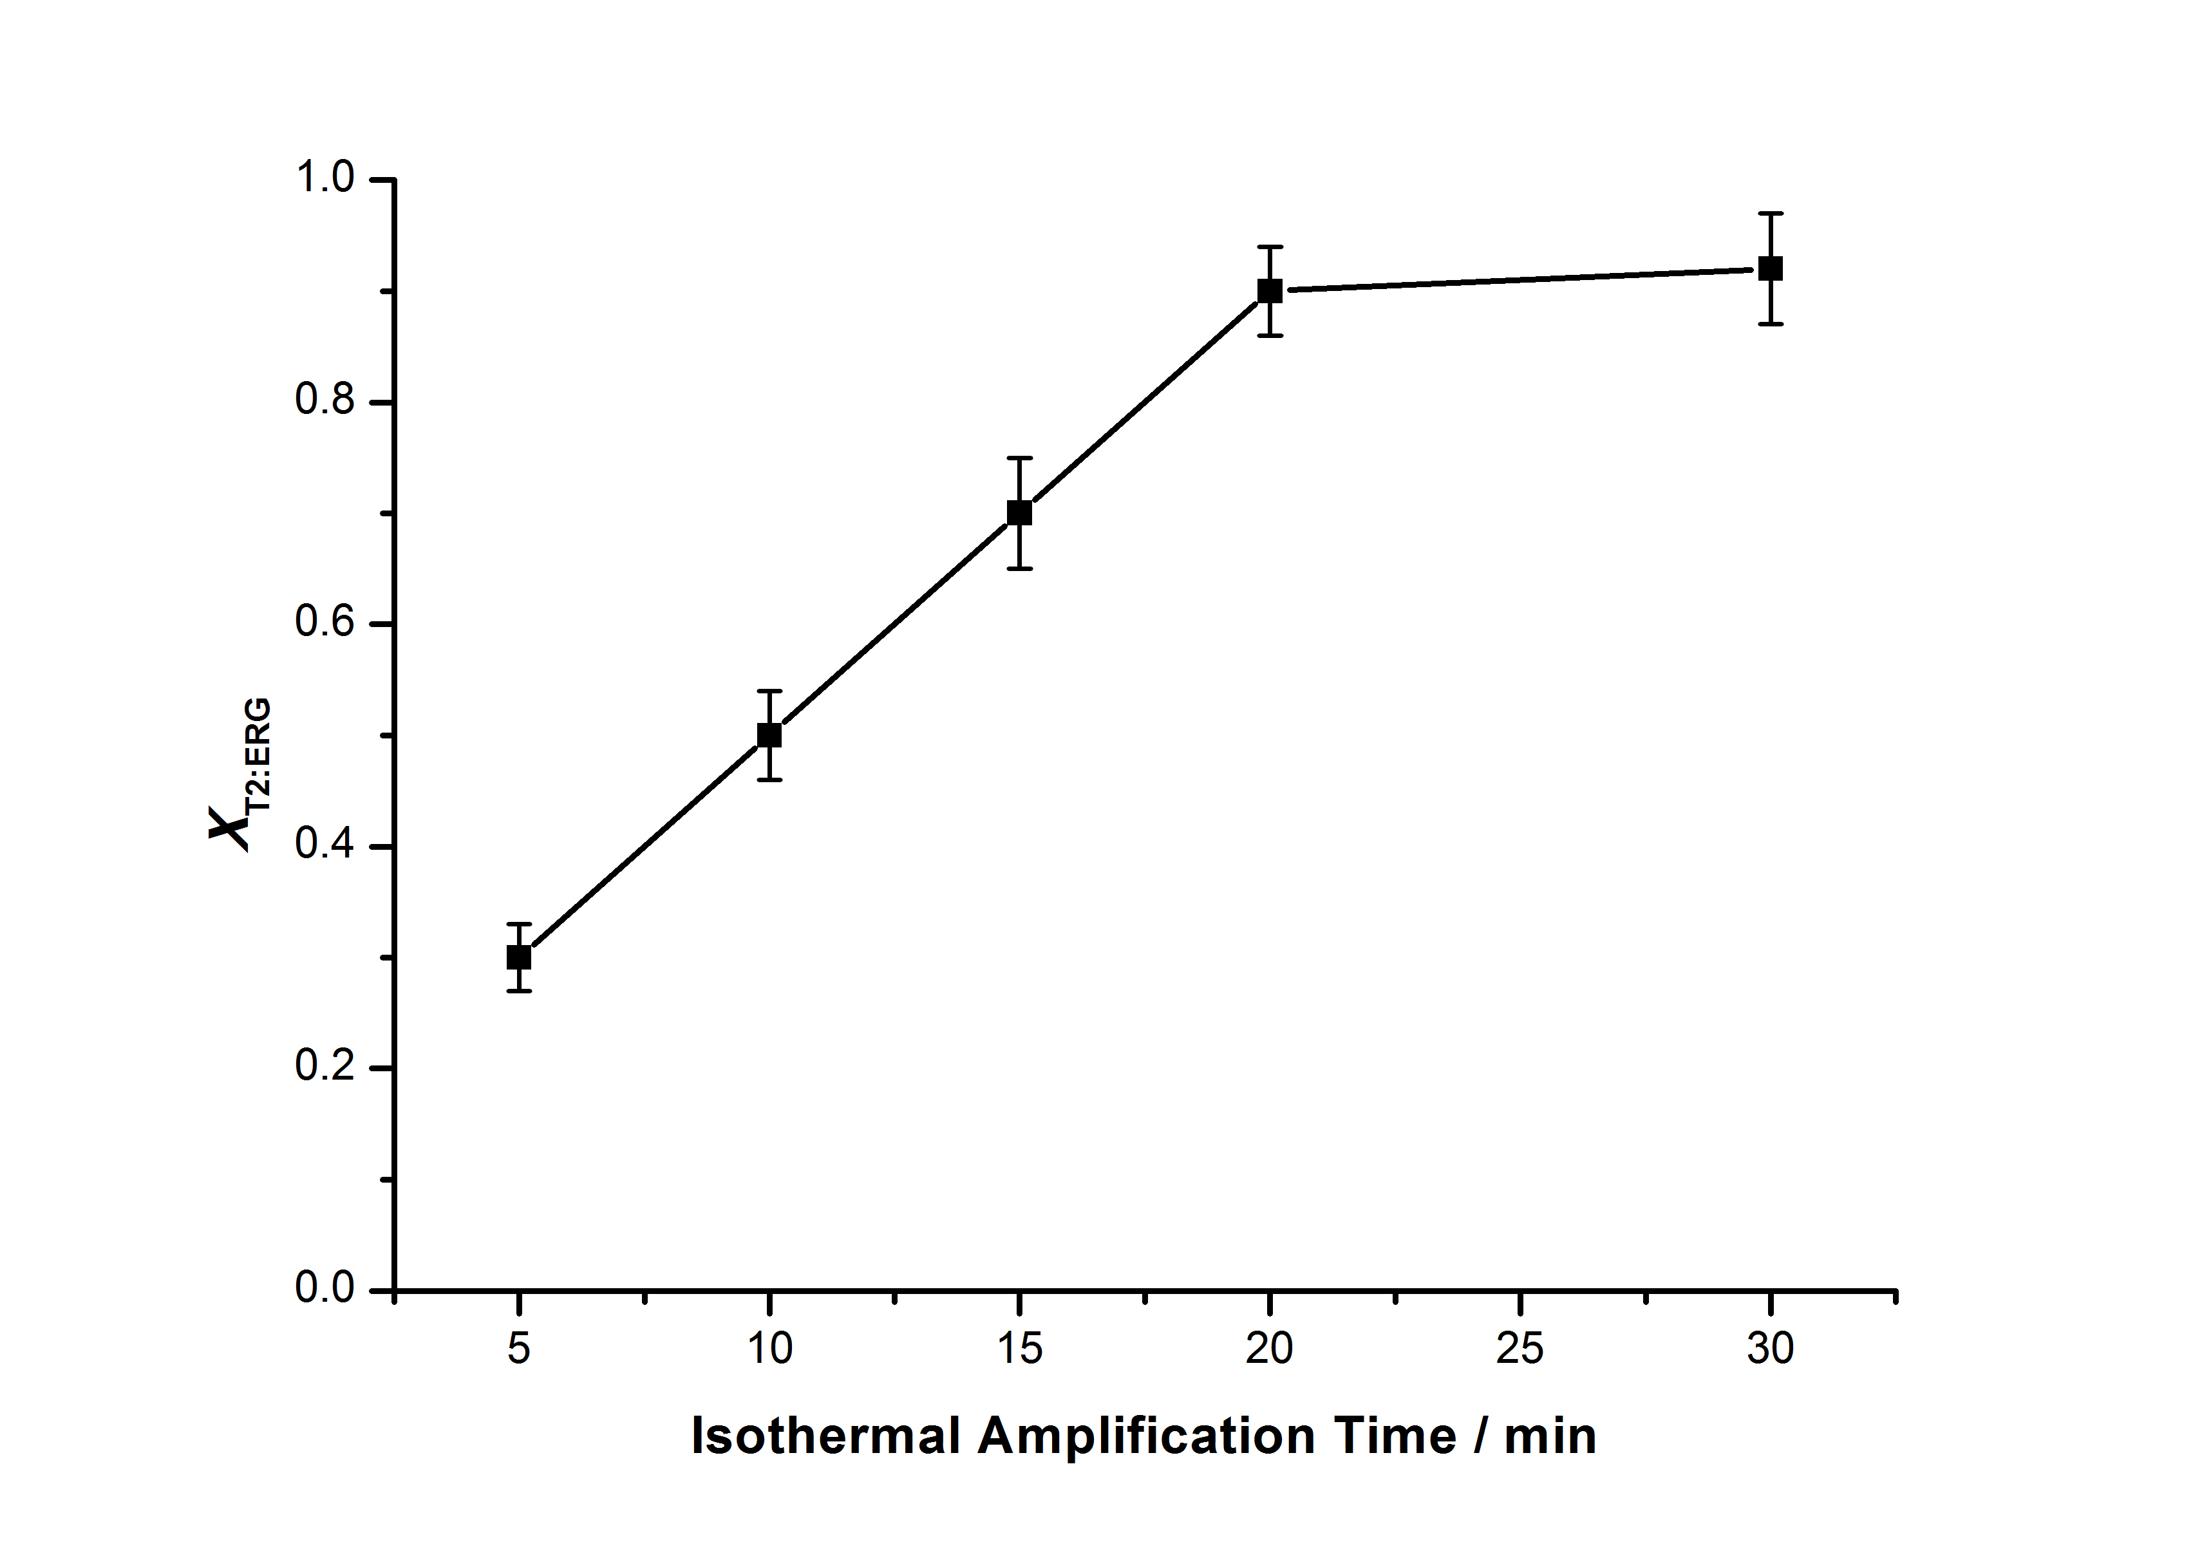Figure S1. Optimization of isothermal amplification times (5, 10, 15, 20, and 30 min). Error bars represent standard deviations of three technical replicates.

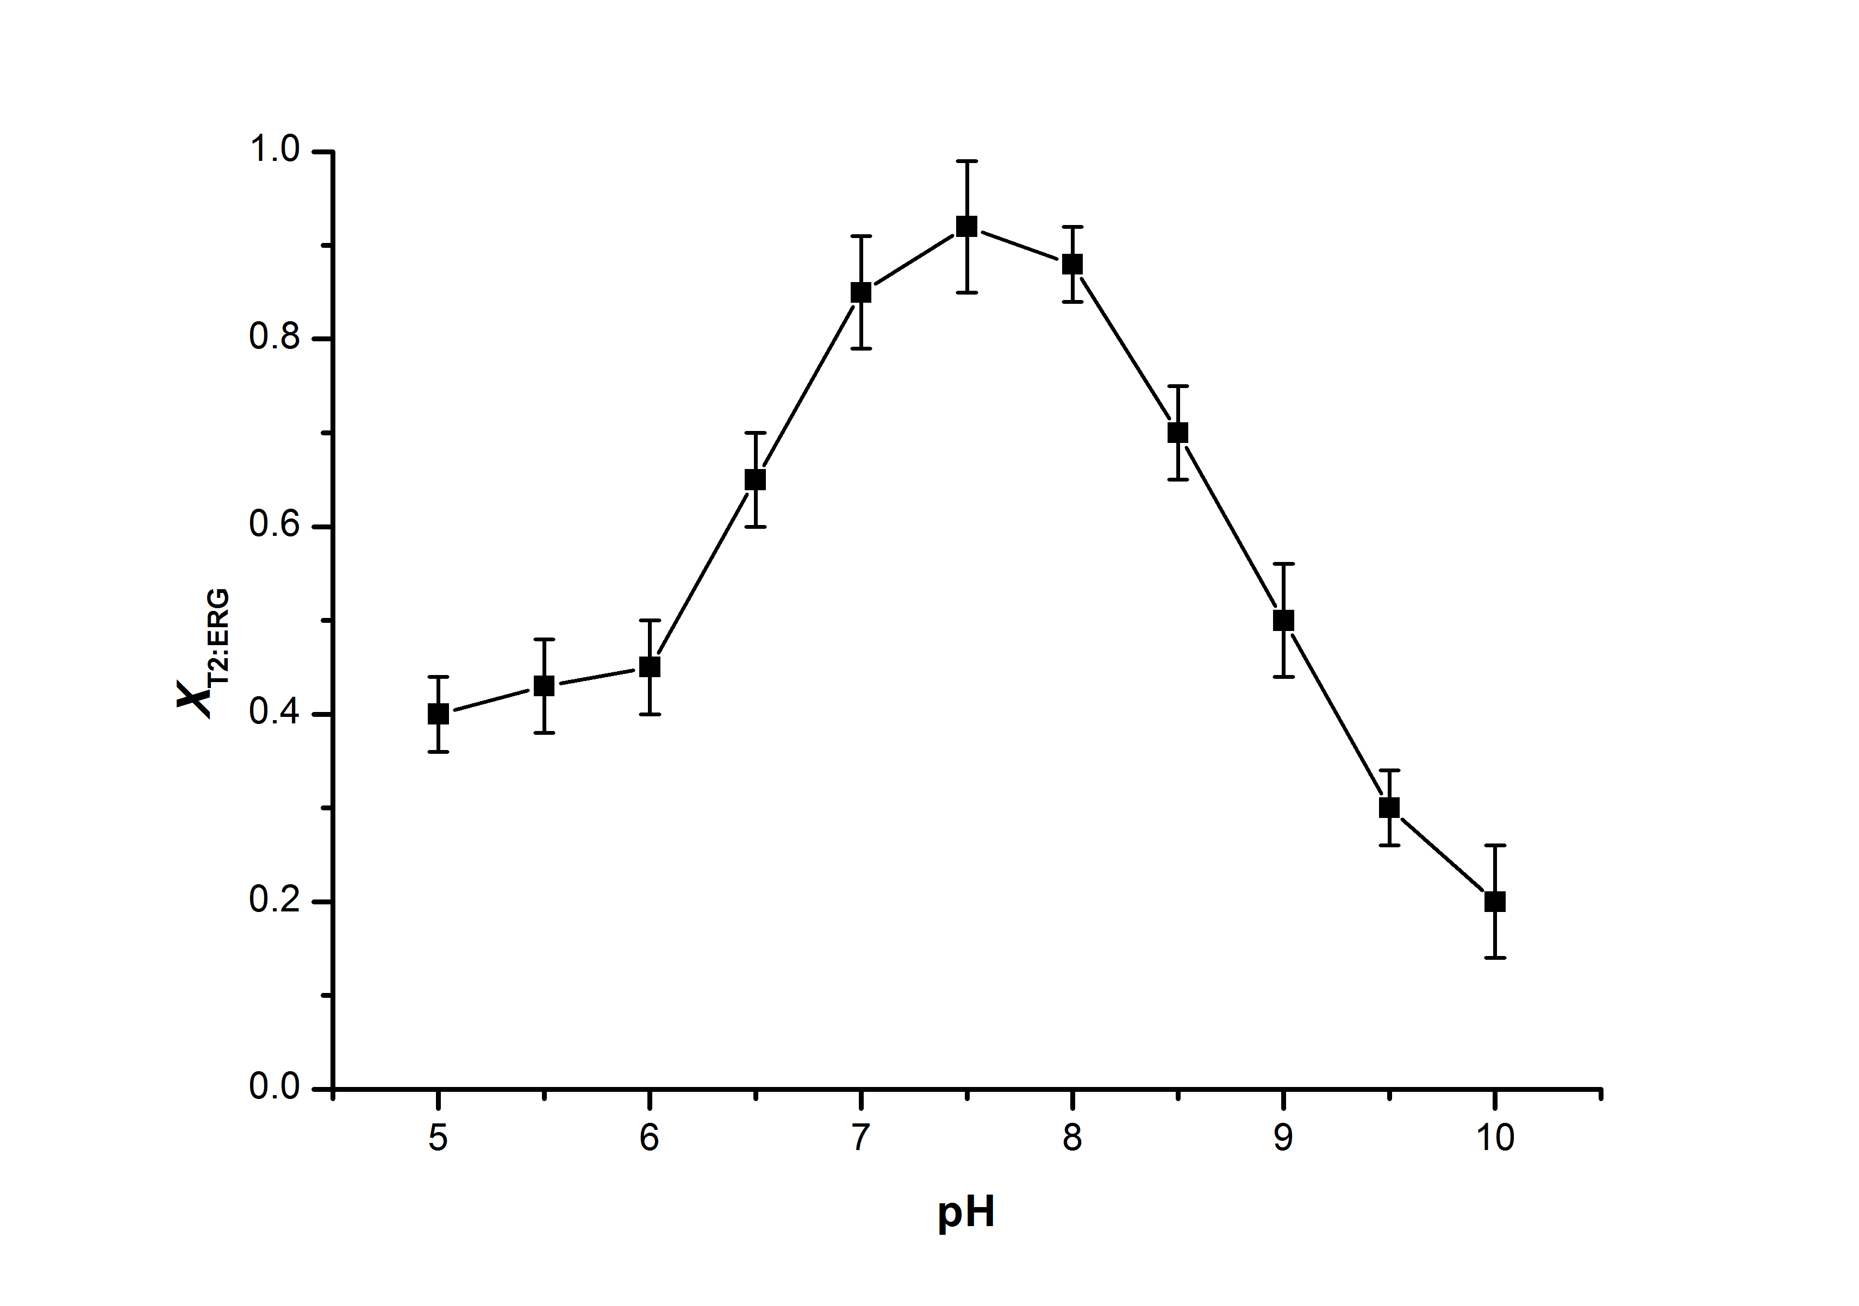
Figure S2. Optimization of electrolyte buffer pH 5.0 – 10.0. Error bars represent standard deviations of three technical replicates.

